Supplement figures
Alcohol consumption and risk of liver fibrosis in HIV patients: a systematic review and meta-analysis
Hang Lyu, et al.

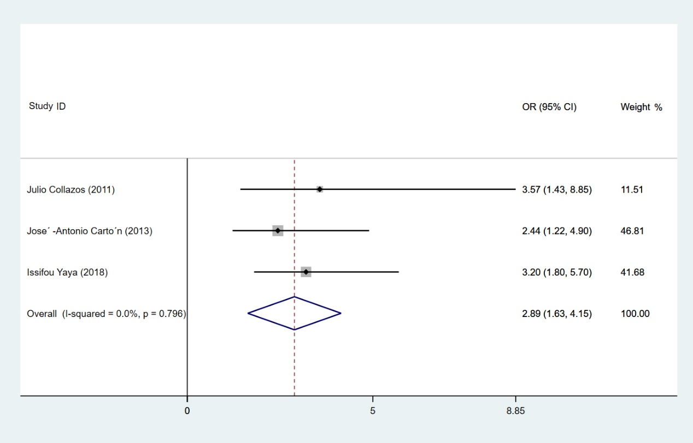
Supplement figure1. Forest plot of liver fibrosis pooled odds risk by alcohol consumption in cohort studies.

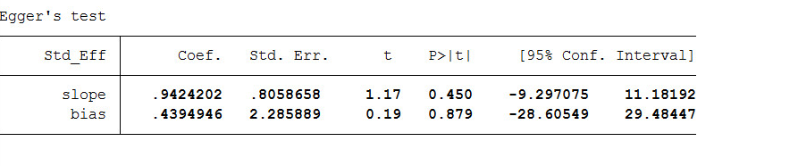
Supplement figure2. Egger’s test for cohort study analysis.

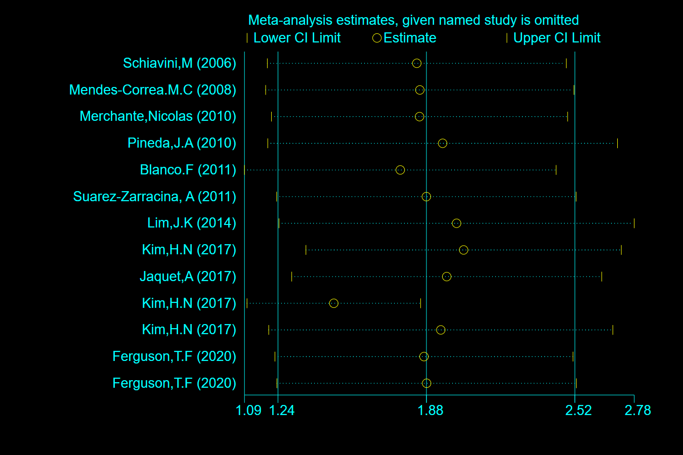
Supplement figure3. Results of sensitivity analysis

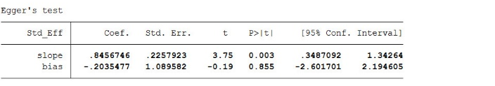
Supplement figure4. Egger’s test of cross-sectional study analysis.

