Supplementary Material

Supplementary Table 1. Additional details on search strategy
Database | Search terms | Results
Medline  (PubMed) | #1. (“Gastrointestinal Microbiome”[mh] OR Microbiota[mh] OR microbiome*[tiab] OR microflora*[tiab] OR microbiota*[tiab] OR microbial[tiab] OR gut flora*[tiab] OR intestinal flora*[tiab] OR intestine flora*[tiab])  #2. (probiotics[mh] OR prebiotics[mh] OR synbiotics[mh] OR probiotic*[tiab] OR prebiotic*[tiab] OR synbiotic*[tiab])  #3. #1 OR #2  #4. ("Attention Deficit Disorder with Hyperactivity"[mh] OR "attention deficit disorder with hyperactivity"[tiab] OR ADHD[tiab] OR ADDH[tiab] OR ADHS[tiab] OR "attention deficit hyperactivity disorder"[tiab] OR "attention deficit disorder"[tiab] OR "disturbance of activity and attention"[tiab] OR hyperkine*[tiab] OR "hyperkinetic disorder"[tiab] OR "hyperkinetic syndrome"[tiab] OR "attention-deficit/hyperactivity disorder"[tiab])  #5. #3 AND #4 | 111
Web of Science | #1. ts=("gastrointestinal microbiome" OR microbiota OR microbiome* OR microflora* OR microbiota* OR microbial OR "gut flora*" OR "intestinal flora*" OR "intestine flora*")  #2. ts= (probiotic* OR prebiotic* OR synbiotic*)  #3. #1 OR #2  #4. ts=("attention deficit disorder with hyperactivity" OR ADHD OR "attention deficit hyperactivity disorder" OR "attention deficit disorder" OR "disturbance of activity and attention" OR "attention-deficit/hyperactivity disorder" OR ADDH OR ADHS OR hyperkine* OR "hyperkinetic disorder" OR "hyperkinetic syndrome")  #5. #3 AND #4 | 143
Embase | #1. ('Intestine Flora'/exp OR 'Microflora'/exp OR microbiome*:ti,ab OR microflora*:ti,ab OR microbiota*:ti,ab OR microbial:ti,ab OR 'gut flora*':ti,ab OR 'intestinal flora*':ti,ab OR 'intestine flora*':ti,ab)  #2. ('Probiotic Agent'/exp OR probiotic*:ti,ab OR 'Prebiotic Agent'/exp OR prebiotic*:ti,ab OR 'Synbiotic Agent'/exp OR synbiotic*:ti,ab)  #3. #1 OR #2  #4. ('Attention Deficit Disorder'/exp OR 'attention deficit disorder with hyperactivity':ti,ab OR ADHD:ti,ab OR 'attention deficit hyperactivity disorder':ti,ab OR 'attention deficit disorder':ti,ab OR 'disturbance of activity and attention':ti,ab OR 'attention-deficit/hyperactivity disorder':ti,ab OR ADDH:ti,ab OR ADHS:ti,ab OR hyperkine*:ti,ab OR 'hyperkinetic disorder':ti,ab OR 'hyperkinetic syndrome':ti,ab)  #5. #3 AND #4 | 266
Cochrane Library | #1. "gastrointestinal microbiome" or "microbiota" or microbiome* or microflora* or microbiota* or microbial or "gut flora*" or "intestinal flora*" or "intestine flora*":ti,ab,kw  #2. MeSH descriptor: ["Gastrointestinal Microbiome"] explode all trees  #3. #1 OR #2  #4. probiotic* or prebiotic* or synbiotic*:ti,ab,kw  #5. MeSH descriptor: [Probiotics] explode all trees  #6. MeSH descriptor: [Prebiotics] explode all trees  #7. MeSH descriptor: [Synbiotics] explode all trees  #8. #4 OR #5 OR #6 OR #7  #9. #3 OR #8  #10. "attention deficit disorder with hyperactivity" OR ADHD OR ADDH OR ADHS OR "attention deficit hyperactivity disorder" OR "attention deficit disorder" OR "disturbance of activity and attention" OR "attention-deficit/hyperactivity disorder" OR hyperkine* OR "hyperkinetic disorder" OR "hyperkinetic syndrome":ti,ab,kw  #11. MeSH descriptor: ["Attention Deficit Disorders with Hyperactivity"] explode all trees  #12. #10 OR #11  #13. #9 AND #12 | 35
PsycINFO | #1. MA ("Gastrointestinal Microbiome" OR Microbiota)  #2. TX (microbiome* OR microflora* OR microbiota* OR microbial OR "gut flora*" OR "intestinal flora*" OR "intestine flora*")  #3. MA (Probiotics OR Prebiotics OR Synbiotics)  #4. TX (probiotic* OR prebiotic* OR synbiotic*)  #5. #1 OR #2 OR #3 OR #4  #6. MA ("Attention Deficit Disorders with Hyperactivity")  #7. TX ("attention deficit disorder with hyperactivity" OR "attention deficit hyperactivity disorder" OR "attention deficit disorder" OR "disturbance of activity and attention" OR "attention-deficit/hyperactivity disorder" OR ADHD OR ADDH OR ADHS OR hyperkine* OR "hyperkinetic disorder" OR "hyperkinetic syndrome")  #8. #6 OR #7  #9. #5 AND #10 | 38

Supplementary Table 2. PRISMA Checklist
# | Item | Guidance | On page #
Title
1 | Title | Identify the report as a systematic review, or systematic review and meta-analysis, as appropriate. | 1
Abstract
2 | Structured summary | Provide a structured summary including, as applicable:  - Background;  - Objectives;  - Data sources;  - Study eligibility criteria, participants, and interventions;  - Study appraisal and synthesis methods;  - Results;  - Limitations; conclusions and implications of key findings;  - Systematic review registration number. | 1-2
Introduction
3 | Rationale | Describe the rationale for the review in the context of what is already known. | 2
4 | Objectives | Provide an explicit Population-Intervention-Comparator-Outcome-Study Design (PICOS) or Population-Exposure-Comparator-Outcome-Study Design (PECOS) statement as appropriate, detailing the following in relation to the research questions being asked:  - Participants  - Interventions / Exposures (as appropriate)  - Comparisons  - Outcomes  - Study design | 2
Methods
5 | Protocol and registration | Indicate if a review protocol exists, if and where it can be accessed (e.g. web address), and registration information including registration number (if available). | 2
6 | Eligibility criteria | Specify study characteristics (e.g. PICOS/PECOS, length of exposure) and report characteristics (e.g. years considered, language, publication status) used as criteria for eligibility, giving rationale. | 2
7 | Information sources | Describe all information sources (e.g. databases with dates of coverage, contact with study authors to identify additional studies) in the search, and date last searched. | 2
8 | Search | Present full electronic search strategy for at least one database, including any limits used, such that it could be repeated. | 2, Supplementary Material 1
9 | Study selection | State the process for selecting studies (i.e., screening, eligibility, included in systematic review, and, if applicable, included in the meta-analysis). | 3
10 | Data collection process | Describe method of data extraction from reports (e.g., piloted forms, independently, in duplicate) and any processes for obtaining and confirming data from investigators. | 3
11 | Data items | List and define all variables for which data were sought (e.g., PICOS/PECOS, funding sources) and any assumptions and simplifications made. | 3
12 | Risk of bias in individual studies | Describe methods used for assessing risk of bias of individual studies (including specification of whether this was done at the study or outcome level), and how this information is to be used in any data synthesis. | 3
13 | Summary measures | State the principal summary measures (e.g., risk ratio, difference in means). | 3
14 | Synthesis of results | Describe the methods of handling data and combining results of studies, if done, including measures of consistency (e.g., I²) for each meta-analysis. | 3
15 | Risk of bias across studies | Specify any assessment of risk of bias that may affect the cumulative evidence (e.g., publication bias, selective reporting within studies). | 3
16 | Additional analyses | Describe methods of additional analyses (e.g., sensitivity or subgroup analyses, meta-regression), if done, indicating which were pre-specified. | 4
Results
17 | Study selection | Give numbers of studies screened, assessed for eligibility, and included in the review, with reasons for exclusions at each stage, illustrated with a PRISMA flow diagram. | 4, Figure 1
18 | Study characteristics | For each study, present in a summary table the characteristics for which data were extracted (e.g., study size, PICOS/PECOS, follow-up period) and provide the citations. | 4, Table 1
19 | Risk of bias within studies | Present data on risk of bias of each study and, if available, any outcome level assessment (see item 12). | 6
20 | Results of individual studies | For all outcomes considered (benefits or harms), present, for each study: (a) simple summary data for each intervention group (b) effect estimates and confidence intervals, ideally with a forest plot (unless such a plot would be misleading) | Figure 2 to 9
21 | Synthesis of results | Present results of each meta-analysis done, including confidence intervals and measures of consistency. | Figure 2 to 9
22 | Risk of bias across studies | Present results of any assessment of risk of bias across studies (see Item 15). | 6, Supplementary Material 3
23 | Additional analysis | Give results of additional analyses, if done (e.g., sensitivity or subgroup analyses, meta-regression [see Item 16]). | Figure 4, 6, and 9
Discussion
24 | Summary of evidence | Summarize the main findings including the strength of evidence for each main outcome; consider their relevance to key groups (e.g., researchers, users, and policy makers). | 7
25 | Limitations | Discuss limitations at study and outcome level (e.g., risk of bias), and at review-level (e.g., incomplete retrieval of identified research, reporting bias). | 7
26 | Conclusions | Provide a general interpretation of the results in the context of other evidence, and implications for future research. | 7
27 | Funding | Describe sources of funding for the systematic review and other support (e.g., supply of data); role of funders for the systematic review. | 26

Supplementary Figure1. Funnel plots of included studies
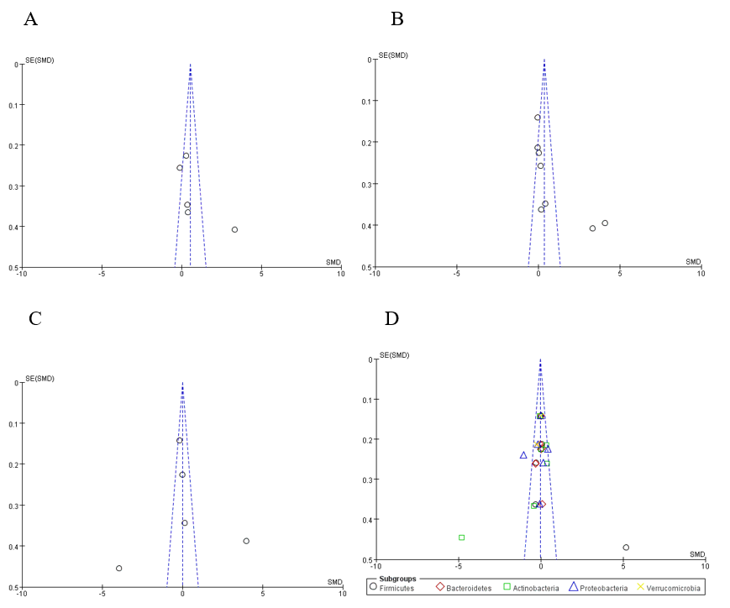
Notes: A) Chao1 index; B) Shannon index; C) Simpson index; D) Phylum.
Abbreviations: SMD, standardized mean difference.

