SUPPLEMENTARY MATERIAL
Appendix I: Search build
Embase.com
('aortic dissection'/de OR 'dissecting aortic aneurysm'/de OR (('dissecting aneurysm'/de OR 'dissection'/de) AND (aorta/de OR 'aortic disease'/exp)) OR (((aort* OR arch OR type-a OR type-b OR debakey) NEAR/6 dissect*)):ab,ti) AND ('thoracic aorta'/de OR 'thoracic aortic surgery'/de OR 'thoracic aorta aneurysm'/de OR 'ascending aorta'/de OR 'descending aorta'/de OR 'descending aortic surgery'/de OR 'ascending aortic surgery'/de OR 'aortic arch'/de OR 'aortic arch surgery'/de OR (thorac* OR ascend* OR descend* OR type-a OR type-b OR debakey OR arch):ab,ti) AND ('survival'/exp OR mortality/exp OR 'fatality'/exp OR (surviv* OR mortalit* OR death-rate OR fatal*):ab,ti) NOT ([animals]/lim NOT [humans]/lim) NOT ('case report'/de OR 'case study'/de OR 'systematic review'/de OR ('systematic review' OR (case NEXT/1 (report* OR stud* OR series*))):ti) NOT ([Conference Abstract]/lim) AND [English]/lim
Medline Ovid
(((Aneurysm, Dissecting/ OR Dissection/) AND (exp Aorta/ OR Aortic Diseases/)) OR (((aort* OR arch OR type-a OR type-b OR debakey) ADJ6 dissect*)).ab,ti.) AND (Aorta, Thoracic/ OR Aortic Aneurysm, Thoracic/ OR (thorac* OR ascend* OR descend* OR type-a OR type-b OR debakey OR arch).ab,ti.) AND (exp survival/ OR exp mortality/ OR Fatal Outcome/ OR (surviv* OR mortalit* OR death-rate OR fatal*).ab,ti.) NOT (exp animals/ NOT humans/) NOT (Case Reports/ OR systematic review/ OR (systematic review OR (case ADJ (report* OR stud* OR series*))).ti.) AND english.la.
Web of science Core Collection
TS=(((((aort* OR arch OR type-a OR type-b OR debakey) NEAR/5 dissect*))) AND ((thorac* OR ascend* OR descend* OR type-a OR type-b OR debakey OR arch)) AND ((surviv* OR mortalit* OR death-rate ORfatal*))) NOT TI=(("systematic review" OR (case NEAR/1 (report* OR stud* OR series*)))) AND DT=(article) AND LA=(english)
Cochrane Central Register of Controlled Trials
((((aort* OR arch OR type-a OR type-b OR debakey) NEAR/6 dissect*)):ab,ti) AND ((thorac* OR ascend* OR descend* OR type-a OR type-b OR debakey OR arch):ab,ti) AND ((surviv* OR mortalit* OR death-rate OR fatal*):ab,ti)
Appendix II: Extracted data and definitions
 | Definition
Study characteristics
Author | First author
Publication year | Year of publication
Study design | Design of included study
Single or multicenter study | Study conducted at single or multiple centers
Number of patients | Number of patients as mentioned in study
Population | Type of dissection according to Stanford classification⁷ and treatment
Institution country | Country in which patient data is collected
Inclusion period | Start of inclusion period as mentioned in study – end of inclusion period as mentioned in study
Patient demographics
Age (mean) | Mean age at presentation
Sex | Male/female
Mean BSA (m²) | As reported in included studies
Mean BMI (kg/m²) | As reported in included studies
History of hypertension | As reported in included studies
Diabetes mellitus | As reported in included studies
Hyperlipidemia | As reported in included studies
Smoking | As reported in included studies
COPD | As reported in included studies
History of cerebrovascular disease | History of stroke or TIA as reported in included studies
Chronic kidney disease | As reported in included studies
Congestive heart failure | As reported in included studies
Marfan syndrome | As reported in included studies
Bicuspid aortic valve | As reported in included studies
Previous aortic aneurysm | As reported in included studies
Previous aortic dissection | As reported in included studies
Presentation | As reported in included studies
Hypotension/shock at presentation | As reported in included studies
Tamponade | As reported in included studies
Pericardial effusion | As reported in included studies
Cerebral ischemia | As reported in included studies
Presentation ≥ 24 h | As reported in included studies
Abrupt onset of pain | As reported in included studies
Chest pain | As reported in included studies
Back pain | As reported in included studies
Abdominal pain | As reported in included studies
Any focal neurological deficits | As reported in included studies
Syncope | As reported in included studies
Altered consciousness/coma | As reported in included studies
Pulse deficit | As reported in included studies
Mean Creatinine (mg/dl) | As reported in included studies
Renal insufficiency | As reported in included studies
DeBakey type II | As reported in included studies
Max. aortic diameter ascendens (mean) mm | As reported in included studies
Aortic regurgitation | As reported in included studies
Management/procedural characteristics
Open surgery | Surgical procedure with sternotomy for type A dissection, thoracotomy for type B dissection
Endovascular treatment | Endovascular procedure with access through blood vessels
Medication | Conservative treatment with medication without surgical/endovascular procedure
Isolated supracoronary ascending aortic replacement | As reported in included studies
Bentall procedure | As reported in included studies
David procedure | As reported in included studies
Aortic valve repair or replacement | As reported in included studies
Aortic valve replacement | As reported in included studies
Total arch replacement | As reported in included studies
Concomitant CABG | As reported in included studies
Total operation time (mean in min) | As reported in included studies
Cardiopulmonary bypass time (mean) min | As reported in included studies
Aortic cross clamp time (mean) min | As reported in included studies
DHCA/Circulatory arrest time (mean) min | As reported in included studies
Early outcomes (in-hospital events or within 30 days)
Early mortality, all | In-hospital mortality / 30 day mortality, when both are mentioned in-hospital mortality is preferred for patients independent of treatment
Early mortality, surgical treatment | In-hospital / 30 day mortality for surgically treated patients
Early mortality, medical treatment | In-hospital / 30 day mortality for medically treated patients
Length of hospital stay (mean days) | As reported in included studies
Length of ICU stay (mean hours) | As reported in included studies
Stroke | As reported in included studies
Acute renal failure | As reported in included studies
Paraplegia | As reported in included studies
Limb ischemia | As reported in included studies
Re-exploration for bleeding | As reported in included studies
Mediastinitis | As reported in included studies
Prolonged ventilation (>48h) | As reported in included studies
Cardiac event | As reported in included studies
Myocardial ischemia | As reported in included studies
Myocardial infarction | As reported in included studies
Mesenteric ischemia/infarction | As reported in included studies
Hypotension | As reported in included studies
Cardiac tamponade | As reported in included studies
Coma/altered mental status | As reported in included studies
Long term outcomes (≥ 30 days)
Overall mortality | As reported in included studies
Late reoperation | As reported in included studies
Risk factor analyses | Estimates of univariable or multivariable logistic regression analysis or Cox proportional hazards analysis as reported in the included studies

Appendix III: Study characteristics of the included studies
Author and publication year (ref) | Population |  | Number of patients (N) | Number of males and females (M/F) | Study design | Single or multicenter | Institution countries | Inclusion period (yyyy) | Quality score *
Chemtob 2019 (17) | Type A, surgical | 1154 |  | 781/373 | Retrospective cohort | Multi | Denmark, Sweden, Iceland, Finland | 2005 – 2014 | Fair
Conway 2014 (18) | Type A, surgical | 251 |  | 172/79 | Retrospective cohort | Multi | U.S.A. | 2000 – 2010 | Good
Friedrich  2020 (19) | Type A,  Surgical | 368 |  | 242/126 | Retrospective cohort | Single | Germany | 2001-2016 | Good
Fukui  2018 (6) | Type A, surgical | 504 |  | 259/245 | Retrospective cohort | Single | Japan | 2006 – 2016 | Good
Pourafkari 2017 (20) | Type A,  all patients | 192 |  | 121/71 | Retrospective cohort | Single | Iran | 2004 – 2015 | Fair
Rylski  2019 (21) | Type A,  Surgical | 3380 |  | 2146/1234 | Retrospective cohort of prospectively collected data | Multi, GERAADA | Germany, Austria, Switzerland, Luxembourg | 2006-2015 | Good
Sabashnikov 2016 (22) | Type A,  surgical | 240 |  | 158/87 | Retrospective cohort of prospectively collected data | Single | Germany | 2005 - 2015 | Fair
Suzuki  2018 (23) | Type A, surgical | 303 |  | 156/147 | Retrospective cohort | Single | Japan | 2004 – 2016 | Good
Yalçin  2014 (24) | Type A, surgical | 50 |  | 26/24 | Retrospective cohort | Single | Turkey | 2011 – 2015 | Fair
Liang  2017 (25) | Type B,  all patients | 9855 |  | 5555/4293 | Retrospective cohort | Multi, National Inpatient Sample | U.S.A. | 2009 – 2012 | Fair
Liu  2018 (26) | Type A/B,  all patients | 884 |  | 673/211 | Retrospective cohort | Single | China | 2002 – 2016 | Poor
Maitusong 2016 (27) | Type A/B,  all patients | 400 |  | 304/96 | Retrospective cohort | Single | China | 2010 – 2015 | Fair
Nienaber 2004 (5) | Type A/B,  all patients | 1078 |  | 732/346 | Retrospective cohort | Multi, IRAD | IRAD countries¡ | 1996 – 2001 | Good
*A detailed overview of the quality scores is shown in Appendix IV
U.S.A = United States of America; GERAADA = German Registry for Acute Aortic Dissection Type A; IRAD = International Registry of Acute Aortic Dissection; ^{i} Japan, Germany, U.S.A., Norway, Spain, Canada, Israel, Italy

Criteria | Chemtob  2019 | Conway  2014 | Friedrich  2020 | Fukui  2015 | Liang  2017 | Liu  2018 | Maitusong  2016 | Nienaber  2004 | Pourafkari  2017 | Rylski  2019 | Sabashnikov  2016 | Suzuki  2018 | Yalcin  2018
1. Was the research question or objective in this paper clearly stated? | Yes | Yes | Yes | Yes | Yes | Yes | Yes | Yes | Yes | Yes | Yes | Yes | Yes
2. Was the study population clearly specified and defined? | Yes | Yes | Yes | Yes | Yes | Yes | Yes | Yes | Yes | Yes | Yes | Yes | Yes
3. Was the participation rate of eligible persons at least 50%? | Yes | Yes | Yes | Yes | Yes | Yes | Yes | Yes | Yes | Yes | Yes | Yes | Yes
4. Were all subjects selected or recruited from the same or similar populations (including the same time period)? Were inclusion and exclusion criteria for being in the study prespecified and applied uniformly to all patients? | NR | Yes | NR | NR | No | NR | Yes | Yes | Yes | NR | NR | NR | NR
5. Was a sample size justification, power description, or variance and effect estimates provided? | No | No | No | Yes | No | No | No | No | Yes | No | No | No | Yes
6. Were the exposure(s) of interest measured prior to the outcome(s) being measured? | Yes | Yes | Yes | Yes | Yes | Yes | Yes | Yes | Yes | Yes | Yes | Yes | Yes
7. Was the timeframe sufficient so that one could reasonably expect to see an association between exposure and outcome if it existed? Definitions of mean FUP:>7 long-term, 1-7 midterm, <1 short term. | Yes | Yes | Yes | No | Yes | No | Yes | Yes | No | Yes | Yes | Yes | Yes
8. For exposures that can vary in amount or level, did the study examine different levels of exposure as related to the outcome (e.g. categories of exposure, or exposure measured as continuous variable)? | NA | NA | NA | NA | NA | NA | NA | NA | NA | NA | NA | NA | NA
9.Were the exposure measures (independent variables) clearly defined, valid, reliable, and implemented consistently  across all study participants? | No | Yes | No | Yes | No | Yes | No | Yes | No | Yes | No | Yes | No
10. Was the exposure(s) assessed more than once over time? | NA | NA | NA | NA | NA | NA | NA | NA | NA | NA | NA | NA | NA
11. Were the outcome measures (dependent variables) clearly defined, valid, reliable, and implemented consistently  across all study participants? | Yes | Yes | Yes | Yes | Yes | No | No | Yes | Yes | Yes | No | Yes | No
12. Were the outcome assessors blinded to the exposure status of participants? | NA | NA | NA | NA | NA | NA | NA | NA | NA | NA | NA | NA | NA
13. Was loss to follow-up after baseline 20% or less? | NA | Yes | Yes | Yes | NA | No | NA | NA | No | NA | Yes | Yes | NA
14. Were key potential confounding variables measured and adjusted statistically for their impact on the relationship  between exposure(s) and outcome(s)? | Yes | No | Yes | Yes | Yes | Yes | No | No | Yes | Yes | Yes | Yes | No
Score: | 7/10 | 9/11 | 9/11 | 9/11 | 7/10 | 6/11 | 6/10 | 8/10 | 8/11 | 8/10 | 6/10 | 9/11 | 6/10
Rating: | Fair | Good | Good | Good | Fair | Poor | Fair | Good | Fair | Good | Fair | Good | Fair

Appendix IV: Quality assessment included studies.
A total score was calculated with the fraction “criteria met/total applicable criteria” with a score of <60% defined as “poor” quality, between 60-75% as “fair” quality, and >75% as “good” quality. NA = not applicable, NR = not reported

Appendix V: Sensitivity analysis for treatment in AD-A patients

Treatment | Males (95% CI) | Females (95% CI) | OR (95% CI) | P-value | Studies | I² (%)
All studies
Open surgery (%) | 67.5  (56.6-80.6) | 68.1  (57.5-80.7) | 1.43  (0.80-2.57) | 0.223 | 4 | 73.4
Endovascular treatment (%) | 0.71  (0.15-3.34) | 1.27  (0.53-3.04) | 0.42  (0.11-1.68) | 0.220 | 4 | 0.0
Medication (%) | 25.1  (9.56-65.7) | 32.7  (18.5-57.8) | 0.69  (0.40-1.20) | 0.189 | 4 | 68.9
Sensitivity analysis
Open surgery (%) | 92.4  (76.2-89.2) | 73.6  (65.9-82.3) | 1.70  (0.94-3.07) | 0.078 | 3 | 71.7
Endovascular treatment (%) | 0.31  (0.09-1.09) | 1.25  (0.50-3.14) | 0.25  (0.05-1.21) | 0.086 | 3 | 0.0
Medication (%) | 17.5  (10.7-28.7) | 25.9  (18.8-35.6) | 0.62  (0.34-1.13) | 0.116 | 3 | 71.8

Appendix VI: Forest plots stroke (A), renal failure (B), re-exploration for bleeding (C)
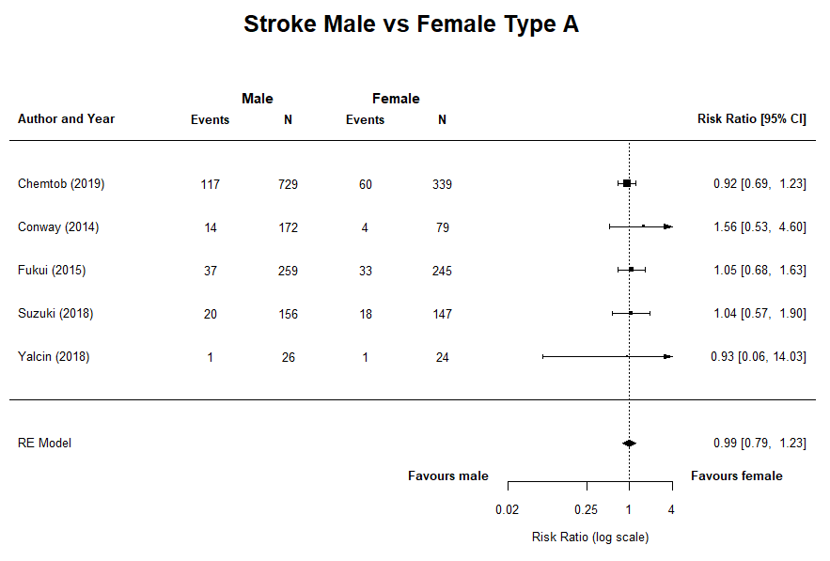
A

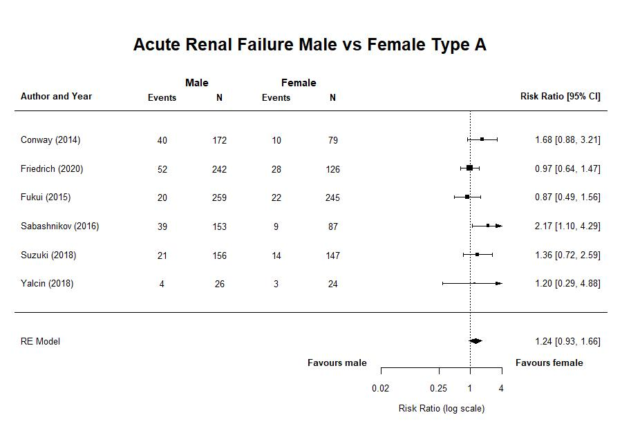
B

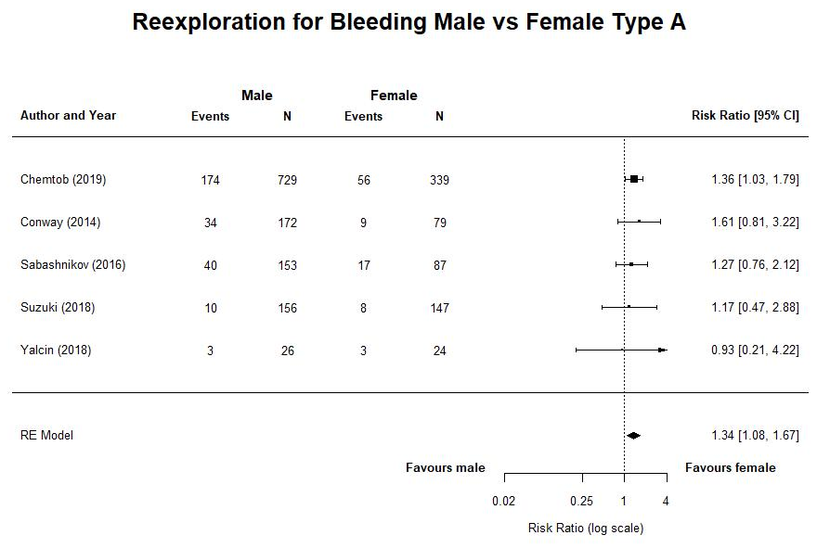
C
Appendix VII. Early outcomes of AD-A, AD-B, and AD patients
 | AD-A |  |  | AD-B |  |  | AD-A + AD-B
Variables | Males,  range | Females,  range | Studies | Males,  range | Females,  range | Studies | Males,  range | Females,  range | Studies
Early mortality, all % | 5.79-45.5 | 8.84-75.8 | 5,6,17,18,19,20,21,23,24,27 (2/10 F) | 3.82-12.2 | 7.93-14.4 | 5,27,25 (0/3) | - | - | -
Early mortality, surgical treatment % | 5.79-34.5 | 4.49-41.7 | 5,6,17,18,19,20,21,23,24,27(2/10 F) | 1.49-21.8 | 5.13-20.0 | 5,27 (0/2) | - | - | -
Early mortality, medical treatment % | 58.6-60.0 | 53.8- 91.3 | 6,27,20 (1/3 F) | 8.08 – 10.2 | 12.5-12.9 | 5,27 (0/2) | - | - | -
Length of hospital stay (mean days) | 7.35-24.1 | 5.83-21.5 | 20,17,18,19,21,23,24 (2/7 M + F) | 5 (2, 9 IQR) | 5 (2, 8 IQR) | 25 (1/1 M) | 13.5 | 13.6 | 26 (0/1)
Length of ICU stay (mean days) | 2.67-7.00 | 2.25-5.23 | 6,22,17,19,21,23,24  (1/7 M) | - | - | - | - | - | -
Stroke % | 3.85-15.0 | 4.17-16.1 | 5,19,20,21,23  (0/5) | 0.95 | 0.51 | 25 (1/1 M) | - | - | -
Acute renal failure % | 7.72-25.5 | 8.98-22.6 | 6,22,18,19,23,24 (2/6 M) | 23.8 | 15.7 | 25 (1/1 M) | 11.6-17.5 | 6.25-15.3 | 5,26,27 (1/3 M)
Paraplegia % | - | - | - | 1.73 | 0.89 | 25 (1/1 M) | 0.45 | 0.47 | 26 (0/1)
Limb ischemia % | 0.4 | 0.4 | 6 (0/1) | - | - | - | 10.2-10.9 | 6.65-7.29 | 5,27 (1/2 M)
Re-exploration for bleeding % | 6.41-26.1 | 5.44-19.5 | 22,17,18,23,24 (1/5 M) | - | - | - | - | - | -
Mediastinitis % | 1.74-4.25 | 0.68-2.04 | 6,18,23 (0/3) | - | - | - | - | - | -
Prolonged ventilation (>48h) % | 19.2-43.0 | 25.0-51.9 | 18,23,24 (0/3) | - | - | - | - | - | -
Cardiac event % | - | - | - | 10.4 | 12.3 | 25 (1/1 F) | - | - | -
Myocardial ischemia % | - | - | - | - | - | - | 6.84-9.02 | 8.38-8.53 | 5,26 (0/2)
Myocardial infarction % | 1.28 | 0.68 | 23 (0/1) | - | - | - | 4.64 | 4.34 | 5 (0/1)
Mesenteric ischemia/infarction % | 0.39 | 0.82 | 6 (0/1) | - | - | - | 5.05-11.8 | 4.17-4.91 | 5,27 (1/2 M)
Hypotension % | - | - | - | - | - | - | 17.4-22.4 | 14.6-30.9 | 5,27 (1/2 F)
Cardiac tamponade % | - | - | - | - | - | - | 4.93-9.70 | 12.5-15.0 | 5,27 (2/2 F)

The pooled percentages, range and studies used for pooling, are shown for each variable. “-“ indicates the variable was not reported in any of the included studies.

*The number of individual studies with a significant outcome comparing males with females can be found in brackets divided by the total number studies reporting statistically tested male-female differences, “F” indicates significantly more present or higher in females, “M” indicates significantly more present or higher in males. A P-value of <0.05 was considered significant in the in the individual studies.

The number of individual studies with a significant outcome comparing males with females can be found in brackets, with an “F” if it favours females and an “M” if it favours males. A P-value of <0.05 was considered significant in the in the individual studies.

Appendix VIII: Funnel plot and trim-and-fill analysis early mortality AD-A


