Supplementary Material
Table S1. The detailed search strategy
No | Search terms
#1 | sunitinib
#2 | pharmacokinetic
#3 | pharmacokinetics
#4 | PK
#5 | TDM
#6 | therapeutic drug monitoring
#7 | personalized dose adjustment
#8 | patient-specific
#9 | individualized
#10 | #1 AND (#2 OR #3 OR #4 OR #5 OR #6 OR #7 OR #8OR#9）

Table S2. Results of quality assessment by the Cochrane risk of bias tool (a) and Newcastle–Ottawa Scale (b).
- Quality assessment of a randomized controlled trial
Study | Random  Sequence  Generation  (Selection Bias) |  | Allocation  Concealment  (Selection Bias) |  | Blinding of  Participants  and Personnel  (Performance  Bias) |  | Blinding of Outcome  Assessment (Detection  Bias) |  | Incomplete Outcome Data Addressed  (Attrition Bias) |  | Selective Reporting (Reporting  Bias) |  | Other Bias
Bjarnason GA et al (2019) | Unclear |  | Low risk |  | High risk |  | Low risk |  | Low risk |  | Low risk |  | Unclear
- Quality assessment of nonrandomized studies
Study | Selection |  |  |  |  |  |  | Comparability |  | Outcome
Study | Represent-ativeness of the exposed  cohort | Selection  of the non-  exposed  cohort |  | Ascertain-ment of exposure |  | Demonstration that outcome of  interest was not  present at start of study |  | Comparability  of cohorts on the basis of the design or analysis |  | Assessment  of outcome |  | Was follow-up  Long enough  for outcomes  to ocur | Adequacy  of follow  up of cohorts
Noda S et al (2015) | 0 | ☆ |  | ☆ |  | ☆ |  | 0 |  | ☆ |  | ☆ | ☆ | 6
Lankheet NA et al (2014) | ☆ | ☆ |  | ☆ |  | ☆ |  | 0 |  | ☆ |  | 0 | 0 | 5
Bjarnason GA et al (2015) | ☆ | ☆ |  | ☆ |  | ☆ |  | 0 |  | ☆ |  | ☆ | ☆ | 7
Takasaki S et al (2018) | 0 | ☆ |  | ☆ |  | ☆ |  | 0 |  | ☆ |  | ☆ | ☆ | 6

Table S3. Checklist of items to include when reporting a systematic review.
Section/topic | # | Checklist item | Reported on page #
TITLE
Title | 1 | Identify the report as a systematic review, meta-analysis, or both. | P1
ABSTRACT
Structured summary | 2 | Provide a structured summary including, as applicable: background; objectives; data sources; study eligibility criteria, participants, and interventions; study appraisal and synthesis methods; results; limitations; conclusions and implications of key findings; systematic review registration number. | P2
INTRODUCTION
Rationale | 3 | Describe the rationale for the review in the context of what is already known.
Objectives | 4 | Provide an explicit statement of questions being addressed with reference to participants, interventions, comparisons, outcomes, and study design (PICOS). | P4
METHODS
Protocol and registration | 5 | Indicate if a review protocol exists, if and where it can be accessed (e.g., Web address), and, if available, provide registration information including registration number.
Eligibility criteria | 6 | Specify study characteristics (e.g., PICOS, length of follow-up) and report characteristics (e.g., years considered, language, publication status) used as criteria for eligibility, giving rationale. | P6
Information sources | 7 | Describe all information sources (e.g., databases with dates of coverage, contact with study authors to identify additional studies) in the search and date last searched. | P6
Search | 8 | Present full electronic search strategy for at least one database, including any limits used, such that it could be repeated. | P6

Study selection | 9 | State the process for selecting studies (i.e., screening, eligibility, included in systematic review, and, if applicable, included in the meta-analysis). | P6
Data collection process | 10 | Describe method of data extraction from reports (e.g., piloted forms, independently, in duplicate) and any processes for obtaining and confirming data from investigators.
Data items | 11 | List and define all variables for which data were sought (e.g., PICOS, funding sources) and any assumptions and simplifications made.
Risk of bias in individual studies | 12 | Describe methods used for assessing risk of bias of individual studies (including specification of whether this was done at the study or outcome level), and how this information is to be used in any data synthesis.
Summary measures | 13 | State the principal summary measures (e.g., risk ratio, difference in means).
Synthesis of results | 14 | Describe the methods of handling data and combining results of studies, if done, including measures of consistency (e.g., I²) for each meta-analysis.
Risk of bias across studies | 15 | Specify any assessment of risk of bias that may affect the cumulative evidence (e.g., publication bias, selective reporting within studies).
Additional analyses | 16 | Describe methods of additional analyses (e.g., sensitivity or subgroup analyses, meta-regression), if done, indicating which were pre-specified.

RESULTS
Study selection | 17 | Give numbers of studies screened, assessed for eligibility, and included in the review, with reasons for exclusions at each stage, ideally with a flow diagram. | P11
Study characteristics | 18 | For each study, present characteristics for which data were extracted (e.g., study size, PICOS, follow-up period) and provide the citations. | P11
Risk of bias within studies | 19 | Present data on risk of bias of each study and, if available, any outcome-level assessment (see Item 12). | P11-12
Results of individual studies | 20 | For all outcomes considered (benefits or harms), present, for each study: (a) simple summary data for each intervention group and (b) effect estimates and confidence intervals, ideally with a forest plot.
Synthesis of results | 21 | Present results of each meta-analysis done, including confidence intervals and measures of consistency.
Risk of bias across studies | 22 | Present results of any assessment of risk of bias across studies (see Item 15).
Additional analysis | 23 | Give results of additional analyses, if done (e.g., sensitivity or subgroup analyses, meta-regression [see Item 16]).

DISCUSSION
Summary of evidence | 24 | Summarize the main findings including the strength of evidence for each main outcome; consider their relevance to key groups (e.g., health care providers, users, and policy makers). | P13
Limitations | 25 | Discuss limitations at study and outcome level (e.g., risk of bias), and at review level (e.g., incomplete retrieval of identified research, reporting bias). | P13
Conclusions | 26 | Provide a general interpretation of the results in the context of other evidence, and implications for future research.

FUNDING
Funding | 27 | Describe sources of funding for the systematic review and other support (e.g., supply of data); role of funders for the systematic review. | P17

Table S4. CHEERS checklist—Items to include when reporting economic evaluations of health interventions.
Section/item | Item  no. | Recommendation | Reported on page no./ line no.
Title and abstract
Title | 1 | Identify the study as an economic evaluation, or use more specific terms such as ‘‘cost-effectiveness analysis’’ and describe the interventions compared. | P1
Abstract | 2 | Provide a structured summary of objectives, perspective, setting, methods (including study design and inputs), results (including base-case and uncertainty analyses), and conclusions. | P2
Introduction
Background and objectives | 3 | Provide an explicit statement of the broader context for the study. Present the study question and its relevance for health policy or practice decisions. | P3-P4
Methods
Target population and  subgroups | 4 | Describe characteristics of the base-case population and subgroups analyzed including why they were chosen. | P7
Setting and location | 5 | State relevant aspects of the system(s) in which the decision(s) need(s) to be made. | P7
Study perspective | 6 | Describe the perspective of the study and relate this to the costs being evaluated. | P8
Comparators | 7 | Describe the interventions or strategies being compared and state why they were chosen. | P7
Time horizon | 8 | State the time horizon(s) over which costs and consequences are being evaluated and say why appropriate. | P7
Discount rate | 9 | Report the choice of discount rate(s) used for costs and outcomes and say why appropriate. | P8
Choice of health outcomes | 10 | Describe what outcomes were used as the measure(s) of benefit in the evaluation and their relevance for the type of analysis performed. | P8
Measurement of effectiveness | 11a | Single study–based estimates: Describe fully the design features of the single effectiveness study and why the single study was a sufficient source of clinical effectiveness data. | P8
 | 11b | Synthesis-based estimates: Describe fully the methods used for the identification of included studies and synthesis of clinical effectiveness data.
Measurement and valuation of  preference-based outcomes | 12 | If applicable, describe the population and methods used to elicit preferences for outcomes. | P9
Estimating resources and costs | 13a | Single study–based economic evaluation: Describe approaches used to estimate resource use associated with the alternative interventions. Describe primary or secondary research methods for valuing each resource item in terms of its unit cost. Describe any adjustments made to approximate to opportunity costs
 | 13b | Model-based economic evaluation: Describe approaches and data sources used to estimate resource use associated with model health states. Describe primary or secondary research methods for valuing each resource item in terms of its unit cost. Describe any adjustments made to approximate to opportunity costs | P9
Currency, price date, and conversion | 14 | Report the dates of the estimated resource quantities and unit costs. Describe methods for adjusting estimated unit costs to the year of reported costs if necessary. Describe methods for converting costs into a common currency base and the exchange rate. | P10
Choice of model | 15 | Describe and give reasons for the specifific type of decision-analytic model used. Providing a fifigure to show model structure is strongly recommended. | P7
Assumptions | 16 | Describe all structural or other assumptions underpinning the decision-analytic model. | P7
Analytic methods | 17 | Describe all analytic methods supporting the evaluation. This could include methods for dealing with skewed, missing, or censored data; extrapolation methods; methods for pooling data; approaches to validate or make adjustments (e.g., half-cycle corrections) to a model; and methods for handling population heterogeneity and uncertainty. | P10
Results
Study parameters | 18 | Report the values, ranges, references, and if used, probability distributions for all parameters. Report reasons or sources for distributions used to represent uncertainty where appropriate. Providing a table to show the input values is strongly recommended. | Table 2 and Table 3
Incremental costs and outcomes | 19 | For each intervention, report mean values for the main categories of estimated costs and outcomes of interest, as well as mean differences between the comparator groups. If applicable, report incremental cost-effectiveness ratios. | P12
Characterizing uncertainty | 20a | Single study–based economic evaluation: Describe the effects of sampling uncertainty for estimated incremental cost, incremental effectiveness, and incremental cost-effectiveness, together with the impact of methodological assumptions (such as discount rate, study perspective).
 | 20b | Model-based economic evaluation: Describe the effects on the results of uncertainty for all input parameters, and uncertainty related to the structure of the model and assumptions. | P13
Characterizing heterogeneity | 21 | If applicable, report differences in costs, outcomes, or costeffectiveness that can be explained by variations between subgroups of patients with different baseline characteristics or other observed variability in effects that are not reducible by more information.
Discussion

Study fifindings, limitations,  generalizability, and current  knowledge | 22 | Summarize key study fifindings and describe how they support the conclusions reached. Discuss limitations and the generalizability of the fifindings and how the fifindings fifit with current knowledge. | P13-16
Other
Source of funding | 23 | Describe how the study was funded and the role of the funder in the identifification, design, conduct, and reporting of the analysis. Describe other nonmonetary sources of support. | P17
Conflicts of interest | 24 | Describe any potential for conflflict of interest among study contributors in accordance with journal policy. In the absence of a journal policy, we recommend authors comply with International Committee of Medical Journal Editors’ recommendations. | P17

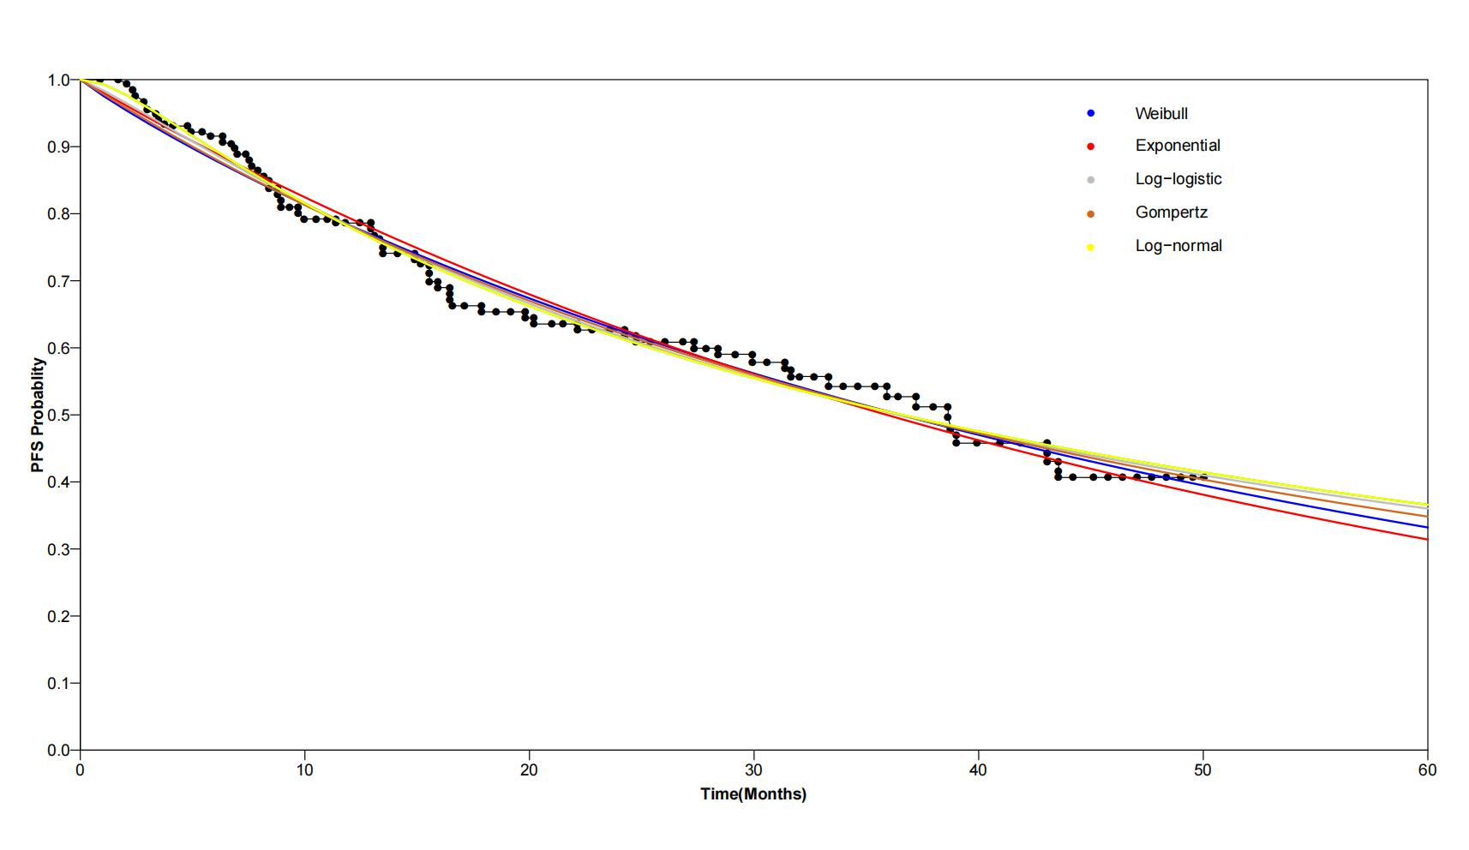
Fig S1. Model validation of overall survival (OS) in PK-guided group.
Fig S2. Model validation of overall survival (OS) in standard dose group.

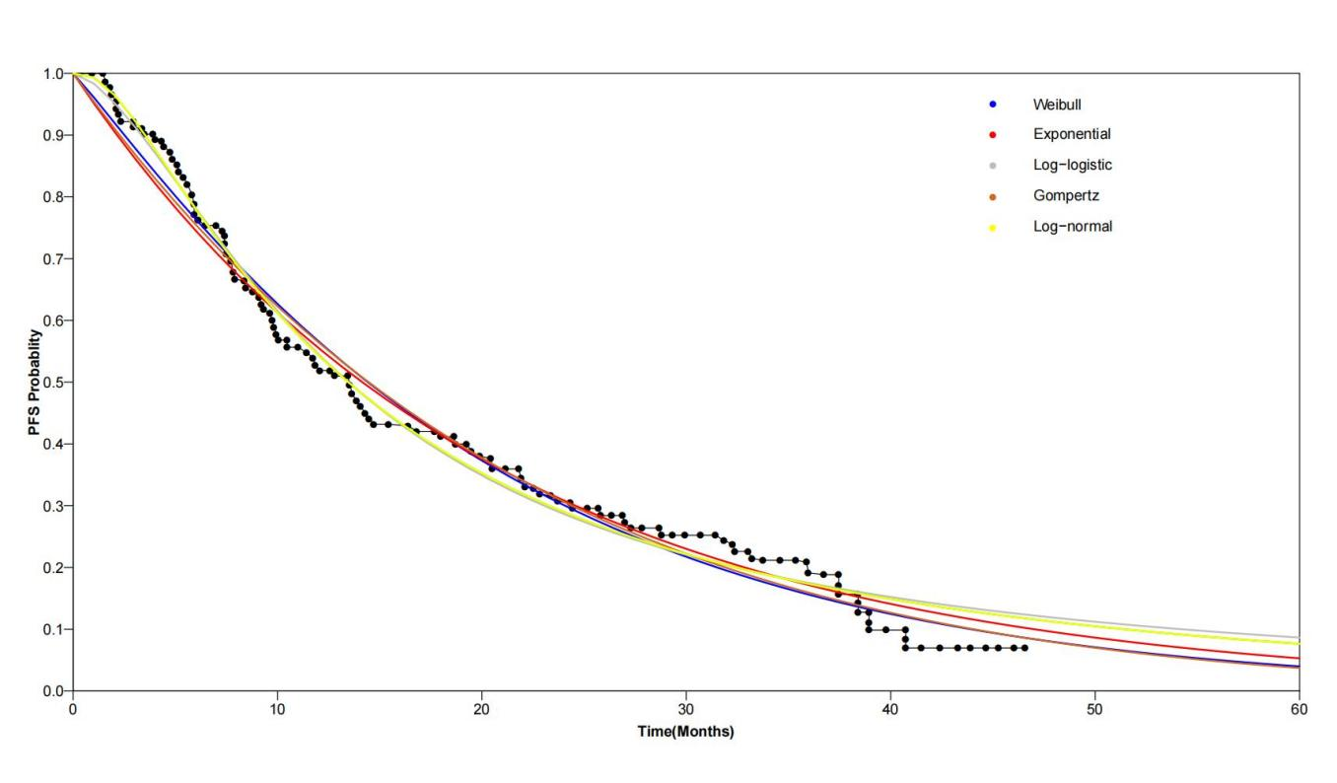
Fig S3. Model validation of progression free survival (PFS) in PK-guided gruop.
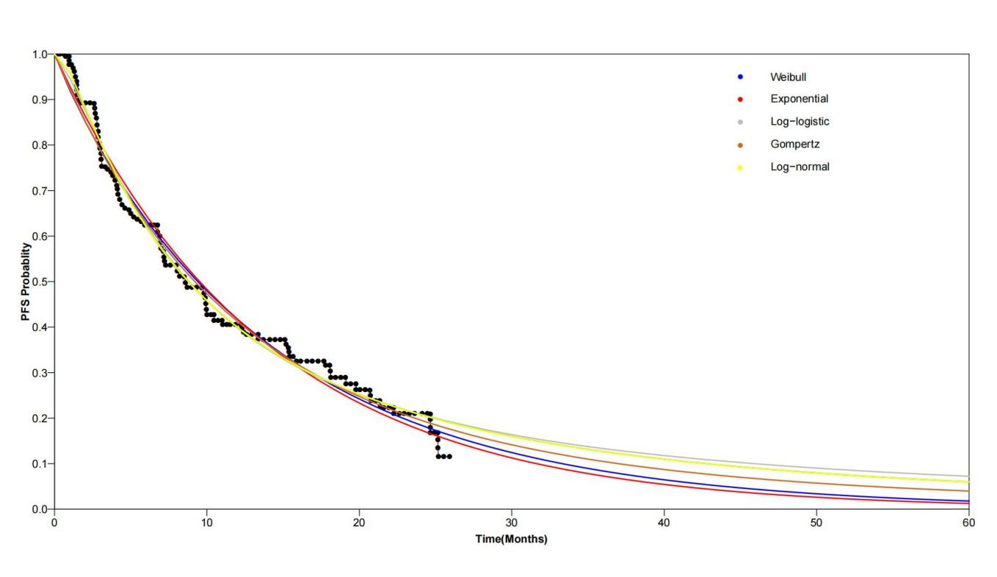
Fig S4. Model validation of progression free survival (PFS) in PK-guided gruop.

