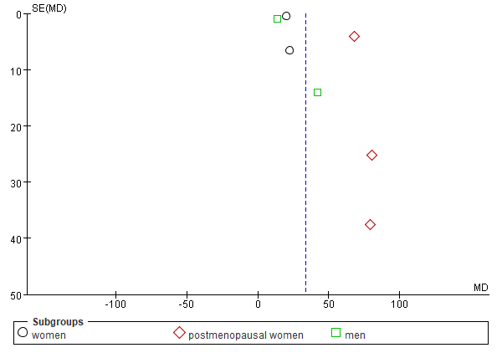 | 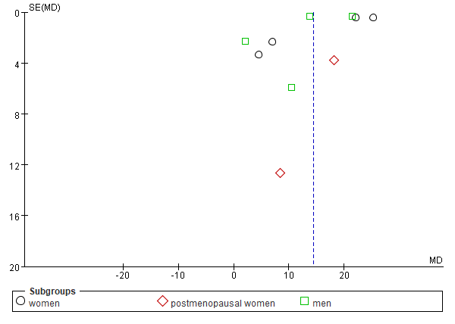
A | B
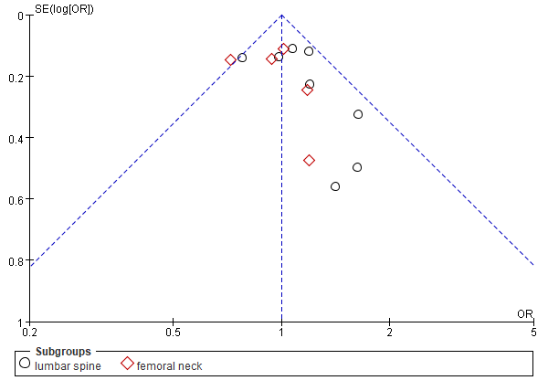 | 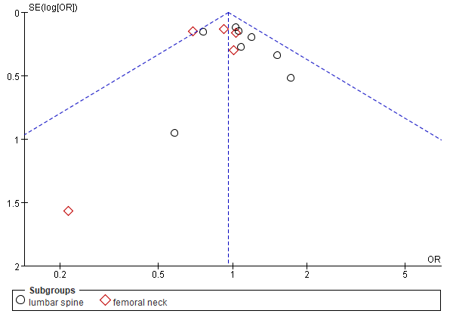
C | D
S_Figure 2
A: Funnel plot of coronary artery calcification score comparison between low bone mineral density and normal bone mineral density.
B: Funnel plot of bone mineral density difference in non- coronary artery calcification and coronary artery calcification.
C: Funnel plot of logistic regression analysis of the relationship between low bone mineral density in different locations and coronary artery calcification (age-adjusted).
D: Funnel plot of logistic regression analysis of the relationship between low BMD in different locations and coronary artery calcification (multivariable-adjusted).

