Supplementary data 2: PRISMA
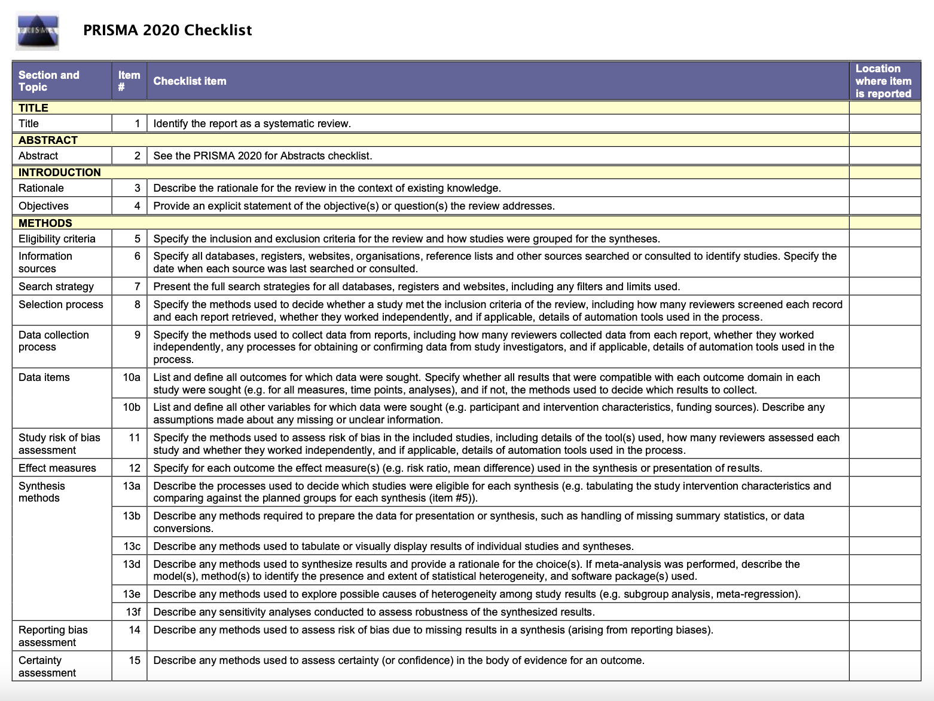
4
4-5
4-5
4-5
4-5
4-5
4-5
4-5
5
5
5
4-5
4-5
4
4
4
4
4
2
3

1
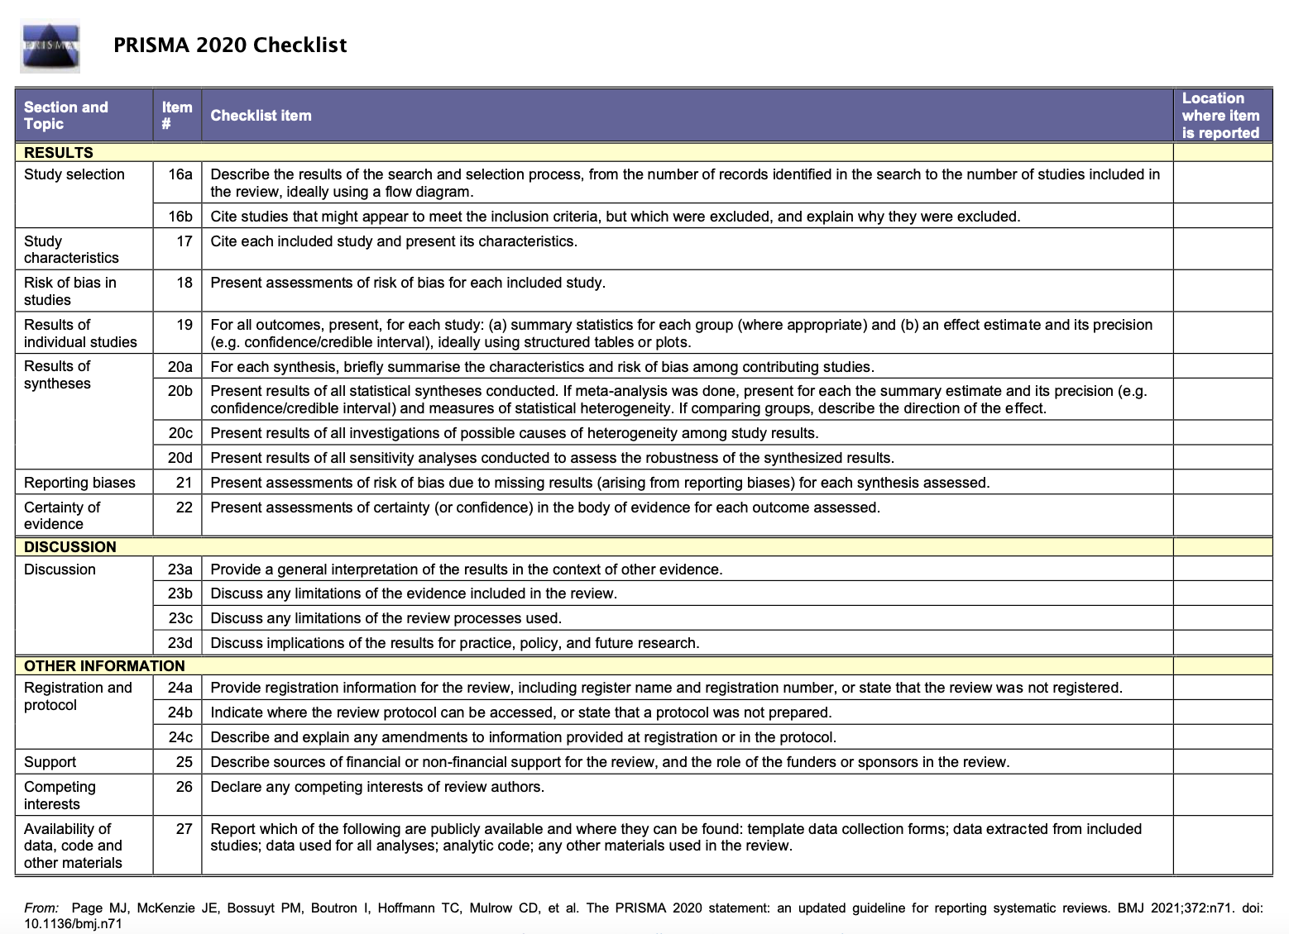
13
13
13
13
13
4
9-11
9-11
9-11
9-11
7-9
9
-
7-9
7-9
7-9
Fig.2
6
6
6
9

