Pubmed
(randomized controlled trial [Publication Type] OR randomized [Title/Abstract] OR placebo [Title/Abstract]) AND (("Exercise Movement Techniques"[Mesh]) OR (((Pilates-Based Exercises) OR (Exercises, Pilates-Based) OR (Pilates Based Exercises) OR (Pilates Training) OR (Training, Pilates)))) 2721

Embase
No. | Query | Results
#5 | #3 AND #4 | 524
#4 | 'randomized controlled trial'/exp OR 'controlled clinical trial'/exp OR 'randomized':ti,ab OR 'placebo':ti,ab OR 'drug therapy':lnk OR 'randomly':ti,ab OR 'trial':ti,ab OR 'groups':ti,ab | 7577677
#3 | #1 OR #2 | 976
#2 | 'movement techniques, exercise' OR 'exercise movement technics' OR 'pilates-based exercises' OR 'exercises, pilates-based' OR 'pilates based exercises' OR 'pilates training' OR 'training, pilates' | 139
#1 | 'pilates'/exp OR pilates | 975
Cochran

ID Search Hits
#1 (pilates):ti,ab,kw (Word variations have been searched) 610
#2 ((Pilates-Based Exercises) OR (Exercises, Pilates-Based) OR (Pilates Based Exercises) OR (Pilates Training) OR (Training, Pilates)):ti,ab,kw (Word variations have been searched) 355
#3 #1 OR #2 610

Web of science:
TS=(Pilates-Based Exercises OR Exercises, Pilates-Based OR Pilates Based Exercises OR Pilates Training OR Training, Pilates OR Pilates) AND TS=(randomized controlled trial OR randomized) 267

CNKI:
主题=普拉提 or 主题= Pilates or ( 题名= 普拉提 or 题名= Pilates) (精确匹配) 540
Supplementary eFigure 1 The search strategy in this review.

Non-RCTs
- Hagner-Derengowska, Magdalena, et al. "Effects of Nordic Walking and Pilates exercise programs on blood glucose and lipid profile in overweight and obese postmenopausal women in an experimental, nonrandomized, open-label, prospective controlled trial." Menopause, 2015; 22 (11): 1215-1223.
- Kim, Hyo-Jin, Jiyeon Kim, and Chang-Sun Kim. "The effects of pilates exercise on lipid metabolism and inflammatory cytokines mRNA expression in female undergraduates." Journal of exercise nutrition & biochemistry, 2014; 18 (3): 267.
- Suna, Gürhan, and Kenan Isildak. Investigation of the Effect of 8-Week Reformer Pilates Exercise on Flexibility, Heart Rate and Glucose Levels in Sedentary Women. Asian Journal of Education and Training, 2020; 6 (2): 226-230.
- Zandi, Sara, Saeedeh Shadmehri, and Nasibe Kazemi. "The Effect of Pilates Training on Isoprostane, Fasting Glucose and Body Composition in Women with Breast Cancer." Report of Health Care, 2016; 2 (4): 26-33
- Hagner-Derengowska, Magdalena, Krystian Kałużny, and Jacek Budzyński. "Effects of Nordic Walking and Pilates training programs on aminotransferase activity in overweight and obese elderly women." Journal of Education, Health and Sport, 2015; 5 (12): 563-580.
Without full-text
- Salem, Leyla, Bahram Abedi, and Mojtaba Khansooz. "The Effect of Six-weeks Pilates Exercise and Cumin Extract Consumption on Lipid Profile and Insulin Resistance Index in Obese and Overweight Women." Health and Development Journal, 2018; 7 (4): 295-304.
- BUTTELLI, Adriana Cristine Koch, et al. "PILATES TRAINING IMPROVES AEROBIC CAPACITY, BUT NOT LIPID OR LIPOPROTEIN LEVELS IN ELDERLY WOMEN WITH DYSLIPIDEMIA: A CONTROLLED TRIAL." Journal of Bodywork and Movement Therapies (2020).
- Erkal ARSLANOĞLU, Ömer ŞENEL. Effects Of Pilates Training On Some Physiological Parameters And Cardiovascular Risk Factors Of Middle Aged Sedentary Women[J]. Ijssjournal Com, 2013.
Supplementary eFigure 2 Fifteen excluded studies according to the inclusion and exclusion criteria.
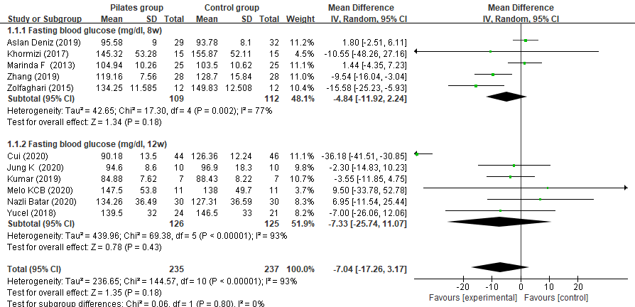
Supplementary eFigure 3 Meta‐analysis and forest plot and for fasting blood glucose at different intervention doses.

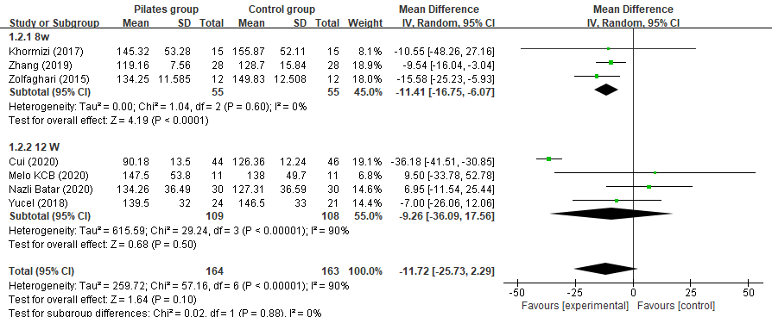
Supplementary eFigure 4 Meta‐analysis and forest plot and for fasting blood glucose at different intervention doses among diabetes patients.
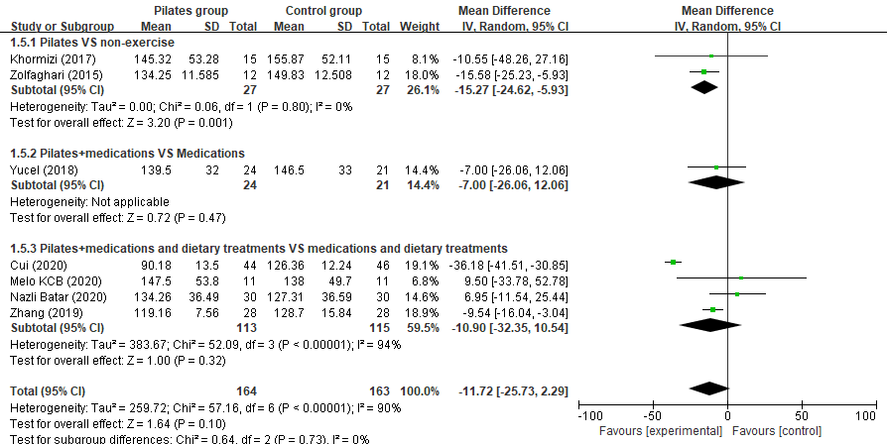
Supplementary eFigure 5 Meta‐analysis and forest plot and for fasting blood glucose in diabetes patients.
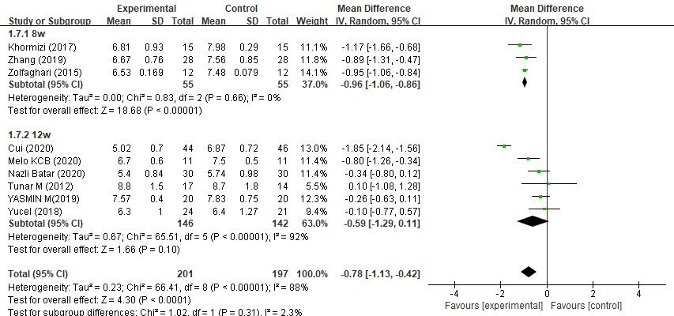
Supplementary eFigure 6 Meta‐analysis and forest plot and for HbA1c at different intervention doses among diabetes patients.

