Figures, tables, and additional files
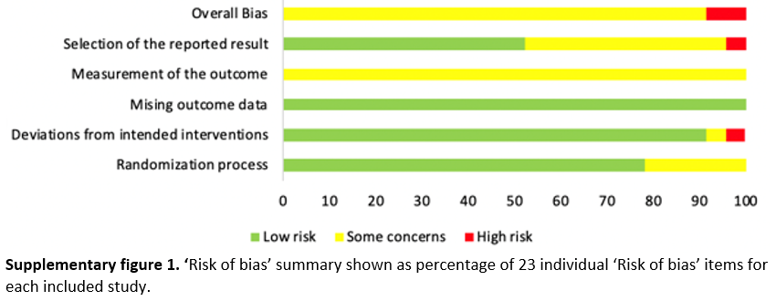

Supplementary table 1. Impact of covariates on recruitment and retention rates
Variable | k_RCTs | Recruitment rates proportion | 95% CI | Tau² | k_RCTs | Retention rates proportion | 95% CI | Tau²
 | 21 | 0.74 | 0.63, 0.86 | .061 | 22 | 0.90 | 0.86, 0.95 | .008
Participant characteristics | k_RCTs | Coefficient | 95% CI | Tau² | k_RCTs | Coefficient | 95% CI | Tau²
Age (years) | 20 | 0.01 | -0.01, 0.02 | .065 | 21 | -0.01 | -0.01, 0.01 | .006
Proportion of women | 20 | -0.01 | -0.01, 0.01 | .067 | 21 | -0.01 | -0.01, 0.01 | .008
BMI (kilogram) | 18 | -0.04 | -0.09, 0.02 | .063 | 19 | 0.01 | -0.02, 0.02 | .009
Low SES (no vs. yes) | 12 | -0.13 | -0.53, 0.27 | .070 | 13 | -0.04 | -0.21, 0.13 | .011
Proportion of people with hypertension | 14 | 0.01 | -0.01, 0.01 | .048 | 15 | -0.01 | -0.01, -0.01 | .006
Proportion of people with type 2 diabetes mellitus | 15 | -0.01 | -0.01, 0.01 | .075 | 15 | -0.01 | -0.01, -0.01 | .006
Proportion of people with depression | 13 | 0.01 | -0.01, 0.01 | .070 | 14 | 0.01 | -0.01, 0.01 | .004
Depression disease severity | 11 | -0.05 | -0.17, 0.08 | .078 | 12 | -0.01 | -0.04, 0.02 | .004
Proportion of people with heart failure | 15 | -0.01 | -0.01, 0.01 | .072 | 17 | 0.01 | 0.01, 0.01 | .002
Intervention/comparator characteristics
Type of intervention used:  - Aerobic vs. tai chi  - Aerobic vs. mixed | 21 | -0.05  -0.04 | -0.50, 0.39  -0.31, 0.23 | .070 | 22 | -0.13  0.01 | -0.28, 0.02  -0.07, 0.09 | .006
Type of comparator used:  - Usual care vs. education  - Usual care vs. others | 21 | 0.01  -0.17 | -0.28, 0.30  -0.43, 0.09 | .060 | 22 | -0.04  -0.04 | -0.15, 0.08  -0.14, 0.06 | .008
Frequency of intervention sessions | 20 | -0.01 | -0.10, 0.08 | .067 | 21 | 0.01 | -0.03, 0.04 | .007
Mode of delivery:  - 1 to 1 vs. group-based  - 1 to 1 vs. self-help | 19 | -0.09  0.06 | -0.40, 0.22  -0.29, 0.41 | .067 | 19 | -0.07  -0.01 | -0.18, 0.03  -0.12, 0.11 | .007
Intervention setting used:  - Home vs. clinic  - Home vs. combination | 20 | -0.03  0.07 | -0.29, 0.24  -0.38, 0.52 | .071 | 20 | -0.06  -0.14 | -0.15, 0.03  -0.29, 0.01 | .007
Length of intervention (weeks) | 21 | 0.01 | -0.01, 0.01 | .064 | 22 | 0.01 | -0.01, 0.01 | .009
Supervision (supervised vs. partially supervised) | 21 | -0.05 | -0.28, 0.19 | .064 | 22 | -0.01 | -0.11, 0.08 | .009
Adherence to intervention (number of sessions attended of total number of sessions available) | n/a |  |  |  | 13 | -0.01 | -0.01, 0.01 | .010
Session intensity (low to moderate vs. moderate) | 20 | -0.01 | -0.28, 0.26 | .068 | 20 | 0.03 | -0.08, 0.14 | .009
Study characteristics
Size of included studies (people randomised) | n/a |  |  |  | 22 | -0.01 | -0.01, 0.01 | .007
Recruitment setting (hospital vs. outpatient) | 19 | -0.10 | -0.33, 0.12 | .049 | 19 | -0.08 | -0.17, 0.02 | .008
Recruitment strategy approach (direct or indirect vs. combination) | 15 | 0.01 | -0.27, 0.28 | .058 | 16 | 0.02 | -0.10, 0.14 | .011
Recruitment length (months) | 18 | -0.01 | -0.01, 0.01 | .049 | 18 | -0.01 | -0.01, 0.01 | .010
Reason for dropout (no vs. yes) | n/a |  |  |  | 22 | 0.02 | -0.08, 0.11 | .009
Risk of bias (low* vs. some concerns or high) | 21 | 0.03 | -0.21, 0.26 | .064 | 22 | -0.02 | -0.11, 0.07 | .009
Type of outcome assessment (only objectively measured vs. only patient-reported outcomes) | n/a |  |  |  | 10 | 0.12 | -0.02, 0.25 | .006
Number of people assessed for eligibility | 21 | -0.01 | -0.01, 0.01 | .062 | n/a
Number of people assessed for eligibility in person | 11 | 0.01 | -0.01, 0.01 | .042 | n/a
Pre-screening of people (no vs. yes) | 13 | -0.08 | -0.42, 0.25 | .062 | n/a
k_RCTs (number of randomised controlled trails), recruitment rates proportion (proportion of people randomised/proportion of people eligible), retention rates proportion (proportion of people providing the outcomes of interest/proportion randomised), 95% CI (95% Confidence Interval), Tau² (between study variation), coefficient (overall percentage of recruitment or retention rate proportion), BMI (Body mass index), low SES (when majority of people are described as having low education levels, low income, being unemployed or sample otherwise labelled as `low SES`), vs. (versus), n/a (not applicable), *Since people enrolled in exercise trials cannot be blinded to the exercise interventions, studies with Low risk of Bias are the studies judged as Low Risk of Bias in all domains but ´measurement of the outcome´. Studies judged as some concerns have been judged at Some ´Concerns for at least one more item then ´measurement of the outcome´

Supplementary table 2. Impact of covariates on differential retention rates
Variable | n_observations | Differential retention rates proportion | 95% CI | Tau²
 | 26 | -0.01 | -0.05, 0.03 | .0035
Intervention/comparator characteristics | n_observations | Coefficient | 95% CI | Tau²
Type of comparator used:  - Usual care vs. education  - Usual care vs. others | 26 | 0.01  0.01 | -0.11, 0.12  -0.08, 0.10 | .0040
Type of intervention used:  - Aerobic vs tai chi  - Aerobic vs. mixed | 26 | -0.06  -0.02 | -0.21, 0.09  -0.06, 0.02 | 0
Difference in number of sessions between intervention and comparison groups | 22 | 0.01 | -0.01, 0.01 | .0039
Intervention mode of delivery:  - 1 to 1 vs. group-based  - 1 to 1 vs. self-help | 22 | -0.07  0.01 | -0.16, 0.03  -0.09, 0.11 | .0030
Intervention setting:  - Home vs. clinic  - Home vs. combination | 23 | -0.06  -0.02 | -0.15, 0.03  -0.15, 0.12 | .0039
Intervention supervision:  Supervised vs partially supervised | 26 | 0.03 | -0.05, 0.10 | .0036
n_observations (number of observations), differential retention rates proportion (difference in proportion of people providing physical and/or psychosocial outcomes in the intervention and comparator group), 95% CI (95% Confidence Interval), Tau² (between study variation), coefficient (overall percentage of differential retention rate proportion), vs. (versus)



