Supplementary Table 1. Search strategies determined until June 2021

PubMed | Queries | Items
#1 | atrial fibrillation | 90,940
#2 | atrial flutter | 9,822
#3 | #1 OR #2 | 94,436
#4 | non-vitamin K antagonist oral anticoagulants | 1,422
#5 | direct oral anticoagulants | 7,042
#6 | NOACs | 1,918
#7 | DOACs | 2,187
#8 | dabigatran | 5,892
#9 | rivaroxaban | 6,628
#10 | apixaban | 4,302
#11 | edoxaban | 1,791
#12 | #4 OR #5 OR #6 OR #7……OR #11 | 16,263
#13 | vitamin K antagonists | 9,199
#14 | warfarin | 31,591
#15 | coumadin | 32,060
#16 | phenprocoumon | 1,324
#17 | acenocoumarol | 1,735
#18 | #13 OR #14 OR #15 OR #16 OR #17 OR #18 | 40,648
#19 | #3 AND #12 AND #18 | 4,984
EMBASE
#1 | 'atrial fibrillation':ab,ti | 135,459
#2 | 'atrial flutter':ab,ti | 9,549
#3 | #1 OR #2 | 139,988
#4 | 'non-vitamin K antagonist oral anticoagulants':ab,ti | 1301
#5 | 'direct oral anticoagulants':ab,ti | 5628
#6 | 'NOACs':ab,ti | 3810
#7 | 'DOACs':ab,ti | 4107
#8 | 'dabigatran':ab,ti | 10124
#9 | 'rivaroxaban':ab,ti | 11742
#10 | 'apixaban':ab,ti | 7829
#11 | 'edoxaban':ab,ti | 2730
#12 | #4 OR #5 OR #6 OR #7……OR #11 | 25303
#13 | 'vitamin K antagonists':ab,ti | 7327
#14 | 'warfarin':ab,ti | 41615
#15 | 'coumadin':ab,ti | 2145
#16 | 'phenprocoumon':ab,ti | 1391
#17 | 'acenocoumarol':ab,ti | 1554
#18 | #13 OR #14 OR #15 OR #16 OR #17 OR #18 | 50904
#19 | #3 AND #12 AND #18 | 7002

Supplemental Table 2. RRs and 95% CIs of fracture risks between DOACs versus VKAs in AF patients.

 | No. of reports | RRs and 95% CIs | P_{interaction}
Any fracture
DOACs | 10 | 0.80 [0.70, 0.91] | -
DOAC types |  |  | 0.16
Dabigatran | 5 | 0.90 [0.80, 1.01] | 0.16
Rivaroxaban | 4 | 0.73 [0.61, 0.88] | 0.16
Apixaban | 3 | 0.75 [0.60, 0.92] | 0.16
Edoxaban | 2 | 0.89 [0.77, 1.03] | 0.16
Fracture position
Hip/pelvic fracture | 6 | 0.88 [0.79, 0.97] | 0.03
Osteoporotic fracture | 3 | 0.63 [0.47, 0.84] | 0.03
Gender
Males | 5 | 0.79 [0.67, 0.92] | 0.48
Females | 5 | 0.71 [0.57, 0.89] | 0.48
Follow-up time
≥1 year | 6 | 0.76 [0.63, 0.91] | 0.84
< 1 year | 2 | 0.73 [0.48, 1.10] | 0.84

AF=atrial fibrillation; DOACs=direct oral anticoagulants; VKAs=vitamin K antagonists; RR=risk ratio; CI=confidence interval.

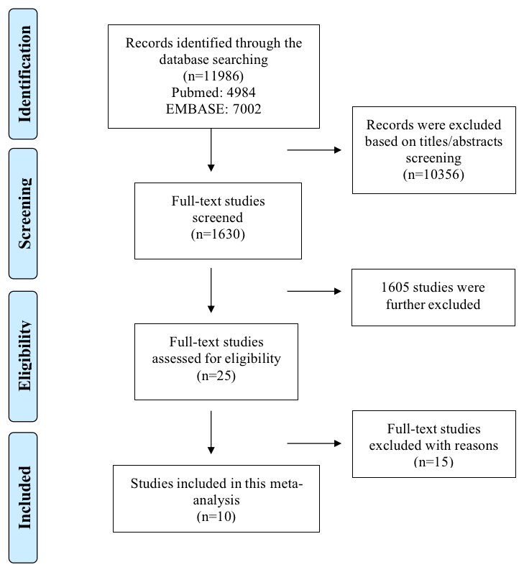
Supplemental Figure 1. The process of electronic retrievals in this meta-analysis

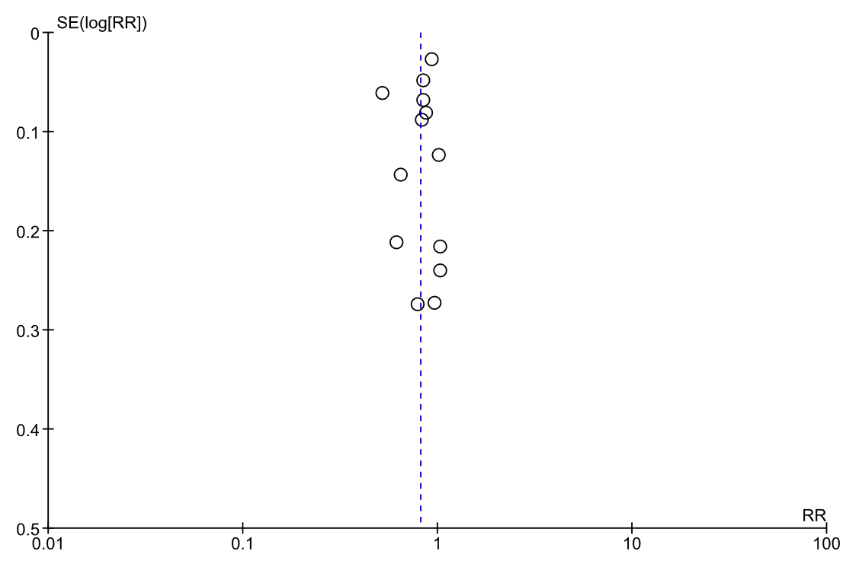
Supplemental Figure 2. Funnel plots of all the included studies.
Abbreviations: RR= risk ratio; SE=standard error.

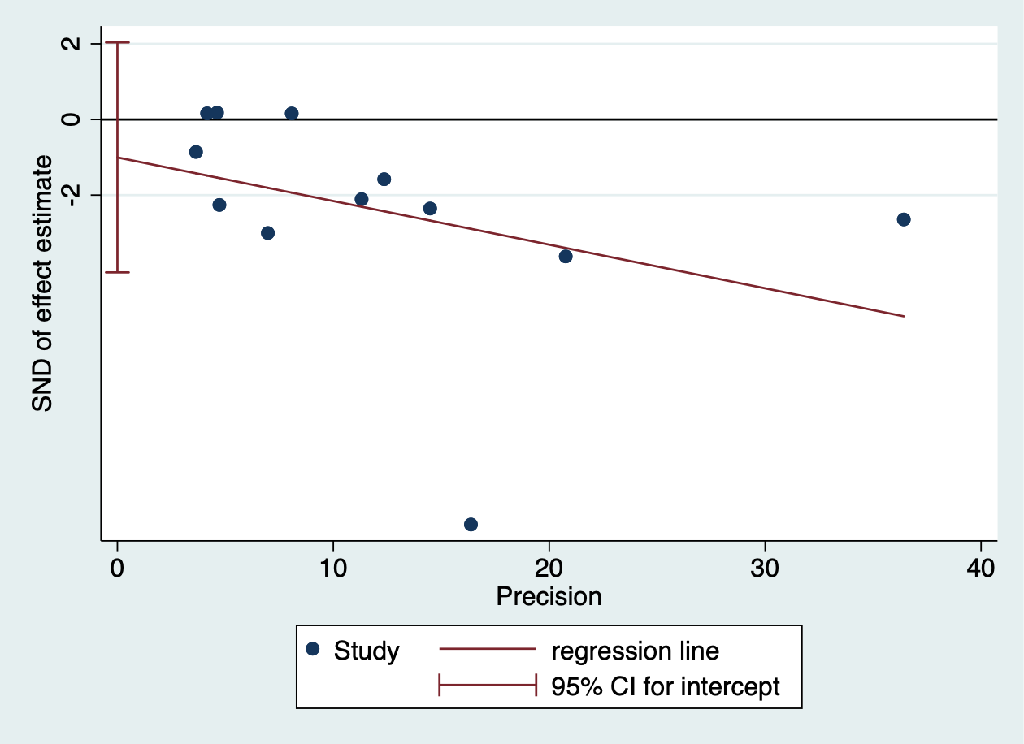
Supplemental Figure 3. Egger’s plots of all the included studies.

