Additional file 7

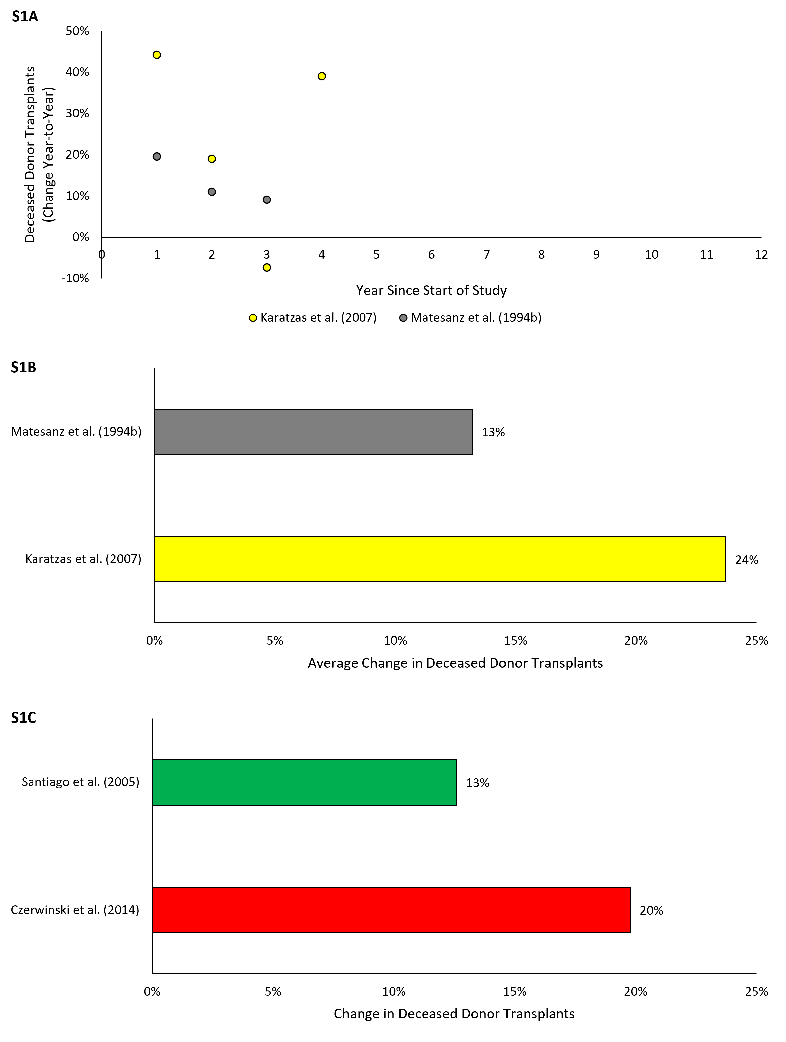
Figure S1. Percent change in deceased donor transplants for interrupted time series (S1A-B) and before-and-after (S1C) studies. Figure S1A reflects the average relative year-to-year increase in organ deceased donor transplants over the course of the study. Figure S1B reflects average relative change year-over-year of the time series data presented in Figure S1A. Figure S1C reflects the percent change in deceased donor transplants following the intervention.

