Additional file 8

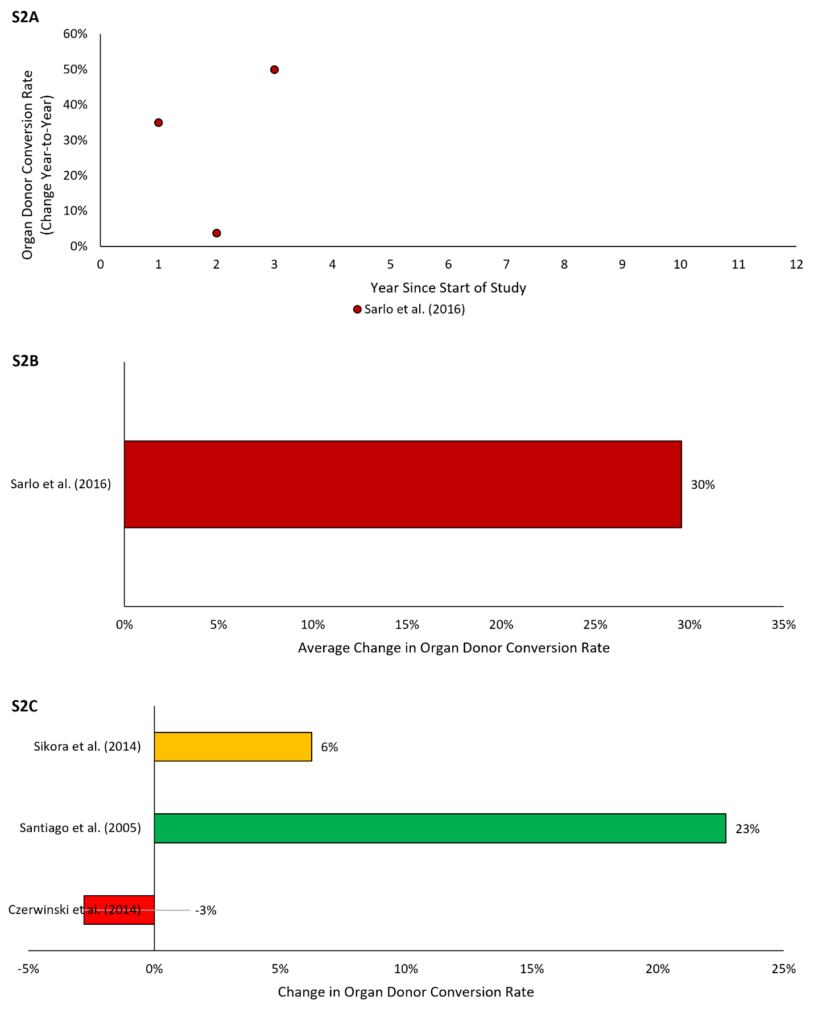

Figure S2. Percent change in organ donor conversion rate for interrupted time series (S2A-B) and before-and-after (S2C) studies. Figure S2A reflects the average relative year-to-year increase in organ donor conversion rate over the course of the study. Figure S2B reflects average relative change year-over-year of the time series data presented in Figure S2A. Figure S2C reflects the percent change in organ donor conversion rate following the intervention

