The effectiveness of rehabilitation interventions including outdoor mobility on older adults physical activity, endurance, outdoor mobility, and falls-related self-efficacy: systematic review and meta-analysis

Supplementary Files
Contents
Supplementary File 1: Search strategies 2
Supplementary File 2: Forest plots for meta-analyses 8
Supplementary File 3: Results for randomized controlled trials not included in meta-analyses 12

Supplementary File 1: Search strategies

MEDLINE and EMBASE Search strategy (Ovid SP Interface)

1. exp Aged/ or Middle Aged/
2. older people.mp.
3. geriatr*.mp.
4. (advanced years or elder* or elderly or gerontolog* or later life or old age or oldest old or pensioner* or post menopausal or post menopausal or senior or seniors)
5. (old* NEAR3 adult* or female* or male* or men or people or person or women))
6. ((65 year* or "over 65" or "over 70" or "over 75" or "over 80" or "over 85" or 85 year*))
7. ((aged or aging or ageing or elder* or geriatric* or gerontolog*))
8. 1 or 2 or 3 or 4 or 5 or 6 or 7
9. exp walking/ or locomotion/ or gait/ or kinesiotherapy/ or patient mobility/
10. (ambulat$ or ambulant or walk$ or locomot$ or gait$ or mobil$ or participat$).tw.
11. 9 or 10
12. (social$ or communit$ or outdoor$ or outside or house or home or dwell$ or neighbourhood$ or neighborhood$).tw.
13. (social$ adj5 (participat$ or interact$)).tw.
14. 12 or 13
15. exp rehabilitation
16. (occupational therap$ or physiotherap$ or physical therap$).tw.
17. Rehabilitation/ or Early Ambulation/ or exp Exercise Therapy/ or Occupational Therapy/ or Rehabilitation, Vocational/
18. 15 or 16 or 17
19. 11 or 18
20. 19 AND 14
21. randomized controlled trial/
22. controlled clinical trial/
23. randomization/
24. clinical trial/
25. control group/
26. single blind procedure/
27. placebo/
28. placebo effect/
29. crossover procedure/
30. multicenter study/
31. 21 or 22 or 23 or 24 or 25 or 26 or 27 or 28 or 29 or 30
32. random$.tw.
33. (controlled adj5 (trial$ or stud$)).tw.
34. (clinical$ adj5 trial$).tw.
35. ((control or treatment or experiment$ or intervention) adj5 (group$ or subject$ or patient$)).tw.
36. (quasi-random$ or quasi random$ or pseudo-random$ or pseudo random$).tw.
37. ((multicenter or multicentre or therapeutic) adj5 (trial$ or stud$)).tw.
38. ((control or experiment$ or conservative) adj5 (treatment or therapy or procedure or manage$)).tw.
39. (cross-over or cross over or crossover).tw.
40. placebo$.tw.
41. ((doubl$ or singl$) adj blind$).tw.
42. (allocat$ or volunteer$ or assign$).tw.
43. (coin adj5 (flip or flipped or toss$)).tw.
44. Versus.tw.
45. (assign$ or alternate or allocat$ or counterbalance$ or multiple baseline).tw.
46. Controls.tw.
47.31 or 32 or 33 or 34 or 35 or 36 or 37 or 38 or 39 or 40 or 41 or 42 or 43 or 44 or 45 or 46
48. 8 AND 20 AND 47
49. Health Facilities/ or Ambulatory Care Facilities/ or Community Health Centres/ or Outpatient Clinics/ or Rehabilitation Centres.mp.
50. Community Health Services/ or Community Health Nursing/ or Counselling/ or Home Care Services/ or Health Services For The Aged/ or Social Work/ or exp Nursing Care/ or Home Care Services/
51. Community based/ or home-based rehabilitation/
52. 49 OR 50 OR 51
53. 48 AND 52

Limits
- Limit (above) to (humans and english language)
- Additional Limits: Over 65, Limit year to 2010 to present

CINAHL Search Strategy (EBSCOhost interface):
- (MH "Aged+")
- (MH "Geriatrics")
- TI ( (elderly or ageing or aging or aged or geriatric* or senior* or “old age” or “late* life” or “elder* care”) ) OR AB ( (elderly or ageing or aging or aged or geriatric* or senior* or “old age” or “late* life” or “elder* care”) )
- TI ( ("65 year*" or "over 65" or "over 70" or "over 75" or "over 80" or "over 85" or "85 year*") ) OR AB ( ("65 year*" or "over 65" or "over 70" or "over 75" or "over 80" or "over 85" or "85 year*") )
- (MH “Frail Elderly”)
- AB ("community dwell*" (elder* or geriatric or Old* or senior))
- TI (geriatric patient*) OR AB (geriatric patient*)
- TI ( (older adult* or older person* or older people or older patient*) ) AND AB ( (older adult* or older person* or older people or older patient*) )
- (MH "Health Services for the Aged")
- TI ( (geriatric* or elder* or senior) AND (care or health service* or healthcare) ) AND AB ( (geriatric* or elder* or senior) AND (care or health service* or healthcare) )
- 1 OR 2 OR 3 OR 4 OR 5 OR 6 OR 7 OR 8 OR 9 OR 10
- (MH "Rehabilitation+")
- MH (geriatric or inter* or multi* or early or post* or home* or intensive or intervention or functional N2 intervention or care or rehabilitation or program* or approach or group or recovery)
- AB (Geriatric rehab* or Home rehab* or Community-based rehab* or Functional rehab*)
- AB (“Mobility Therapy”) OR (“Occupational therapy”) OR (“Physical Therapy”)
- 12 OR 13 OR 14 OR 15
- (MH "Walking+") OR (MH "Gait+") OR (MH "Locomotion") OR (MH "Therapeutic Exercise") OR (MH "Gait Disorders, Neurologic+")
- TI (ambulat* or ambulant or walk* or locomot* or gait* or mobil* or participat*) AND AB ( ambulat* or ambulant or walk* or locomot*or gait* or mobil* or participat* )
- 17 OR 18
- (MH "Social Participation")
- TI (social* or communit* or outdoor* or outside or house* or home* or dwell* or neighbourhood* or neighborhood* ) AND AB ( social*or communit* or outdoor* or outside or house* or home* or dwell* or neighbourhood* or neighborhood* )
- 20 OR 21
- 16 AND 19 AND 22
- (MH "Randomized Controlled Trials") OR (MH "Clinical Trials")
- TX randomly
- AB trial
- AB placebo
- AB "double‐blind*"
- AB groups
- 24 OR 25 OR 26 OR 27 OR 28 OR 29
- 11 AND 23 AND 30
Limits
- Humans
- Exclude MEDLINE records
- English language
Open Grey Search terms (Available at http://www.opengrey.eu/):

- Older adults
- Geriatri*
- Outdoor mobility
- Exercise Therapy*
- Community rehab*
- Randomised control trials

PEDro Search Strategy (Available at https://pedro.org.au/):

Abstract/ Title: Outdoor mobility, exercise therapy*, community ambulation, outdoor ambulation, ambulation, outdoor walking, outdoor* (Search individually)
Subdiscipline: Gerontology
Method: Clinical trial

Supplementary File 2: Forest plots for meta-analyses

Figure S1: The effectiveness of rehabilitation interventions incorporating outdoor mobility on physical activity at (a) intervention end and (b) 12-month follow up.
(a)
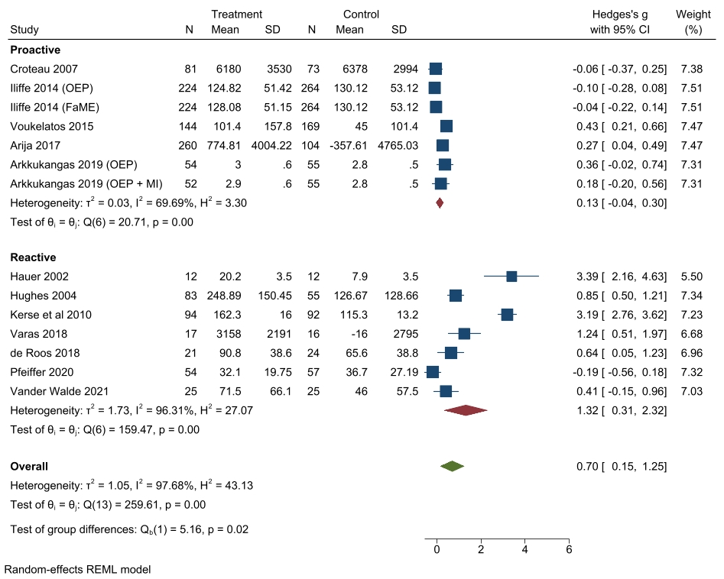
(b)
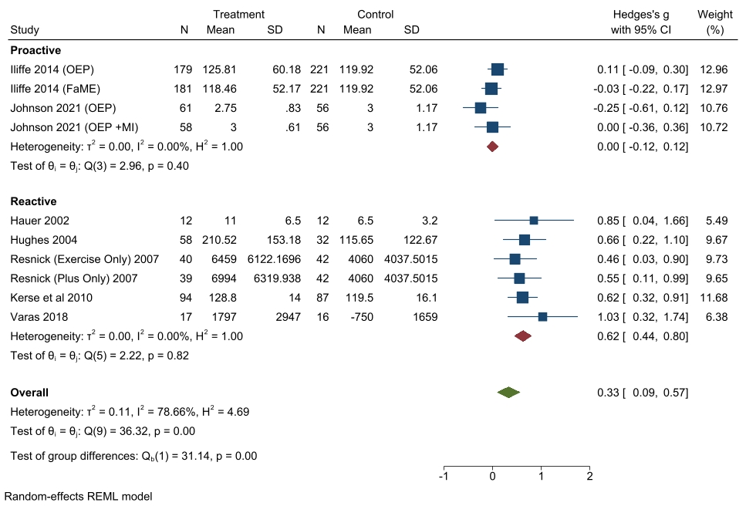

Figure S2: The effectiveness of rehabilitation interventions incorporating outdoor mobility on endurance at intervention end.
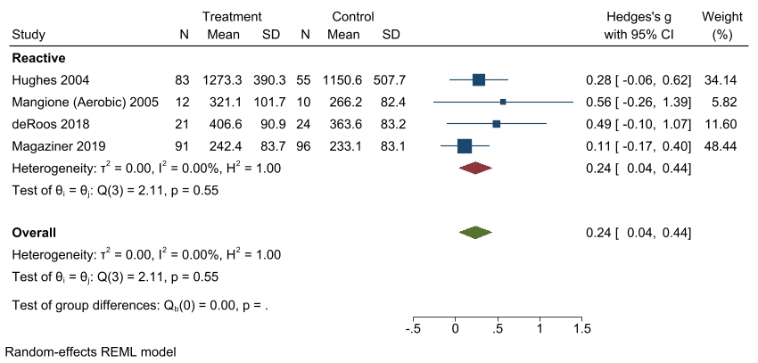

Figure S3: The effectiveness of reactive rehabilitation interventions incorporating outdoor mobility on outdoor mobility at (a) intervention end and (b) final follow up.
(a)
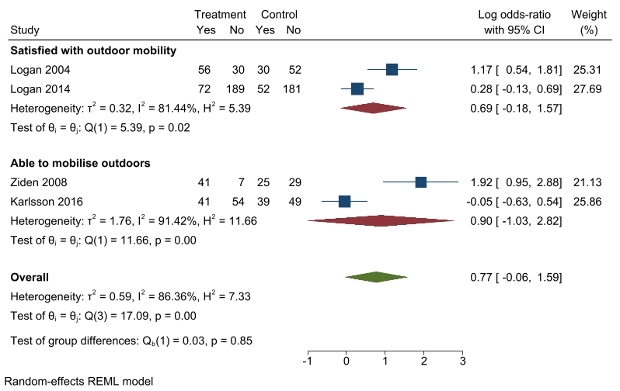
(b)
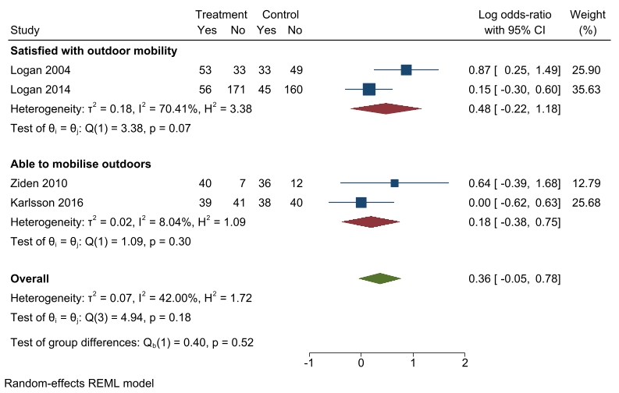
Figure S4: The effectiveness of rehabilitation interventions incorporating outdoor mobility on falls-related self-efficacy at (a) intervention end and (b) 24-month follow up.
(a)
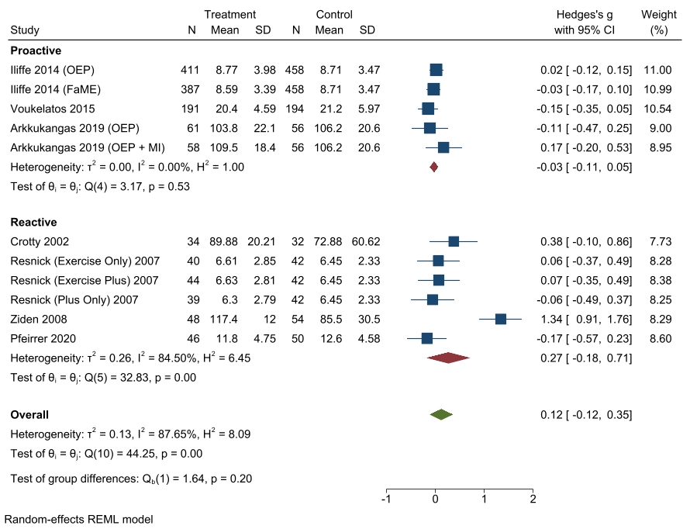
(b)
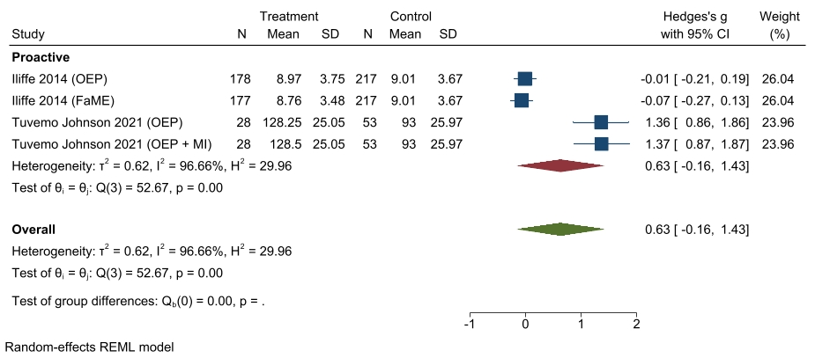

Supplementary File 3: Results for randomized controlled trials not included in meta-analyses

Proactive population
Author/year | Outcome | Outcome measure | Intervention | Control | Follow-up | Effect
Echeverria 2020 | Physical activity | Steps per day | mean (standard deviation (SD))  short term group: baseline 3342(2849)  intervention end 3859 (3439)  long term group: baseline 2722(2136)  intervention end 3630(2347) | N/A | Intervention end and 24-weeks after intervention end | No change (effect estimate not reported)  No change from intervention end to 24-weeks (effect estimate not reported)
Bae 2019 | Physical activity | Steps per day | mean difference (95% Confidence Interval (CI))  31.49 (-722.47, 785.47) | mean difference (95% CI)  -970.33 (-1688.20, -252.45) | Intervention end | No between group difference p>0.05
Bae 2019 | Physical activity | Minutes spent in moderate-to-vigorous activity measured by accelerometery | mean difference (95% CI)  -1.16 (-6.85, 4.52) | mean difference (95% CI)  -9.08 (-14.15, -3.65) | Intervention end | No between group difference p = 0.136
Kerr 2018 | Physical activity | Minutes spent in moderate-to-vigorous activity measured by accelerometery | mean (SD)  baseline: 31.74 (23.10)  3-months: 46.02 (34.23)  6-months: 40.59 (32.87)  9-months: 35.46 (26.34)  12-months: 37.45 (30.38) | mean (SD)  baseline: 24.12 (20.72)  3-months: 24.8 (21.94)  6-months: 23.78(18.08)  9-months: 22.52(18.32)  12months:23.21(30.38) | Intervention end | Intervention group increased moderate-t—vigorous activity compared to no change in the control group.  Between group difference sustained at 6-, 9-, and 12-month follow-up
Iliffe 2014 | Physical activity | Proportion of patients meeting target of ≥150 minutes spent in moderate-to-vigorous activity per week measured by Community Healthy Activities Model Program | Falls management exercise programme  Baseline: 41%  12-months:43% | Baseline: 37.5%  12-months: 38% | 12-months follow-up | p<0.001 favouring intervention
Iliffe 2014 | Physical activity | Proportion of patients meeting target of ≥150 minutes spent in moderate-to-vigorous activity per week measured by Community Healthy Activities Model Program | Otago exercise programme  Baseline: 40%  12-months:49% | Baseline: 37.5%  12-months: 38% | 12-months follow-up | No between group difference. p=0.22
Echeverria 2020 | Endurance | 6-minute walk test distance in metres | mean (SD)  short term group: baseline 324(135)  intervention end 372(118)  long term group:  baseline 321(117)  intervention end 383(110) | N/A | Intervention end and 24-weeks after intervention end | No between group difference. (Effect estimate not reported)  No change from intervention end to 24-weeks (effect estimate not reported)
Crist 2021 | Outdoor mobility | Total walking time in minutes/day in 4 mutually exclusive domains -home, campus, neighbourhood, beyond neighbourhood measured by GPS and accelerometery | mean (SD)  Baseline:  Home: 40.6 (34.5)  Campus:17.9 (21.1)  Neighbourhood: 9.4 (18.3)  Beyond neighbourhood: 13.5 (25.6) | mean (SD)  Baseline:  Home: 38.2 (29.6)  Campus:19.9 (22.7)  Neighbourhood: 5.6 (13.4)  Beyond neighbourhood: 8.1 (16.3) | Intervention end | Between group difference (effect estimate not reported)  Intervention:  Increase in daily walking time from baseline to 3 months by 21.48 minutes/day. Increase was observed for non-home domains at 3 months (linear regression coefficient =11.48, 95% CI: 1.7, 21.3).  Control:  No change in walk time (data provided graphically)
Bae 2019 | Outdoor mobility | Number of times went outdoors per day | Mean difference (95% CI)  0.78 (-0.19, 1.77) | Mean difference (95% CI)  0.18 (-0.75, 1.11) | Intervention end | No between group difference p = 0.178
Merom 2015 | Falls-related self-efficacy | Falls Efficacy Scale-International Short form dichotomized at the highest quartile for concern. | Baseline: 24.8% | Baseline :26.5% | 12-months | Falls-related self-efficacy did not moderate the intervention effect. Odds ratio 0.85 (95% Confidence Interval: 0.48; 1.57)
Boongird 2017 | Falls-related self-efficacy | Thai fall efficacy scale | Mean 24.7 | Mean: 27 | 6-months | Between group difference favouring intervention p = 0.003
Reactive population
Author/year | Outcome | Outcome measure | Intervention | Control | Follow-up | Effect
Lee 2007 | Physical activity | Self-reported walking frequency | %  Baseline:  >3 times/week: 31.4  0-3times/week:9.8  never:58.8  Change in self-reported level of walking:  Walking more: 51.6  No change: 46.2  Walking less: 2.2 | %  Baseline:  >3 times/week: 45.0  0-3times/week:9.0  never:46.0  Change in self-reported level of walking:  Walking more: 8.6  No change: 76.3  Walking less: 15.1 | Intervention end | Between group difference favouring the intervention (p<0.0005)
Orwig 2011 | Physical activity | Yale Physical Activity Scale measured in hours | N/A | N/A | 2 months, 6 months, 12 months | Between group difference favouring the intervention  2-months: who amounted 0.59 hours (95% CI 0.15 – 1.33) more physical activity than control  6-months: 0.77 hours (95% CI 0.03 – 1.50) more physical activity than control  12-months: 0.68 hours (95% CI 0.05 – 1.41) more physical activity than control
Clemson 2004 | Physical activity | Physical Activity Scale for the Elderly | mean difference (SD)  -13.48 (42.25) | mean difference (SD)  -4.40 (36.25) | 14-months | No between group difference p=0.06
Varas 2018 | Endurance | Endurance Shuttle Test distance in metres | Baseline mean (SD): 657 (573.8)  Intervention end mean difference (SD): 491.4 (486.5)  3-month follow-up mean difference (SD): 592.6 (595.6)  12-month follow-up mean difference (SD): 472 (576.6) | Baseline mean (SD): 678.7 (553.7)  Intervention end mean difference (SD): -70.3 (163.4)  3-month follow-up mean difference (SD): --57.3 (262.0)  12-month follow-up mean difference (SD): -152.4 (164.9) | Intervention end, 3nad 12 month follow-up | Between group difference favouring the intervention (p<0.000)
Hughes 2006 | Endurance | 6-minute walk test distance in metres | mean (SD)  Baseline: 1133.14 (400.91)  2-months: 1273.27 (390.30)  6-months: 1250.12 (464.25)  12-months: 1281.53 (502.93) | mean (SD)  Baseline: 1048.79 (379.88)  2-months: 1150.62 (507.70)  6-months: 1129.40 (564.74)  12-months:1106.29 (484.10) | Intervention end, 2 months, 6 months, 12months | No between group difference (effect estimate not provided)
Logan 2004 | Outdoor mobility | Outdoor journey count | mean (interquartile range)  4-months: 37 (18 - 62)  10-months: 42 (13 - 69) | mean (interquartile range)  4-months: 14 (5 - 34)  10-months: 14 (7-32) | 4-months, 10-months | Between group difference favouring the intervention (p<0.01)
Logan 2014 | Outdoor mobility | Likelihood to make an outdoor journey -travel journeys/day | mean (SD)  6-months: 1.1 (1.2)  12-months: 1.1 (1.3) | mean (SD)  6-months: 1.0 (1.0)  12-months: 1.0 (1.1) | 6-months, 12-months | Rate ratio 1.42 (95% CI: 1.14, 1.67)  Rate ratio 1.76 (95% CI: 1.36, 1.95)
Ziden 2010 | Falls-related self-efficacy | Swedish Version of the Falls Efficacy Scale | Median (min – max)  128 (61 - 130) | Median (min – max)  102 (13 - 130) | 12-months | p<0.01
Clemson 2004 | Falls-related self-efficacy | Modified Falls-Efficacy Scale | mean difference (SD)  -110 (19.6) | mean difference (SD)  0.63 (16.40) | 14-months | p>0.05
Pol 2019 | Falls-related self-efficacy | Falls Efficacy Scale International | mean (standard error (SE))  1-month:  OT coach: 25.8 (1.18)  OT coach and sensor: 24.78 (1.04)  4-months:  OT coach: 22.77 (1.26)  OT coach and sensor: 21.75 (1.17)  6-months:  OT coach: 23.85 (1.28)  OT coach and sensor: 22.83 (1.17) | mean (SE)  1-month:  27.11 (1.32)  4-months:  24.08 (1.39)  6-months:  25.16 (1.38) | 1 month, 4-months, 6-months | No between group difference p>0.05

