Appendix 1 searching strategy
1. population/ or region.tw. or regional.tw. or population based.tw. or community based.tw. or community.tw. or stroke register.tw. or stroke registry.tw.
2. incidence.tw. or incidence/ or fatality.tw. or mortality.tw. or mortality/ or trend.tw. or survival/
3. hemorrhagic stroke.tw. or stroke/ or intracranial haemorrhage, hypertensive/ or cerebral hemorrhage/ or ((intracerebral or intraparenchymal).tw. and ((hemorrhage or haemorrhage).tw. or hemorrhage/ or hematoma/ or haematoma.tw. or hematoma.tw.))
4. 1 and 2 and 3
5. limit 4 to human

Appendix 2 Bubble plot of meta regression for study midyear and incidence
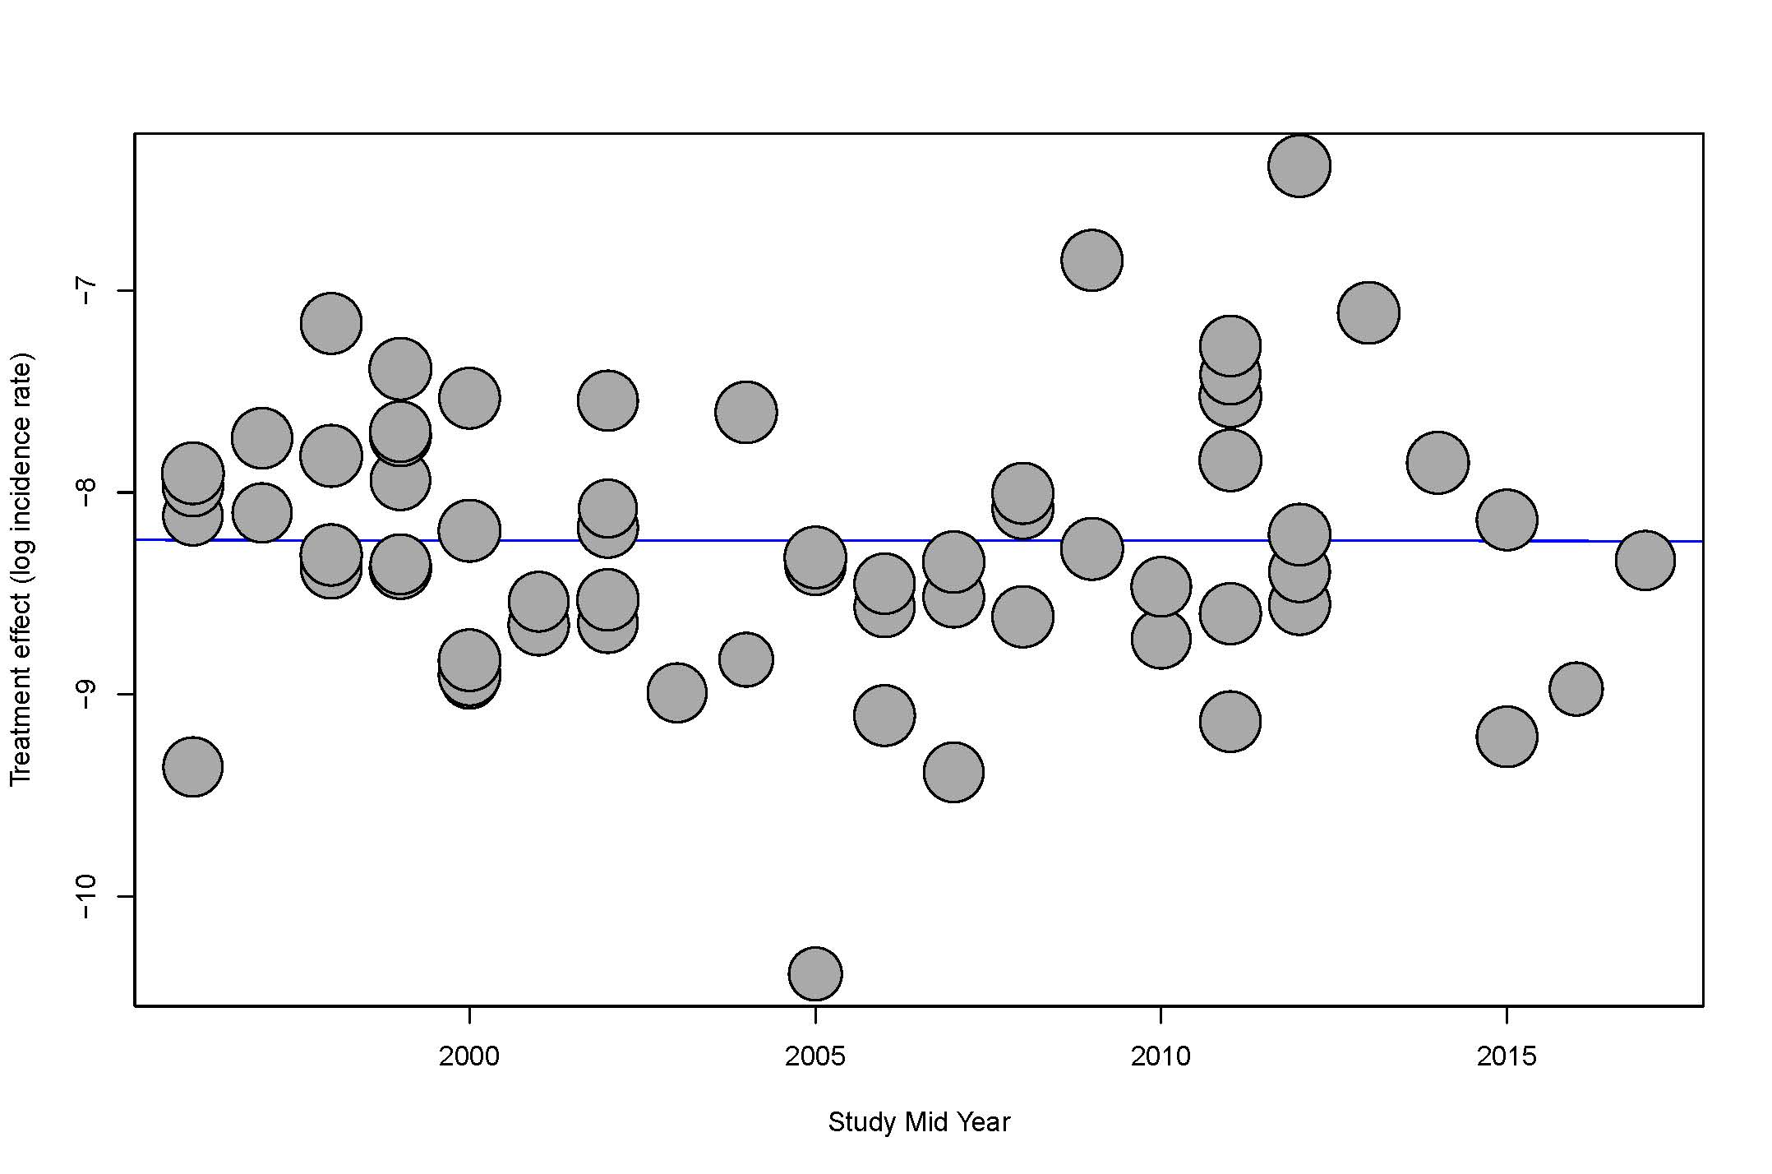
Appendix 3 Funnel plot of studies reporting incidences after intracerebral haemorrhage
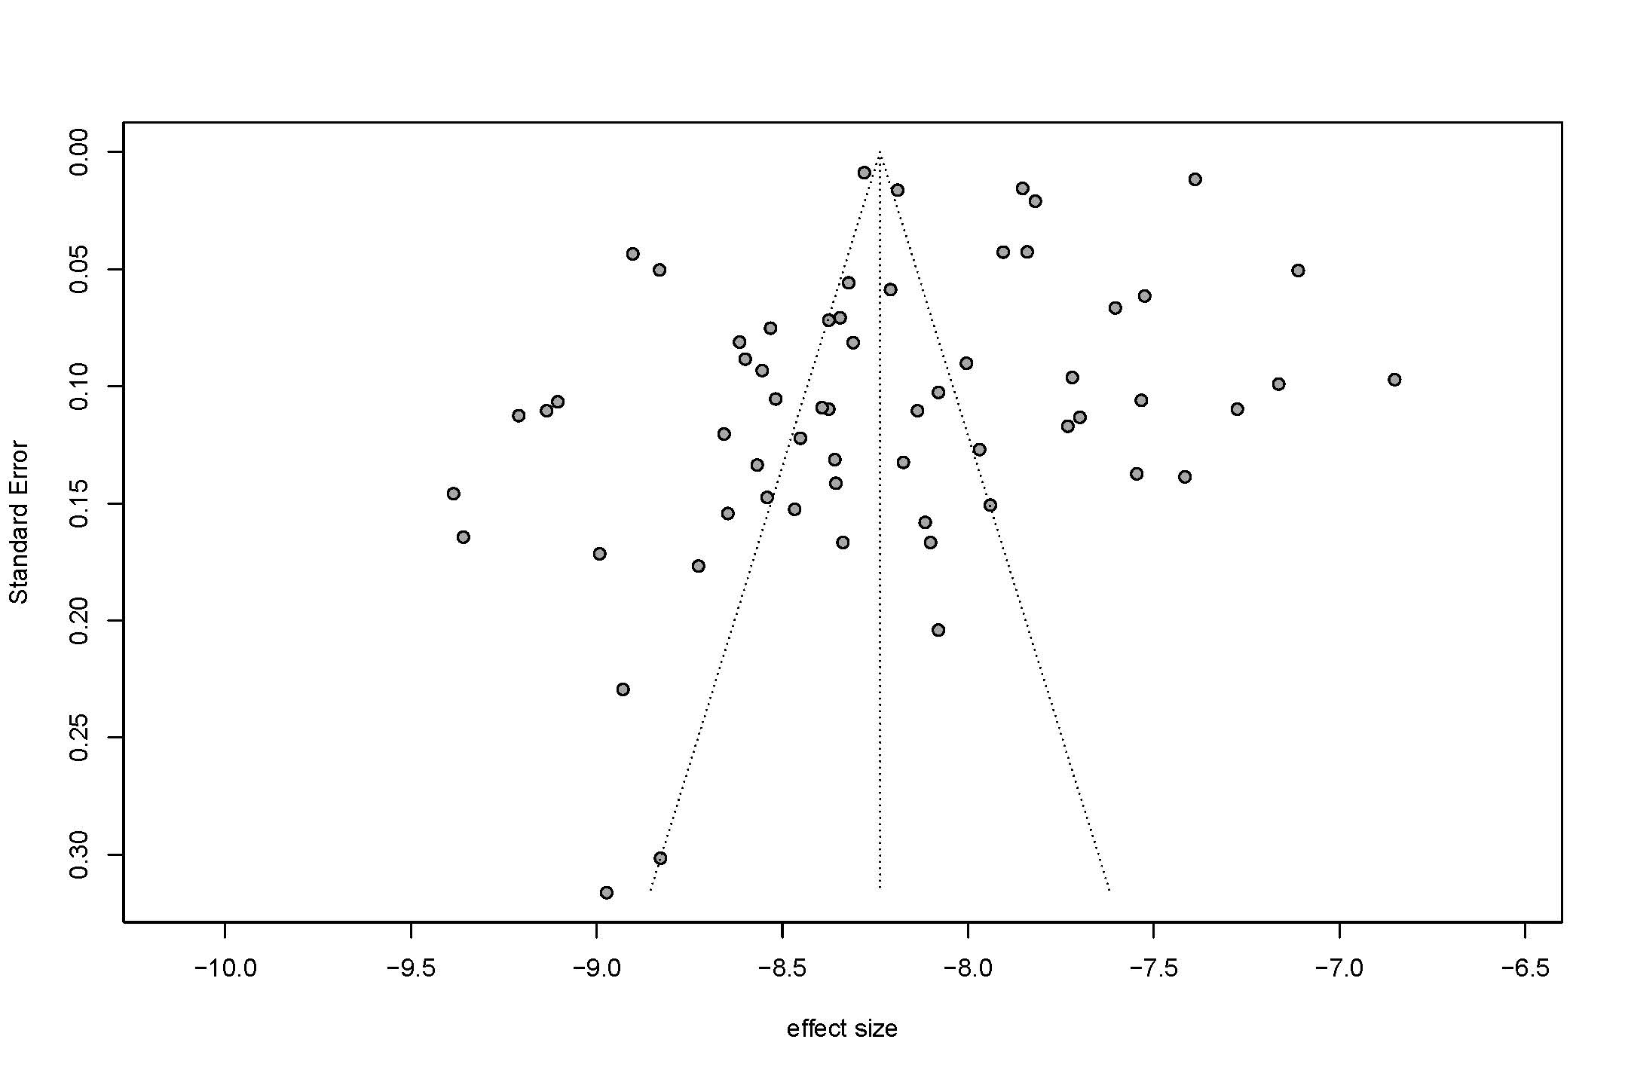
Appendix 4 Funnel plot of studies reporting 1-year survival after intracerebral haemorrhage
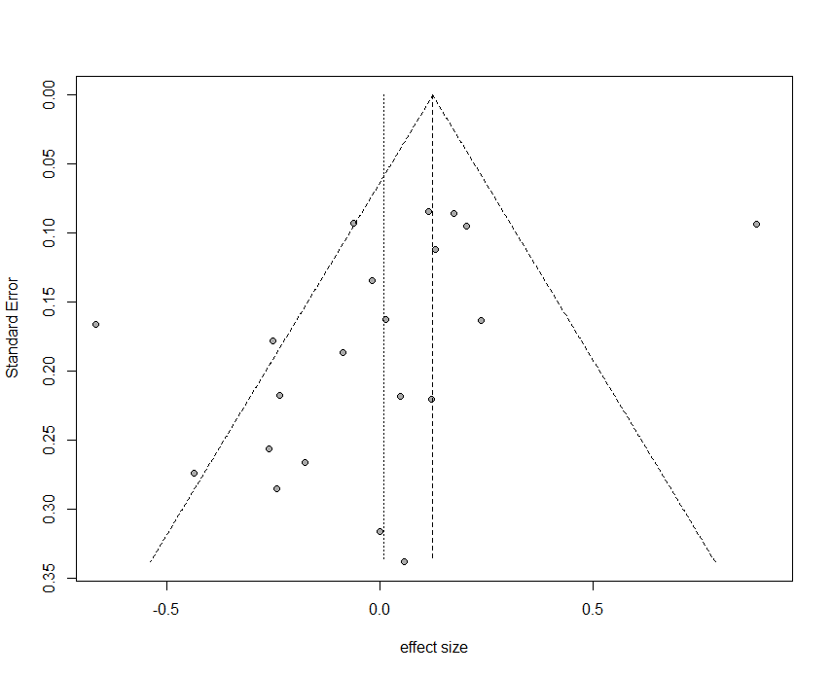
Appendix 5 Funnel plot of studies reporting 5-year survival after intracerebral haemorrhage


