SUPPLEMENTARY MATERIALS

Table S1. Literature Search
- Keywords
#1 (Covid-19) OR (Covid) OR (SARS-COV-2)
#2 (Ozone) OR (Autohemotherapy)
Search Results
Database | Keywords | Search Result | Search-time
MEDLINE | #1 AND #2 | 426 | May 21, 2022
ScienceDirect | #1 AND #2 | 2200 | May 21, 2022
Proquest | #1 AND #2 | 2271 | May 21, 2022
Springer | #1 AND #2 | 655 | May 21, 2022
Cochrane Library | #1 AND #2 | 22 | May 21, 2022
Manual searching | - | 170 | May 22, 2022-  May 25, 2022

Table S2. Quality assessment of ROB.2 for RCTs studies
Jurnal | Domain |  |  |  |  | Overall | RESULT
Jurnal | D1 | D2 | D3 | D4 | D5 | Overall | RESULT
Sozio et al. [23] |  |  |  |  |  |  | Low risk
Araimo et al. [24] |  |  |  |  |  |  | Some Concerns
Shah et al. [25] |  |  |  |  |  |  | Low risk
Dengiz et al. [26] |  |  |  |  |  |  | Low risk
Domains
D1 : bias arising from the randomization process
D2 : bias due to deviations from intended interventions
D3 : bias due to missing outcome data
D4 : bias in measurement of the outcome
D5 : bias in selection of the reported result
Low risk
some concerns
high risk

Table S3. Quality assessment for Clinical Trial Study using Robin-I
 | Bias due to confounding | Bias in selection of participants into the study | Bias in classification of interventions | Bias due to deviations from intended interventions | Bias due to missing data | Bias in measurement of outcomes | Bias in selection of the reported result | Overall Bias
Sharma et al. [22] |  |  |  |  |  |  |  | Moderate risk

low risk
Moderate risk
serious risk
critical risk
no information

Table S4. NOS for Case Control Studies
Jurnal | Selection |  |  |  | Comparability | Exposure |  |  | Total Score | RESULT
Jurnal | Is the case definition adequate? | Representativeness of the cases | Selection of Controls | Definition of Controls | Comparability of cases and controls on the basis of the design or analysis | Ascertainment of exposure | Same method of ascertainment for cases and controls | Non-Response rate | Total Score | RESULT
Tascini et al. [18] | * | * | * | - | * | * | * | * | 7 | High Quality
Fernández-Cuadros et al.[19] | * | * | * | - | * | * | * | * | 7 | High Quality
Hernández et al. [20] | * | * | * | - | * | * | * | * | 7 | High Quality
Çolak et al. [21] | * | * | * | - | * | * | * | - | 6 | Medium Quality

Table S5. JBI for Case Series Studies
No | Checklist questions | Franzini et al. [28] | Hernandez et al. [29] | Wu et al. [30]
1. | Were there clear criteria for inclusion in the case series? | Yes | No | No
2. | Was the condition measured in a standard, reliable way for all participants included in the case series? | Yes | Yes | Yes
3. | Were valid methods used for identification of the condition for all participants included in the case series? | Yes | Yes | Yes
4. | Did the case series have consecutive inclusion of participants? | No | No | No
5. | Did the case series have complete inclusion of participants? | No | No | No
6. | Was there clear reporting of the demographics of the participants in the study? | No | No | No
7. | Was there clear reporting of clinical information of the participants? | Yes | Yes | Yes
8. | Were the outcomes or follow up results of cases clearly reported? | Yes | Yes | Yes
9. | Was there clear reporting of the presenting site(s)/clinic(s) demographic information? | No | No | No
10. | Was statistical analysis appropriate? | Yes | No | Yes

Table S6. JBI for Case Report Study
No | Checklist questions | Hendawy et al. [27]
1. | Were patient’s demographic characteristics clearly described? | No
2. | Was the patient’s history clearly described and presented as a timeline? | Yes
3. | Was the current clinical condition of the patient on presentation clearly described? | Yes
4. | Were diagnostic tests or assessment methods and the results clearly described? | No
5. | Was the intervention(s) or treatment procedure(s) clearly described? | Yes
6. | Was the post-intervention clinical condition clearly described? | Yes
7. | Were adverse events (harms) or unanticipated events identified and described? | Yes
8. | Does the case report provide takeaway lessons? | Yes

Figure S1. Begg`s Funnel Plot on Mortality in RCTs (A) and Case Control studies (B)
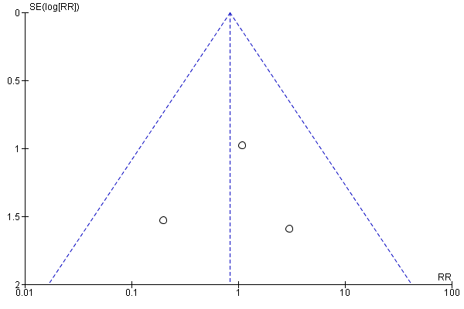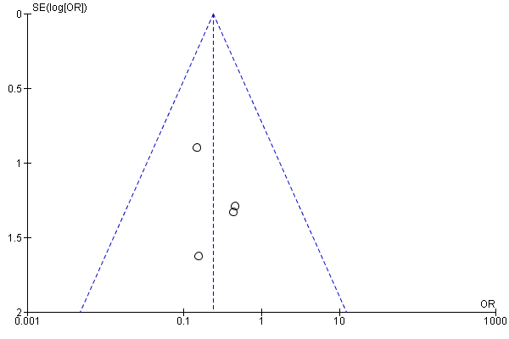

Figure S2. Begg`s Funnel Plot on Length of Hospital Stay
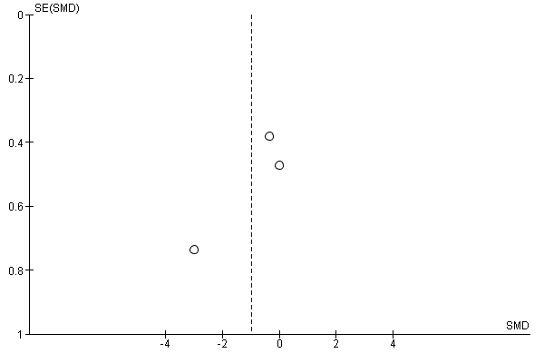

Figure S3. Begg`s Funnel Plot on ICU Admission


