Pubmed Search strategy:
((((Mycoplasma pneumoniae pneumonia[Title/Abstract]) OR (MPP[Title/Abstract])) OR (refractory Mycoplasma pneumoniae pneumonia[Title/Abstract])) OR (RMPP[Title/Abstract])) AND ((children[Title/Abstract]) OR (child[Title/Abstract]))

Table S1 Predicted RMPP results of various indicators
Study | Cutoff | Sensitivity | Specificity | AUC
CRP(mg/L)
Zhang,2016[3] | 16.5 | 74.7 | 77.2 | 0.817
Zhao,2020[25] | 12.1 | 73.3 | 55.0 | 0.655
Chen,2021[9] |  |  |  | 0.862
Shao,2015[15] | 51 | 97.1 | 96.8 | 0.917
Li,2019[20] | 17.5 | 50.0 | 48.0 | 0.35
Zhai,2017[18] | 15.3 | 77.6 | 79.5 | 0.821
LDH(IU/L)
Lu,2015[12] | 379 | 48 | 85.5 | 0.718
Zhang,2016[3] | 417 | 79.7 | 65 | 0.772
Liu,2018[18] | 408 | 75 | 72.2 | 0.812
Zhao,2020[25] | 436.5 | 77.8 | 62.4 | 0.775
Shao,2015[15] | 353 | 85.7 | 92.4 | 0.9
Li,2019[20] | 314.5 | 44.0 | 35.0 | 0.147
Zhai,2017[18] | 402 | 81.5 | 66.3 | 0.783
ESR(IU/L)
Lu,2015[12] | 32.5 | 62 | 66.4 | 0.718
Neutrophils(%)
Shao,2015[15] | 71.0 | 88.6 | 93.7 | 0.91
Zhang,2016[3] | 68.6 | 68.4 | 81.1 | 0.803

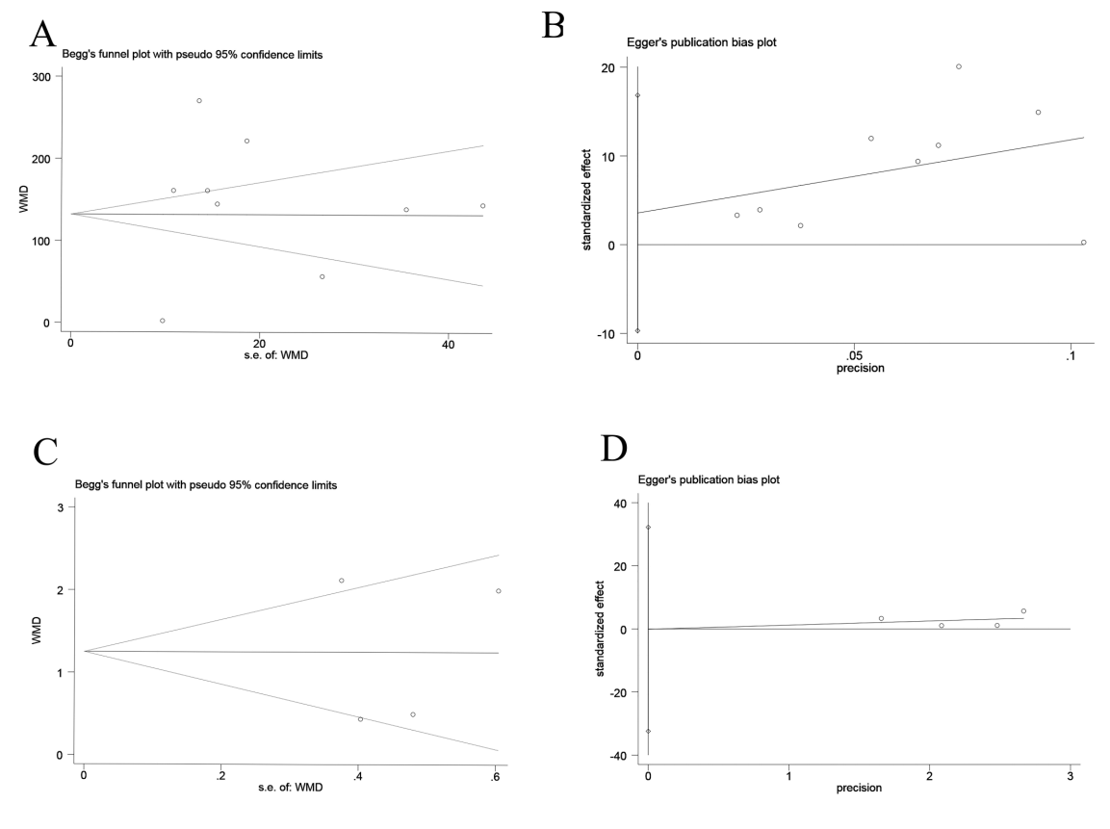
Figure S1 Publication bias tested by Begg’s test and Egger’s test. (A) Begg’s test for LDH; (B) Egger’s test for LDH; (C) Begg’s test for Neutrophils (%); (D) Egger’s test for Neutrophils (%)

Sensitivity analysis:
FigureS2: Sensitivity analysis of CRP
FigureS3: Sensitivity analysis of LDH
FigureS4: Sensitivity analysis of ESR
FigureS5: Sensitivity analysis of Neutrophils (%)
FigureS6: Sensitivity analysis of Lymphocytes (%)
FigureS7: Sensitivity analysis of D-Dimer
FigureS8: Sensitivity analysis of Lung consolidation
Figure S2 Sensitivity analysis of CRP
Figure S3 Sensitivity analysis of LDH
Figure S4 Sensitivity analysis of ESR
Figure S5 Sensitivity analysis of Neutrophils (%)
Figure S6 Sensitivity analysis of Lymphocytes (%)
Figure S7 Sensitivity analysis of D-Dimer
Figure S8 Sensitivity analysis of Lung consolidation

