Supplementary Material
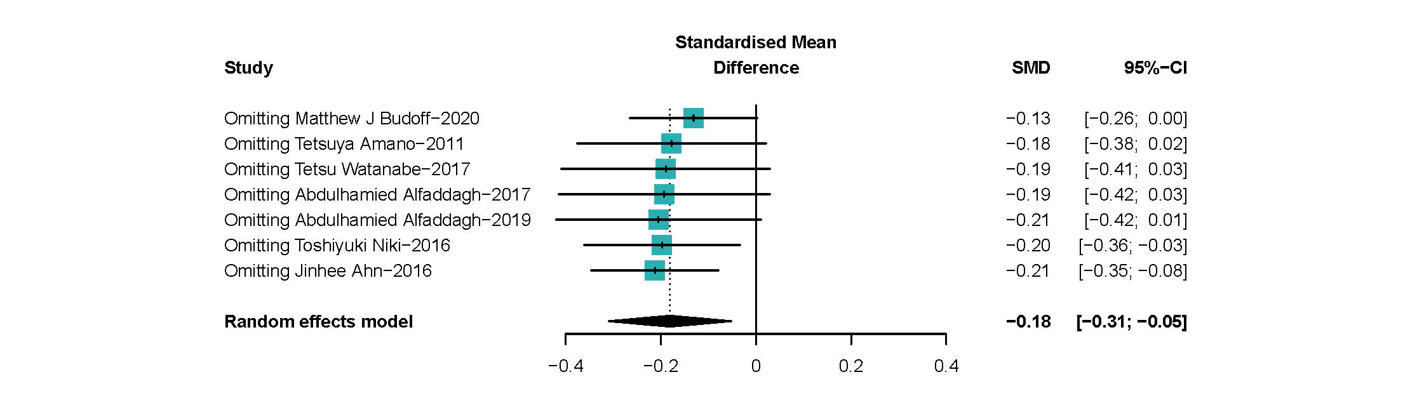S Fig 1.1. Sensitivity analysis of ω-3 PUFAs supplementation and coronary atherosclerotic plaques. Omitting: study number. Data was calculated in a random-effects model.

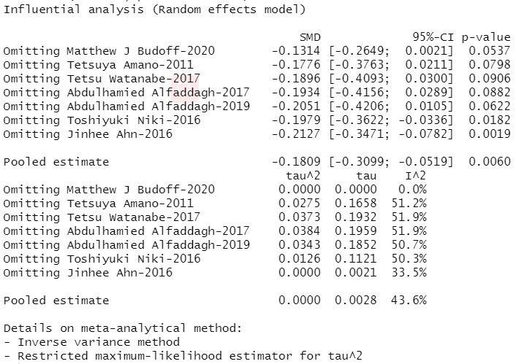S Fig 1.2. Sensitivity analysis in R workstation of ω-3 PUFAs supplementation and coronary atherosclerotic plaques. Data was calculated in a random-effects model.
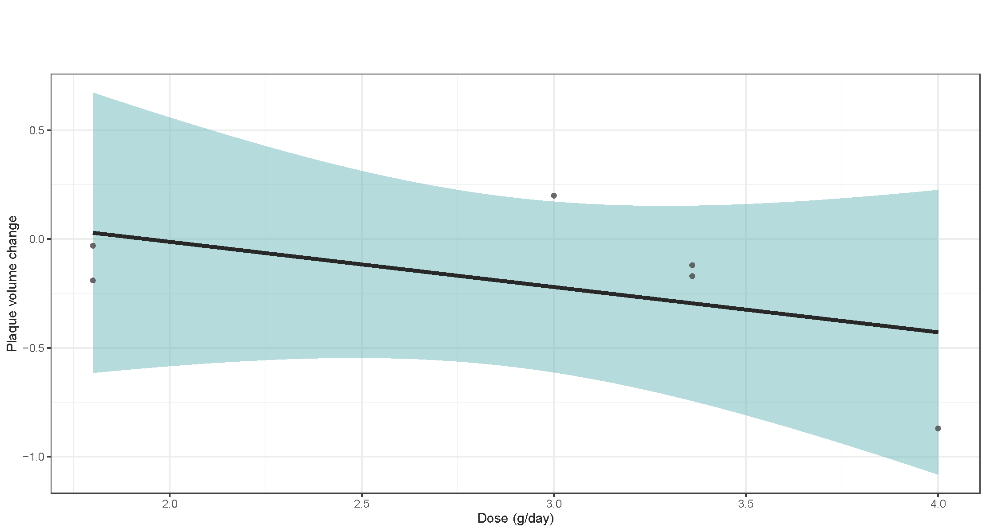S Fig 1.3. Linear regression of ω-3 PUFAs supplementation dose and change in plaque volume
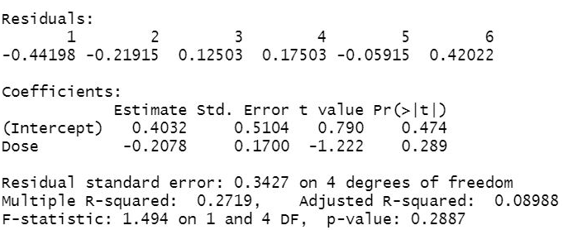
S Fig 1.4. Linear regression results in R workstation of ω-3 PUFAs supplementation dose and change in plaque volume
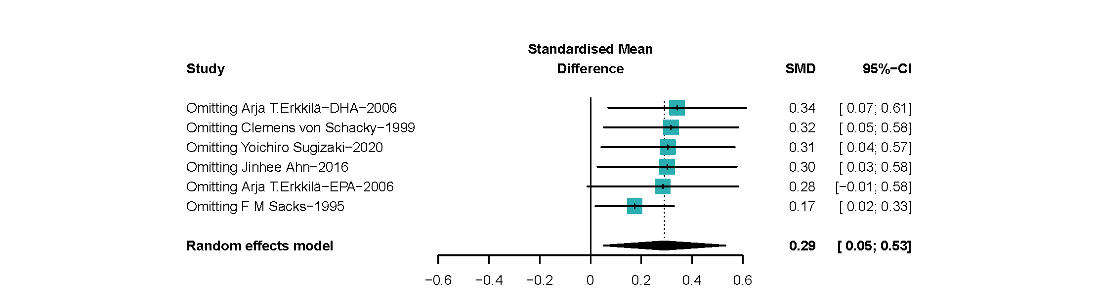S Fig 2.1. Sensitivity analysis of associations of ω-3 PUFAs and most stenotic segment of the coronary arteries. Omitting: study number. Data was calculated in a random-effects model.

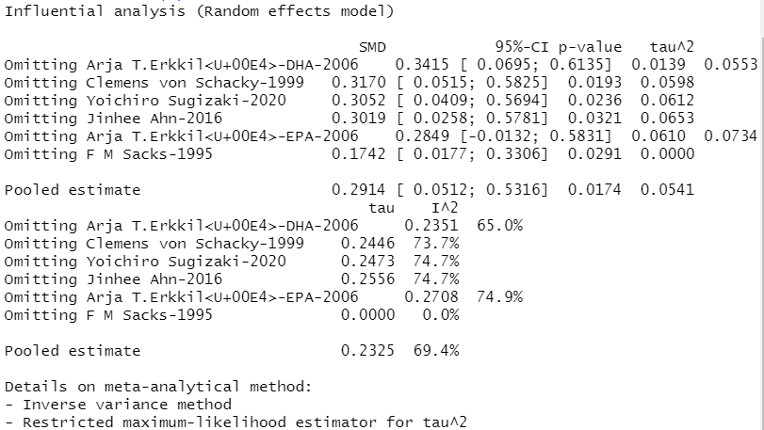S Fig 2.2. Sensitivity analysis in R workstation of associations of ω-3 PUFAs and most stenotic segment of the coronary artery. Data was calculated in a random-effects model.

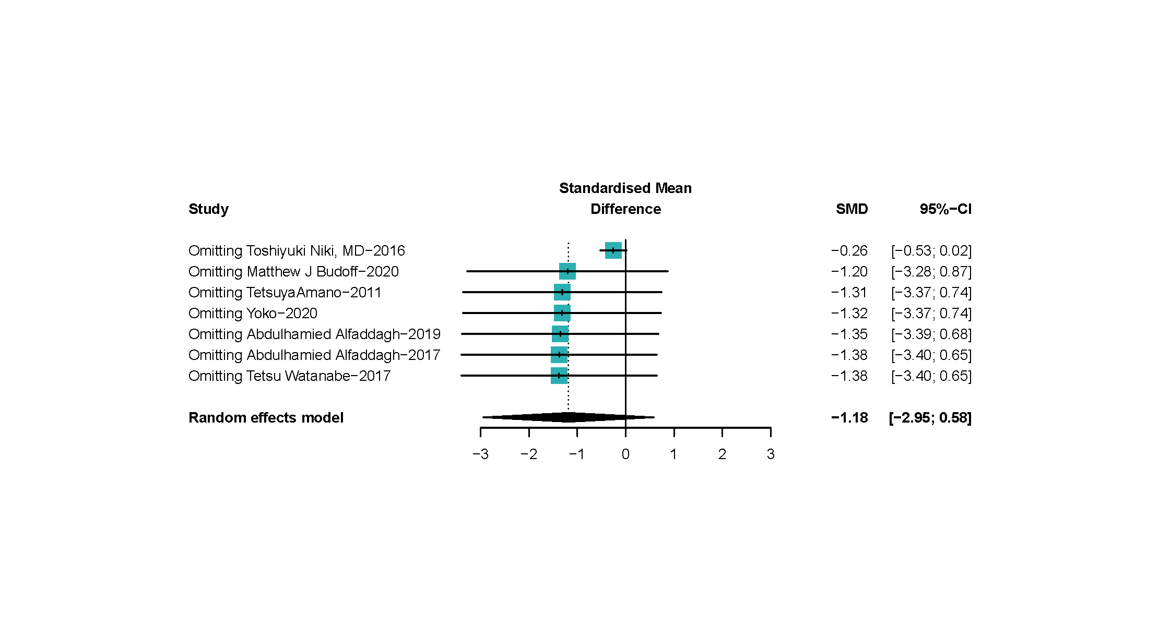S Fig 3.1. Sensitivity analysis of ω-3 PUFAs and lipid plaques volume. Omitting: study number. Data was calculated in a random-effects model.
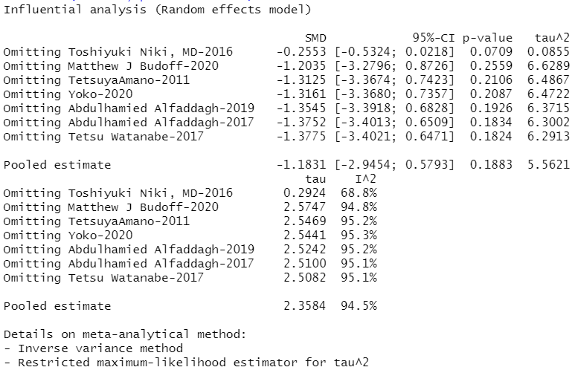
S Fig 3.2. Sensitivity analysis in R workstation of ω-3 PUFAs ω-3 PUFAs and lipid plaques volume. Data was calculated in a random-effects model.
S Fig 4.1. Sensitivity analysis of ω-3 PUFAs and fiber plaque volume. Omitting: study number. Data was calculated in a random-effects model.

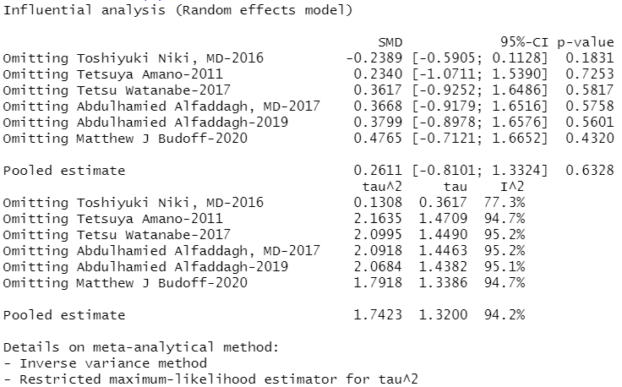S Fig 4.2. Sensitivity analysis in R workstation of ω-3 PUFAs and coronary fiber plaque volume. Data was calculated in a random-effects model.

S Fig 5.1. Sensitivity analysis of ω-3 PUFAs and calcified plaque volume. Omitting: study number. Data was calculated in a random-effects model.

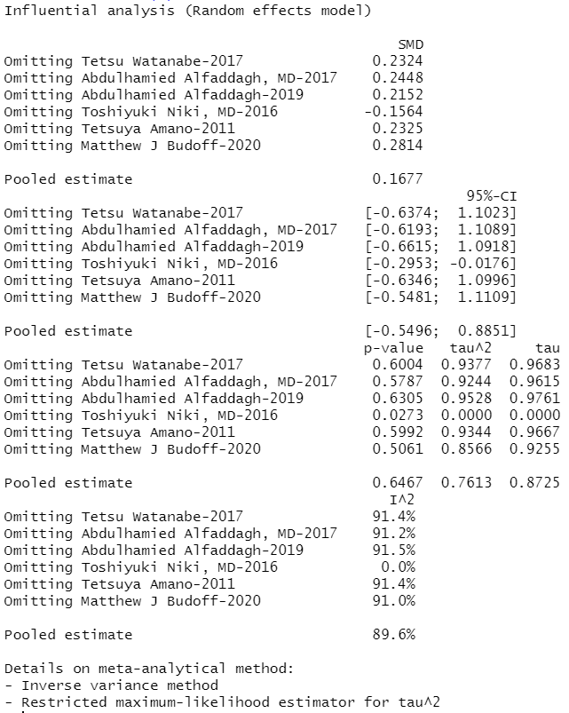
S Fig 5.2. Sensitivity analysis in R workstation of ω-3 PUFAs and calcified plaque volume. Data was calculated in a random-effects model.

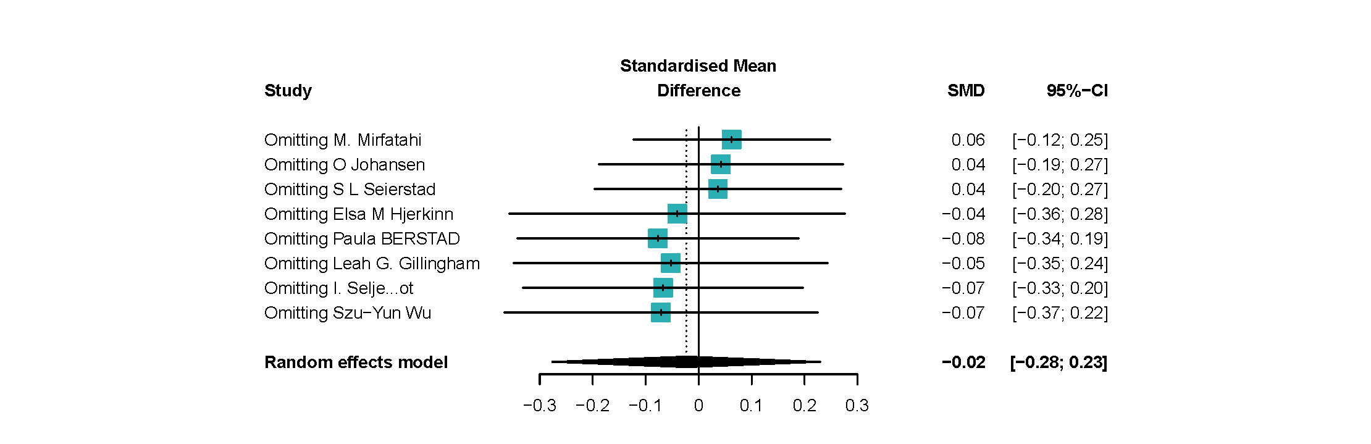S Fig 6.1. Sensitivity analysis of ω-3 PUFAs and sVCAM-1 level. Omitting: study number. Data was calculated in a random-effects model.

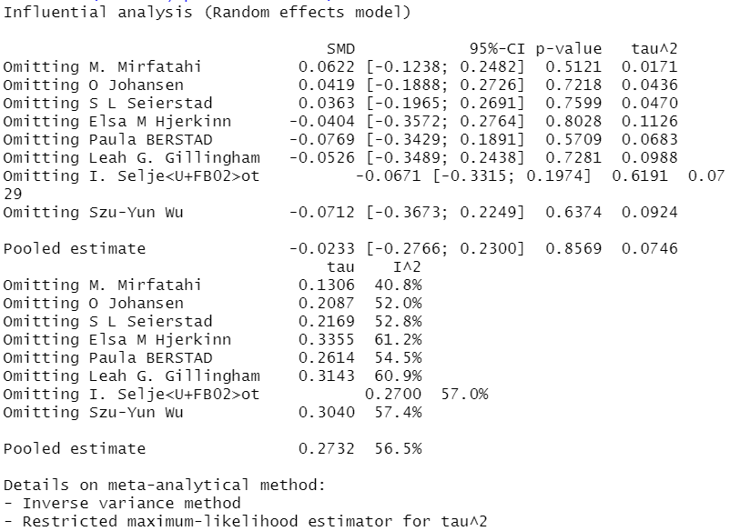
S Fig 6.2. Sensitivity analysis in R workstation of ω-3 PUFAs and sVCAM-1 level. Data was calculated in a random-effects model.
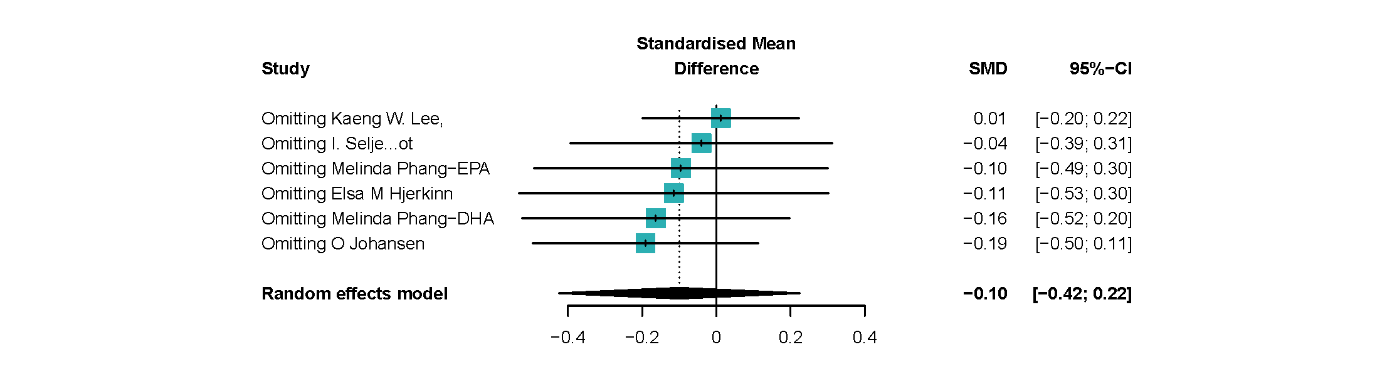S Fig 7.1. Sensitivity analysis of ω-3 PUFAs and VWF%. Omitting: study number. Data was calculated in a random-effects model.

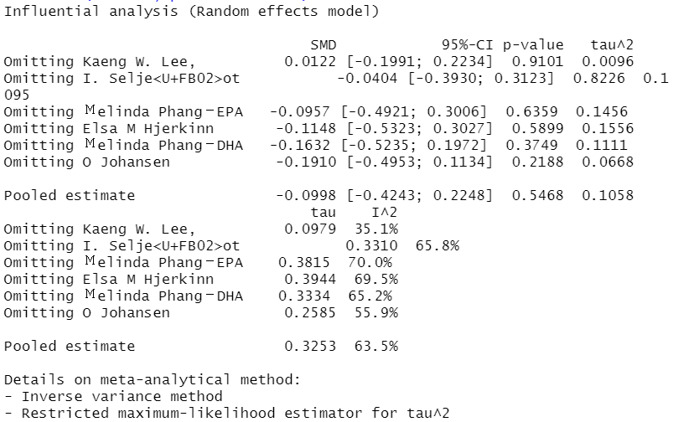S Fig 7.2. Sensitivity analysis in R workstation of ω-3 PUFAs and VWF%. Data was calculated in a random-effects model.

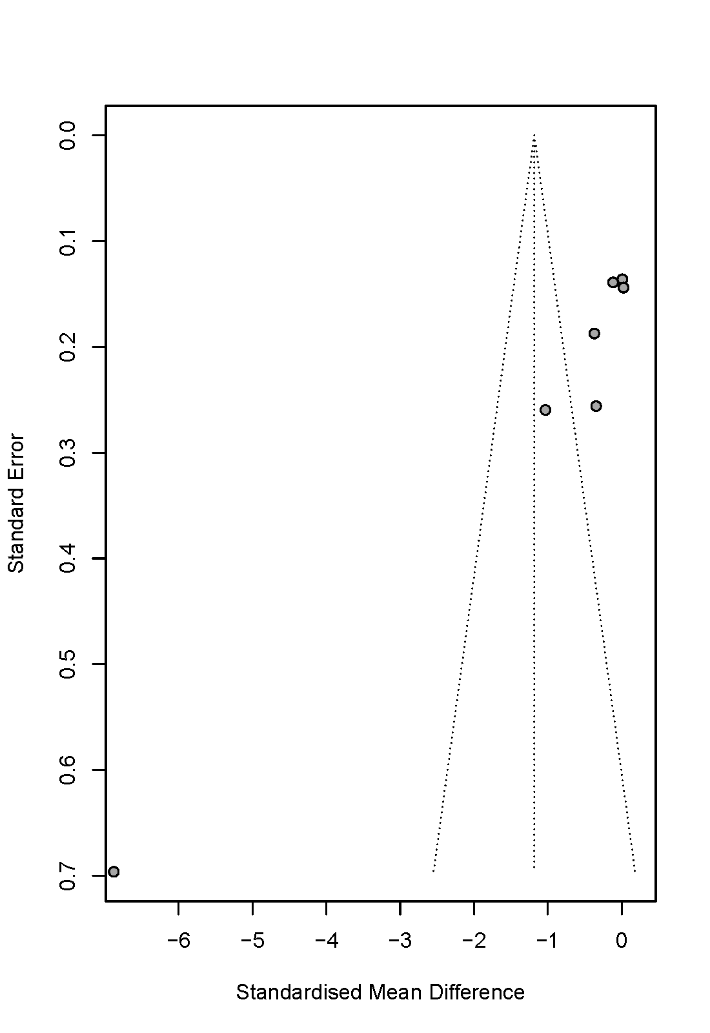
S Fig 8.1 Funnel plot of ω-3 PUFAs and lipid plaques volume.
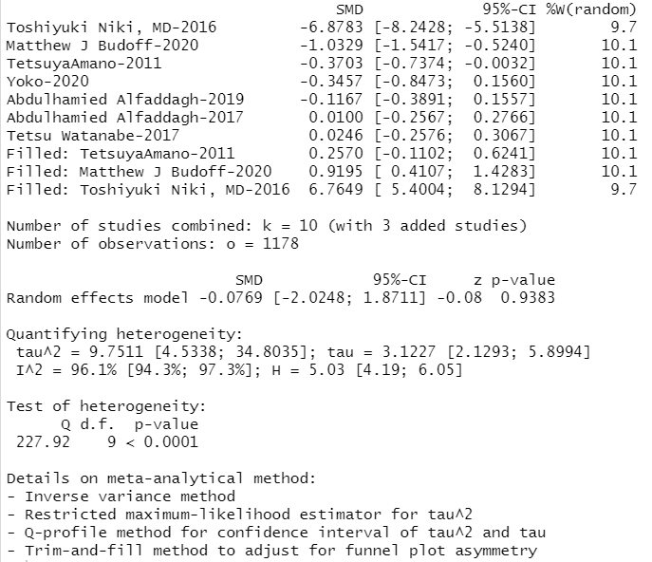S Fig 8.2 R workstation of “trim and fill” of ω-3 PUFAs and lipid plaques volume.
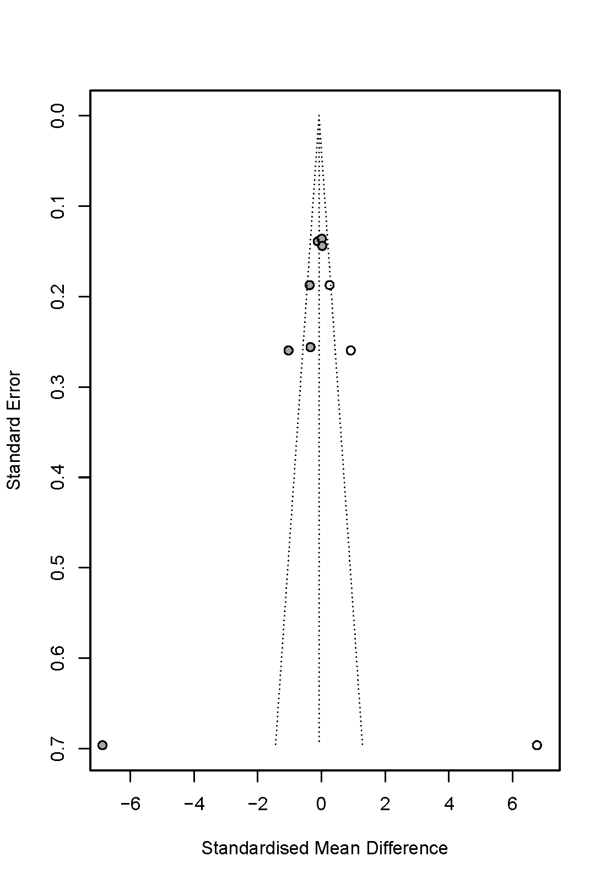
S Fig 8.3 Trimmed funnel plot of ω-3 PUFAs and lipid plaques volume.
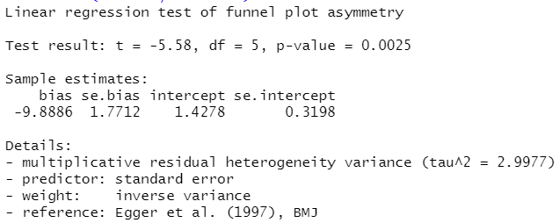
S Fig 8.4 Peter’s test of ω-3 PUFAs and lipid plaques volume.
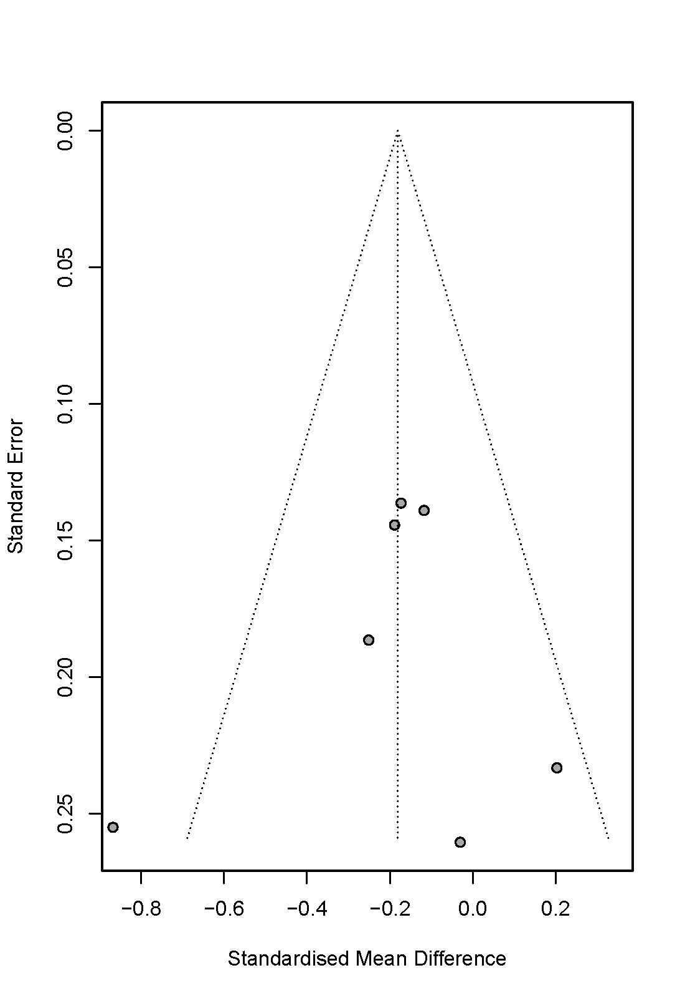
S Fig 9.1 Funnel plot of ω-3 PUFAs supplementation and coronary atherosclerotic plaques.
S Fig 9.2 Funnel plot of ω-3 PUFAs and lipid plaques volume
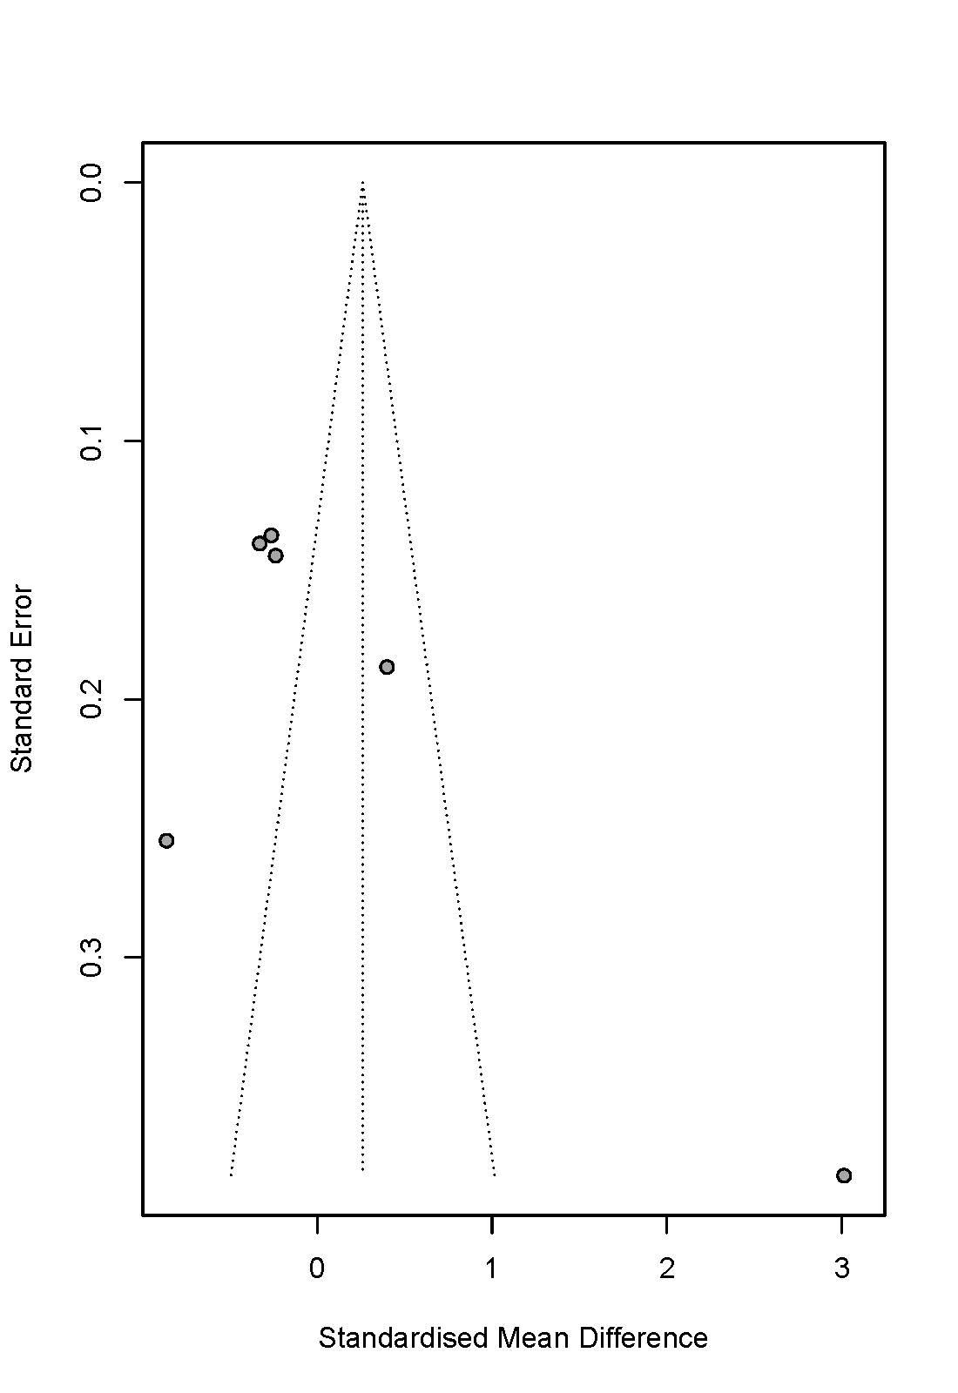
S Fig 9.3 Funnel plot of ω-3 PUFAs and fiber plaques volume
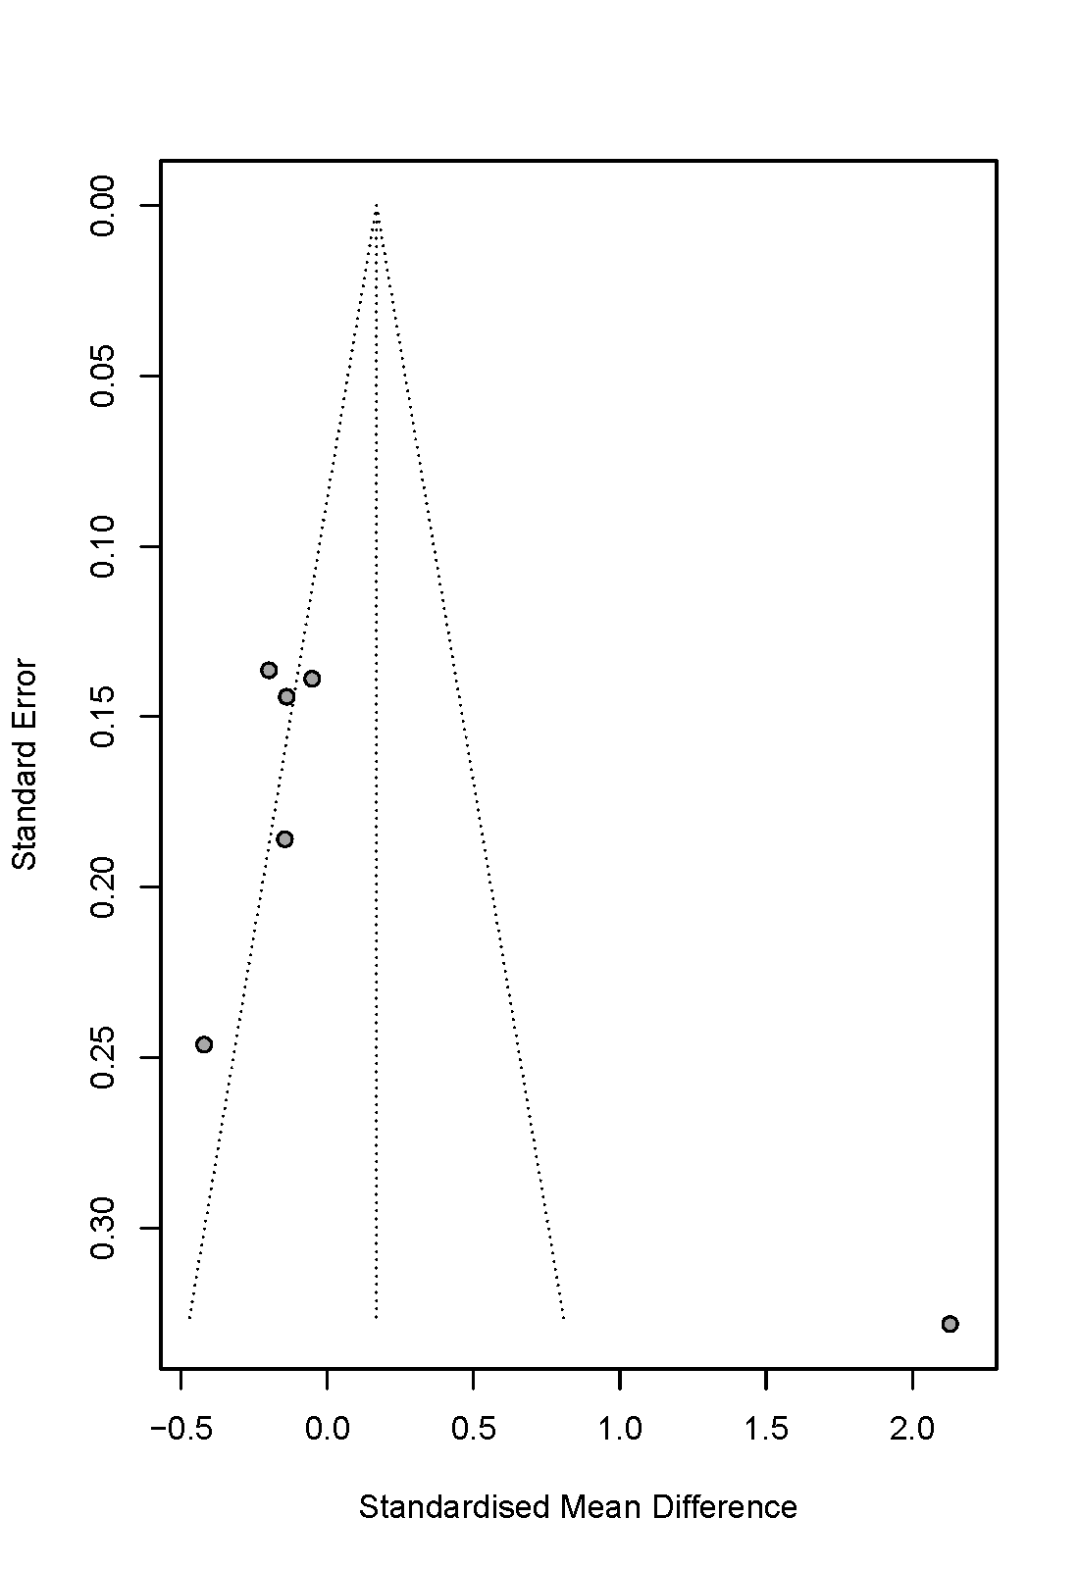
S Fig 9.4 Funnel plot of ω-3 PUFAs and calcified plaque volume
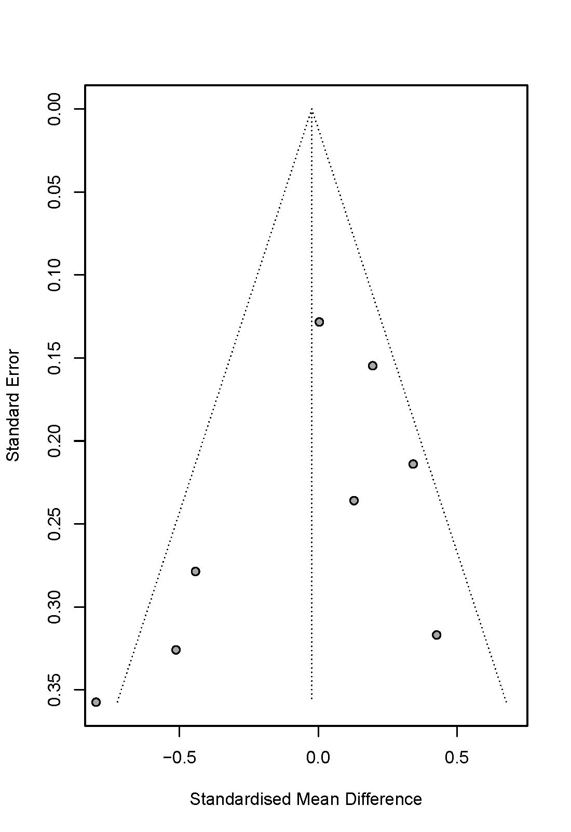
S Fig 9.5 Funnel plot of ω-3 PUFAs and sVCAM-1.
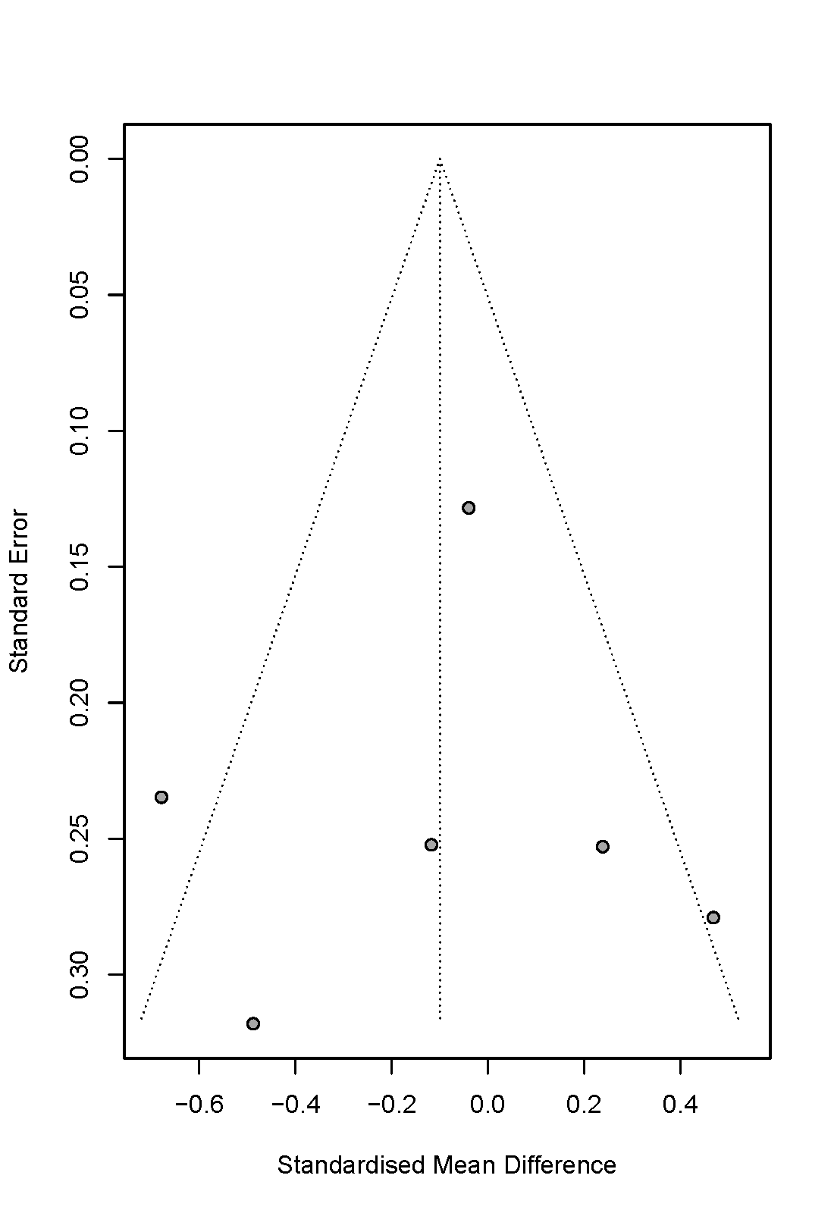
S Fig 9.6 Funnel plot of ω-3 PUFAs and VWF%
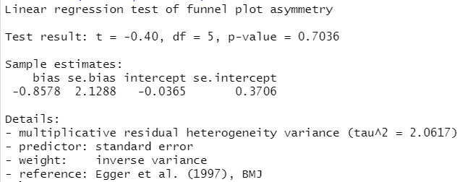
S Fig 10.1 Peter’s bias of ω-3 PUFAs supplementation and coronary atherosclerotic plaques.

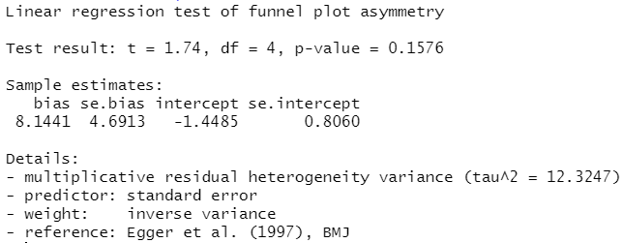
S Fig 10.2 Peter’s bias of ω-3 PUFAs and most stenotic segment of the coronary arteries.

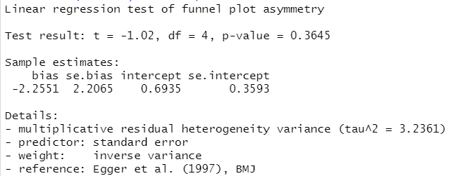
S Fig 10.3 Peter’s bias of ω-3 PUFAs and fiber plaques volume

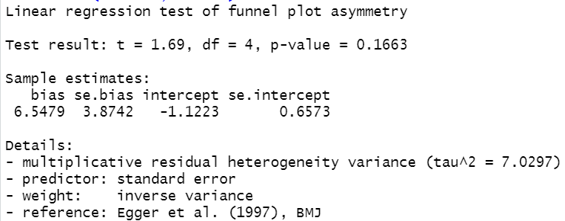S Fig 10.4 Peter’s bias of ω-3 PUFAs and calcified plaque volume

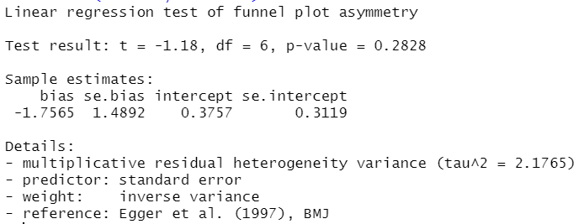S Fig 10.5 Peter’s bias of ω-3 PUFAs and sVCAM-1.

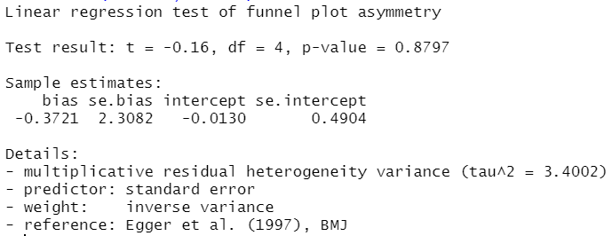S Fig 10.6 Peter’s bias of ω-3 PUFAs and VWF%.
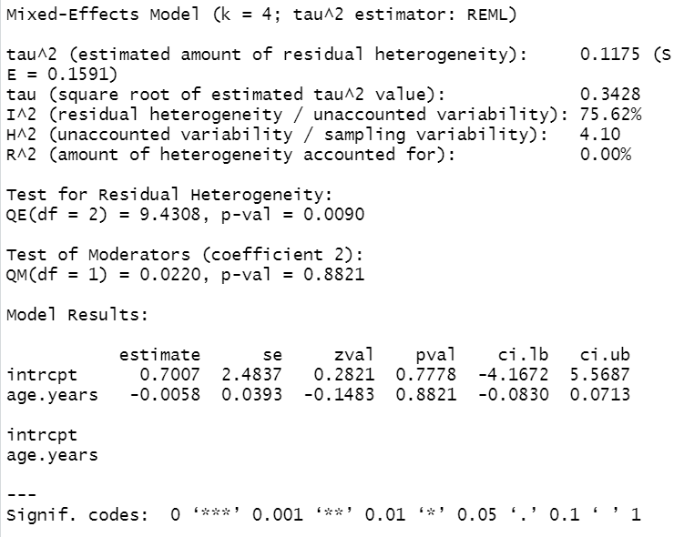 S Fig 11.1 R work station of meta-regression of individuals’ main age and the diameter of the narrowest segments of coronary arteries
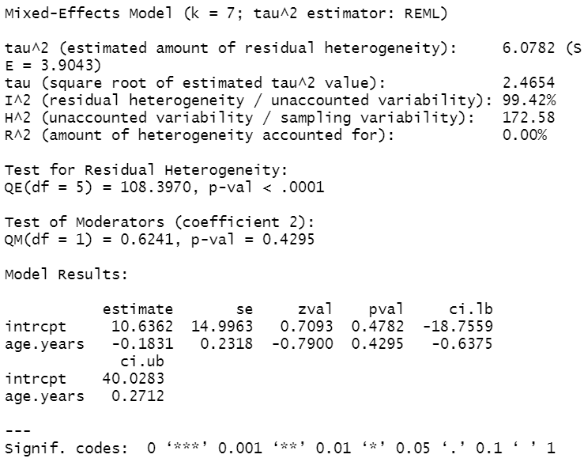 S Fig 11.2 R work station of meta-regression of individuals’ main age and volume of lipid plaques
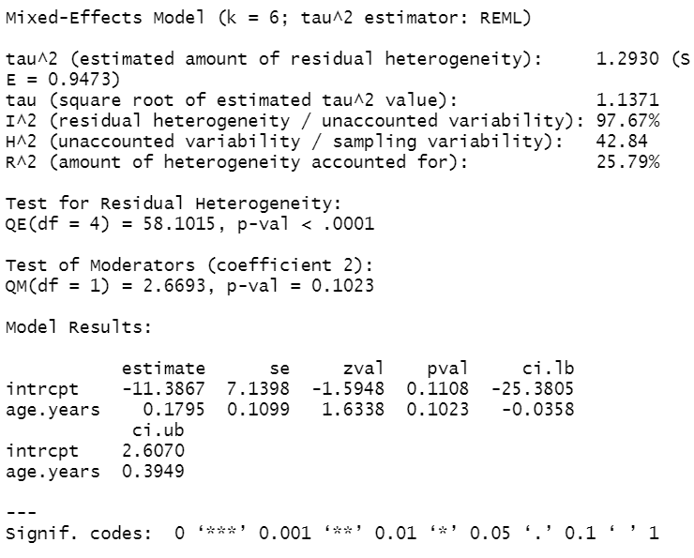 S Fig 11.3 R work station of meta-regression of individuals’ main age and volume of fiber plaques
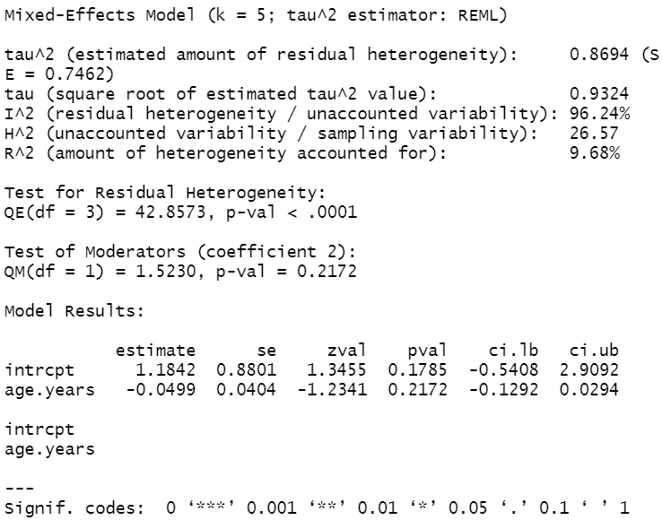 S Fig 11.4 R work station of meta-regression of individuals’ main age and volume of calcified plaques
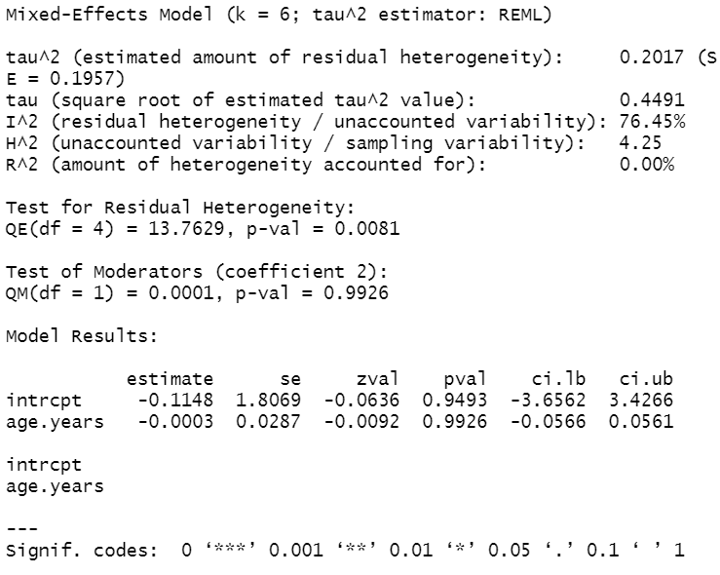 S Fig 11.5 R work station of meta-regression of individuals’ main age and volume of sVCAM-1 plaques
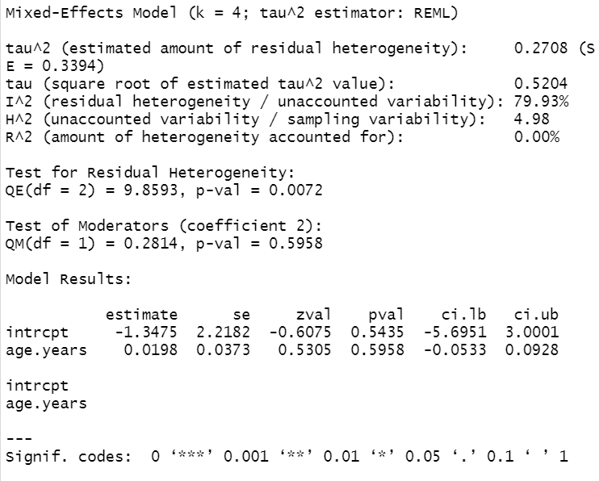 S Fig 11.6 R work station of meta-regression of individuals’ main age and volume of VWF% plaques
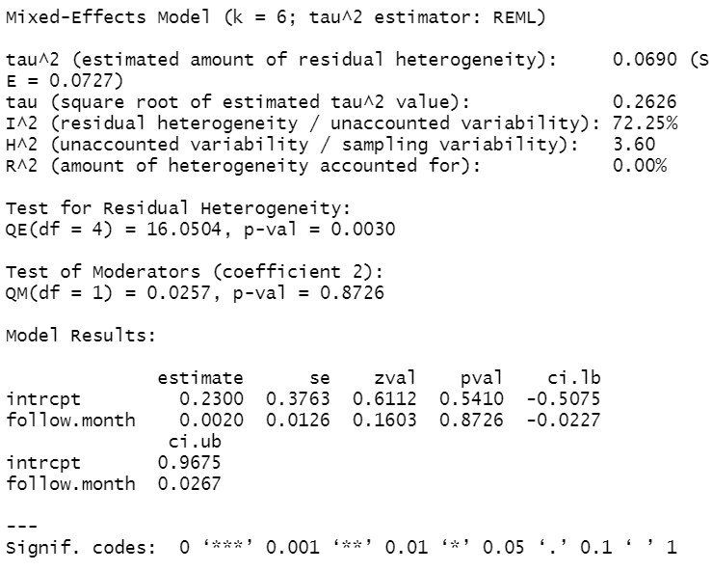 S Fig 11.7 R work station of meta-regression of follow-up duration and the diameter of the narrowest segments of coronary arteries
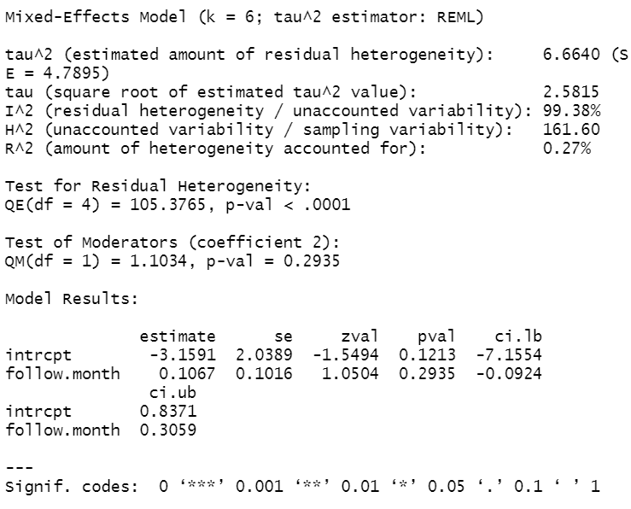 S Fig 11.8 R work station of meta-regression of follow-up duration and volume of lipid plaques
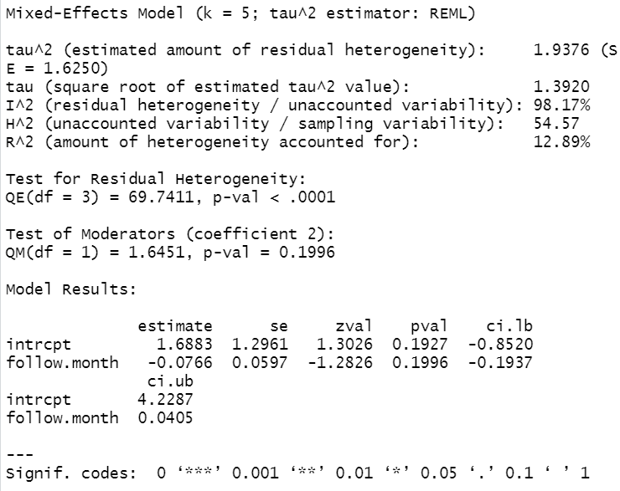 S Fig 11.9 R work station of meta-regression of follow-up duration and volume of fiber plaques
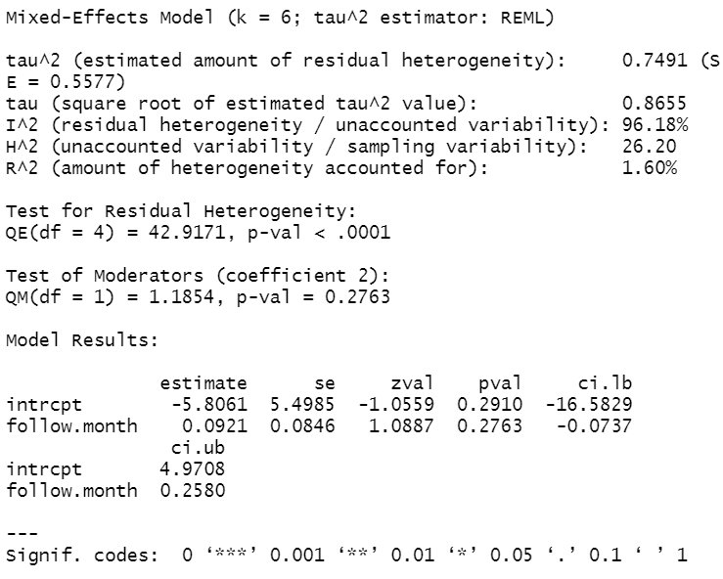 S Fig 11.10 R work station of meta-regression of follow-up duration and volume of calcified plaques
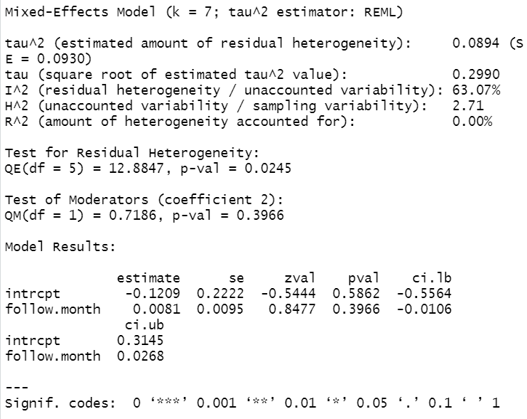 S Fig 11.11 R work station of meta-regression of follow-up duration and volume of sVCAM-1
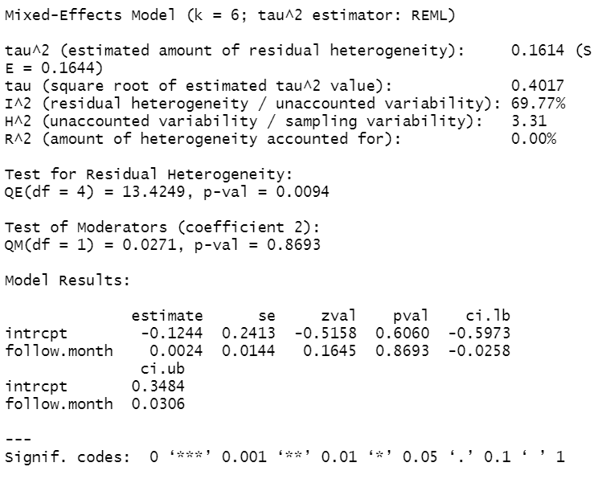 S Fig 11.12 R work station of meta-regression of follow-up duration and volume of lipid VWF%

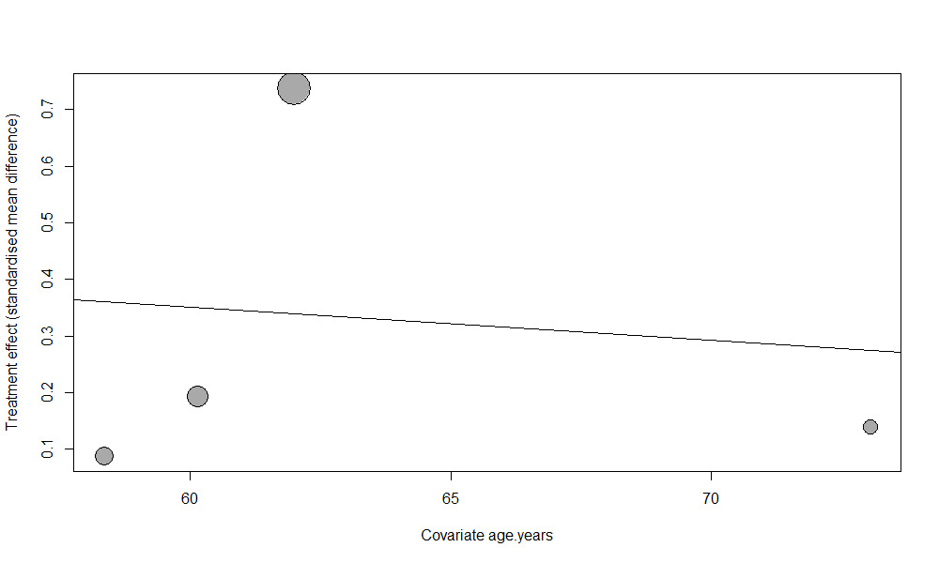 S Fig 12.1 Meta-regression curve of individuals’ main age and the diameter of the narrowest segments of coronary arteries
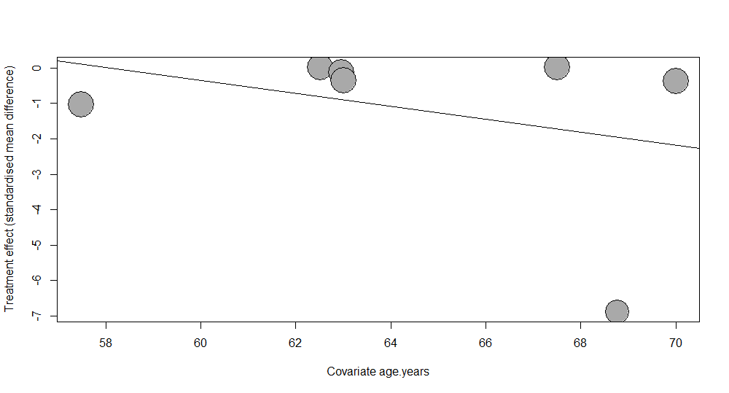 S Fig 12.2 Meta-regression curve of individuals’ main age and the volume of the lipid plaques
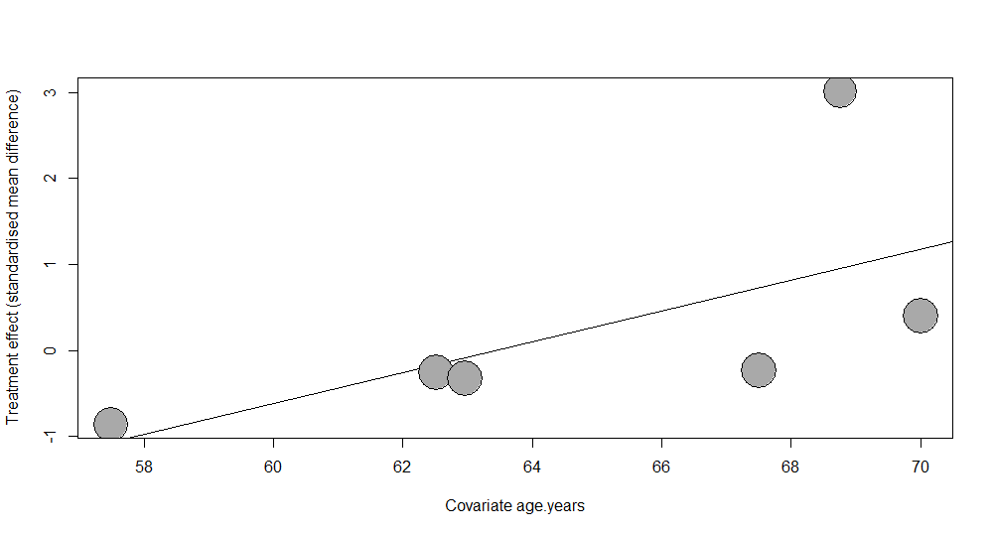 S Fig 12.3 Meta-regression curve of individuals’ main age and the volume of the fiber plaques
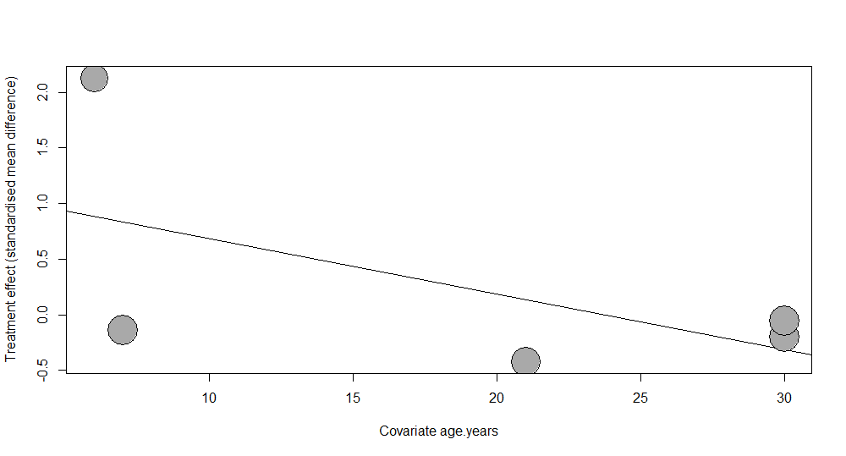 S Fig 12.4 Meta-regression curve of individuals’ main age and the volume of the calcified plaques
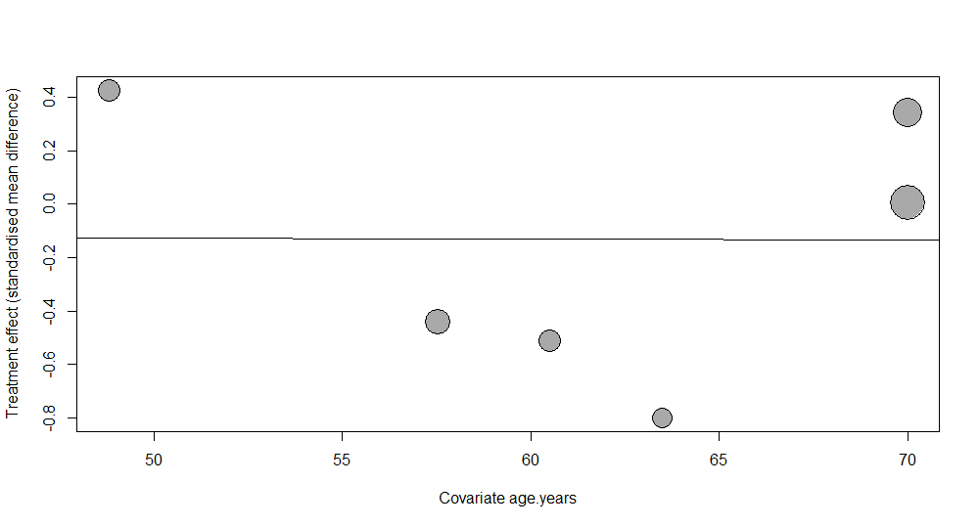 S Fig 12.5 Meta-regression curve of individuals’ main age and sVCAM-1
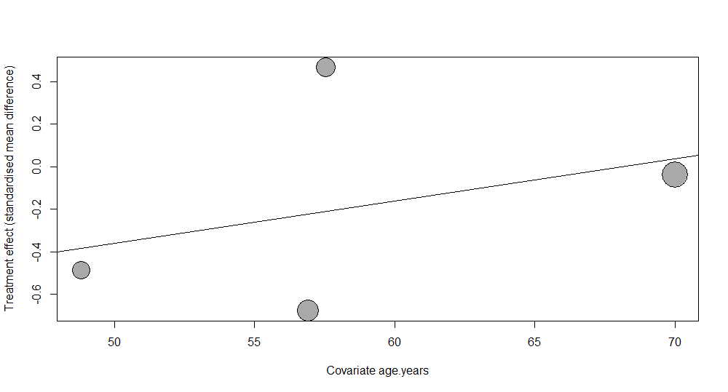 S Fig 12.6 Meta-regression curve of individuals’ main age and VWF%
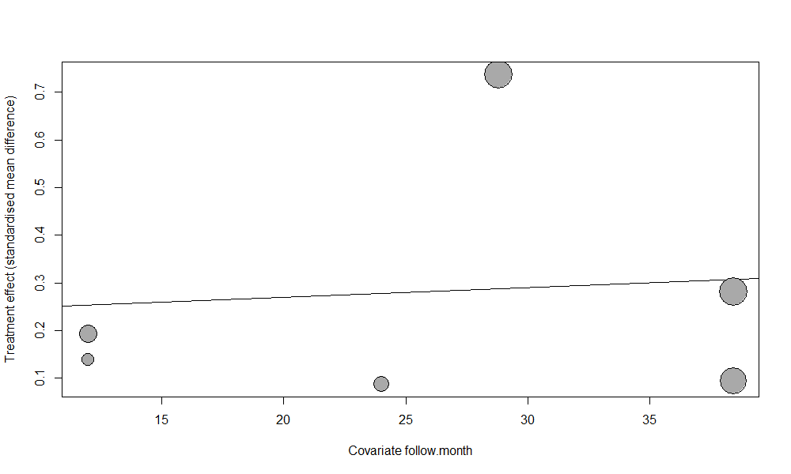 S Fig 12.7 Meta-regression curve of duration of follow-up and the diameter of the narrowest segments of coronary arteries
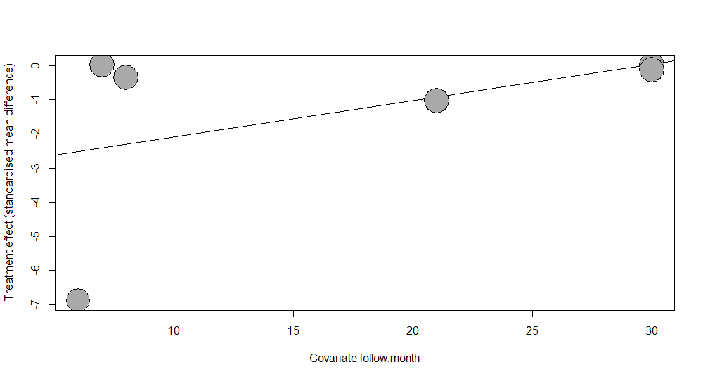 S Fig 12.8 Meta-regression curve of duration of follow-up and the volume of lipid plaques
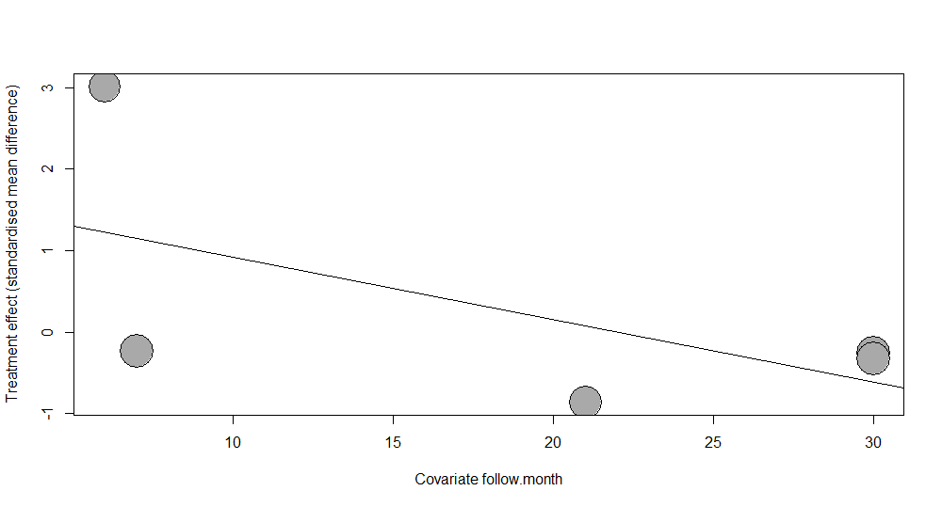 S Fig 12.9 Meta-regression curve of duration of follow-up and the volume of fiber plaques
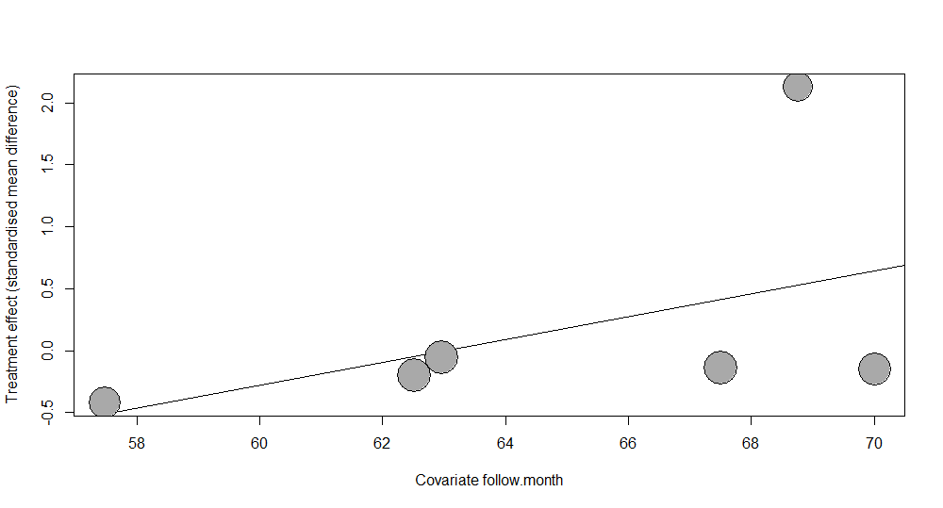 S Fig 12.10 Meta-regression curve of duration of follow-up and the volume of calcified plaques
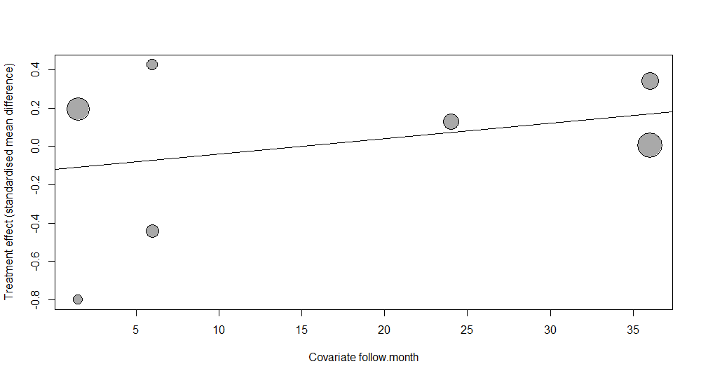 S Fig 12.11 Meta-regression curve of duration of follow-up and sVCAM-1
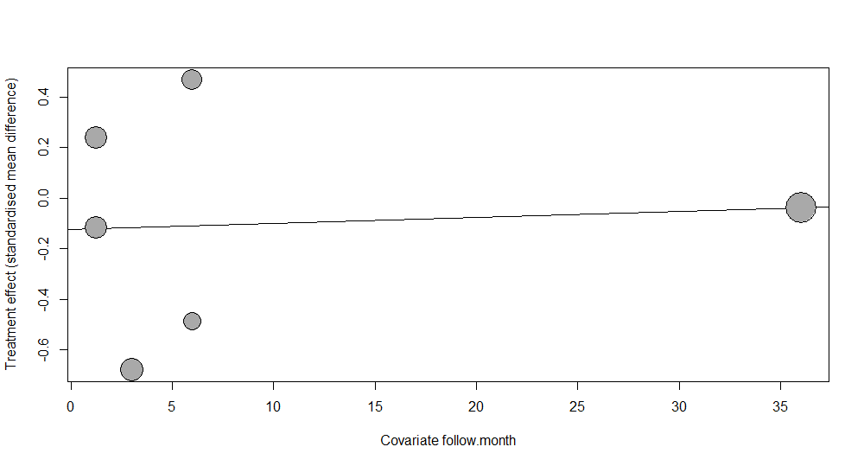 S Fig 12.12 Meta-regression curve of duration of follow-up and VWF%
S Appendix 1 Search strategy.

Search strategy
No. | Items
#1 | Atheromatous Plaques【MeSh】
#2 | Fatty Streak, Arterial【Title/Abstruct】
#3 | Arterial Fatty Streak【Title/Abstruct】
#4 | Arterial Fatty Streaks【Title/Abstruct】
#5 | Fatty Streaks, Arterial【Title/Abstruct】
#6 | Streak, Arterial Fatty【Title/Abstruct】
#7 | Streaks, Arterial Fatty【Title/Abstruct】
#8 | Fibroatheroma【Title/Abstruct】
#9 | Fibroatheromas【Title/Abstruct】
#10 | Fibroatheromatous Plaques【Title/Abstruct】
#11 | Fibroatheromatous Plaque【Title/Abstruct】
#12 | Plaque, Fibroatheromatous【Title/Abstruct】
#13 | Plaques, Fibroatheromatous【Title/Abstruct】
#14 | Atheroma【Title/Abstruct】
#15 | Atheromas【Title/Abstruct】
#16 | Atheromatous Plaque【Title/Abstruct】
#17 | Plaque, Atheromatous【Title/Abstruct】
#18 | Plaques, Atheromatous【Title/Abstruct】
#19 | Atheroscleroses【Title/Abstruct】
#20 | Atherogenesis【Title/Abstruct】
#21 | #1 or #2 or #3 or #4 or #5 or #6 or #7 or #8 or #9 or #10 or #11 or #12 or #13 or #14 or #15 or #16 or #17 or #18 or #19 or #20
#22 | Blood Vessel【MeSh】
#23 | Vessel, Blood【Title/Abstruct】
#24 | vascular【Title/Abstruct】
#25 | Vessels, Blood【Title/Abstruct】
#26 | Vessels【Title/Abstruct】
#27 | #24 or #25 or #26
#28 | Coronary Heart Disease【MeSh】
#29 | Coronary Diseases【Title/Abstruct】
#30 | Disease, Coronary【Title/Abstruct】
#31 | Diseases, Coronary【Title/Abstruct】
#32 | Coronary Heart Diseases【Title/Abstruct】
#33 | Disease, Coronary Heart【Title/Abstruct】
#34 | Diseases, Coronary Heart【Title/Abstruct】
#35 | Heart Disease, Coronary【Title/Abstruct】
#36 | Heart Diseases, Coronary【Title/Abstruct】
#37 | Acids, Unsaturated Fatty【Title/Abstruct】
#38 | #28 or #29 or #30 or # 31 or #32 r #33 or #34 or #35 or #36 or #37
#39 | Unsaturated Fatty Acids【MeSh】
#40 | Acids, Unsaturated Fatty【Title/Abstruct】
#41 | Unsaturated Fatty Acid【Title/Abstruct】
#42 | Acid, Unsaturated Fatty【Title/Abstruct】
#43 | Fatty Acid, Unsaturated【Title/Abstruct】
#44 | Polyunsaturated Fatty Acids【Title/Abstruct】
#45 | Acids, Polyunsaturated Fatty【Title/Abstruct】
#46 | Fatty Acids, Polyunsaturated【Title/Abstruct】
#47 | Polyunsaturated Fatty Acid【Title/Abstruct】
#48 | Acid, Polyunsaturated Fatty【Title/Abstruct】
#49 | Fatty Acid, Polyunsaturated【Title/Abstruct】
#50 | #39 or #40 or #41 or #42 or #43 or #44 or #45 or #46 or #47 or #48 or #49
#51 | ω-3【MeSh】
#52 | n-3【Title/Abstruct】
#53 | Omega-3【Title/Abstruct】
#54 | #51 or #52 or #53
#55 | # 54 and #50
#56 | #21 or #27
#57 | #55 and #56

