Table of Contents
 |  | Page
Table S1 | Literature search criteria | 2
Table S2 | Comparisons of the fit of consistency and inconsistency models in the fixed/random model | 3
Table S3 | Node-splitting analysis of inconsistency | 4
Table S4 | The Grading of Recommendations Assessment, Development and Evaluation (GRADE)  （results of head-to-head comparisons according to pairwise and network meta-analyses） | 5-16
Table S5 | Pooled estimates of the blood loss | 17
Table S6 | Pooled estimates of the operation time | 18
Table S7 | Pooled estimates of the duration of hospital stay | 19
Table S8 | Pooled estimates of complications | 20
Table S9 | Meta-regression using the mean ODI, VAS-back/leg pain of participants’ preoperative data | 21
Figure S1 | Convergence of the three chains established by inspection of the history feature, density and the Brooks-Gelman-Rubin diagnostic | 22-29
Figure S2 | Assessment of transitivity | 30

Table S1 Literature search criteria
((((((((spinal stenosis[MeSH Terms]) OR (spinal disease[MeSH Terms])) OR (lumbar spinal stenosis[Title/Abstract])) OR (spinal stenosis[Title/Abstract])) OR (spinal disease[Title/Abstract])) OR (canal stenosis[Title/Abstract])) OR (spondylisthesis[Title/Abstract])) OR (neurogenic claudication[Title/Abstract])) AND (((((((((conventional laminectomy[Title/Abstract]) OR (laminectomy[Title/Abstract])) OR (unilateral laminectomy[Title/Abstract])) OR (laminotomy[Title/Abstract])) OR (decompression[Title/Abstract])) OR (decompression fusion[Title/Abstract])) OR (minimally invasive[Title/Abstract])) OR (surgery[Title/Abstract])) OR (endoscopic[Title/Abstract])) AND (randomizedcontrolledtrial[Filter])

Table S2 Comparisons of the fit of consistency and inconsistency models in the fixed/random model
model | Fixed |  |  |  | Random
model | consistency |  | inconsistency |  | consistency |  | inconsistency
Item | I² | DIC | I² | DIC | I² | DIC | I² | DIC
ODI | 21% | 29.47825 | 21% | 29.5579 | 8% | 28.23152 | 8% | 28.21632
VAS -back pain | 29% | 26.51868 | 29% | 26.48401 | 12% | 24.39923 | 12% | 24.42477
VAS -Leg pain | 8% | 24.02492 | 8% | 24.00792 | 9% | 24.0824 | 8% | 23.955
Complications | 4% | 54.54918 | 0% | 54.05142 | 0% | 55.68994 | 0% | 55.86212
Blood loss | 99% | 2700.727 | 99% | 2704.827 | 2% | 46.57006 | 2% | 47.01882
Reoperation | 30% | 65.46816 | 35% | 71.83147 | 7% | 59.38298 | 9% | 62.15578
The duration of  hospital stay | 66% | 94.77473 | 58% | 83.70212 | 5% | 52.09213 | 4% | 51.6685
Operation time | 93% | 761.606 | 87% | 308.2084 | 4% | 71.97612 | 3% | 72.04065

Nodes | Direct effect | Indirect effect | Overall | P
Duration of hospital stay
BDUL, CL | -0.23（-2.1, 1.6） | 3.4（2.7, 4.1） | 2.9（2.2, 3.6） | 0
BDUL, ED | -0.53（-1.1, 0.015） | -4.2（-6.1, -2.3） | -0.8（-1.3, -0.28） | 0
CL, DF | 1.7（1.3, 2.1） | 3.6（1.7, 5.6） | 1.8（1.4, 2.2） | 0.054
CL, ED | -3.9（-4.4, -3.4） | -2.9（-4, -1.8） | -3.7（-4.2, -3.2） | 0.11
CL, IPDs | -0.061（-0.4, 0.28） | -2（-4, -0.058） | -0.12（-0.46, 0.22） | 0.055
CL, MTD | -1.9（-3.2, -0.59） | -1.4（-1.9, -0.76） | -1.4（-2, -0.9） | 0.45
DF, UD | -2.5（-4.1, -0.95） | -0.55（-1.8, 0.66） | -1.3（-2.2, -0.33） | 0.052
EMTD | 2.3（2, 2.6） | 1.7（0.34, 3.2） | 2.3（2, 2.6） | 0.45
IPDs, UD | 1.2（0.12, 2.3） | -0.75（-2.4, 0.89） | 0.61（-0.3, 1.5） | 0.052
Blood loss
DF, DILS | 240（18, 460） | 280（-34, 590） | 250（110, 400） | 0.775
DF, UD | 250（24, 480） | 210（-100, 530） | 240（-95, 390） | 0.771
DILS, UD | -25（-240, 190） | 16（-290, 320） | -13（-150, 130） | 0.764
Operation time
BDUL, CL | -36（-110, 44） | -20（-87, 46） | -26（-74, 21） | 0.73
BDUL, DF | 60（-15, 130） | 99（23, 180） | 79（28, 130） | 0.42
BDUL, ED | -3（-74, 68） | -62（-140, 11） | -31（-84, 21） | 0.22
CL, DF | 110（60, 170） | 89（17, 160） | 100（64, 150） | 0.53
CL, ED | -19（-69, 31） | 41（-49, 130） | -5.3（-50, 40） | 0.22
CL, IPDs | -19（-98, 59） | -22（-120, 73） | -20（-76, 35） | 0.96
DF, DILS | -55（-130, 21） | -97（-200, -0.2） | -71（-130, -13） | 0.46
DF, UD | -96（-170, -17） | -61（-130, 11） | -76（-130, -26） | 0.48
DILS, UD | 10（-67, 87） | -32（-130, 65） | -5.6（-64, 51） | 0.46
IPDs, UD | 49（3.5, 95） | 46（-68, 160） | 49（9.9, 88） | 0.95
Complications
CL, DF | 0.87（0.44, 1.7） | 0.05（0, 0.53） | 0.7（0.37, 1.35） | 0.02
CL, ED | 1.21（0.33, 4.48） | 4.95（0.06, 500） | 1.36（0.41, 4.95） | 0.54
CL, IPDs | 1.48（0.39, 6.06） | 30.3（3.66, 333.33） | 3.66（1.2, 14.93） | 0.02
CL, MTD | 4.05（0.41, 142.86） | 1.14（0.02, 55.56） | 2.56（0.41, 22.22） | 0.54
DF, UD | 16.39（4.05, 142.86） | 0.92（0.12, 6.67） | 6.06（2.07, 20） | 0.02
EMTD | 0.96（0.02, 37.04） | 3.66（0.25, 142.86） | 1.88（0.27, 18.18） | 0.55
IPDs, UD | 0.54（0.14, 1.88） | 10（1.13, 125） | 1.12（0.38, 3.32） | 0.02
Reoperation
CL, DF | 1.1（0.55, 2.18） | 0.84（0.17, 4.05） | 1.06（0.57, 1.97） | 0.75
CL, ED | 2.58（0.18, 90.91） | 4.95（0.06, 500） | 3（0.33, 40） | 0.83
CL, IPDs | 0.17（0.06, 0.43） | 0.22（0.06, 0.88） | 0.18（0.08, 0.4） | 0.76
CL, MTD | 4.05（0.41, 142.86） | 2.58（0.03, 333.33） | 3.32（0.47, 40） | 0.83
DF, DILS | 0.66（0.27, 1.48） | 0.7（0.17, 2.72） | 0.68（0.3, 1.35） | 0.93
DF, UD | 0.97（0.03, 37.04） | 0.3（0.14, 0.7） | 0.33（0.15, 0.73） | 0.49
DILS, UD | 0.5（0.25, 0.93） | 0.53（0.11, 2.46） | 0.5（0.27, 0.89） | 0.94
EMTD | 0.96（0.02, 37.04） | 1.68（0.02, 125） | 1.18（0.1, 14.93） | 0.83
IPDs, UD | 1.81（0.93, 3.66） | 2.41（0.5, 12.2） | 1.88（1.02, 3.66） | 0.74
Table S3 Node-splitting analysis of inconsistency

Summary of Primary Findings for the Main Comparison. (ODI scores)
Comparison of interventions | Direct estimate | Certainty direct estimate | Indirect estimate | Certainty indirect estimate | Network estimate | Certainty network estimate
Comparison of interventions | MD [95%CI] | Certainty direct estimate | MD [95%CI] | Certainty indirect estimate | MD [95%CI] | Certainty network estimate
BDUL vs. CL | 0.52 [-3.63, 4.67] | Low^{a, b} | - | - | 0.52[-3.62, 4.67] | Low
BDUL vs. DF | - | - | 5.18[0.05, 10.32] | Low^{e} | 5.18[0.05, 10.32] | Low
BDUL vs. DILS | - | - | 9.86[2.46, 17.26] | Low^{e} | 9.86[2.46, 17.26] | Low
BDUL vs. IPDs | - | - | -7.85[-16.77, 1.03] | Very Low^{c, e} | -7.85[-16.77, 1.03] | Very Low
BDUL vs. MTD | - | - | 8.39[-2.21, 18.99] | Low^{e} | 8.39[-2.21, 18.99] | Low
BDUL vs. UD | - | - | -11.96[-20.8, -3.16] | Very Low^{c, e} | -11.96[-20.8, -3.16] | Very Low
CL vs. DF | 4.65[1.64, 7.65] | Moderate^{b} | - | - | 4.65[1.64, 7.65] | Moderate
CL vs. DILS | - | - | 9.33[3.16, 15.5] | Low^{e} | 9.33[3.16, 15.5] | Low
CL vs. IPDs | - | - | -8.38[-16.24, -0.49] | Very Low^{c, e} | -8.38[-16.24, -0.49] | Very Low
CL vs. MTD | 7.86[-1.89, 17.6] | Low^{a, b} | - | - | 7.86[-1.89, 17.6] | Low
CL vs. UD | - | - | -12.48[-20.24, -4.67] | Low^{e} | -12.48[-20.24, -4.67] | Low
DF vs. DILS | 4.68[-0.68, 10.02] | Low^{a, b} | - | - | 4.68[-0.68，10.02] | Low
DF vs. IPDs | - | - | -13.04[-20.25, -5.73] | Low^{e} | -13.04[-20.25, -5.73] | Low
DF vs. MTD | - | - | 3.21[-6.99, 13.46] | Low^{e} | 3.21[-6.99, 13.46] | Low
DF vs. UD | - | - | -17.14[-24.27, -9.94] | Low^{e} | -17.14[-24.27, -9.94] | Low
DILS vs. IPDs | - | - | -17.7[-22.59, -12.78] | Low^{e} | -17.7[-22.59, -12.78] | Low
DILS vs. MTD | - | - | -1.48[-12.98, 10.08] | Low^{e} | -1.48[-12.98, 10.08] | Low
DILS vs. UD | -21.81[-26.57, -17.03] | Low^{a, b} | - | - | -21.81[-26.57, -17.03] | Low
IPDs vs. MTD | - | - | 16.21[3.69, 28.77] | Very Low^{c, e} | 16.21[3.69, 28.77] | Very Low
IPDs vs. UD | -4.1[-5.25, -2.96] | Low^{a, b} | - | - | -4.1[-5.25, -2.96] | Low
MTD vs. UD | - | - | -20.32[-32.82, -7.87] | Very Low^{c, e} | -20.32[-32.82, -7.87] | Very Low
a. Only one study was available to elucidate the question.
b. It was imprecision since the total number of participants was <400.
c. The number of common comparators was >2.
d. Due to risk of bias.
e. Low or very low direct evidence.
Table S4 The Grading of Recommendations Assessment, Development and Evaluation (GRADE)

Summary of Secondary Findings for the Main Comparison. (VAS -back pain scores)
Comparison of interventions | Direct estimate | Certainty direct estimate | Indirect estimate | Certainty indirect estimate | Network estimate | Certainty network estimate
Comparison of interventions | MD [95%CI] | Certainty direct estimate | MD [95%CI] | Certainty indirect estimate | MD [95%CI] | Certainty network estimate
CL vs. DF | 3.96[-8.48, 16.39] | Low^{a, b} | - | - | 3.96[-8.48, 16.39] | Low
CL vs. DILS | - | - | 7.35[-7.14, 21.81] | Low^{e} |  | Low
CL vs. IPDs | -8.01[-22.14, 6.03] | Low^{a, b} | - | - | -8.01[-22.14, 6.03] | Low
CL vs. LSPSL | 16[12.82, 19.19] | Low^{a, b} | - | - | 16[12.82, 19.19] | Low
CL vs. UD | - | - | -8.34[-23.57, 6.8] | Low^{e} | -8.34[-23.57, 6.8] | Low
DF vs. DILS | 3.39[-3.95, 10.8] | Low^{a, b} | - | - | 3.39[-3.95, 10.8] | Low
DF vs. IPDs | - | - | -11.98[-30.71, 6.77] | Low^{e} | -11.98[-30.71, 6.77] | Low
DF vs. LSPSL | - | - | 12.03[-0.81, 24.91] | Low^{e} | 12.03[-0.81, 24.91] | Low
DF vs. UD | - | - | -12.31[-31.91, 7.23] | Low^{e} | -12.31[-31.91, 7.23] | Low
DILS vs. IPDs | - | - | -15.38[-35.61, 4.79] | Low^{e} | -15.38[-35.61, 4.79] | Low
DILS vs. LSPSL | - | - | 8.64[-6.21, 23.49] | Low^{e} | 8.64[-6.21, 23.49] | Low
DILS vs. UD | - | - | -15.69[-36.75, 5.24] | Very Low^{c, e} | -15.69[-36.75, 5.24] | Very Low
IPDs vs. LSPSL | - | - | 24[9.63, 38.5] | Low^{e} | 24[9.63, 38.5] | Low
IPDs vs. UD | -0.34[-6.12,5.46] | Moderate^{b} | - | - | -0.34[-6.12,5.46] | Moderate
LSPSL vs. UD | - | - | -24.34[-39.93, -8.84] | Low^{e} | -24.34[-39.93, -8.84] | Low
a. Only one study was available to elucidate the question.
b. It was imprecision since the total number of participants was <400.
c. The number of common comparators was >2.
d. Due to risk of bias.
e. Low or very low direct evidence.

Summary of Secondary Findings for the Main Comparison. (VAS -leg pain scores)
Comparison of interventions |  | Direct estimate | Certainty direct estimate |  | Indirect estimate |  | Certainty indirect estimate |  | Network estimate |  | Certainty network estimate
 |  | MD [95%CI] |  |  | MD [95%CI] |  |  |  | MD [95%CI]
CL vs. DF |  | -0.96[-13.7,11.66] | Low^{a, b} |  | - |  | - |  | -0.96[-13.7,11.66] |  | Low
CL vs. DILS |  | - | - |  | 2.56[-12.3, 17.4] |  | Low^{e} |  | 2.56[-12.3, 17.4] |  | Low
CL vs. IPDs |  | 5[-3.92, 13.89] | Low^{a, b} |  | - |  | - |  | 5[-3.92, 13.89] |  | Low
CL vs. LSPSL |  | 4[2.66, 5.33] | Low^{a, b} |  | - |  | - |  | 4[2.66, 5.33] |  | Low
CL vs. MTD |  | 16.96[6.06, 27.94] | Very Low^{a, b, c, d} |  | - |  | - |  | 16.96[6.06, 27.94] |  | Very Low
CL vs. UD |  | - | - |  | 0.11[-11.71, 11.98] |  | Low^{e} |  | 0.11[-11.71, 11.98] |  | Low
DF vs. DILS |  | 3.51[-4.23, 11.22] | Low^{a, b} |  | - |  | - |  | 3.51[-4.23, 11.22] |  | Low
DF vs. IPDs |  | - | - |  | 5.99[-9.49, 21.51] |  | Low^{e} |  | 5.99[-9.49, 21.51] |  | Low
DF vs. LSPSL |  | - | - |  | 4.95[-7.73, 17.75] |  | Low^{e} |  | 4.95[-7.73, 17.75] |  | Low
DF vs. MTD |  | - | - |  | 17.95[1.22, 34.76] |  | Low^{e} |  | 17.95[1.22, 34.76] |  | Low
DF vs. UD |  | - | - |  | 1.11[-16.29, 18.52] |  | Low^{e} |  | 1.11[-16.29, 18.52] |  | Low
DILS vs. IPDs |  | - | - |  | 2.48[-14.77, 19.82] |  | Low^{e} |  | 2.48[-14.77, 19.82] |  | Low
DILS vs. LSPSL |  | - | - |  | 1.44[-13.48, 16.38] |  | Low^{e} |  | 1.44[-13.48, 16.38] |  | Low
DILS vs. MTD |  | - | - |  | 14.45[-4, 32.95] |  | Low^{e} |  | 14.45[-4, 32.95] |  | Low
DILS vs. UD |  | - | - |  | -2.4[-21.38, 16.6] |  | Very Low^{c, e} |  | -2.4[-21.38, 16.6] |  | Very Low
IPDs vs. LSPSL |  | - | - |  | -1.01[-10.01, 8] |  | Low^{e} |  | -1.01[-10.01, 8] |  | Low
IPDs vs. MTD |  | - | - |  | 11.98[-2.13, 26.05] |  | Low^{e} |  | 11.98[-2.13, 26.05] |  | Low
IPDs vs. UD |  | -4.89[-12.64, 2.89] | Low^{a, b} |  | - |  | - |  | -4.89[-12.64, 2.89] |  | Low
LSPSL vs. MTD |  | - | - |  | 12.97[1.95, 24.03] |  | Low^{e} |  | 12.97[1.95, 24.03] |  | Low
LSPSL vs. UD |  | - | - |  | -3.88[-15.75, 8.09] |  | Low^{e} |  | -3.88[-15.75, 8.09] |  | Low
MTD vs. UD |  | - | - |  | -16.86[-33.01, -0.75] |  | Low^{e} |  | -16.86[-33.01, -0.75] |  | Low
a. Only one study was available to elucidate the question.
b. It was imprecision since the total number of participants was <400.
c. The number of common comparators was >2.
d. Due to risk of bias.
e. Low or very low direct evidence.
Table Summary of Secondary Findings for the Main Comparison. [Blood loss]
Comparison of interventions | Direct estimate |  |  | Certainty direct estimate |  | Indirect estimate |  | Certainty indirect estimate |  | Network estimate |  | Certainty network estimate
Comparison of interventions | MD [95%CI] |  |  |  |  | MD [95%CI] |  |  |  | MD [95%CI]
BDUL vs. CL | - |  |  | - |  | 20.29[-122.57, 188.75] |  | Low^{e} |  | 20.29[-122.57, 188.75] |  | Low
BDUL vs. DF | -230.70 [-237.76, -223.64] |  |  | Low^{a, b} |  | - |  | - |  | -296.6[-464.33, -152.8] |  | Low
BDUL vs. DILS | - |  |  | - |  | -44.86[-283.98, 171.36] |  | Low^{e} |  | -44.86[-283.98, 171.36] |  | Low
BDUL vs. ED | - |  |  | - |  | 200.79[-34.86, 465.96] |  | Very Low^{e} |  | 200.79[-34.86, 465.96] |  | Very Low
BDUL vs. IPDs | - |  |  | - |  | 125.17[-188.51, 417.6] |  | Low^{e} |  | 125.17[-188.51, 417.6] |  | Low
BDUL vs. LSPSL | - |  |  | - |  | 22.85[-157.23, 229.49] |  | Low^{e} |  | 22.85[-157.23, 229.49] |  | Low
BDUL vs. UD | - |  |  | - |  | -58.41[-296.44, 160.33] |  | Low^{e} |  | -58.41[-296.44, 160.33] |  | Low
CL vs. DF | -406.65 [-504.10, -309.19] |  |  | Moderate^{b} |  | - |  | - |  | -319.98[-482.95, -194.05] |  | Moderate
CL vs. DILS | - |  |  | - |  | -66.6[-306.65, 131.52] |  | Low^{e} |  | -66.6[-306.65, 131.52] |  | Low
CL vs. ED | 96.19 [93.69, 98.69] |  |  | Very Low^{a, b, d} |  | - |  | - |  | 181.34[-15.03, 378.64] |  | Very Low
CL vs. IPDs | - |  |  | - |  | 104.08[-215.4, 377.37] |  | Low^{e} |  | 104.08[-215.4, 377.37] |  | Low
CL vs. LSPSL | 19.84 [14.44, 25.24] |  |  | Low^{b, d} |  | - |  | - |  | 2.96[-112.08, 116.58] |  | Low
CL vs. UD | - |  |  | - |  | -79.7[-320.18, 120.87] |  | Low^{e} |  | -79.7[-320.18, 120.87] |  | Low
DF vs. DILS | 238.90 [182.66, 295.14] |  |  | Low^{a, b} |  | 280[-34, 590] |  | - |  | 251.74[85.73, 418.4] |  | Low
DF vs. ED | - |  |  | - |  | 499.08[279.82, 765.67] |  | Very Low^{e} |  | 499.08[279.82, 765.67] |  | Very Low
DF vs. IPDs | - |  |  | - |  | 421.35[161.29, 681.13] |  | Low^{e} |  | 421.35[161.29, 681.13] |  | Low
DF vs. LSPSL | - |  |  | - |  | 321.83[159.3, 526.88] |  | Low^{e} |  | 321.83[159.3, 526.88] |  | Low
DF vs. UD | 254.50 [178.40, 330.60] |  |  | Low^{a, b} |  | 210[-100, 530] |  | Very Low^{e} |  | 238.37[72.15, 408.59] |  | Low
DILS vs. ED | - |  |  | - |  | 247.02[-22.09, 561.5] |  | Very Low^{e} |  | 247.02[-22.09, 561.5] |  | Very Low
DILS vs. IPDs | - |  |  | - |  | 169.74[-87.06, 426.35] |  | Very Low^{e} |  | 169.74[-87.06, 426.35] |  | Very Low
DILS vs. LSPSL | - |  |  | - |  | 68.83[-156.54, 338.69] |  | Low^{e} |  | 68.83[-156.54, 338.69] |  | Low
DILS vs. UD | -25.20[-64.04, 13.64] |  |  | Very Low^{a, b, d} |  | 16[-290, 320] |  | Low^{e} |  | -13.1[-176, 152.76] |  | Low
ED vs. IPDs | - |  |  | - |  | -76.97[-456.98, 255.84] |  | Very Low^{c, e} |  | -76.97[-456.98, 255.84] |  | Very Low
ED vs. LSPSL | - |  |  | - |  | -178.3[-405.85, 47.81] |  | Very Low^{e} |  | -178.3[-405.85, 47.81] |  | Very Low
ED vs. UD | - |  |  | - |  | -260.3[-576.69, 10.89] |  | Very Low^{e} |  | -260.3[-576.69, 10.89] |  | Very Low
IPDs vs. LSPSL | - |  |  | - |  | -101.03[-396.58, 239.82] |  | Very Low^{c, e} |  | -101.03[-396.58, 239.82] |  | Very Low
IPDs vs. UD | -183.00 [-215.32, -150.68] |  |  | Low^{a, b} |  | - |  | - |  | -183.09[-380.24, 16.87] |  | Low
LSPSL vs. UD | - |  |  | - |  | -82.27[-350.86, 145.21] |  | Low^{e} |  | -82.27[-350.86, 145.21] |  | Low
a. Only one study was available to elucidate the question.
b. It was imprecision since the total number of participants was <400.
c. The number of common comparators was >2.
d. Due to risk of bias.
e. Low or very low direct evidence.

Table Summary of Secondary Findings for the Main Comparison. [Operation time]
Comparison of interventions | Direct estimate | Certainty direct estimate | Indirect estimate | Certainty indirect estimate | Network estimate | Certainty network estimate
Comparison of interventions | MD [95%CI] | Certainty direct estimate | MD [95%CI] | Certainty indirect estimate | MD [95%CI] | Certainty network estimate
BDUL vs. CL | 36[-44, 110] | Low^{a, b} | 20[-46, 87] | Low^{f} | 33.87[-14.52, 50.47] | Low
BDUL vs. DF | -60[-130, 15] | Low^{a, b} | -99[-180, -23] | Low^{f} | -60.26[-63.53, -55.4] | Low
BDUL vs. DILS | - | - | 7.91[-15.88, 20.9] | Low^{f} | 7.91[-15.88, 20.9] | Low
BDUL vs. ED | 3[-68, 74] | Low^{a, b} | 62[-11, 140] | Low^{f} | 47.55[6.76, 62.06] | Low
BDUL vs. IPDs | - | - | 49.51[8.47, 69.46] | Low^{f} | 49.51[8.47, 69.46] | Low
BDUL vs. LSPSL | - | - | 26.88[-21.89, 44.96] | Low^{f} | 26.88[-21.89, 44.96] | Low
BDUL vs. MTD | - | - | 29.14[-12.01, 44.76] | Low^{f} | 29.14[-12.01, 44.76] | Low
BDUL vs. UD | - | - | 13.51[-27.54, 33.46] | Low^{f} | 13.51[-27.54, 33.46] | Low
CL vs. DF | -110[-170, -60] | Moderate^{b} | -89[-160, -17] | Low^{f} | -91.64[-112.96, -47.24] | Moderate
CL vs. DILS | - | - | -22.65[-36.62, 5.52] | Low^{f} | -22.65[-36.62, 5.52] | Low
CL vs. ED | 19[-31, 69] | Low^{b, d} | -41[-130, 49] | Low^{f} | 15.03[9.21, 23.82] | Low
CL vs. IPDs | 19[-59, 98] | Moderate^{b} | 22[-73, 120] | Low^{f} | 18.88[12.79, 23.47] | Moderate
CL vs. LSPSL | -6.15 [-12.78, 0.48] | Low^{b, d} | - | - | -6.16[-12.79, 0.45] | Low
CL vs. MTD | - | - | -2.57[-10.76, 7.52] | Low^{f} | -2.57[-10.76, 7.52] | Low
CL vs. UD | - | - | -17.12[-23.21, -12.53] | Low^{f} | -17.12[-23.21, -12.53] | Low
DF vs. DILS | 55[-21, 130] | Low^{a, b} | 97[0.2, 200] | Low^{f} | 66.28[46.56, 81.43] | Low
DF vs. ED | - | - | 105.56[68.64, 123.79] | Low^{f} | 105.56[68.64, 123.79] | Low
DF vs. IPDs | - | - | 106.93[70.49, 131.43] | Moderate^{e} | 106.93[70.49, 131.43] | Moderate
DF vs. LSPSL | - | - | 84.99[40.04, 106.47] | Low^{f} | 84.99[40.04, 106.47] | Low
DF vs. MTD | - | - | 87.25[49.96, 106.22] | Low^{f} | 87.25[49.96, 106.22] | Low
DF vs. UD | 96[17, 170] | Low^{a, b} | 61[-11, 130] | Low^{f} | 70.93[34.49, 95.43] | Low
DILS vs. ED | - | - | 36.32[15.2, 49.82] | Low^{f} | 36.32[15.2, 49.82] | Low
DILS vs. IPDs | - | - | 38.86[16.94, 55.26] | Low^{f} | 38.86[16.94, 55.26] | Low
DILS vs. LSPSL | - | - | 15.87[-12.99, 32.12] | Low^{f} | 15.87[-12.99, 32.12] | Low
DILS vs. MTD | - | - | 18[-3.6, 32.77] | Very Low^{c, f} | 18[-3.6, 32.77] | Very Low
DILS vs. UD | -10[-87, 67] | Very Low^{a, b, d} | 32[-65.130] | Low^{f} | 2.86[-19.06, 19.26] | Low
ED vs. IPDs | - | - | 2.25[-3, 9.65] | Low^{f} | 2.25[-3, 9.65] | Low
ED vs. LSPSL | - | - | -21.74[-32.62, -12.25] | Low^{f} | -21.74[-32.62, -12.25] | Low
ED vs. MTD | -18.00 [-22.99, -13.01] | Low^{a, b} | - | - | -18.01[-23.02, -13.01] | Low
ED vs. UD | - | - | -33.76[-39, -26.34] | Low^{f} | -33.76[-39, -26.34] | Low
IPDs vs. LSPSL | - | - | -24.73[-33.22, -15.71] | Low^{f} | -24.73[-33.22, -15.71] | Low
IPDs vs. MTD | - | - | -20.46[-29.3, -12.88] | Low^{f} | -20.46[-29.3, -12.88] | Low
IPDs vs. UD | -49[-95, -3.5] | Very Low^{a, b, d} | -46[-160, 68] | Low^{f} | -36[-36.04, -35.96] | Low
LSPSL vs. MTD | - | - | 3.81[-7.07, 15.79] | Low^{f} | 3.81[-7.07, 15.79] | Low
LSPSL vs. UD | - | - | -11.27[-20.29, -2.77] | Low^{f} | -11.27[-20.29, -2.77] | Low
MTD vs. UD | - | - | -15.54[-23.12, -6.7] | Low^{f} | -15.54[-23.12, -6.7] | Low
a. Only one study was available to elucidate the question.
b. It was imprecision since the total number of participants was <400.
c. The number of common comparators was >2.
d. Due to risk of bias.
e. Moderate direct evidence.
f. Low or very low direct evidence.

Table Summary of Secondary Findings for the Main Comparison. [Duration of hospital stay]
Comparison of interventions | Direct estimate | Certainty direct estimate | Indirect estimate | Certainty indirect estimate | Network estimate | Certainty network estimate
Comparison of interventions | MD [95%CI] | Certainty direct estimate | MD [95%CI] | Certainty indirect estimate | MD [95%CI] | Certainty network estimate
BDUL vs. CL | 0.23[-1.6, 2.1] | Low^{a, b} | -3.4[-4.1, -2.7] | Low^{c} | -2.92[-3.6, -2.23] | Low
BDUL vs. DF | - | - | -4.7[-5.49, -3.89] | Low^{c} | -4.7[-5.49, -3.89] | Low
BDUL vs. DILS | - | - | -3.41[-4.27, -2.54] | Low^{c} | -3.41[-4.27, -2.54] | Low
BDUL vs. ED | 0.53[-0.015, 1.1] | Low^{a, b} | 4.2[2.3, 6.1] | Low^{c} | 0.8[0.28, 1.33] | Low
BDUL vs. IPDs | - | - | -2.8[-3.56, -2.03] | Low^{c} | -2.8[-3.56, -2.03] | Low
BDUL vs. LSPSL | - | - | -3.02[-3.89, -2.13] | Low^{c} | -3.02[-3.89, -2.13] | Low
BDUL vs. MTD | - | - | -1.47[-2.07, -0.87] | Low^{c} | -1.47[-2.07, -0.87] | Low
BDUL vs. UD | - | - | -3.42[-4.57, -2.25] | Low^{c} | -3.42[-4.57, -2.25] | Low
CL vs. DF | -1.7[-2.1, -1.3] | Moderate^{b} | -3.6[-5.6, -1.7] | Low^{c} | -1.78[-2.2, -1.36] | Moderate
CL vs. DILS | - | - | -0.49[-1.03, 0.05] | Low^{c} | -0.49[-1.03, 0.05] | Low
CL vs. ED | 3.9[3.4, 4.4] | Low^{b, d} | 2.9[1.8, 4.0] | Very Low^{c} | 3.72[3.25, 4.19] | Low
CL vs. IPDs | 0.06[-0.28, 0.40] | Low^{a, b} | 2[0.06, 4.00] | Low^{c} | 0.12[-0.22, 0.46] | Low
CL vs. LSPSL | -0.10 [-0.66, 0.46] | Low^{a, b} | - | - | -0.1[-0.66, 0.46] | Low
CL vs. MTD | 1.9[0.59, 3.2] | Very Low^{a, b, d} | 1.4[0.76, 1.9] | Low^{c} | 1.44[0.9, 1.98] | Low
CL vs. UD | - | - | -0.5[-1.43, 0.43] | Low^{c} | -0.5[-1.43, 0.43] | Low
DF vs. DILS | 1.29 [0.95, 1.63] | Low^{a, b} | - | - | 1.29[0.95, 1.62] | Low
DF vs. ED | - | - | 5.5[4.87, 6.13] | Low^{c} | 5.5[4.87, 6.13] | Low
DF vs. IPDs | - | - | 1.9[1.37, 2.44] | Low^{c} | 1.9[1.37, 2.44] | Low
DF vs. LSPSL | - | - | 1.68[0.98, 2.38] | Low^{c} | 1.68[0.98, 2.38] | Low
DF vs. MTD | - | - | 3.23[2.54, 3.91] | Very Low^{c} | 3.23[2.54, 3.91] | Very Low
DF vs. UD | 2.5[0.95, 4.1] | Low^{a, b} | 0.55[-0.66, 1.8] | Low^{c} | 1.28[0.33, 2.25] | Low
DILS vs. ED | - | - | 4.21[3.49, 4.93] | Low^{c} | 4.21[3.49, 4.93] | Low
DILS vs. IPDs | - | - | 0.61[-0.02, 1.24] | Low^{c} | 0.61[-0.02, 1.24] | Low
DILS vs. LSPSL | - | - | 0.39[-0.39, 1.17] | Low^{c} | 0.39[-0.39, 1.17] | Low
DILS vs. MTD | - | - | 1.94[1.17, 2.7] | Very Low^{c} | 1.94[1.17, 2.7] | Very Low
DILS vs. UD | - | - | -0.01[-1.02, 1.01] | Low^{c} | -0.01[-1.02, 1.01] | Low
ED vs. IPDs | - | - | -3.6[-4.19, -3.02] | Low^{c} | -3.6[-4.19, -3.02] | Low
ED vs. LSPSL | - | - | -3.82[-4.55, -3.08] | Low^{c} | -3.82[-4.55, -3.08] | Low
ED vs. MTD | -2.3[-2.6, -2.0] | Low^{a, b} | -1.7[-3.2, -0.34] | Very Low^{c} | -2.28[-2.57, -1.98] | Low
ED vs. UD | - | - | 1.55[0.76, 2.32] | Low^{c} | 1.55[0.76, 2.32] | Low
IPDs vs. LSPSL | - | - | -0.4[-1.49, 0.7] | Low^{c} | -0.4[-1.49, 0.7] | Low
IPDs vs. MTD | - | - | -1.94[-3.02, -0.86] | Very Low^{c} | -1.94[-3.02, -0.86] | Low
IPDs vs. UD | -1.2[-2.3, -0.12] | Low^{a, b} | 0.75[-0.89, 2.4] | Low^{c} | -0.61[-1.53, 0.29] | Low
LSPSL vs. MTD | - | - | 1.55[0.76, 2.32] | Low^{c} | 1.55[0.76, 2.32] | Low
LSPSL vs. UD | - | - | -0.4[-1.49, 0.7] | Low^{c} | -0.4[-1.49, 0.7] | Low
MTD vs. UD | - | - | -1.94[-3.02, -0.86] | Very Low^{c} | -1.94[-3.02, -0.86] | Very Low
a. Only one study was available to elucidate the question.
b. It was imprecision since the total number of participants was <400.
c. Low or very low direct evidence.
d. Due to risk of bias.

Table Summary of Secondary Findings for the Main Comparison. [Reoperation]
Comparison of interventions | Direct estimate | Certainty direct estimate | Indirect estimate | Certainty indirect estimate | Network estimate | Certainty network estimate
Comparison of interventions | OR [95%CI] | Certainty direct estimate | OR [95%CI] | Certainty indirect estimate | OR [95%CI] | Certainty network estimate
BDUL vs. CL | - | - | 0.22[0.01, 3.37] | Low^{e} | 0.22[0.01, 3.37] | Low
BDUL vs. DF | - | - | 0.23[0.01, 3.81] | Low^{e} | 0.23[0.01, 3.81] | Low
BDUL vs. DILS | - | - | 0.16[0.01, 2.71] | Very Low^{c, e} | 0.16[0.01, 2.71] | Very Low
BDUL vs. ED | 0.67[0.12, 3.32] | Moderate^{b} | - | - | 0.66[0.12, 3.24] | Moderate
BDUL vs. IPDs | - | - | 0.22[0.01, 3.37] | Low^{e} | 0.22[0.01, 3.37] | Low
BDUL vs. LSPSL | - | - | 0.23[0.01, 3.81] | Low^{e} | 0.23[0.01, 3.81] | Low
BDUL vs. MTD | - | - | 0.16[0.01, 2.71] | Very Low^{e} | 0.16[0.01, 2.71] | Very Low
BDUL vs. UD | - | - | 0.08[0, 1.34] | Very Low^{c, e} | 0.08[0, 1.34] | Very Low
CL vs. DF | 1.1[0.55, 2.16] | Moderate^{b} | 0.84[0.17, 4.05] | Low^{e} | 1.05[0.56, 1.97] | Low
CL vs. DILS | - | - | 0.71[0.3, 1.63] | Low^{e} | 0.71[0.3, 1.63] | Low
CL vs. ED | 2.58[0.18, 90.91] | Low^{b, d} | 4.95[0.06, 500] | Very Low^{e} | 2.91[0.33, 39.49] | Low
CL vs. IPDs | 0.17[0.06, 0.43] | Low^{a, b} | 0.22[0.06, 0.88] | Low^{e} | 0.19[0.08, 0.4] | Low
CL vs. LSPSL | 0.28 [0.03, 2.83] | Low^{a, b} | - | - | 0.21[0.01, 2.14] | Low
CL vs. MTD | 4.05[0.41, 142.86] | Very Low^{a, b, d} | 2.58[0.03, 333.33] | Low^{e} | 3.43[0.47, 41.44] | Low
CL vs. UD | - | - | 0.35[0.15, 0.81] | Low^{e} | 0.35[0.15, 0.81] | Low
DF vs. DILS | 0.66[0.27, 1.48] | Low^{a, b} | 0.7[0.17, 2.72] | Low^{e} | 0.67[0.32, 1.36] | Low
DF vs. ED | - | - | 2.78[0.29, 40.17] | Low^{e} | 2.78[0.29, 40.17] | Low
DF vs. IPDs | - | - | 0.18[0.07, 0.41] | Low^{e} | 0.18[0.07, 0.41] | Low
DF vs. LSPSL | - | - | 0.2[0.01, 2.21] | Low^{e} | 0.2[0.01, 2.21] | Low
DF vs. MTD | - | - | 3.27[0.41, 42.45] | Low^{e} | 3.27[0.41, 42.45] | Low
DF vs. UD | 0.97[0.03, 37.04] | Low^{a, b} | 0.3[0.14, 0.7] | Low^{e} | 0.33[0.14, 0.74] | Low
DILS vs. ED | - | - | 4.17[0.4, 63.97] | Low^{e} | 4.17[0.4, 63.97] | Low
DILS vs. IPDs | - | - | 0.26[0.12, 0.58] | Low^{e} | 0.26[0.12, 0.58] | Low
DILS vs. LSPSL | - | - | 0.3[0.01, 3.52] | Low^{e} | 0.3[0.01, 3.52] | Low
DILS vs. MTD | - | - | 4.9[0.57, 67.12] | Very Low^{e} | 4.9[0.57, 67.12] | Very Low
DILS vs. UD | 0.5[0.25, 0.93] | Very Low^{a, b, d} | 0.53[0.11, 2.46] | Low^{e} | 0.5[0.27, 0.89] | Low
ED vs. IPDs | - | - | 0.06[0, 0.66] | Low^{e} | 0.06[0, 0.66] | Low
ED vs. LSPSL | - | - | 0.07[0, 1.78] | Low^{e} | 0.07[0, 1.78] | Low
ED vs. MTD | 0.96[0.02, 37.04] | Low^{a, b} | 1.68[0.02, 125] | Very Low^{e} | 1.18[0.1, 15.28] | Low
ED vs. UD | - | - | 0.12[0.01, 1.26] | Low^{e} | 0.12[0.01, 1.26] | Low
IPDs vs. LSPSL | - | - | 1.14[0.04, 13.27] | Low^{e} | 1.14[0.04, 13.27] | Low
IPDs vs. MTD | - | - | 18.61[2.19, 251.47] | Very Low^{e} | 18.61[2.19, 251.47] | Very Low
IPDs vs. UD | 1.81[0.93, 3.66] | Very Low^{a, b, d} | 2.41[0.5, 12.2] | Low^{e} | 1.88[1.02, 3.54] | Low
LSPSL vs. MTD | - | - | 17.49[0.75, 1039.98] | Low^{e} | 17.49[0.75, 1039.98] | Low
LSPSL vs. UD | - | - | 1.65[0.14, 53.57] | Low^{e} | 1.65[0.14, 53.57] | Low
MTD vs. UD | - | - | 0.1[0.01, 0.88] | Very Low^{e} | 0.1[0.01, 0.88] | Very Low
a. Only one study was available to elucidate the question.
b. It was imprecision since the total number of participants was <400.
c. The number of common comparators was >2.
d. Due to risk of bias.
e. Low or very low direct evidence.

Table Summary of Secondary Findings for the Main Comparison. [Complications]
Comparison of interventions | Direct estimate | Certainty direct estimate | Indirect estimate | Certainty indirect estimate | Network estimate | Certainty network estimate
Comparison of interventions | OR [95%CI] | Certainty direct estimate | OR [95%CI] | Certainty indirect estimate | OR [95%CI] | Certainty network estimate
BDUL vs. CL | - | - | 1.67[0.35, 7.9] | Low^{e} | 1.67[0.35, 7.9] | Low
BDUL vs. DF | - | - | 1.17[0.21, 6.29] | Low^{e} | 1.17[0.21, 6.29] | Low
BDUL vs. DILS | - | - | 0.97[0.17, 5.57] | Very Low^{c, e} | 0.97[0.17, 5.57] | Very Low
BDUL vs. ED | 2.20 [0.88, 5.53] | Low^{a, b} | - | - | 2.26[0.92, 6] | Low
BDUL vs. IPDs | - | - | 6.4[0.9, 48.52] | Low^{e} | 6.4[0.9, 48.52] | Low
BDUL vs. LSPSL | - | - | 1.6[0.03, 88.3] | Low^{e} | 1.6[0.03, 88.3] | Low
BDUL vs. MTD | - | - | 4.25[0.48, 50.16] | Low^{e} | 4.25[0.48, 50.16] | Low
BDUL vs. UD | - | - | 7.17[1.01, 52.26] | Very Low^{c, e} | 7.17[1.01, 52.26] | Very Low
CL vs. DF | 0.87[0.44, 1.7] | Moderate^{b} | 0.05[0, 0.53] | Very Low^{e} | 0.7[0.36, 1.34] | Moderate
CL vs. DILS | - | - | 0.58[0.26, 1.29] | Low^{e} | 0.58[0.26, 1.29] | Low
CL vs. ED | 1.21[0.33, 4.48] | Low^{b, d} | 4.95[0.06, 500] | Very Low^{e} | 1.36[0.41, 4.82] | Low
CL vs. IPDs | 1.48[0.39, 6.06] | Low^{a, b} | 30.3[3.36, 333.33] | Very Low^{e} | 3.79[1.2, 14.22] | Low
CL vs. LSPSL | 0.46 [0.04, 5.43] | Low^{a, b} | - | - | 0.96[0.02, 38.91] | Low
CL vs. MTD | 4.05[0.41, 142.86] | Very Low^{a, b, d} | 1.14[0.02, 55.56] | Low^{e} | 2.53[0.4, 22.69] | Low
CL vs. UD | - | - | 4.26[1.34, 15.12] | Low^{e} | 4.26[1.34, 15.12] | Low
DF vs. DILS | 0.83 [0.53, 1.31] | Low^{a, b} | - | - | 0.83[0.53, 1.31] | Low
DF vs. ED | - | - | 1.94[0.49, 8.06] | Low^{e} | 1.94[0.49, 8.06] | Low
DF vs. IPDs | - | - | 5.45[1.65, 20.55] | Low^{e} | 5.45[1.65, 20.55] | Low
DF vs. LSPSL | - | - | 1.37[0.03, 58.85] | Low^{e} | 1.37[0.03, 58.85] | Low
DF vs. MTD | - | - | 3.65[0.51, 35.7] | Very Low^{e} | 3.65[0.51, 35.7] | Very Low
DF vs. UD | 16.39[4.05, 142.86] | Low^{a, b} | 0.92[0.12, 6.67] | Very Low^{e} | 6.08[2.08, 20.28] | Low
DILS vs. ED | - | - | 2.34[0.55, 10.45] | Low^{e} | 2.34[0.55, 10.45] | Low
DILS vs. IPDs | - | - | 6.56[1.82, 26.78] | Low^{e} | 6.56[1.82, 26.78] | Low
DILS vs. LSPSL | - | - | 1.65[0.04, 72.84] | Low^{e} | 1.65[0.04, 72.84] | Low
DILS vs. MTD | - | - | 4.38[0.59, 44.46] | Very Low^{e} | 4.38[0.59, 44.46] | Very Low
DILS vs. UD | - | - | 7.32[2.29, 26.5] | Low^{e} | 7.32[2.29, 26.5] | Low
ED vs. IPDs | - | - | 2.81[0.5, 16.65] | Low^{e} | 2.81[0.5, 16.65] | Low
ED vs. LSPSL | - | - | 0.7[0.01, 33.76] | Low^{e} | 0.7[0.01, 33.76] | Low
ED vs. MTD | 0.96[0.02, 37.04] | Low^{a, b} | 3.66[0.25, 142.86] | Very Low^{e} | 1.86[0.26, 18.22] | Low
ED vs. UD | - | - | 3.15[0.56, 18] | Low^{e} | 3.15[0.56, 18] | Low
IPDs vs. LSPSL | - | - | 0.25[0, 12.26] | Low^{e} | 0.25[0, 12.26] | Low
IPDs vs. MTD | - | - | 0.66[0.07, 7.9] | Low^{e} | 0.66[0.07, 7.9] | Low
IPDs vs. UD | 0.54[0.14, 1.88] | Very Low^{a, b, d} | 10[1.13, 125] | Low^{e} | 1.11[0.38, 3.31] | Low
LSPSL vs. MTD | - | - | 2.73[0.04, 188.52] | Low^{e} | 2.73[0.04, 188.52] | Low
LSPSL vs. UD | - | - | 4.5[0.09, 219.51] | Low^{e} | 4.5[0.09, 219.51] | Low
MTD vs. UD | - | - | 1.68[0.14, 15.6] | Very Low^{e} | 1.68[0.14, 15.6] | Very Low
a. Only one study was available to elucidate the question.
b. It was imprecision since the total number of participants was <400.
c. The number of common comparators was >2.
d. Due to risk of bias.
e. Low or very low direct evidence.

Table S5 Pooled estimates of the blood loss

BDUL | -20.29  (-188.75, 122.57) | 296.6  (152.8, 464.33) | 44.86z  (-171.36, 283.98) | -200.79  (-465.96, 34.86) | -125.17  (-417.6, 188.51) | -22.8  5(-229.49, 157.23) | 58.41  (-160.33, 296.44)
20.29  (-122.57, 188.75) | CL | 319.98  (194.05, 482.95) | 66.6  (-131.52, 306.65) | -181.34  (-378.64, 15.03) | -104.08  (-377.37, 215.4) | -2.96  (-116.58, 112.08) | 79.7  (-120.87, 320.18)
-296.6  (-464.33, -152.8) | -319.98  (-482.95, -194.05) | DF | -251.74  (-418.4, -85.73) | -499.08  (-765.67, -279.82) | -421.35  (-681.13, -161.29) | -321.83  (-526.88, -159.3) | -238.37  (-408.59, -72.15)
-44.86  (-283.98, 171.36) | -66.6  (-306.65, 131.52) | 251.74  (85.73, 418.4) | DILS | -247.02  (-561.5, 22.09) | -169.74  (-426.35, 87.06) | -68.83  (-338.69, 156.54) | 13.1  (-152.76, 176)
200.79  (-34.86, 465.96) | 181.34  (-15.03, 378.64) | 499.08  (279.82, 765.67) | 247.02  (-22.09, 561.5) | ED | 76.97  (-255.84, 456.98) | 178.3  (-47.81, 405.85) | 260.3  (-10.89, 576.69)
125.17  (-188.51, 417.6) | 104.08  (-215.4, 377.37) | 421.35  (161.29, 681.13) | 169.74  (-87.06, 426.35) | -76.97  (-456.98, 255.84) | IPDs | 101.03  (-239.82, 396.58) | 183.09  (-16.87, 380.24)
22.85  (-157.23, 229.49) | 2.96  (-112.08, 116.58) | 321.83  (159.3, 526.88) | 68.83  (-156.54, 338.69) | -178.3  (-405.85, 47.81) | -101.03  (-396.58, 239.82) | LSPSL | 82.27  (-145.21, 350.86)
-58.41  (-296.44, 160.33) | -79.7  (-320.18, 120.87) | 238.37  (72.15, 408.59) | -13.1  (-176, 152.76) | -260.3  (-576.69, 10.89) | -183.09  (-380.24, 16.87) | -82.27  (-350.86, 145.21) | UD

Table S6 Pooled estimates of operation time
BDUL | -33.87  (-50.47, 14.52) | 60.26  (55.4, 63.53) | -7.91  (-20.9, 15.88) | -47.55  (-62.06, -6.76) | -49.51  (-69.46, -8.47) | -26.88  (-44.96, 21.89) | -29.14  (-44.76, 12.01) | -13.51  (-33.46, 27.54)
33.87  (-14.52, 50.47) | CL | 91.64  (47.24, 112.96) | 22.65  (-5.52, 36.62) | -15.03  (-23.82, -9.21) | -18.88  (-23.47, -12.79) | 6.16  (-0.45, 12.79) | 2.57  (-7.52, 10.76) | 17.12  (12.53, 23.21)
-60.26  (-63.53, -55.4) | -91.64  (-112.96, -47.24) | DF | -66.28  (-81.43, -46.56) | -105.56  (-123.79, -68.64) | -106.93  (-131.43, -70.49) | -84.99  (-106.47, -40.04) | -87.25  (-106.22, -49.96) | -70.93  (-95.43, -34.49)
7.91  (-15.88, 20.9) | -22.65  (-36.62, 5.52) | 66.28  (46.56, 81.43) | DILS | -36.32  (-49.82, -15.2) | -38.86  (-55.26, -16.94) | -15.87  (-32.12, 12.99) | -18  (-32.77, 3.6) | -2.86  (-19.26, 19.06)
47.55  (6.76, 62.06) | 15.03  (9.21, 23.82) | 105.56  (68.64, 123.79) | 36.32  (15.2, 49.82) | ED | -2.25  (-9.65, 3) | 21.74  (12.25, 32.62) | 18.01  (13.01, 23.02) | 33.76  (26.34, 39)
49.51  (8.47, 69.46) | 18.88  (12.79, 23.47) | 106.93  (70.49, 131.43) | 38.86  (16.94, 55.26) | 2.25  (-3, 9.65) | IPDs | 24.73  (15.71, 33.22) | 20.46  (12.88, 29.3) | 36  (35.96, 36.04)
26.88  (-21.89, 44.96) | -6.16  (-12.79, 0.45) | 84.99  (40.04, 106.47) | 15.87  (-12.99, 32.12) | -21.74  (-32.62, -12.25) | -24.73  (-33.22, -15.71) | LSPSL | -3.81  (-15.79, 7.07) | 11.27  (2.77, 20.29)
29.14  (-12.01, 44.76) | -2.57  (-10.76, 7.52) | 87.25  (49.96, 106.22) | 18  (-3.6, 32.77) | -18.01  (-23.02, -13.01) | -20.46  (-29.3, -12.88) | 3.81  (-7.07, 15.79) | MTD | 15.54  (6.7, 23.12)
13.51  (-27.54, 33.46) | -17.12  (-23.21, -12.53) | 70.93  (34.49, 95.43) | 2.86  (-19.06, 19.26) | -33.76  (-39, -26.34) | -36  (-36.04, -35.96) | -11.27  (-20.29, -2.77) | -15.54  (-23.12, -6.7) | UD

Table S7 Pooled estimates of the duration of hospital stay
BDUL | 2.92  (2.23, 3.6) | 4.7  (3.89, 5.49) | 3.41  (2.54, 4.27) | -0.8  (-1.33, -0.28) | 2.8  (2.03, 3.56) | 3.02  (2.13, 3.89) | 1.47  (0.87, 2.07) | 3.42  (2.25, 4.57)
-2.92  (-3.6, -2.23) | CL | 1.78  (1.36, 2.2) | 0.49  (-0.05, 1.03) | -3.72  (-4.19, -3.25) | -0.12  (-0.46, 0.22) | 0.1  (-0.46, 0.66) | -1.44  (-1.98, -0.9) | 0.5  (-0.43, 1.43)
-4.7  (-5.49, -3.89) | -1.78  (-2.2, -1.36) | DF | -1.29  (-1.62, -0.95) | -5.5  (-6.13, -4.87) | -1.9  (-2.44, -1.37) | -1.68  (-2.38, -0.98) | -3.23  (-3.91, -2.54) | -1.28  (-2.25, -0.33)
-3.41  (-4.27, -2.54) | -0.49  (-1.03, 0.05) | 1.29  (0.95, 1.62) | DILS | -4.21  (-4.93, -3.49) | -0.61  (-1.24, 0.02) | -0.39  (-1.17, 0.39) | -1.94  (-2.7, -1.17) | 0.01  (-1.01, 1.02)
0.8  (0.28, 1.33) | 3.72  (3.25, 4.19) | 5.5  (4.87, 6.13) | 4.21  (3.49, 4.93) | ED | 3.6  (3.02, 4.19) | 3.82  (3.08, 4.55) | 2.28  (1.98, 2.57) | 4.22  (3.17, 5.27)
-2.8  (-3.56, -2.03) | 0.12  (-0.22, 0.46) | 1.9  (1.37, 2.44) | 0.61  (-0.02, 1.24) | -3.6  (-4.19, -3.02) | IPDs | 0.22  (-0.43, 0.88) | -1.33  (-1.96, -0.69) | 0.61  (-0.29, 1.53)
-3.02  (-3.89, -2.13) | -0.1  (-0.66, 0.46) | 1.68  (0.98, 2.38) | 0.39  (-0.39, 1.17) | -3.82  (-4.55, -3.08) | -0.22  (-0.88, 0.43) | LSPSL | -1.55  (-2.32, -0.76) | 0.4  (-0.7, 1.49)
-1.47  (-2.07, -0.87) | 1.44  (0.9, 1.98) | 3.23  (2.54, 3.91) | 1.94  (1.17, 2.7) | -2.28  (-2.57, -1.98) | 1.33  (0.69, 1.96) | 1.55  (0.76, 2.32) | MTD | 1.94  (0.86, 3.02)
-3.42  (-4.57, -2.25) | -0.5  (-1.43, 0.43) | 1.28  (0.33, 2.25) | -0.01  (-1.02, 1.01) | -4.22  (-5.27, -3.17) | -0.61  (-1.53, 0.29) | -0.4  (-1.49, 0.7) | -1.94  (-3.02, -0.86) | UD

Table S8 Pooled estimates of complications
BDUL | 0.6  (0.13, 2.85) | 0.86  (0.16, 4.69) | 1.03  (0.18, 5.96) | 0.44  (0.17, 1.09) | 0.16  (0.02, 1.11) | 0.62  (0.01, 33.7) | 0.24  (0.02, 2.08) | 0.14  (0.02, 0.99)
1.67  (0.35, 7.9) | CL | 1.43  (0.75, 2.77) | 1.72  (0.78, 3.84) | 0.74  (0.21, 2.46) | 0.26  (0.07, 0.84) | 1.04  (0.03, 42.42) | 0.4  (0.04, 2.48) | 0.23  (0.07, 0.75)
1.17  (0.21, 6.29) | 0.7  (0.36, 1.34) | DF | 1.2  (0.76, 1.9) | 0.51  (0.12, 2.04) | 0.18  (0.05, 0.61) | 0.73  (0.02, 31.26) | 0.27  (0.03, 1.94) | 0.16  (0.05, 0.48)
0.97  (0.17, 5.57) | 0.58  (0.26, 1.29) | 0.83  (0.53, 1.31) | DILS | 0.43  (0.1, 1.83) | 0.15  (0.04, 0.55) | 0.6  (0.01, 26.58) | 0.23  (0.02, 1.7) | 0.14  (0.04, 0.44)
2.26  (0.92, 6) | 1.36  (0.41, 4.82) | 1.94  (0.49, 8.06) | 2.34  (0.55, 10.45) | ED | 0.36  (0.06, 2) | 1.43  (0.03, 69.9) | 0.54  (0.05, 3.83) | 0.32  (0.06, 1.78)
6.4  (0.9, 48.52) | 3.79  (1.2, 14.22) | 5.45  (1.65, 20.55) | 6.56  (1.82, 26.78) | 2.81  (0.5, 16.65) | IPDs | 4.03  (0.08, 200.96) | 1.5  (0.13, 14.35) | 0.9  (0.3, 2.66)
1.6  (0.03, 88.3) | 0.96  (0.02, 38.91) | 1.37  (0.03, 58.85) | 1.65  (0.04, 72.84) | 0.7  (0.01, 33.76) | 0.25  (0, 12.26) | LSPSL | 0.37  (0.01, 22.87) | 0.22  (0, 10.89)
4.25  (0.48, 50.16) | 2.53  (0.4, 22.69) | 3.65  (0.51, 35.7) | 4.38  (0.59, 44.46) | 1.86  (0.26, 18.22) | 0.66  (0.07, 7.9) | 2.73  (0.04, 188.52) | MTD | 0.6  (0.06, 7.07)
7.17  (1.01, 52.26) | 4.26  (1.34, 15.12) | 6.08  (2.08, 20.28) | 7.32  (2.29, 26.5) | 3.15  (0.56, 18) | 1.11  (0.38, 3.31) | 4.5  (0.09, 219.51) | 1.68  (0.14, 15.6) | UD

Table S9 Meta-regression using the mean ODI, VAS-back/leg pain of participants’ preoperative data

Outcome | Procedure | Beta†  Mean(SD） | Beta  Confidant intervals | Centering value‡ | I^2
ODI | CL-MTD | 10.71(20.20) | -18.72, 64.21 | 46.87 | 9%
ODI | DF-CL | 0.92(20.21) | -40.17, 48.46 | 46.87 | 9%
ODI | DF-DILS | -4.16(21.03) | -74.14, 26.11 | 46.87 | 9%
ODI | DILS-UD | 3.98(63.13) | -71.63, 101.26 | 46.87 | 9%
ODI | UD-IPDs | -3.81(21.97) | -74.57, 32.48 | 46.87 | 9%
VAS-back pain | CL-DF | -11.85(60.02) | -193.92, 84.34 | 57.25 | 8%
VAS-back pain | CL-IPDs | 2.66(45.09) | -80.66, 116.27 | 57.25 | 8%
VAS-back pain | CL-LSPSL | 9.9(21.33) | -31.51, 55.45 | 57.25 | 8%
VAS-back pain | DF-DILS | -7.62(173.82) | -221.54, 178.7 | 57.25 | 8%
VAS-back pain | IPDs-UD | -10.27(21.21) | -58.24, 27.9 | 57.25 | 8%
VAS-leg pain | CL-DF | -2.49(67.24) | -175.13, 124.41 | 69.72 | 8%
VAS-leg pain | CL-IPDs | -2.85(72.12) | -189.6, 141.23 | 69.72 | 8%
VAS-leg pain | CL-LSPSL | 7.8(48.23) | -82.73, 130.22 | 69.72 | 8%
VAS-leg pain | CL-MTD | -4.46(57.27) | -130.48, 89.37 | 69.72 | 8%
VAS-leg pain | DF-DILS | 4.35(75.4) | -127.98, 187.63 | 69.72 | 8%
VAS-leg pain | IPDs-UD | 3.97(104.48) | -195.62, 308.45 | 69.72 | 8%

† Beta represents regression coefficient. If the confident intervals of beta include zero, a significant statistical difference was not observed.
‡ Concerning value represents the estimated outcome value.
Figure S1 Convergence of the three chains established by inspection of the history feature, density and the Brooks-Gelman-Rubin diagnostic. (A~H)

A. The history feature, density and the Brooks-Gelman-Rubin diagnostic for ODI
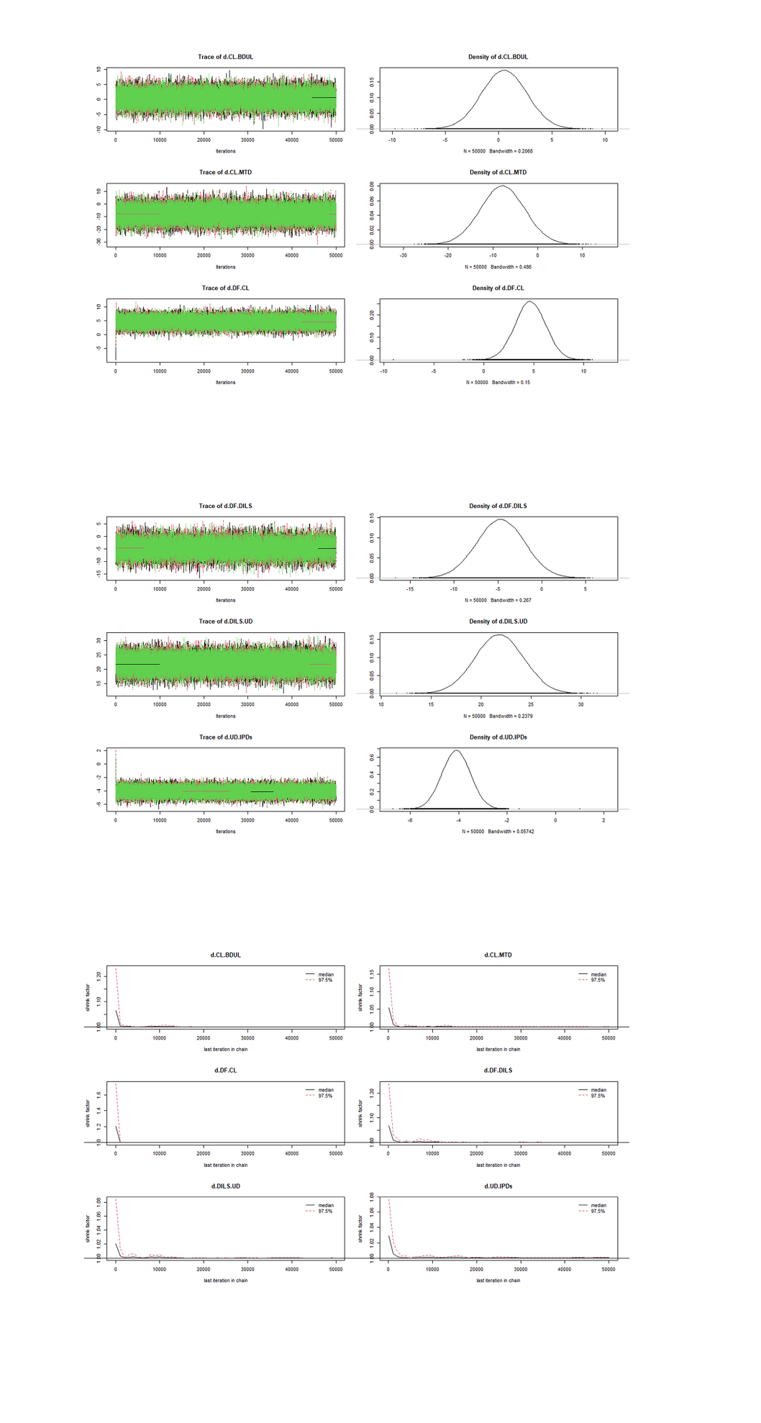
a
b
c
a、b：The history feature, density

c：The Brooks-Gelman-Rubin diagnostic

B. The history feature, density and the Brooks-Gelman-Rubin diagnostic for VAS -back pain

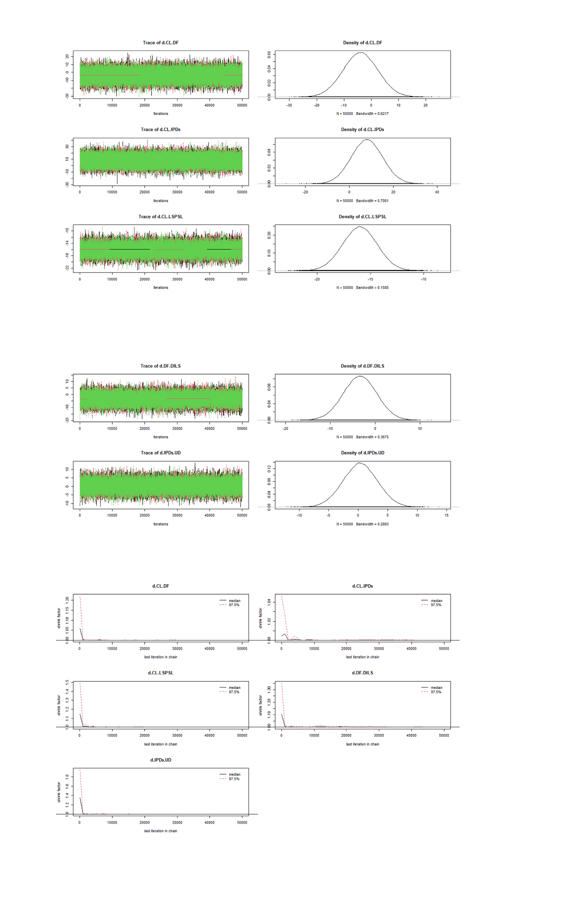
a
b
c
a、b：The history feature, density

c：The Brooks-Gelman-Rubin diagnostic

C. The history feature, density and the Brooks-Gelman-Rubin diagnostic for VAS -leg pain.
a
b
c
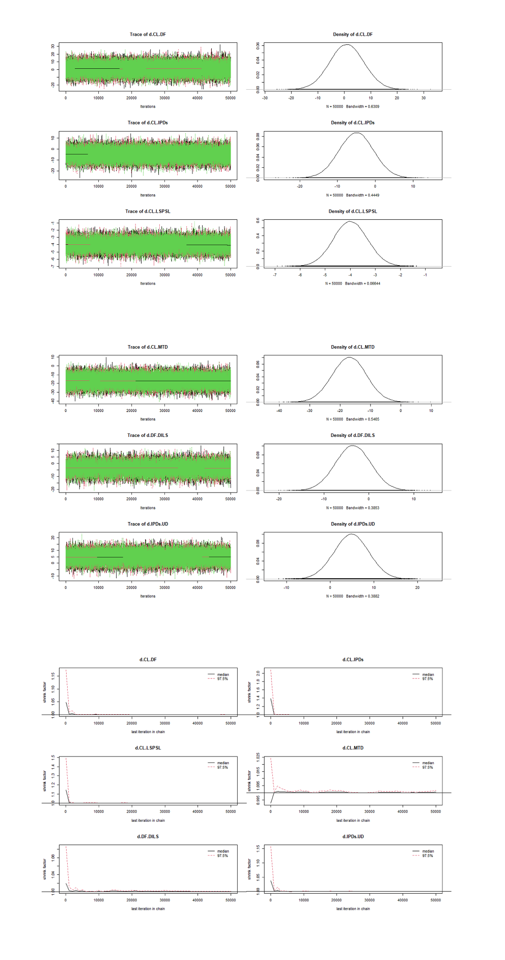
a、b：The history feature, density

c：The Brooks-Gelman-Rubin diagnostic

D. The history feature, density and the Brooks-Gelman-Rubin diagnostic for Complications
a
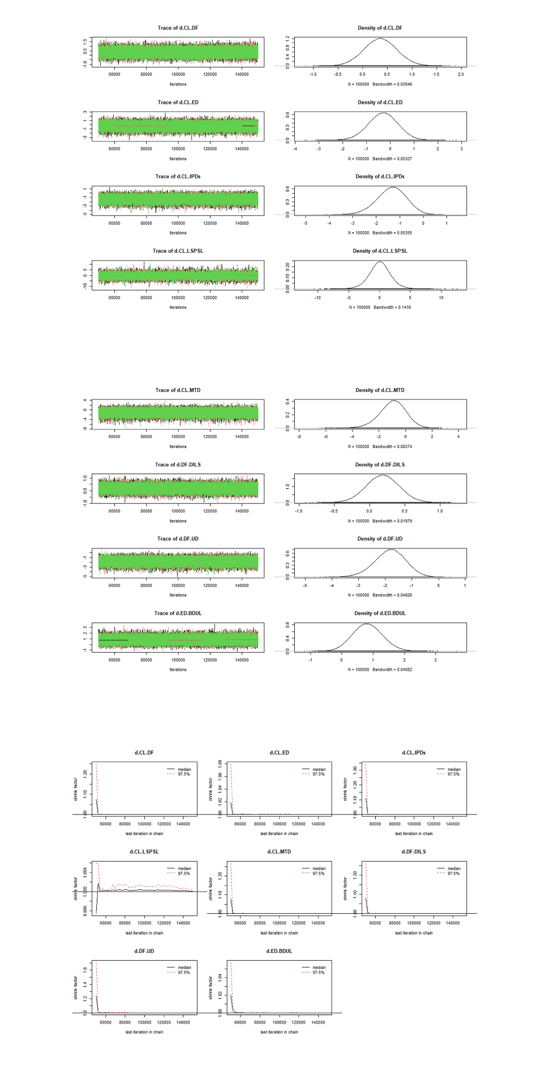
b
c
a、b：The history feature, density

c：The Brooks-Gelman-Rubin diagnostic

E. The history feature, density and the Brooks-Gelman-Rubin diagnostic for Blood loss
a
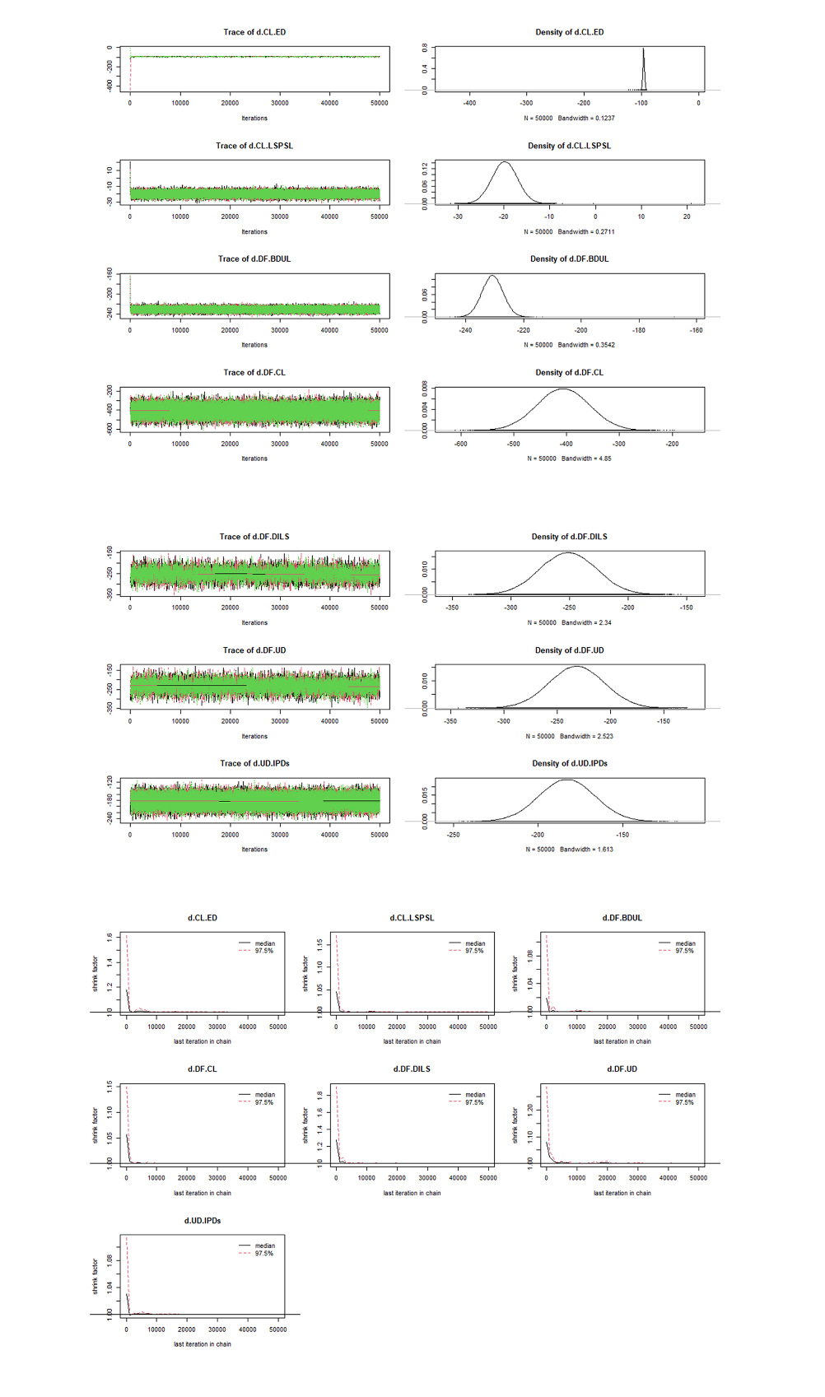
b
c
a、b：The history feature, density

c：The Brooks-Gelman-Rubin diagnostic

F. The history feature, density and the Brooks-Gelman-Rubin diagnostic for Operation time
a
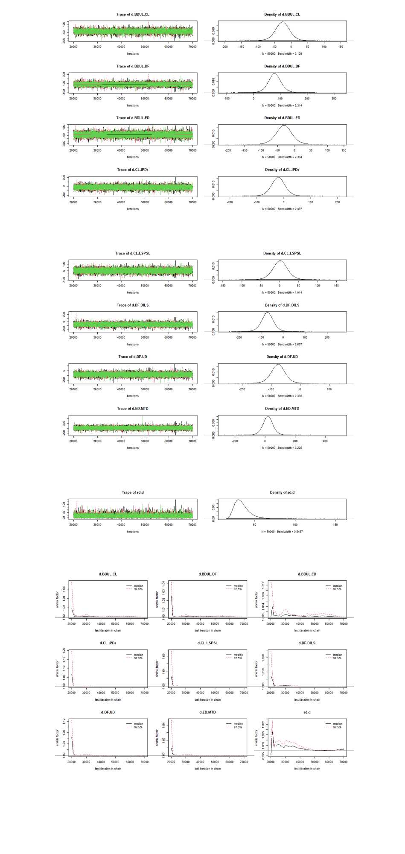
b
c
a、b、c：The history feature, density

d：The Brooks-Gelman-Rubin diagnostic
d

G. The history feature, density and the Brooks-Gelman-Rubin diagnostic for Reoperation
a
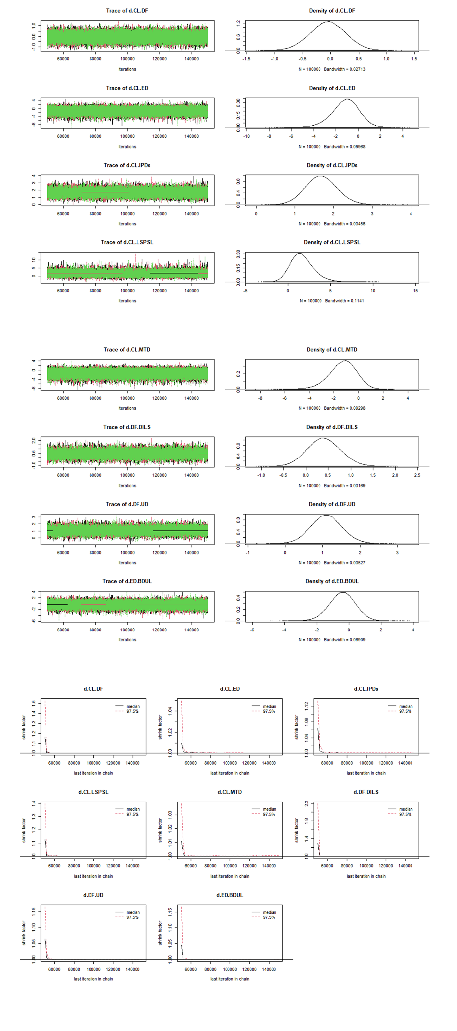
b
c
a、b：The history feature, density

c：The Brooks-Gelman-Rubin diagnostic

H. The history feature, density and the Brooks-Gelman-Rubin diagnostic for the duration of hospital stay
a
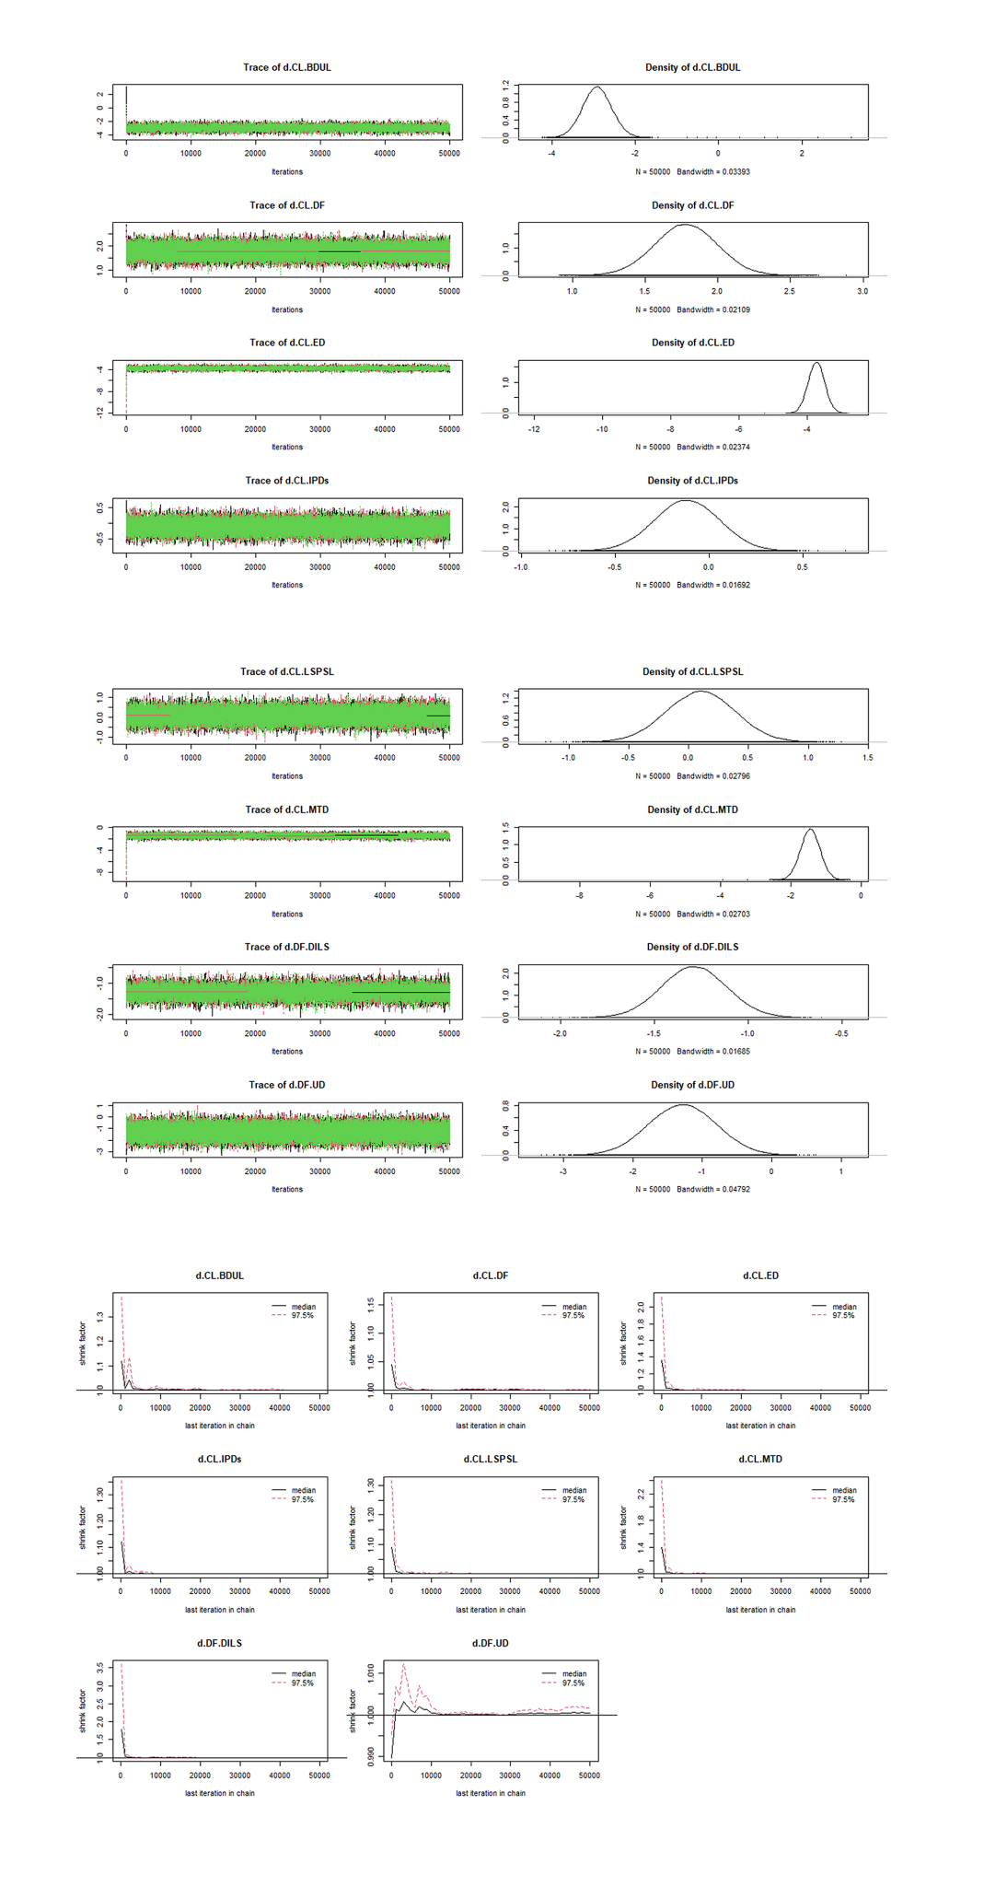
b
c
a、b：The history feature, density

c：The Brooks-Gelman-Rubin diagnostic

Figure S2 Assessment of transitivity


