Supplementary Figure Captions
Figure S1. Funnel plot for estimation of publication bias. (a) Female. (b) T4. (c) N1-2. (d) Poorly differentiated grade.
Figure S2. Funnel plot for estimation of publication bias. (a) Right-sided colon. (b) Left-sided colon. (c) Rectum. (d) NMC.
Figure S3. Funnel plot for estimation of publication bias. (a) MC. (b) SRCC. (c) Serum CA19-9. (d) PROK1/PROKR2.
Figure S4. Funnel plot for estimation of publication bias. (a) BRAF. (b) KRAS. (c) NRAS. (d) PIK3CA.
Figure S5. Funnel plot for estimation of the MSI-H/dMMR’s publication bias.
Figure S6. Begg and Mazumdar rank correlation coefficients.

Figure S1
a
b
c
d

Figure S2

a
b
c
d

a
b
c
d
Figure S3

Figure S4

a
b
c
d

Figure S5

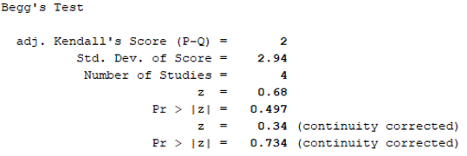
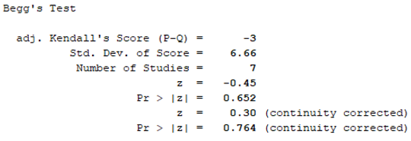
(1) Female (2) T4

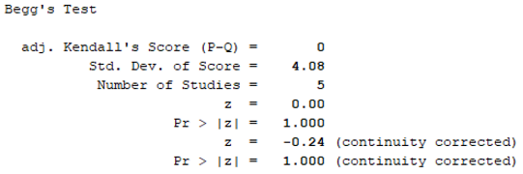
(3) N1-2 (4) Poorly differentiated grade
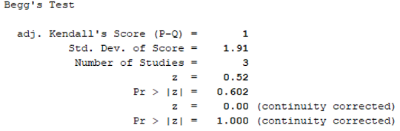

(5) Right-sided colon (6) Left-sided colon
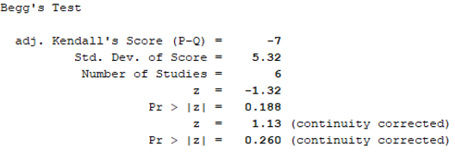
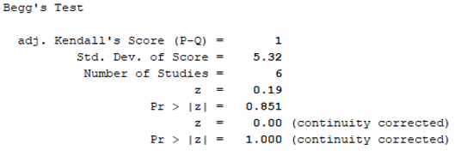

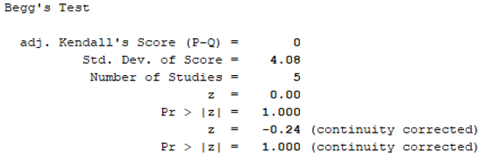
(7) Rectum (8) NMC
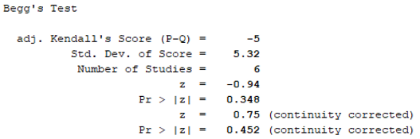

(9) MC (10) SRCC
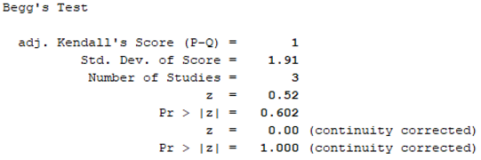
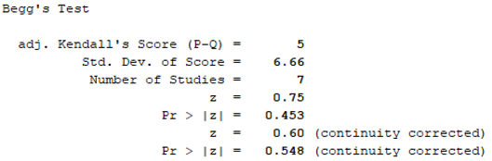

(11) Serum CA19-9 (12) PROK1/PROKR2
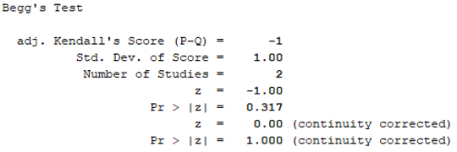
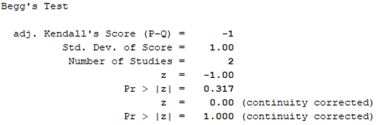

(13) BRAF (14) KRAS
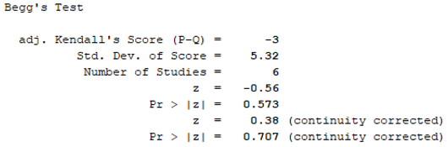
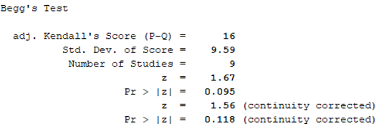

(15) NRAS (16) PIK3CA
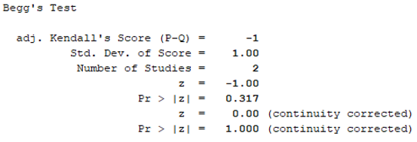
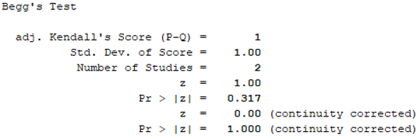

(17) MSI-H/dMMR
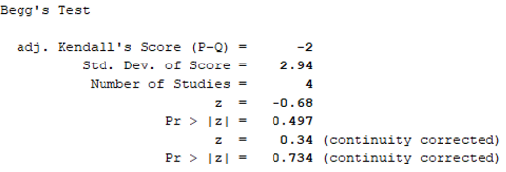

Figure S6

