Methods S1: Search strategy
Table S1. Study quality based on (Before-After (Pre-Post)) outlined by National Institutes of Health (NIH)
Table S2. Characteristics of studies include in this review
Table S3. The median time to first hematologic response
Table S4. The median time to best hematologic response
Table S5. Other adverse events in included studies
Table S6. Results of the random effects model in sensitivity analysis
Figure S1. Meta-analysis forest plot of overall response rate
Figure S2. Meta-analysis forest plot of complete remission
Figure S3. Meta-analysis forest plot of very good partial response
Figure S4. Meta-analysis forest plot of partial response
Figure S5. Meta-analysis forest plot of cardiac response
Figure S6. Meta-analysis forest plot of renal response
Figure S7. Meta-analysis forest plot of ≥ VGPR-intervention
Figure S8. Meta-analysis forest plot of ≥ VGPR-Mayo 2004
Figure S9. Meta-analysis forest plot of ≥ VGPR-Mayo 2004 ⅢA/B
Figure S10. Meta-analysis forest plot of ≥ VGPR-primary or secondary
Figure S11. Meta-analysis forest plot of ≥ VGPR-line of therapy
Figure S12. Meta-analysis forest plot of PFS-1 year or longer
Figure S13. Meta-analysis forest plot of OS-1 year or longer
Figure S14. Meta-analysis forest plot of Infusion related reaction-grade-1-2
Figure S15. Meta-analysis forest plot of Infusion related reaction-grade-3-4
Figure S16. Meta-analysis forest plot of complete remission
Figure S17. Meta-analysis forest plot of very good partial response
Figure S18. Meta-analysis forest plot of partial response
Figure S19. Meta-analysis forest plot of Renal response
Figure S20. Meta-analysis forest plot of Infusion related reaction-grade-3-4
Methods S1: Search strategy
- EMBASEe
- 'Daratumumab'/exp OR "humax CD38":ab,ti,kw OR darzalex:ab,ti,kw OR daratumumab:ab,ti,kw
- 'amyloidosis'/exp OR (amyloidos* OR amyloid NEAR/2 tumor OR amyloid NEAR/2 tumour OR amyloido* OR paraamyloidos* OR Muckle NEAR/3 Wells NEAR/3 syndrome OR amyloid NEAR/2 neuropathy OR familial NEAR/2 Mediterranean NEAR/2 fever OR familial NEAR/3 amyloid NEAR/3 polyneuropathy OR Amyloid NEAR/3 Neuropathies OR Amyloid NEAR/3 Angiopathy):ab,ti,kw
- #1 AND #2

- PubMed
- "daratumumab" [Supplementary Concept] OR Daratumumab[tw] OR "humax CD38"[tw] OR darzalex[tw]
- "Amyloidosis"[Mesh] OR amyloidos*[tiab] OR amyloid tumor[tiab] OR amyloid tumour[tiab] OR amyloido*[tiab] OR paraamyloidos*[tiab] OR Muckle Wells syndrome[tiab] OR amyloid neuropathy[tiab] OR familial Mediterranean fever[tiab] OR familial amyloid polyneuropathy[tiab] OR Amyloid Neuropathies[tiab] OR Amyloid Angiopathy[tiab]
- #1 AND #2

- Web of science
- TS=(Daratumumab OR "humax CD38" OR darzalex)
- TS=(amyloidos* OR amyloid NEAR/1 tumor OR amyloid NEAR/1 tumour OR amyloido* OR paraamyloidos* OR Muckle NEAR/1 Wells NEAR/1 syndrome OR amyloid NEAR/1 neuropathy OR familial NEAR/1 Mediterranean NEAR/1 fever OR familial NEAR/1 amyloid NEAR/1 polyneuropathy OR Amyloid NEAR/3 Neuropathies OR Amyloid NEAR/3 Angiopathy)
- #1 AND #2

- Cochrane library
#1 Daratumumab OR "humax CD38" OR darzalex
#2 MeSH descriptor: [Amyloidosis] explode all trees
#3 (amyloidos* OR amyloid NEAR/1 tumor OR amyloid NEAR/1 tumour OR amyloido* OR paraamyloidos* OR Muckle NEAR/1 Wells NEAR/1 syndrome OR amyloid NEAR/1 neuropathy OR familial NEAR/1 Mediterranean NEAR/1 fever OR familial NEAR/1 amyloid NEAR/1 polyneuropathy OR Amyloid NEAR/3 Neuropathies OR Amyloid NEAR/3 Angiopathy):ti,ab,kw
#4 #2 or #3
#5 #1 and #4
Table S1. Study quality based on (Before-After (Pre-Post)) outlined by National Institutes of Health (NIH)
Study ID |  | Abeykoon 2018 | Chung 2020 | Cohen 2020 | Dima 2020 | Fazio 2019 | Godara 2019 | Gounot 2020 | Jeryczynski 2021 | Kastritis 2019 | Kaufman 2017
Question/objective | ·Study question or objective clearly stated | Yes | Yes | Yes | Yes | Yes | Yes | Yes | Yes | Yes | Yes
Participants | ·Eligibility/selection criteria for the study population prespecified and clearly described | Yes | Yes | Yes | Yes | No | Yes | Yes | Yes | No | Yes
Participants | ·Participants in the study representative of those who would be eligible for the test/service/intervention in the general or clinical population of interest | Yes | Yes | Yes | NR | Yes | Yes | Yes | NR | Yes | Yes
Participants | ·All eligible participants that met the prespecified entry criteria enrolled | Yes | Yes | Yes | NR | NR | Yes | Yes | NR | Yes | Yes
Participants | ·Sample size sufficiently large to provide confidence in the findings | CD | CD | CD | CD | CD | CD | CD | CD | CD | CD
Participants | ·Test/service/intervention clearly described and delivered consistently across the study population | Yes | Yes | Yes | NA | NA | Yes | Yes | Yes | Yes | Yes
Outcomes | ·Outcome measures prespecified, clearly defined, valid, reliable, and assessed consistently across all study participants | Yes | Yes | Yes | CD | NA | Yes | Yes | Yes | Yes | No
Outcomes | ·People assessing the outcomes blinded to the participants' exposures/interventions | NR | NR | NR | NR | NR | NR | NR | NR | NR | NR
Outcomes | ·Loss to follow-up after baseline 20% or less, those lost to follow-up accounted for in the analysis | Yes | Yes | No | Yes | Yes | Yes | No | Yes | Yes | No
Statistical analysis | ·Statistical methods examine changes in outcome measures from before to after the intervention, statistical tests done that provided p values for the pre-to-post changes | No | No | No | No | No | No | No | No | No | No
Statistical analysis | ·Outcome measures of interest taken multiple times before the intervention and multiple times after the intervention (i.e., did they use an interrupted time-series design) | No | No | No | No | No | Yes | No | No | Yes | No
Statistical analysis | ·Intervention was conducted at a group level (e.g., a whole hospital, a community, etc.) did the statistical analysis take into account the use of individual-level data to determine effects at the group level | NA | NA | NA | NA | NA | NA | NA | NA | NA | NA

Study ID |  | Kennedy  2020 | Khouri 2018 | Kimmich 2020 | Kimmich 2021 | Kleman 2019 | Lecumberri 2020 | Lee  2018 | Lee  2019 | Milani 2020 | Ozga 2019
Question/objective | ·Study question or objective clearly stated | Yes | Yes | Yes | Yes | Yes | Yes | Yes | Yes | Yes | Yes
Participants | ·Eligibility/selection criteria for the study population prespecified and clearly described | Yes | Yes | Yes | No | Yes | Yes | Yes | Yes | Yes | Yes
Participants | ·Participants in the study representative of those who would be eligible for the test/service/intervention in the general or clinical population of interest | NR | Yes | Yes | NR | NR | Yes | NR | NR | Yes | NR
Participants | ·All eligible participants that met the prespecified entry criteria enrolled | NR | Yes | Yes | NR | NR | NR | NR | NR | Yes | NR
Participants | ·Sample size sufficiently large to provide confidence in the findings | CD | CD | CD | CD | CD | CD | CD | CD | CD | CD
Participants | ·Test/service/intervention clearly described and delivered consistently across the study population | NA | Yes | Yes | Yes | NA | No | Yes | Yes | Yes | NA
Outcomes | ·Outcome measures prespecified, clearly defined, valid, reliable, and assessed consistently across all study participants | CD | Yes | Yes | CD | CD | No | Yes | Yes | Yes | CD
Outcomes | ·People assessing the outcomes blinded to the participants' exposures/interventions | NR | NR | NR | NR | NR | NR | NR | NR | NR | NR
Outcomes | ·Loss to follow-up after baseline 20% or less, those lost to follow-up accounted for in the analysis | Yes | Yes | No | Yes | Yes | Yes | Yes | Yes | Yes | Yes
Statistical analysis | ·Statistical methods examine changes in outcome measures from before to after the intervention, statistical tests done that provided p values for the pre-to-post changes | No | No | No | No | Yes | No | No | No | No | No
Statistical analysis | ·Outcome measures of interest taken multiple times before the intervention and multiple times after the intervention (i.e., did they use an interrupted time-series design) | No | No | Yes | No | Yes | No | No | No | No | No
Statistical analysis | ·Intervention was conducted at a group level (e.g., a whole hospital, a community, etc.) did the statistical analysis take into account the use of individual-level data to determine effects at the group level | NA | NA | NA | NA | NA | NA | NA | NA | NA | NA

Study ID |  | Pick 2018 | Rahel 2019 | Ratermann 2019 | Riva 2019 | Rosko 2019 | Roussel 2020 | Sanchorawala 2020 | Shragai 2020 | Sidiqi 2019 | Wyngaert 2019
Question/objective | ·Study question or objective clearly stated | Yes | Yes | Yes | Yes | Yes | Yes | Yes | Yes | Yes | Yes
Participants | ·Eligibility/selection criteria for the study population prespecified and clearly described | Yes | Yes | Yes | Yes | Yes | Yes | Yes | Yes | Yes | Yes
Participants | ·Participants in the study representative of those who would be eligible for the test/service/intervention in the general or clinical population of interest | Yes | Yes | NR | NR | NR | Yes | Yes | Yes | NR | Yes
Participants | ·All eligible participants that met the prespecified entry criteria enrolled | Yes | Yes | NR | NR | NR | Yes | Yes | Yes | NR | Yes
Participants | ·Sample size sufficiently large to provide confidence in the findings | CD | CD | CD | CD | CD | Yes | CD | CD | CD | CD
Participants | ·Test/service/intervention clearly described and delivered consistently across the study population | No | Yes | NA | Yes | Yes | Yes | Yes | Yes | NA | Yes
Outcomes | ·Outcome measures prespecified, clearly defined, valid, reliable, and assessed consistently across all study participants | Yes | Yes | CD | Yes | No | Yes | Yes | Yes | CD | Yes
Outcomes | ·People assessing the outcomes blinded to the participants' exposures/interventions | NR | NR | NR | NR | NR | NR | NR | NR | NR | NR
Outcomes | ·Loss to follow-up after baseline 20% or less, those lost to follow-up accounted for in the analysis | Yes | Yes | Yes | Yes | Yes | Yes | Yes | Yes | Yes | Yes
Statistical analysis | ·Statistical methods examine changes in outcome measures from before to after the intervention, statistical tests done that provided p values for the pre-to-post changes | No | No | No | No | No | No | No | No | No | No
Statistical analysis | ·Outcome measures of interest taken multiple times before the intervention and multiple times after the intervention (i.e., did they use an interrupted time-series design) | No | No | No | No | No | No | No | No | No | No
Statistical analysis | ·Intervention was conducted at a group level (e.g., a whole hospital, a community, etc.) did the statistical analysis take into account the use of individual-level data to determine effects at the group level | NA | NA | NA | NA | NA | NA | NA | NA | NA | NA
Notes:
CD = cannot determine; NA = not applicable; NR = not reported

Table S2. Characteristics of studies include in this review
Ref nubmer | Study ID | Country | Centre | Newly diagnosed or relapsed | Total sample size, n | Gender, n | Mayo Stage 2012 n | Type of AL,  n | Age  (years)  Media (range) | Involved organs,  n | eGFR  (mL/min/ m²) | dFLC  (mg/L)  Media (range) | Lines of therapy Media (range) | Intervention | n of infusions  Median  (range) | Outcome
22 | Abeykoon 2018 | USA | Single | Relapsed and/or refractory | Arm 1: 22 | NR | Ⅰ: 2  Ⅱ: 7  Ⅲ: 7  Ⅳ: 4 | NR | NR | Heart: 14  Kidney: 11  Liver: 2 | NR | 70  (10–700) | 4 (2–6) | Dara ± dex | 8.0 (2–24) | HR  OR  SUR  AE
 |  |  |  |  | Arm 2: 22 | NR | Ⅰ: 1  Ⅱ: 12  Ⅲ: 5  Ⅳ: 2 | NR | NR | Heart: 13  Kidney: 11  Liver: 1 | NR | 101  (6–3010) | 4 (2–9) | Mixed* | 8.0 (2–24) | HR  OR  SUR  AE
22–24 | Chung 2020 | USA | Single | NR | 72 | Male: 44  Female: 28 | 2004  Ⅰ: 10  Ⅱ: 37  ⅢA: 12  ⅢB: 5 | λ: 54  k: 18 | 67  IQR  (60–72) | Heart: 57  Kidney: 47  Liver: 5  Heart and kidney: 35 | NR | 34.5  IQR  (18–107) | 3  IQR (2–4) | Dara ± dex | 24 weeks + a maintenance dose Q4W | HR  OR  SUR  AE
25–26 | Cohen 2020 | UK | NR | Relapsed/refractory | 53 | Male: 34  Female: 19 | 2004  Ⅰ: 11  Ⅱ: 19  ⅢA: 18  ⅢB: 5 | λ: 36  k: NR | 68  (42–85) | Heart: 39  Kidney: 30  Liver: 14 | 51.5 (15–90) | 78.9  (0.3–4897) | 4 (2–5) | Dara ± dex | NR | HR  OR  SUR  AE
27 | Dima 2020 | USA | Single | NR | 40 | Male: 22  Female: 18 | NR | NR | 66  (35–80) | Heart: 30  Kidney: 20  Other: 12 | NR | NR | 1: 10  2–3: 15  >3: 15 | Dara ± dex + McAb | NR | HR  OR  SUR  AE
28 | Fazio 2019 | Italy | Single | Relapsed/refractory | 46 | Male: 27  Female: 19 | NR | NR | 62  (34–79) | Heart: 33  Kidney: 31 | NR | NR | 4 (2–10) | Mixed | NR | HR  OR  SUR  AE
29–30 | Godara 2019 | USA | Single | N + R | Arm 1: 9 | Male: 4  Female: 5 | 2004  Ⅱ: 3  Ⅲ: 5 | λ: 8  k: 1 | 68  (52–75) | Heart: 8  Kidney: 4 | NR | NR | 4 (2–6) | Dara ± dex + McAb | 258 (47–637) days | HR  OR  SUR  AE
 |  |  |  |  | Arm 2: 10 | Male: 8  Female: 2 | 2004  Ⅰ: 0  Ⅱ: 10  Ⅲ: 0 | λ: 7  k: 3 | 66.5  (54–74) | Heart: 7  Kidney: 8 | NR | NR | 2 (2–4) | Dara ± dex | NR | HR  OR  SUR  AE
31–32 | Gounot 2020 | France | Single | N + R | 25 | Male: 18  Female: 7 | 2004  Ⅰ: 0  Ⅱ: 0  Ⅲ: 25 | λ: 20  k: NR | 65  (52–83) | Heart: 25  Kidney: 12  Liver: 2  Pulmonary: 1 | 34.8  (10.5–76.5) | 108.6  (37.6–1100.7) | 2 (1–5) | Mixed | 4  (0.25–11) | HR  OR  SUR  AE
34–35 | Jeryczynski 2021 | Austria | Single | Newly diagnose | Arm 1: 7 | Male: 5  Female: 2 | Ⅰ: 1  Ⅱ: 1  Ⅲ: 1  Ⅳ: 4 | λ: 7  k: 0 | 71.8  (49–80.7) | Heart: 6  Kidney: 4  Other: 1 | NR | 276.9  (100.6–2924.4) | 1 | Dara ± dex | 16 (3–21) | HR  OR
 |  |  |  |  | Arm 2: 7 | Male: 4  Female: 3 | Ⅰ: 1  Ⅱ: 1  Ⅲ: 2  Ⅳ: 3 | λ: 5  k: 2 | 62.7  (47.8–80.3) | Heart: 5  Kidney: 5  Other: 1 | NR | 223.5  (21–954.6) | 1 | Mixed | 16 (3–21) | HR  OR
36 | Kastritis 2019 | NR | NR | NR | 23 | NR | NR | λ: 19  k: NR | NR | NR | NR | NR | NR | Dara ± dex | 4 | HR
37–38 | Kaufman 2017 | USA | Single | Refractory diagnose | 25 | Male: 17  Female: 8 | 2004  Ⅰ: 4  Ⅱ: 11  Ⅲ: 10 | NR | 66  (50–76) | Heart: 18  Kidney: 17 | 47(10–90) | 74  (4–280) | 4 (2–6) | Dara ± dex | 12 (3–35) | HR  SUR  AE
39 | Kennedy 2020 | USA | Single | Newly diagnose | 14 | Male: 7  Female: 7 | 2004  I: 1  Ⅱ: 2  Ⅲ: 11 | λ: 7  k: NR | 69  (45–87) | Heart: 14  Kidney: 14 | NR | NR | 1 | Mixed | 5 (1–14) | HR  OR  AE
40–41 | Khouri 2018 | USA | Multi | Relapsed | 20 | Male: 10  Female: 10 | NR | NR | 67  (40–88) | Heart: 10  Kidney: 7  Tongue: 4 | NR | 88.7  (13.8–680) | 4 (2–11) | Dara ± dex | 17 (6–34) | HR  SUR  AE
42–43 | Kimmich 2020 | Germany | Multi | N + R | Arm 1: 106 | Male: 73  Female: 33 | NR | λ: 90  k: NR | 65  (36–81) | Heart: 88  Kidney: 67  Liver: 15 | 51.5  (12–126) | 236  (22–9600) | 3 (2–8) | Dara ± dex | 14 (2–35) | HR  OR  SUR  AE
 |  |  |  |  | Arm 2: 62 | Male: 33  Female: 29 | NR | λ: 47  k: NR | 60  (38–79) | Heart: 54  Kidney: 40  Liver: 15 | 53.5  (11– 106) | 247  (0–2237) | 2 (2–8) | DVd | 14 (1–29) | HR  OR  SUR  AE
44 | Kimmich 2021 | Germany | Multi | NR | 44 | Male: 31  Female: 13 | NR | NR | 62  (50–80) | Heart: 34  Kidney: 26  Liver: 3 | NR | 102  (0–3394) | 2: 27  3: 11  4: 6 | DRd | 17 (2–38) | HR  OR  SUR  AE
45 | Kleman 2019 | USA | Multi | N + R | 42 | Male: 26  Female: 16 | Ⅰ–Ⅱ: 18  Ⅲ–Ⅳ: 24 | NR | 67  (42–91) | Heart: 32  Kidney: 18 | NR | NR | 2 (1–8) | Mixed | 6.8 (0–22) months | SUR
16 | Lecumberri 2020 | Spain | Multi | Relapsed/refractory | 38 | Male: 23  Female: 15 | Ⅰ: 6  Ⅱ: 9  Ⅲ: 12  Ⅳ: 10 | NR | NR | Heart: 29  Kidney: 28 | NR | 150  (6–2389) | 3 (2–9) | Mixed | 18 (1–38) | HR  OR  SUR  AE
46–47 | Lee 2019 | USA | NR | Relapsed/refractory | 17 | NR | NR | NR | NR | Heart: 11  Kidney: 12 | 34  (0–98)  n = 12* | NR | 4 (2–6) | Dara ± dex | NR | HR  OR  SUR
48 | Lee 2018 | USA | NR | Relapsed/refractory | 10 | Male: 8  Female: 2 | NR | NR | 67  (38–75) | Cardiad/Renal  GI/Lung  and/or bone marrow | NR | NR | 2 | Mixed | 5 (1–9) | HR  OR  AE
49–50 | Milani 2020 | Italy | Multi | Relapsed/refractory | 72 | Male: 45  Female: 27 | NR | NR | 62  (37–79) | Heart: 49  Kidney: 49  Liver: 3 | NR | 118  IQR  (55–1099) | 3 (2–10) | Mixed | 28  (Living patients) | HR  OR  SUR  AE
51 | Ozga 2019 | USA | Single | NR | 20 | NR | NR | NR | NR | NR | NR | NR | NR | Dara ± dex | NR | HR  SUR
52 | Pick 2018 | Israel | Single | Refractory diagnose | 4 | Male: 2  Female: 2 | NR | λ: 2  k: 2 | 58  (51–75) | NR | NR | NR | 6 (2–10) | Mixed | NR | HR  AE
17 | Rahel 2019 | Swiss | Multi | Relapsed/refractory | 10 | Male: 8  Female: 2 | Ⅰ: 0  Ⅱ: 3  Ⅲ: 5  Ⅳ: 2 | NR | 62.3  (39.7–73.2) | Heart: 10  Kidney: 6 | 73  (25–108) | 191  (40–1382) | 4 (2–6) | Dara ± dex | 18  (8–23) | HR  OR  AE
53 | Ratermann 2019 | USA | Single | Newly diagnose | Arm 1: 2 | NR | NR | NR | NR | NR | NR | NR | 1 | DCd | NR | HR
 |  |  |  | Relapsed/refractory  Relapsed/refractory | Arm 2: 2  Arm 3: 1 | NR  NR | NR  NR | NR  NR | NR  NR | NR  NR | NR  NR | NR  NR | NR  NR | DRd  Dara ± dex | NR  NR | HR  HR
54 | Riva 2019 | Italy | Single | Refractory diagnose | 10 | Male: 6  Female: 4 | NR | λ: 9  k: 1 | 63.2  (53–77) | Heart: 2  Kidney: 1  Heart and renal: 6 | <50: n = 4 | 4640  (280–23530) | ≥ 2 | Dara ± dex | NR | HR  AE
55 | Rosko 2019 | USA | NR | NR | 27 | Male: 15  Female: 12 | NR | NR | 72 | Heart: 17  Kidney: 14 | NR | NR | NR | Dara ± dex | NR | AE
2, 33, 56–57 | Roussel 2020 | 14 centers# and Italy | Multi | Refractory diagnose | 40 | Male: 25  Female: 15 | 2004  Ⅰ: 11  Ⅱ: 10  ⅢA: 19 | λ: 30  k: NR | 69  (45–83) | Heart: 24  Kidney: 26  Liver: 4 | NR | 164  IQR  (112–334) | 4  IQR (2.75–4) | Dara ± dex | ≥ 6 cycles  82.5% patients | HR  OR  SUR  AE
58–60 | Sanchorawala 2020 | USA | Single | Refractory diagnose | 22 | Male: 16  Female: 6 | NR | λ: 17  k: NR | 63  (42–83) | Heart: 14  Kidney: 15 | 58  (20–112) | 80.7  (2.9–854) | 3 (2–8) | Dara ± dex | 31 (7–34) | HR  OR  SUR  AE
61 | Shragai 2020 | Israel | Multi | Relapsed/refractory | 49 | Male: 30  Female: 19 | NR | λ: 29  k: 20 | 62  (47–90) | Heart: 35  Kidney: 28  Liver: 7  Other: 6 | NR | 134  IQR  (68–279) | 2 (2–7) | Mixed | 8 (1–28) | HR  OR  SUR  AE
62 | Sidiqi 2019 | USA | Single | Refractory diagnose | 9 | Male: 6  Female: 3 | Ⅰ: 3  Ⅱ: 3  Ⅲ: 1  Ⅳ: 1 | NR | 65  (51–73) | NR | NR | NR | ≥ 2 | Unclear  (Dara based) | 10.2 month | HR  SUR
63–64 | Wyngaert 2019 | France | Multi | Relapsed/refractory | 15 | Male: 10  Female: 5 | NR | λ: NR  k: 7 | 60  IQR  (47–67) | Heart: 10  Kidney: 9  Liver: 5  Spleen 2  UAT: 4  Lung: 2  Muscle: 1 | 37  IQR  (35–48) | 121  IQR  (69–967) | 3 (2–6) | Dara ± dex | 12  (0.25–19) | HR  OR  SUR  AE
Notes:
AE = adverse event; Dara ± dex = Daratumumab ± Dexamethasone, Dara + McAb = Daratumumab + NEOD001, DVd = Daratumumab + Bortezomib + Dexamethasone, DRd = Daratumumab + Lenalidomide + Dexamethasone, DCd = Daratumumab + Cyclophosphamide + Dexamethasone, eGFR = estimated glomerular filtration rate, HR = hematologic response, IQR = interquartile range, N + R = newly diagnosed and relapsed, NR = not reported, OR = organ response, SUR = survival
*Mixed Daratumumab–based treatments indicate there were more than one kind of daratumumab–based treatment in the study (daratumumab may be combined with dexamethasone, bortezomib, lenalidomide, pomalidomide, cyclophosphamide, ixazomid, carfilzomib, etc.)

Table S3. The median time to first hematologic response
Study ID | Intervention | Median (days) | Range or 95% CI | Total (n)
Abeykoon 2018 | Dara ± dex | 78 | 95% CI (51, 186) | 14
Cohen 2020 | Dara ± dex | 30 | Range (30－180) | 50
Godara 2019 | Dara ± dex | 75 | Range (28－250) | 10
Khouri 2018 | Dara ± dex | 28 | Not reported | 15
Kimmich 2020 | Dara ± dex | 49 | Range (5－287) | 32
Roussel 2020 | Dara ± dex | 7 | Not reported | 40
Sanchorawala 2020 | Dara ± dex | 53 | Not reported | 22
Godara 2019 | Dara + McAb | 33 | Range (19－161) | 9
Chung 2020 | Dara ± dex | 30 | Not reported | 52
Lecumberri 2020 | Dara ± dex | 14 | Range (7－84) | 36
Rahel 2019 | Dara ± dex | 14 | Range (7－28) | 10
Abeykoon 2018 | Mixed* | 57 | 95% CI (27, 102) | 16
Dima 2020 | Mixed | 45 | 95% CI (30, 60) | 40
Gounot 2020 | Mixed | 45 | Range (1－4) | 23
Jeryczynski 2021 | Mixed | 42 | Rang (6－249) | 14
Kennedy 2020 | Mixed | 11 | Range (7－61) | 14
Wyngaert 2019 | Dara ± dex | 28 (mean, days) | Not reported | 14
Notes:
Dara ± dex = Daratumumab ± Dexamethasone, Dara + McAb = Daratumumab + NEOD001
*Mixed Daratumumab-based treatments indicate there were more than one kind of daratumumab-based treatment in the study (daratumumab may be combined with dexamethasone, bortezomib, lenalidomide, pomalidomide, cyclophosphamide, ixazomid, carfilzomib, etc.)

Table S4. The median time to best hematologic response
Study ID | Intervention | Median (days) | Range or 95% CI | Total (n)
Abeykoon 2018 | Dara ± dex | 186 | 95% CI (132, 267) | 14
Lee 2019 | Dara ± dex | 81 | Not reported | 17
Sanchorawala 2020 | Dara ± dex | 90 | Range (90－360) | 22
Wyngaert 2019 | Dara ± dex | 70 | Range (28－350) | 14
Kaufman 2017 | Dara ± dex | 30 | Range (7－188) | 25
Lecumberri 2020 | Dara ± dex | 60 | Range (30－330) | 36
Rahel 2019 | Dara ± dex | 73 | Range (7－301) | 10
Abeykoon 2018 | Mixed* | 171 | 95% CI (69, 366) | 16
Gounot 2020 | Mixed | 75 | Range (30－150) | 23
Jeryczynski 2021 | Mixed | 336 | Range (15－630) | 14
Kennedy 2020 | Mixed | 46 | Range (9.8－168) | 14
Shragai 2020 | Mixed | 60 | Range (15－300) | 48
Notes:
Dara ± dex = Daratumumab ± Dexamethasone
*Mixed Daratumumab-based treatments indicate there were more than one kind of daratumumab-based treatment in the study (daratumumab may be combined with dexamethasone, bortezomib, lenalidomide, pomalidomide, cyclophosphamide, ixazomid, carfilzomib, etc.)

Table S5. Other adverse events in included studies
Adverse event | Study ID | Intervention | Event | Total (n) | Percentage (%)
Cardiovascular toxicity | Shragai 2020 | Mixed* | 4 | 48 | 8.3
Dyspnea | Shragai 2020 | Mixed | 4 | 48 | 8.3
Peripheral neuropathy | Shragai 2020 | Mixed | 4 | 48 | 8.3
Large bowel perforation related to colitis | Kimmich 2021 | DRd | 3 | 44 | 6.8
Cutaneous rash | Roussel 2020 | Dara ± dex | 2 | 40 | 5.0
Gastrointestinal bleeding | Sanchorawala 2020 | Dara ± dex | 1 | 22 | 4.5
Increased creatinine | Sanchorawala 2020 | Dara ± dex | 1 | 22 | 4.5
Skin abscesses | Kimmich 2020 | DRd | 2 | 44 | 4.5
Hypersensitivity reaction | Shragai 2020 | Mixed | 2 | 48 | 4.2
Renal toxicity | Shragai 2020 | Mixed | 2 | 48 | 4.2
Spontaneous pneumothorax | Kaufman 2017 | Dara ± dex | 1 | 25 | 4.0
Decompensated heart failure | Kaufman 2017 | Dara ± dex | 1 | 25 | 4.0
Fall | Cohen 2020 | Dara ± dex | 2 | 53 | 3.8
Fluid overload | Cohen 2020 | Dara ± dex | 2 | 53 | 3.8
Other | Kimmich 2020 | Dara ± dex, DVd | 5 | 168 | 3.0
Acute renal failure and hypokalaemia | Lecumberri 2020 | Mixed | 1 | 38 | 2.6
Leucopenia | Roussel 2020 | Dara ± dex | 1 | 40 | 2.5
Orthostatic hypotension | Roussel 2020 | Dara ± dex | 1 | 40 | 2.5
Septic shock-lethal infection | Dima 2020 | Mixed | 1 | 40 | 2.5
Anaemia | Abeykoon 2018 | Mixed | 1 | 44 | 2.3
Hematologic toxicity | Kimmich 2021 | DRd | 1 | 44 | 2.3
Nausea/vomiting | Shragai 2020 | Mixed | 1 | 48 | 2.1
Thrombocytopenia | Cohen 2020 | Dara ± dex | 0 | 53 | 0.0
 | Kimmich 2020 | Dara ± dex, DVd | 1 | 149 | 0.7
 | Milani 2020 | Mixed | 2 | 72 | 2.8
Blurred vision | Cohen 2020 | Dara ± dex | 0 | 53 | 0.0
Cellulitis | Dima 2020 | Mixed | 0 | 40 | 0.0
Hypertension | Cohen 2020 | Dara ± dex | 0 | 53 | 0.0
Insomnia | Cohen 2020 | Dara ± dex | 0 | 53 | 0.0
Nausea | Cohen 2020 | Dara ± dex | 0 | 53 | 0.0
Polyneuropathy | Kimmich 2020 | Dara ± dex, DVd | 0 | 168 | 0.0
Viral gastroenteritis | Dima 2020 | Mixed | 0 | 40 | 0.0
Note:
Dara ± dex = Daratumumab ± Dexamethasone, DVd = Daratumumab + Bortezomib + Dexamethasone, DRd = Daratumumab + Lenalidomide + Dexamethasone
*Mixed Daratumumab-based treatments indicate there were more than one kind of daratumumab-based treatment in the study (daratumumab may be combined with dexamethasone, bortezomib, lenalidomide, pomalidomide, cyclophosphamide, ixazomid, carfilzomib, etc.)

Table S6. Results of the random effects model in sensitivity analysis
Outcome or Subgroup | Studies | Patients (n) | Effect Estimate | I²
Overall response rate | 26 | 786 | 0.81 [0.76, 0.85] | 45%
Partial response | 19 | 544 | 0.17 [0.12, 0.22] | 47%
≥ VGPR-intervention
Dara +/- dexamethasone | 16 | 387 | 0.66 [0.59, 0.73] | 39%
Triple regimens | 3 | 89 | 0.72 [0.56, 0.84] | 35%
≥ VGPR-Mayo 2004
Mayo Ⅰ | 1 | 10 | 0.40 [0.12, 0.74] | —
Mayo Ⅱ | 3 | 38 | 0.73 [0.57, 0.85] | 0%
Mayo Ⅲ | 3 | 54 | 0.70 [0.66, 1.00] | 48%
PFS-1 year or longer | 3 | 126 | 0.58 [0.45, 0.69] | 46%
OS-1 year or longer | 11 | 534 | 0.78 [0.73, 0.82] | 31%
Infusion related reaction-grade -3-4 | 10 | 437 | 0.03 [0.02, 0.06] | 0%

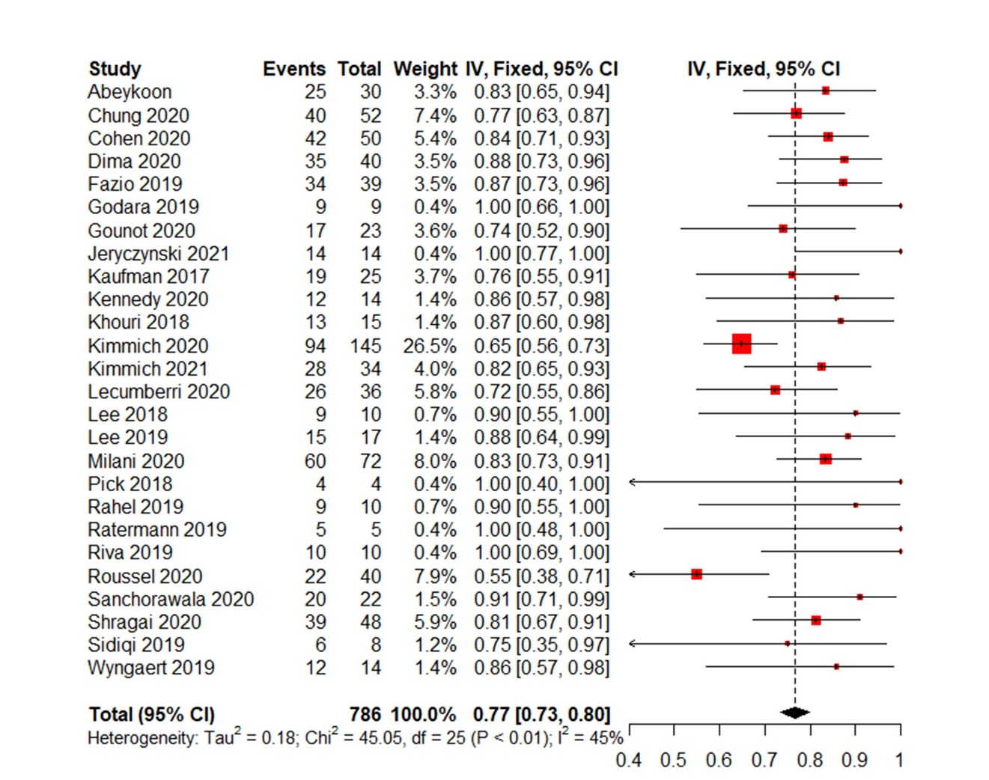
Figure S1. Meta-analysis forest plot of overall response rate
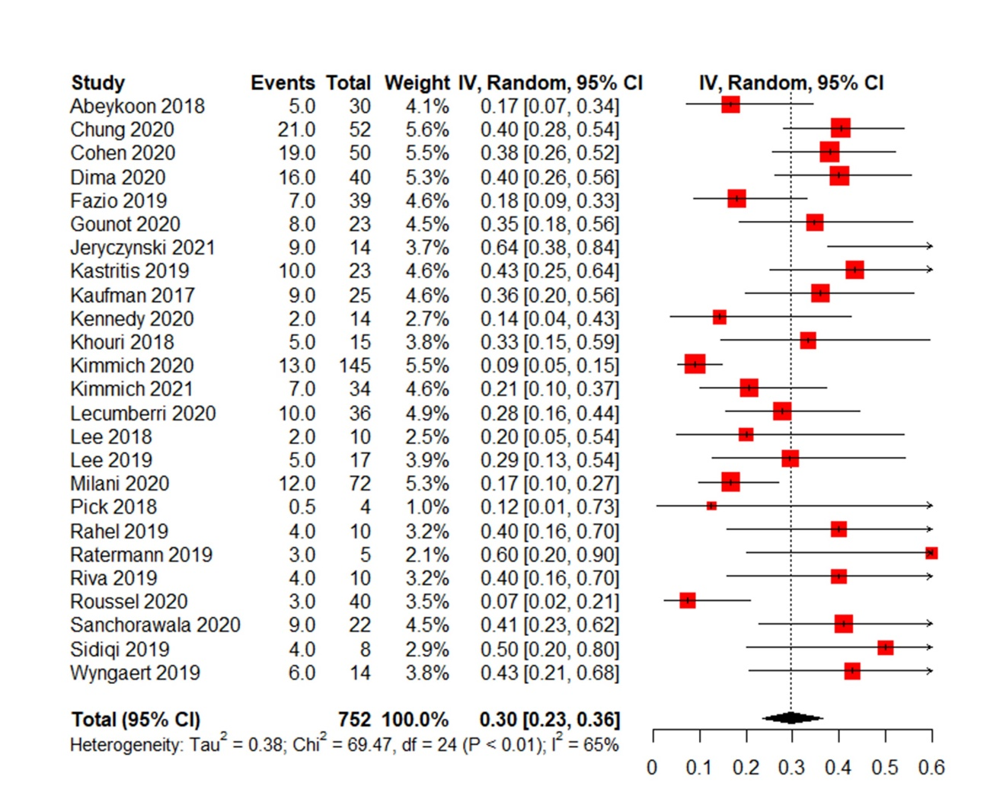
Figure S2. Meta-analysis forest plot of complete remission
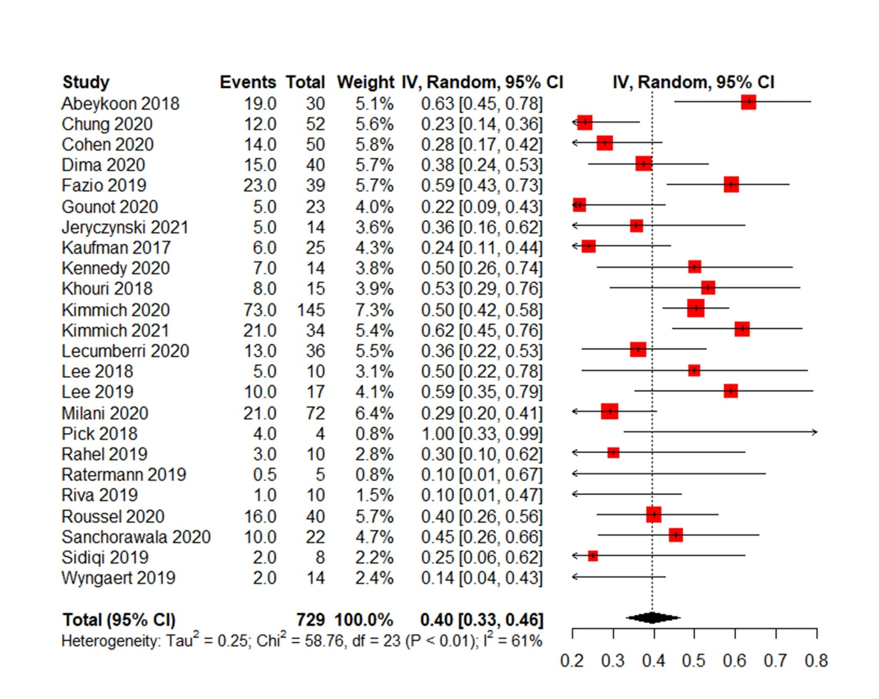
Figure S3. Meta-analysis forest plot of very good partial response
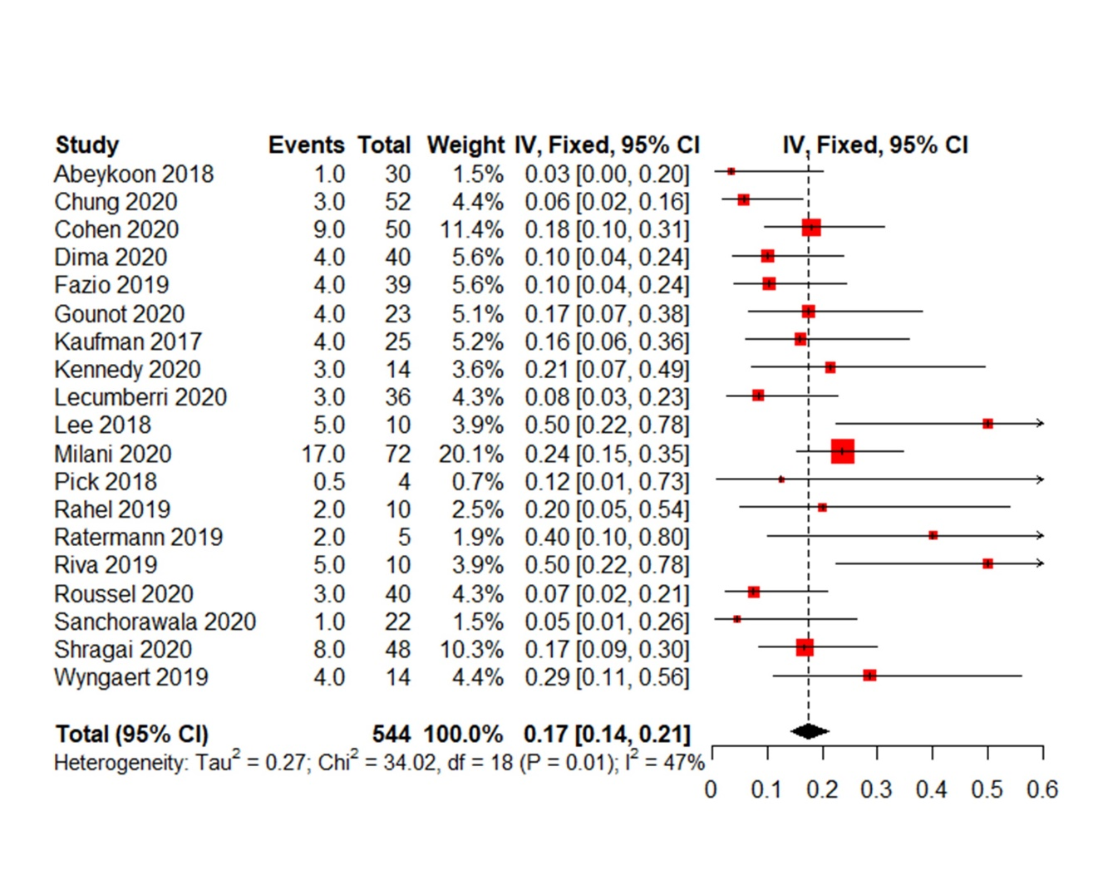
Figure S4. Meta-analysis forest plot of partial response
Figure S5. Meta-analysis forest plot of cardiac response
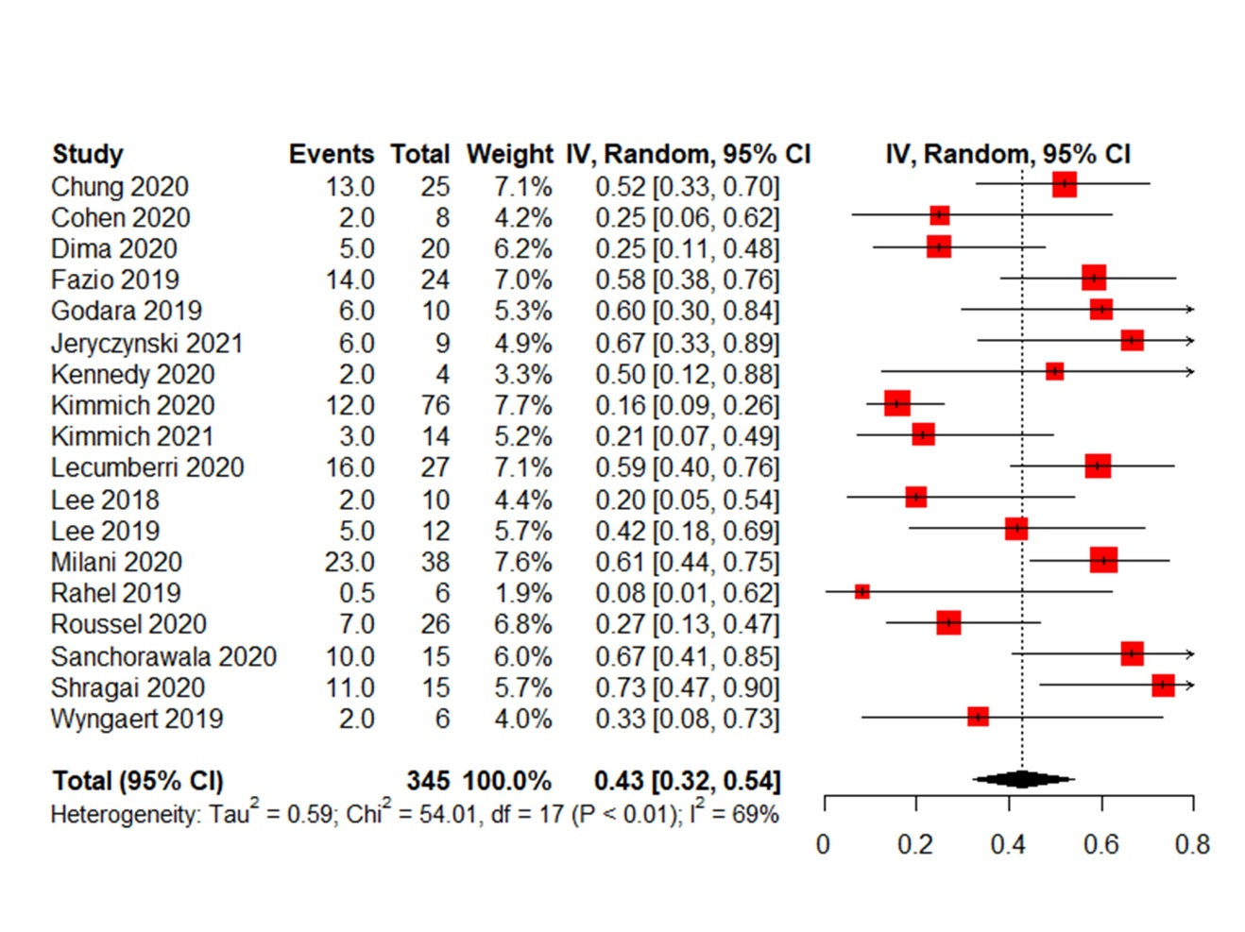
Figure S6. Meta-analysis forest plot of renal response
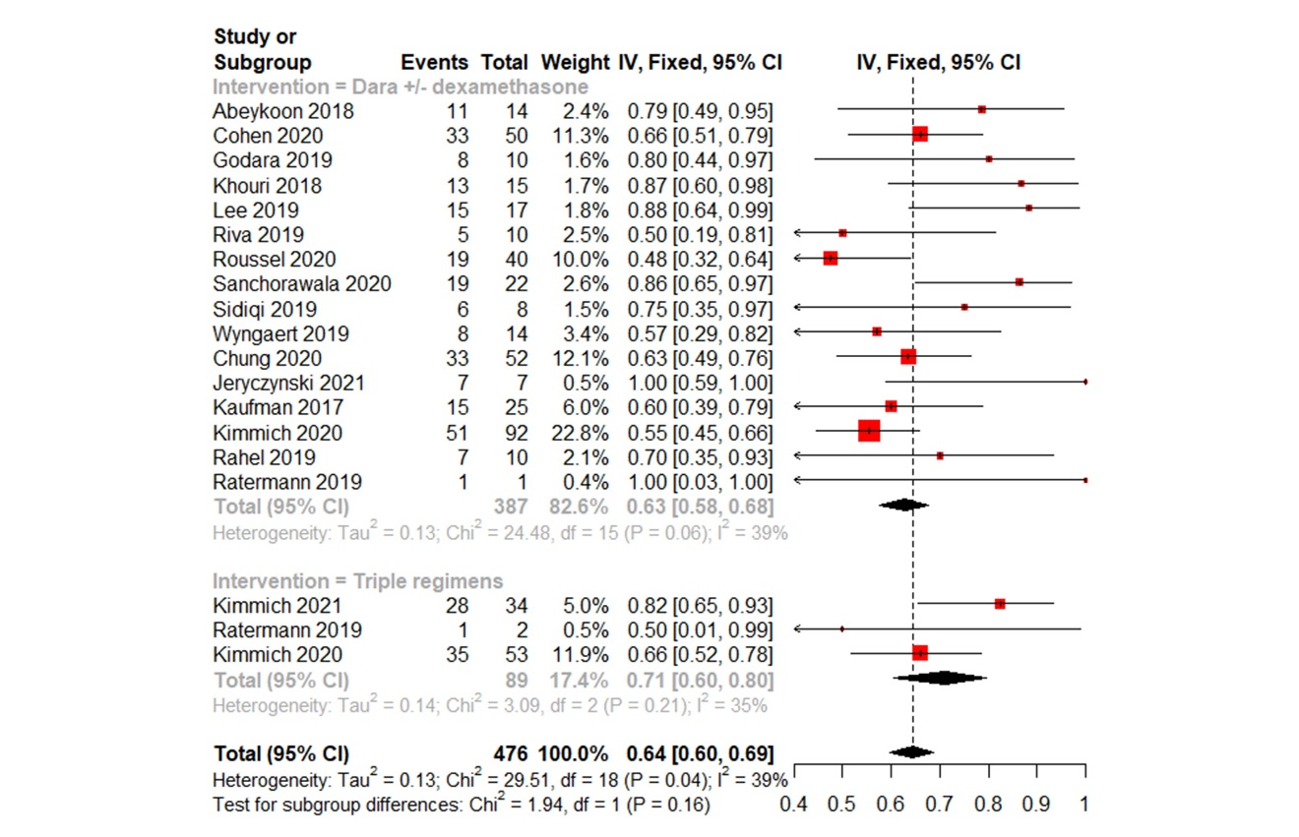
Figure S7. Meta-analysis forest plot of ≥ VGPR-intervention
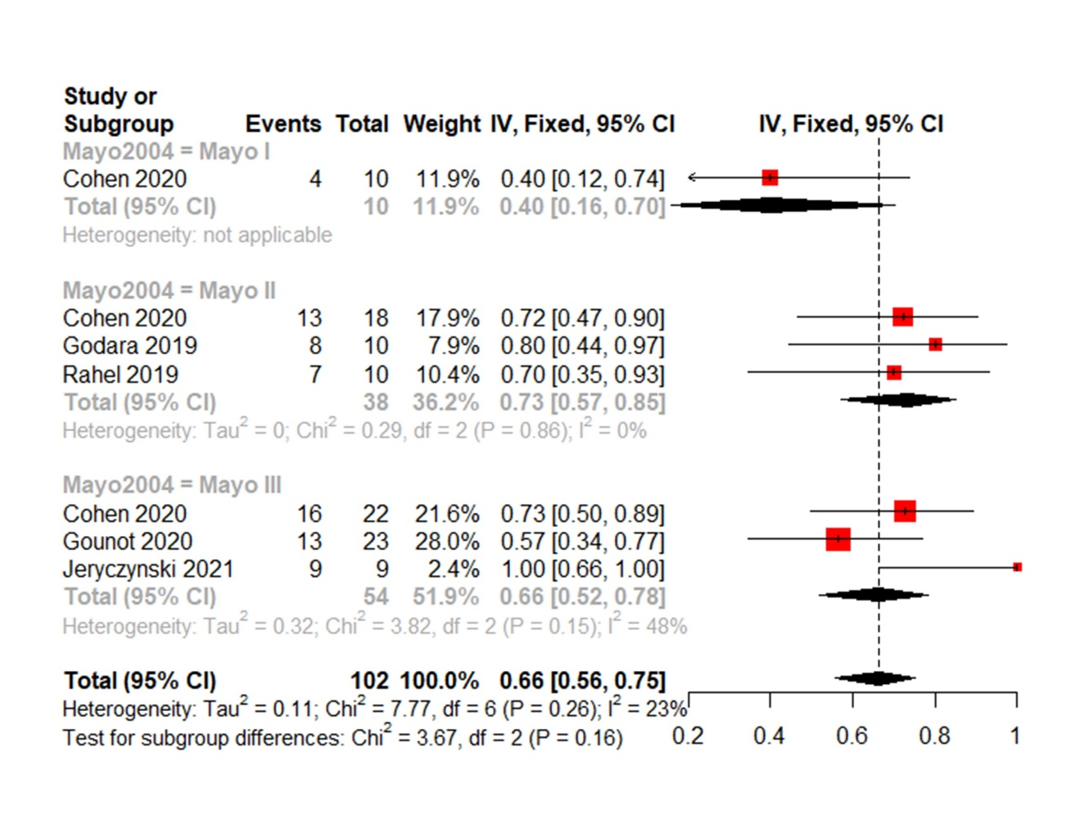
Figure S8. Meta-analysis forest plot of ≥ VGPR-Mayo 2004
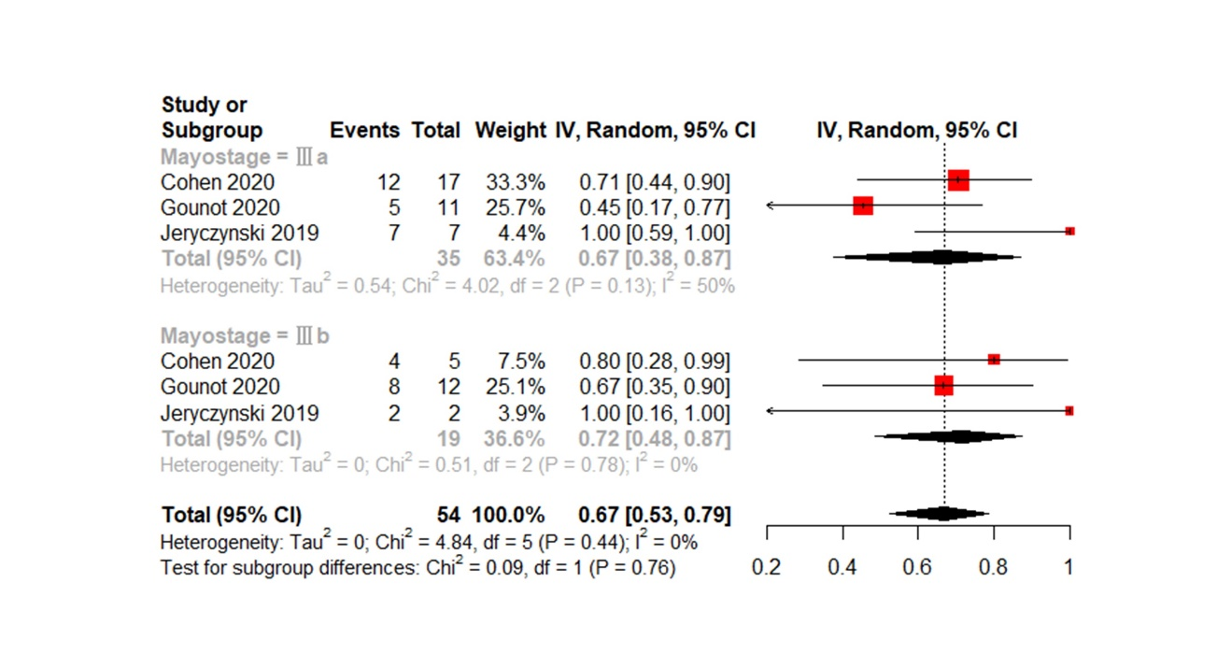
Figure S9. Meta-analysis forest plot of ≥ VGPR-Mayo 2004 ⅢA/B
Figure S10. Meta-analysis forest plot of ≥ VGPR-primary or secondary
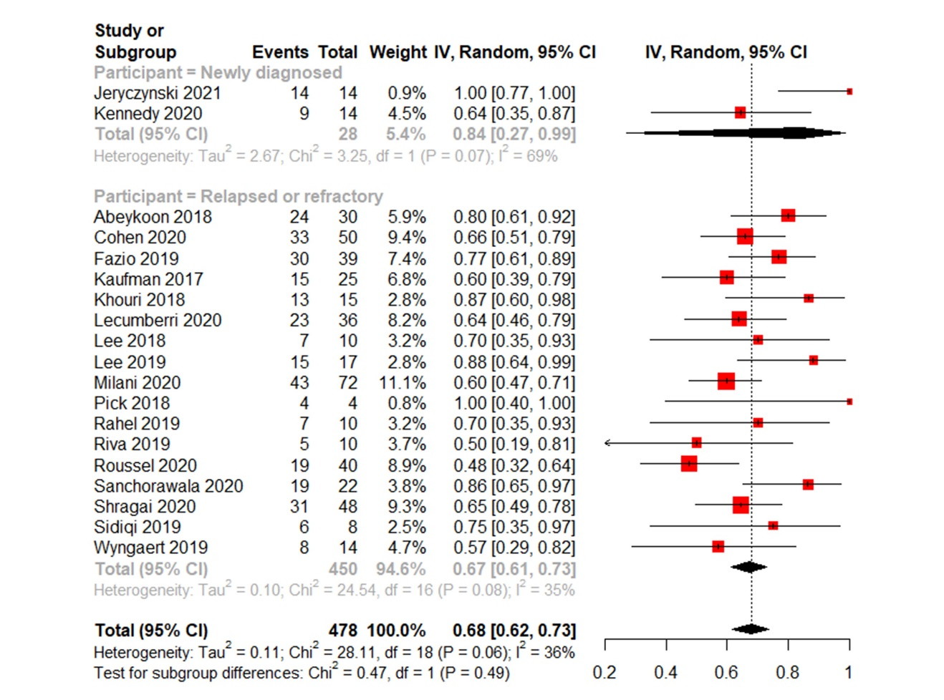
Figure S11. Meta-analysis forest plot of ≥ VGPR-line of therapy
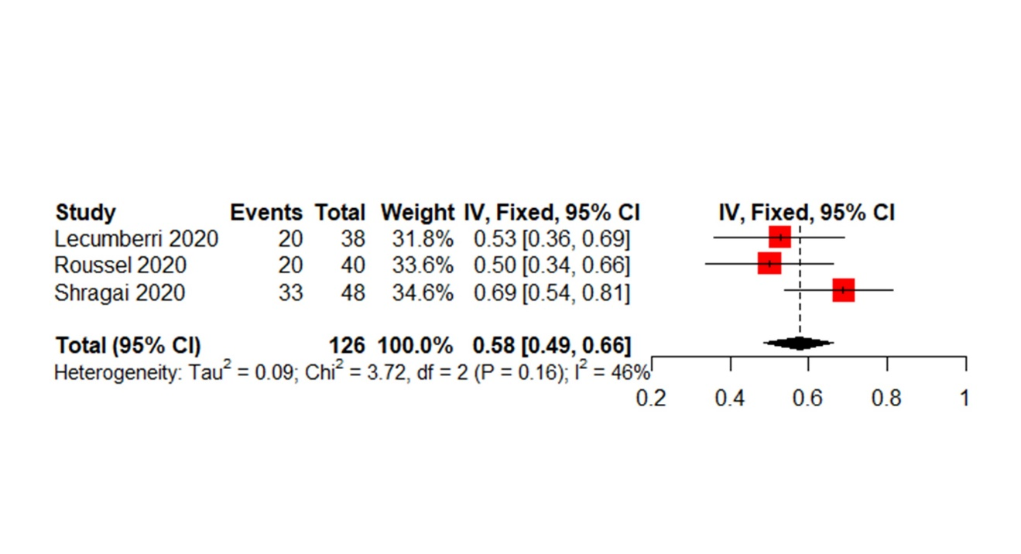
Figure S12. Meta-analysis forest plot of PFS-1 year or longer
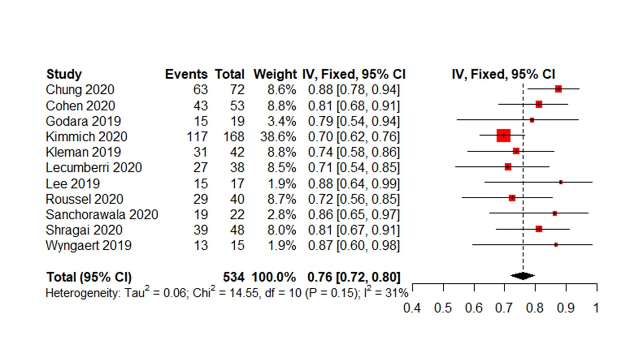
Figure S13. Meta-analysis forest plot of OS-1 year or longer
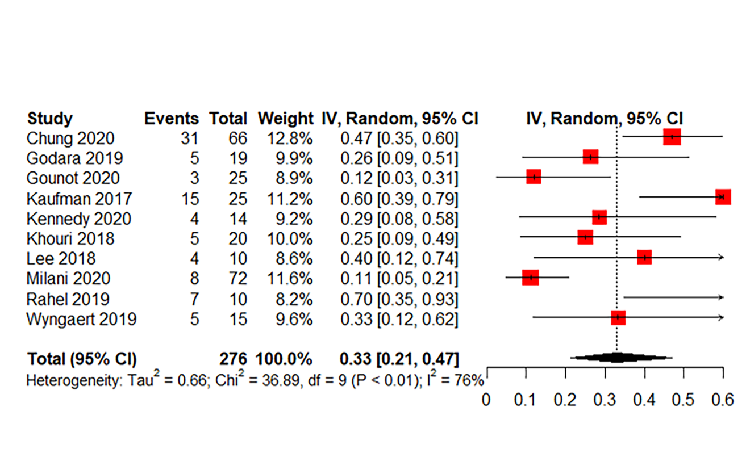
Figure S14. Meta-analysis forest plot of Infusion related reaction-grade-1-2
Figure S15. Meta-analysis forest plot of Infusion related reaction-grade-3-4
Figure S16. Meta-analysis forest plot of complete remission
Figure S17. Meta-analysis forest plot of very good partial response
Figure S18. Meta-analysis forest plot of partial response
Figure S19. Meta-analysis forest plot of Renal response
Figure S20. Meta-analysis forest plot of Infusion related reaction-grade-3-4

