Online Supplementary Material C. Funnel plots of meta-analysis examining relationship between prelacteal feeds and breastfeeding outcomes.
Figure 1S. Funnel plot examining relationship between prelacteal feeds and any breastfeeding cessation under six months.

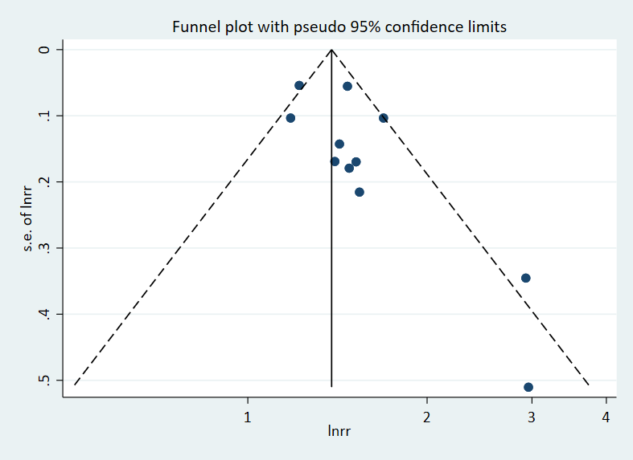

Figure 2S. Funnel plot examining relationship between prelacteal feeds and exclusive breastfeeding cessation under six months.

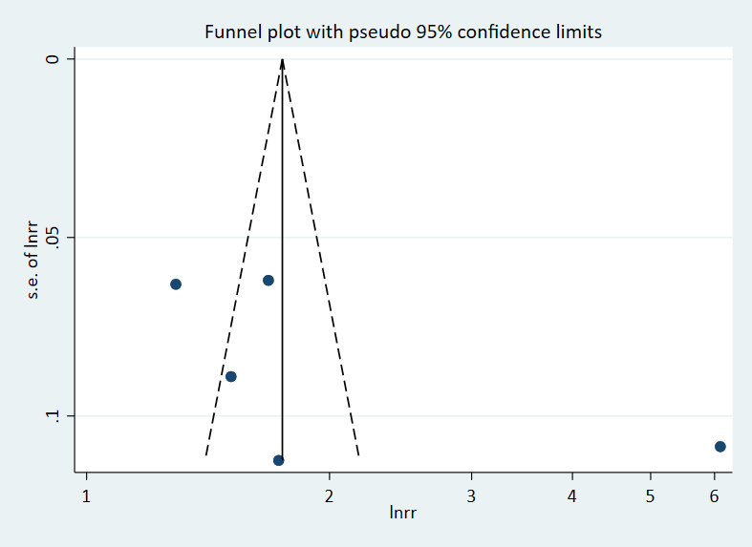
Figure 3S. Funnel plot examining relationship between prelacteal feeds and any breastfeeding under six months.

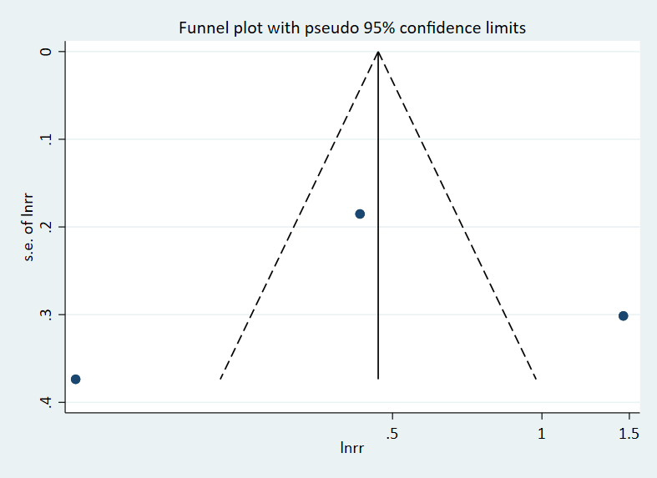

Figure 4S. Funnel plot examining relationship between prelacteal feeds and any breastfeeding cessation up to one year.

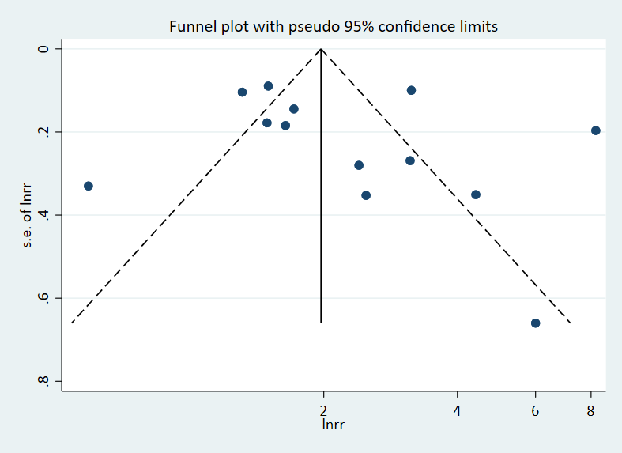

Figure 5S. Funnel plot examining relationship between prelacteal feeds and exclusive breastfeeding under six months.



