Additional File 5: Forest Plots for Secondary Outcomes

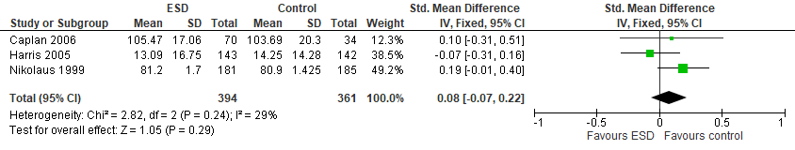
Supplementary figure 1: Forest plot for function

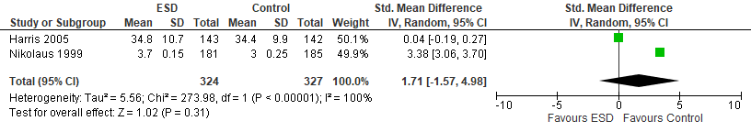
Supplementary figure 2: Forest plot for HRQoL

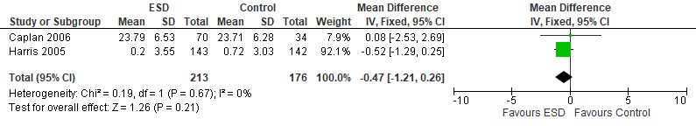
Supplementary figure 3: Forest plot for cognition

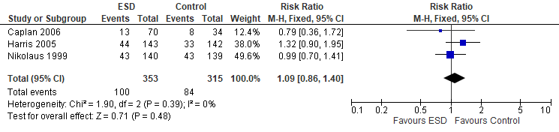
Supplementary figure 4: Forest plot for hospital re-admissions

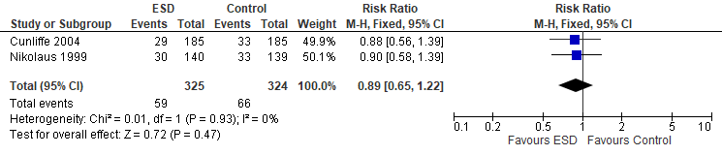
Supplementary figure 5: Forest plot for LTC admissions

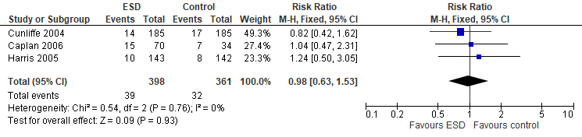
Supplementary figure 6: Forest plot for mortality

