Table S1 Studies excluded because of non-pathogenic genes of PD
Author (year) | Gene | Sleep disorders
Hua (2021)(1) | TEF | PDSS
Lin (2019)(2) | ALDH2 | EDS, RBD, PDSS
Li (2018)(3) | MAPT | RBD
Lou (2018)(4) | CLOCK | PSQI
Mohtashami (2018)(5) | TOX3 | RLS
Gao (2010)(6) | BDNF | RBD, OSAS
Rissling (2006)(7) | COMT | EDS
Frauscher (2004)(8) | COMT | EDS
Zhang (2020)(9) | ZNF184 | RBD, EDS
Kim (2021)(10) | APOE | RBD, EDS
Deutschlander (2020)(11) | MAPT | RBD, RLS
Wu (2020)(12) | NMD3 | RBD, RLS, EDS
Abbreviations: TEF, thyrotroph embryonic factor gene; ALDH2, aldehyde dehydrogenase 2; BDNF, brain-derived neurotrophic factor; COMT, catechol-O-methyltransferase; APOE, apolipoprotein E; RBD, rapid eye movement (REM) sleep behavior disorder; EDS, excessive daytime sleepiness; RLS, restless legs syndrome; PDSS, Parkinson Disease Sleep Scale; PSQI, Pittsburgh Sleep Quality Index; OSAS, obstructive sleep apnea syndrome

Table S2 Study Evaluation according to Newcastle-Ottawa Quality Assessment Scale
Source | Study Design | Selection | Comparability | Exposure/Outcome | Total Score
Chen et al (2020) | cross-sectional | 4 | 2 | 1 | 7
Malek et al (2018) | cross-sectional | 4 | 2 | 1 | 7
Simuni et al (2020) | cross-sectional | 4 | 2 | 3 | 9
Yahalom et al (2019) | cross-sectional | 4 | 2 | 1 | 7
Lerche et al (2020) | cross-sectional | 4 | 2 | 1 | 7
Gan-Or et al (2015) | cross-sectional | 3 | 2 | 2 | 7
Bonner et al (2020) | cross-sectional | 2 | 2 | 1 | 5
Thaler et al (2021) | cross-sectional | 4 | 1 | 1 | 6
Thaler et al (2018) | cross-sectional | 4 | 1 | 1 | 6
Zhao et al (2020) | cross-sectional | 4 | 2 | 1 | 7
Canu et al (2021) | cross-sectional | 4 | 1 | 2 | 7
Caminiti et al (2021) | cross-sectional | 4 | 1 | 1 | 6
Moran et al (2021) | cross-sectional | 4 | 1 | 1 | 6
Simuni et al (2020) | cross-sectional | 4 | 2 | 2 | 8
Chahine et al (2018) | cross-sectional | 4 | 2 | 1 | 7
Ehrminger et al (2015) | cross-sectional | 4 | 2 | 1 | 7
Gaig et al (2014) | cross-sectional | 4 | 2 | 1 | 7
Trinh et al (2014) | cross-sectional | 4 | 2 | 1 | 7
Marras et, al (2016) | cross-sectional | 4 | 2 | 1 | 7
Alcalay et al (2013) | cross-sectional | 4 | 1 | 1 | 6
Saunders-Pullman et al (2015) | cross-sectional | 4 | 2 | 1 | 7
Liang et al (2018) | cross-sectional | 3 | 2 | 2 | 7
Li et al (2015) | cross-sectional | 4 | 2 | 1 | 7
Sun et al (2016) | cross-sectional | 4 | 2 | 1 | 7
Yang et al (2021) | cross-sectional | 4 | 2 | 1 | 7
Cui et al (2021) | cross-sectional | 4 | 2 | 1 | 7
Pont-Sunyer et al (2015) | cross-sectional | 4 | 2 | 2 | 8
Johansen et al (2011) | cross-sectional | 3 | 1 | 2 | 6
Pont-Sunyer et al (2017) | cross-sectional | 4 | 1 | 3 | 8
van den Heuve et al (2018) | cross-sectional | 3 | 2 | 1 | 6
Mirelman et al (2015), Israel | cross-sectional | 3 | 2 | 1 | 6
Mestre et al (2018) | cross-sectional | 4 | 2 | 2 | 8
Morgante et al (2016) | cross-sectional | 4 | 2 | 1 | 7
Song et al (2020) | cross-sectional | 4 | 0 | 2 | 6
Kim et al (2011) | cross-sectional | 4 | 1 | 1 | 6
Kagi et al (2010) | cross-sectional | 3 | 1 | 2 | 6
Limousin et al (2009) | cross-sectional | 4 | 1 | 2 | 7
Zhou et al (2020) | cross-sectional | 4 | 1 | 2 | 7
Avenali et al (2019) | cohort | 3 | 1 | 2 | 6
Beavan et al (2015) | cohort | 3 | 1 | 2 | 6

Table S3 General characteristics of included studies
Source (y), country | Gene variants | Sample size (n) | Sex (male, %) | Age at enrollment, mean (SD), y | Disease duration, mean (SD), y | UPDRS III, mean (SD) | MoCA, mean (SD)
Chen et al (2020), China | GBA, LRRK2 | GBA-PD: 32  LRRK2-PD: 18  iPD: 376 | GBA-PD: 41.7  LRRK2-PD: 35.0  iPD: 55.7 | GBA-PD: 46 (9.50)  LRRK2-PD: 47 (6.41)  iPD: 44.9 (7.94) | GBA-PD: 5.1 (8.2)  LRRK2-PD: 5.6 (5.5)  iPD: 5.6 (5.2) | GBA-PD: 12.3 (10.9)  LRRK2-PD: 10.7 (9.8)  iPD: 9.2 (8.2) | GBA-PD: 24.9 (3.9)  LRRK2-PD: 23.1 (3.7)  iPD: 24.9 (4.3)
Malek et al (2018), UK | GBA | GBA-PD group 1*: 44  GBA-PD group 2**: 99  iPD: 1584 | GBA-PD group 1: 63.6  GBA-PD group 2: 66.3  iPD: 65.4 | GBA-PD group 1: 62.9 (12.3)  GBA-PD group 2: 66.8 (8.7)  iPD: 67.6 (9.2) | GBA-PD group 1: 1.5 (1.1)  GBA-PD group 2: 1.2 (0.9)  iPD: 1.3 (0.9) | GBA-PD group 1: 24.2 (13.0)  GBA-PD group 2: 21.8 (11.5)  iPD: 22.6 (12.2) | GBA-PD group 1: 25.9 (2.7)  GBA-PD group 2: 25.0 (3.3)  iPD: 25.2 (3.5)
Simuni et al (2020), USA | GBA, LRRK2 | GBA-PD: 80  LRRK2-PD: 158  iPD: 361 | GBA-PD: 53.8  LRRK2-PD: 48.1  iPD: 65.9 | GBA-PD: 62.7 (9.9)  LRRK2-PD: 63.8 (9.2)  iPD: 63.8 (9.7) | GBA-PD: 3.1 (2.0)  LRRK2-PD: 2.9 (1.9)  iPD: 2.6 (0.6) | GBA-PD†: 26.2 (10.8)  LRRK2-PD†: 22.1 (11.6)  iPD†: 27.2 (11.1) | GBA-PD: 26.1 (2.9)  LRRK2-PD: 25.9 (3.2)  iPD: 26.2 (3.2)
Yahalom et al (2019), Israel | GBA  LRRK2 | GBA-PD: 78  LRRK2-PD: 66  iPD: 80 | GBA-PD: 60.3  LRRK2-PD: 57.6  iPD: 65 | GBA-PD: 70.1 (12.6)  LRRK2-PD: 72.1 (13.6)  iPD: 72.7 (13.4) | GBA-PD: 11.5 (7.0)  LRRK2-PD: 14.4 (8.3)  iPD: 11.3 (6.5) | GBA-PD: 37.3 (18.1)  LRRK2-PD: 30.9 (19.1)  iPD: 29.6 (11.2) | NA
Lerche et al (2020), Germany | GBA | GBA-PD group 1#: 21  GBA-PD group 2##: 16  GBA-PD group 3###: 43  iPD: 80 | GBA-PD group 1: 71  GBA-PD group 2: 69  GBA-PD group 3: 67  iPD: 70 | GBA-PD group 1: 59 (10)  GBA-PD group 2: 65 (9)  GBA-PD group 3: 66 (10)  iPD: 64 (10) | GBA-PD group 1: 8 (6)  GBA-PD group 2: 8 (4)  GBA-PD group 3: 8 (5)  iPD: 7 (4) | GBA-PD group 1: 29 (10)  GBA-PD group 2: 39 (16)  GBA-PD group 3: 28 (11)  iPD: 28 (12) | GBA-PD group 1: 23 (5)  GBA-PD group 2: 24 (6)  GBA-PD group 3: 24 (5)  iPD: 26 (4)
Gan-Or et al (2015), Canada | GBA | GBA-PD: 19  iPD: 101 | NA | NA | NA | NA | NA
Bonner et al (2020), UK | GBA | GBA-PD: 15  iPD: 5 | GBA-PD: 53  iPD: 40 | GBA-PD: 62.3 (13.6)  iPD: 64.9 (9.8) | NA | NA | NA

Table S3 continued
Source (y), country | Gene variants | Sample size (n) | Sex (male, %) | Age at enrollment, mean (SD), y | Disease duration, mean (SD), y | UPDRS III, mean (SD) | MoCA, mean (SD)
Thaler et al (2021), Israel | GBA, LRRK2 | GBA-PD: 77  LRRK2-PD: 30  iPD: 31  GBA-NMC: 105  LRRK2-NMC:67  HC: 32 | GBA-PD: 66.3  LRRK2-PD: 60.0  iPD: 64.5  GBA-NMC: 35.8  LRRK2-NMC: 49.3  HC: 39.4 | GBA-PD: 68.43 (10.2)  LRRK2-PD: 65.21 (10.0)  iPD: 65.77 (10.4)  GBA-NMC: 54.88 (10.03)  LRRK2-NMC: 54.45 (12.46)  HC: 54.82 (10.03) | GBA-PD: 3.78 (2.6)  LRRK2-PD: 3.82 (2.7)  iPD: 3.69 (1.9) | GBA-PD: 40.54 (21.4)  LRRK2-PD: 35.87 (16.9)  iPD: 41.87 (15.7)  GBA-NMC: 5.94 (6.85)  LRRK2-NMC: 5.33 (4.29)  HC: 4.85 (4.76) | GBA-PD: 23.32 (4.4)  LRRK2-PD: 25.03 (4.0)  iPD: 23.71 (3.7)  GBA-NMC: 25.87 (3.13)  LRRK2-NMC: 26.05 (3.34)  HC: 27.39 (2.96)
Thaler et al (2018), Israel | GBA | GBA-PD group 1&: 48  GBA-PD group 2&&: 139  iPD: 152 | GBA-PD group 1&: 55.3  GBA-PD group 2&&: 59.7  iPD: 56.6 | GBA-PD group 1&: 64.15 (10.2)  GBA-PD group 2&&: 66.44 (10.0)  iPD: 63.23 (10.4) | GBA-PD group 1&: 6.47 (5.0)  GBA-PD group 2&&: 7.00 (6.1)  iPD: 4.91 (4.7) | GBA-PD group 1&: 26.84 (9.2)  GBA-PD group 2&&: 25.92 (12.4)  iPD: 15.59 (12.5) | GBA-PD group 1&: 23.84 (3.2)  GBA-PD group 2&&: 24.06 (3.7)  iPD: 25.00 (3.5)
Zhao et al (2020), China | GBA, LRRK2, PRKN | GBA-PD: 59  LRRK2-PD: 10  PRKN-PD: 83  iPD: 1544 | NA | GBA-PD: 49.63 (6.4)  LRRK2-PD: 55.30 (10.9)  PRKN-PD: 41.43 (11.5)  iPD: 52.25 (8.9) | GBA-PD: 5.78 (4.6)  LRRK2-PD: 7.10 (3.8)  PRKN-PD: 12.36 (9.2)  iPD: 6.24 (5.2) | GBA-PD: 28.73 (13.2)  LRRK2-PD: 31.30 (19.9)  PRKN-PD: 26.78 (16.4)  iPD: 27.49 (16.0) | NA
Canu et al (2021), Germany | GBA | GBA-PD: 10  iPD: 20 | GBA-PD: 30  iPD: 30 | GBA-PD: 62.1 (4.9)  iPD: 62.4 (5.2) | GBA-PD: 2.4 (0.7)  iPD: 2.4 (2.0) | GBA-PD: 15.4 (6.5)  iPD: 15.6 (4.3) | NA
Caminiti et al (2021), Italy | GBA | GBA-PD: 46  iPD: 58 | GBA-PD: 56.5  iPD: 56.9 | GBA-PD: 58.9 (9.6)  iPD: 47 (4.8) | GBA-PD: 1.5 (1.4)  iPD: 2.5 (3.2) | GBA-PD: 28.9 (10.2)  iPD: 21.7 (10.8) | GBA-PD: 26.9 (2.5)  iPD: 28.1 (2.3)
Moran et al (2021), USA | GBA | GBA-NMC: 30  HC: 49 | GBA-NMC: 63.3  HC: 75.5 | GBA-NMC: 53.93 (14.41)  HC: 59.90 (12.58) | - | GBA-NMC: 0.75 (1.19)  HC: 0.70 (1.36) | GBA-NMC: 27.60 (2.06)  HC:27.78 (1.81)
Simuni et al (2020), USA | GBA, LRRK2 | GBA-NMC: 184  LRRK2-NMC: 208  HC: 194 | GBA-NMC: 38  LRRK2-NMC: 42  HC: 64 | GBA-NMC: 61.8 (6.9)  LRRK2-NMC: 61.6 (7.6)  HC: 60.8 (11.3) | - | GBA-NMC:2.5 (3.7)  LRRK2-NMC: 1.0 (2.1)  HC: 0.4 (1.0) | GBA-NMC: 26.8 (2.4)  LRRK2-NMC: 26.8 (2.4)  HC: 28.2 (1.1)

Table S3 continued
Source (y), country | Gene variants | Sample size (n) | Sex (male, %) | Age at enrollment, mean (SD), y | Disease duration, mean (SD), y | UPDRS III, mean (SD) | MoCA, mean (SD)
Avenali et al (2019), Italy | GBA | GBA-NMC: 16  HC: 16 | GBA-NMC: 56.3  HC: 50 | GBA-NMC: 59.0 (9.0)  HC: 56.5 (11.0) | - | GBA-NMC (baseline / follow-up): 0.94 (0.46) / 3.31 (1.05)  HC (baseline / follow-up): 0.44 (0.27) / 2.06 (0.77) | GBA-NMC (baseline / follow-up): 25.81 (0.7) / 27.19 (0.46)  HC (baseline / follow-up): 26.56 (0.50) / 28.06 (0.42)
Chahine et al (2018), USA | GBA, LRRK2 | GBA-NMC: 38  LRRK2-NMC: 88  HC: 126 | GBA-NMC: 29  LRRK2-NMC: 36  HC: 66 | GBA-NMC: 63.6 (7.5)  LRRK2-NMC: 61.6 (7.1)  HC: 62.2 (7.3) | - | NA | NA
Beavan et al (2015), UK | GBA | GBA-NMC: 28  HC: 26 | GBA-NMC: 42.9  HC: 53.8 | GBA-NMC: 63.6 (10.6)  HC: 61.7 (11.2) | - | GBA-NMC (baseline / follow-up): 1.97 (3.44) / 4.50 (3.97)  HC (baseline / follow-up): 0.21 (0.87) / 0.92 (1.89) | GBA-NMC (baseline / follow-up): 25.55 (3.07) / 26.21 (3.02)  HC (baseline / follow-up): 27.32 (1.17) / 27.73 (1.33)
Ehrminger et al (2015), France | LRRK2 | LRRK2-PD: 10  iPD: 20  LRRK2-NMC: 4  HC: 12 | LRRK2-PD: 70  iPD: 70  LRRK2-NMC: 50  HC: 50 | LRRK2-PD: 60.5 (11.4)  iPD: 65.9 (8.7)  LRRK2-NMC: 45.8 (15.5)  HC: 45.8 (11.2) | LRRK2-PD: 8.3 (3.1)  iPD: 9.0 (4.4) | NA | NA
Gaig et al (2014), USA | LRRK2 | LRRK2-PD: 33  iPD: 33 | LRRK2-PD: 45.4  iPD: 45.4 | LRRK2-PD: 64.8 (11.4)  iPD: 65.1 (10.0) | LRRK2-PD: 9.2 (5.7)  iPD: 9.0 (6.1) | LRRK2-PD: 24.0 (14.0)  iPD: 19.9 (12.2) | NA
Trinh et al (2014), Canada | LRRK2 | LRRK2-PD: 75  iPD: 118 | LRRK2-PD: 56  iPD: 53 | LRRK2-PD: 67.6 (12.6)  iPD: 66.6 (12.9) | NA | LRRK2-PD: 36.7 (16.4)  iPD: 33.3 (19.5) | LRRK2-PD: 21.7 (6.8)  iPD: 19.3 (8.5)
Marras et, al (2016), Canada | LRRK2 | LRRK2-PD: 516  iPD: 790 | LRRK2-PD: 51.6  iPD: 58.9 | LRRK2-PD: 64.98 (11.5)  iPD: 65.70 (11.3) | LRRK2-PD: 9.43 (6.6)  iPD: 7.24 (6.0) | LRRK2-PD: 27.68 (28.60)  iPD: 24.55 (9.27) | LRRK2-PD: 24.03  iPD: 28.83
Alcalay et al (2013), USA | LRRK2 | LRRK2-PD: 97  iPD: 391 | LRRK2-PD: 48.5  iPD: 62.1 | LRRK2-PD: 68.6 (8.8)  iPD: 68.1 (10.3) | LRRK2-PD: 8.6 (7.2)  iPD: 6.1 (5.1) | LRRK2-PD: 19.8 (12.8)  iPD: 19.9 (11.3) | LRRK2-PD: 25.2 (2.9)  iPD: 24.7 (3.9)
Table S3 continued
Source (y), country | Gene variants | Sample size (n) | Sex (male, %) | Age at enrollment, mean (SD), y | Disease duration, mean (SD), y | UPDRS III, mean (SD) | MoCA, mean (SD)
Saunders-Pullman et al (2015), USA | LRRK2 | LRRK2-PD: 142  iPD: 144  LRRK2-NMC: 117  HC: 113 | LRRK2-PD: 54.2  iPD: 64.6  LRRK2-NMC: 40.2  HC: 42.9 | LRRK2-PD: 67.2 (9.8)  iPD: 64.9 (11.3)  LRRK2-NMC: 53.3 (15.9)  HC: 52.8 (18.5) | LRRK2-PD: 10.0 (7.1)  iPD: 7.4 (7.5) | LRRK2-PD: 12.1 (13.1)  iPD: 20.1 (11.8)  LRRK2-NMC: 2.5 (3.5)  HC: 2.5 (3.5) | NA
Liang et al (2018), China | LRRK2 | LRRK2-PD: 62  iPD: 623 | LRRK2-PD: 56.5  iPD: 59.1 | LRRK2-PD: 60.95 (13.3)  iPD: 61.86 (13.0) | NA | LRRK2-PD: 25.25 (14.2)  iPD: 28.64 (16.3) | NA
Li et al (2015), China | LRRK2 | LRRK2-PD: 163  iPD: 1062 | LRRK2-PD: 60.5  iPD: 64.4 | LRRK2-PD: 60.34 (10.5)  iPD: 61.65 (10.5) | LRRK2-PD: 3.86 (3.6)  iPD: 4.25 (4.1) | LRRK2-PD: 60.5  iPD: 64.4 | NA
Sun et al (2016), China | LRRK2 | LRRK2-PD: 76  iPD: 225 | LRRK2-PD: 48.68  iPD: 55.56 | LRRK2-PD: 62.16 (8.0)  iPD: 62.85 (8.5) | LRRK2-PD: 6.57 (4.2)  iPD: 5.73 (3.6) | LRRK2-PD: 24.55 (12.1)  iPD: 26.52 (12.6) | NA
Yang et al (2021), China | LRRK2 | LRRK2-PD: 12  iPD: 47 | LRRK2-PD: 33.3  iPD: 48.9 | LRRK2-PD: 63 (7.92)  iPD: 59.91 (8.84) | LRRK2-PD: 5.17 (4.24)  iPD: 4.12 (3.10) | LRRK2-PD: 52.17 (26.29)  iPD: 36.55 (17.82) | NA
Cui et al (2021), China | LRRK2 | LRRK2-PD: 79  iPD: 534 | LRRK2-PD: 53.2  iPD: 55.2 | LRRK2-PD: 63.11 (9.73)  iPD: 61.5 (10.56) | LRRK2-PD: 5.31 (3.64)  iPD: 5.06 (4.32) | LRRK2-PD: 23.70 (18.63)  iPD: 22.78 (5.08) | LRRK2-PD: 23.29 (5.79)  iPD: 22.78 (5.08)
Pont-Sunyer et al (2015), Spain | LRRK2 | LRRK2-PD: 18  iPD: 19  LRRK2-NMC: 17  HC: 14 | LRRK2-PD: 50  iPD: 57.9  LRRK2-NMC: 47.7  HC: 50 | LRRK2-PD: 61.0 (11.2)  iPD: 63.1 (11.2)  LRRK2-NMC: 44.4 (12.3)  HC: 50.8 (16.0) | LRRK2-PD: 7.8 (5.8)  iPD: 7.3 (3.7) | LRRK2-PD: 14.4 (7.7)  iPD: 21.8 (10.8)  LRRK2-NMC: 1.1 (1.9)  HC: 0.2 (0.4) | LRRK2-PD: 24.2 (4.7)  iPD: 24.9 (2.4)  LRRK2-NMC: 26.3 (2.4)  HC: 27.4 (1.9)
Johansen et al (2011), Norway | LRRK2 | LRRK2-NMC: 32  HC: 15 | LRRK2-NMC: 59.4  HC: 60 | LRRK2-NMC: 54.8 (14.9)  HC: 52.8 (13.8) | - | LRRK2-NMC: 5.7 (3.6)  HC: 3.2 (2.2) | NA
Pont-Sunyer et al (2017), Spain | LRRK2 | LRRK2-NMC: 342  HC: 259 | LRRK2-NMC: 41.57  HC: 45.59 | LRRK2-NMC: 51.58 (15.6)  HC: 51.52 (16.4) | - | LRRK2-NMC: 2.88 (2.36)  HC: 1.64 (1.31) | LRRK2-NMC: 26.25 (25.91)  HC: 26.24 (25.78)

Table S3 continued
Source (y), country | Gene variants | Sample size (n) | Sex (male, %) | Age at enrollment, mean (SD), y | Disease duration, mean (SD), y | UPDRS III, mean (SD) | MoCA, mean (SD)
van den Heuve et al (2018), Canada | LRRK2 | LRRK2-NMC: 11  HC: 26 | LRRK2-NMC: 55  HC: 46 | LRRK2-NMC: 61.4 (17.89)  HC: 55 (17.67) | - | LRRK2-NMC: 4.0 (4.4)  HC: 3.0 (3.0) | NA
Mirelman et al (2015), Israel, USA | LRRK2 | LRRK2-NMC: 134  HC: 119 | LRRK2-NMC: 44.1  HC: 49.6 | LRRK2-NMC: 51.08 (17.61)  HC: 49.11 (16.51) | - | LRRK2-NMC: 1.70 (3.00)  HC: 1.65 (2.25) | LRRK2-NMC: 27.00 (3.00)  HC: 26.47 (2.63)
Mestre et al (2018), Canada | LRRK2 | LRRK2-NMC: 52  HC: 90 | LRRK2-NMC: 53.8  HC: 43.3 | LRRK2-NMC: 49.2 (14.5)  HC: 47.9 (12.5) | - | LRRK2-NMC: 1.7 (2.8)  HC: 1.8 (3.1) | NA
Morgante et al (2016), Italy | PRKN | PRKN-PD: 22  iPD: 26 | PRKN-PD: 59.1  iPD: 65.4 | PRKN-PD: 52.26 (10.9)  iPD: 55.1 (8.5) | PRKN-PD: 21.29 (10.9)  iPD: 11.82 (9.8) | PRKN-PD: 18.90 (9.6)  iPD: 21.0 (8.5) | NA
Song et al (2020), China | PRKN | PRKN-PD: 53  iPD: 208 | PRKN-PD: 58.5  iPD: 64.4 | PRKN-PD: 35.6 (8.8)  iPD: 44.8 (8.8) | PRKN-PD: 9.0 (6.4)  iPD: 5.2 (6.4) | PRKN-PD†: 33.2 (13.8)  iPD†: 30.5 (15.0) | NA
Kim et al (2011), Korea | PRKN | PRKN-PD: 14  iPD: 64 | PRKN-PD: 57.1  iPD: 59.4 | PRKN-PD: 43.9 (10.4)  iPD: 46.7 (8.5) | PRKN-PD: 16.9 (8.1)  iPD: 11.0 (6.3) | NA | NA
Kagi et al (2010), Italy | PRKN | PRKN-PD: 16  iPD: 27 | PRKN-PD: 68.8  iPD: 55.6 | PRKN-PD: 46.1 (9.3)  iPD: 52.0 (6.3) | PRKN-PD: 21.0 (9.0)  iPD: 14.2 (6.2) | PRKN-PD: 33.5 (13.6)  iPD: 29 (12.4) | NA
Limousin et al (2009), France | PRKN | PRKN-PD: 11  iPD: 11 | PRKN-PD: 27.3  iPD: 27.3 | PRKN-PD: 49 (8)  iPD: 59 (6) | PRKN-PD: 20 (6)  iPD: 5 (4) | NA | NA
Zhou et al (2020), China | PRKN | PRKN-PD: 24  iPD: 24 | PRKN-PD: 50  iPD: 66.7 | PRKN-PD: 33.17 (6.74)  iPD: 35.25 (6.30) | PRKN-PD: 6.79 (6.45)  iPD: 2.60 (1.60) | PRKN-PD: 26.83 (10.15)  iPD: 24.38 (12.82) | NA
* GBA-PD group 1: PD with GD-causing variants (L444P, N370S, R463C, G202R, R359S), ** GBA-PD group 2: PD with GBA E326K and T369M variants
† MDS-UPDRS part III in off-stage
# GBA-PD group 1: PD with GD severe variant (L444P, G202R, R359X, W184R, c.1265-1319del), ## GBA-PD group 2: PD with GD mild variant (N370S), ### GBA-PD group 3: PD with GD risk variant (E326K, T369M, T297S)
& GBA-PD group 1: PD with GD severe variant (84GG, IVS2+1, L444P, V394L, 370Rec), && GBA-PD group 2: PD with GD mild variant (N370S, R496H)
SD, standard deviation; UPDRS III, Unified Parkinson’s Disease Rating Scale Part III; MoCA, Montreal Cognitive Assessment; GBA, glucocerebrosidase gene; LRRK2, Leucine-rich repeat kinase 2 gene; PRKN, parkin gene; PD, Parkinson’s disease; iPD: idiopathic PD; NMC, non-manifesting carrier; HC, healthy control; NA: not applicable

Table S4 Primary outcomes of included studies
Source (y), country | Gene variants | Sample size (n) | Sleep disorder assessment tools | Sleep disorder outcome, n, mean (SD)
 |  |  |  | RBD | EDS | RLS | PDSS
Chen et al (2020), China | GBA, LRRK2 | GBA-PD: 32  LRRK2-PD: 18  iPD: 376 | NA | GBA-PD: 12  LRRK2-PD: 7  iPD: 132 | - | - | -
Malek et al (2018), UK | GBA | GBA-PD group 1*: 40  GBA-PD group 2**: 93  iPD: 1480 | RBDSQ score > 4 | GBA-PD group 1: 17  GBA-PD group 2: 46  iPD: 639 | - | - | -
Simuni et al (2020), USA | GBA, LRRK2 | GBA-PD: 78  LRRK2-PD: 157  iPD: 361 | RBDSQ score > 4  ESS | GBA-PD: 41, 5.3 (3.7)  LRRK2-PD: 46, 3.5 (2.3)  iPD: 151, 4.6 (3.0) | GBA-PD: 6.5 (4.2)  LRRK2-PD: 7.1 (4.7)  iPD: 6.7 (4.2) | - | -
Yahalom et al (2019), Israel | GBA  LRRK2 | GBA-PD: 60  LRRK2-PD: 55  iPD: 72 | RBD1Q | GBA-PD: 40  LRRK2-PD: 9  iPD: 27 | - | - | -
Lerche et al (2020), Germany | GBA | GBA-PD group 1#: 10  GBA-PD group 2##: 8  GBA-PD group 3###: 27  iPD: 53 | NA | GBA-PD group 1: 6  GBA-PD group 2: 4  GBA-PD group 3: 16  iPD: 13 | - | - | -
Gan-Or et al (2015), Canada | GBA | GBA-PD: 19  iPD: 101 | RBDSQ score > 5 | GBA-PD: 9, 5.63 (3.7)  iPD: 24, 3.43 (2.9) | - | - | -
Bonner et al (2020), UK | GBA | GBA-PD: 15  iPD: 5 | NA | GBA-PD: 7  iPD: 15 | - | - | -

Table S4 Continued
Source (y), country | Gene variants | Sample size (n) | Sleep disorder assessment tools | Sleep disorder outcome, n, mean (SD)
 |  |  |  | RBD | EDS | RLS | PDSS
Thaler et al (2021), Israel | GBA, LRRK2 | GBA-PD: 77  LRRK2-PD: 30  iPD: 31  GBA-NMC: 105  LRRK2-NMC:67  HC: 32 | RBDSQ | GBA-PD: 3.84 (3.1)  LRRK2-PD: 3.06 (2.3)  iPD: 3.1 (3.1)  GBA-NMC: 1.95 (1.91)  LRRK2-NMC: 1.40 (1.46)  HC: 1.79 (1.45) | - | - | -
Thaler et al (2018), Israel | GBA | GBA-PD group 1&: 48  GBA-PD group 2&&: 139  iPD: 152 | RBDSQ | GBA-PD group 1&: 4.71 (3.3)  GBA-PD group 2&&: 4.13 (3.5)  iPD: 3.38 (2.8) | - | - | -
Zhao et al (2020), China | GBA, LRRK2, PRKN | GBA-PD: 59  LRRK2-PD: 10  PRKN-PD: 83  iPD: 1544 | RBDQ-HK, ESS | GBA-PD: 18.20 (18.6)  LRRK2-PD: 16.75 (23.3)  PRKN-PD: 9.85 (12.2)  iPD: 13.43 (16.0) | GBA-PD: 7.90 (6.6)  LRRK2-PD: 11.75 (7.3)  PRKN-PD: 6.73 (64)  iPD: 7.38 (6.1) | - | -
Canu et al (2021), Germany | GBA | GBA-PD: 10  iPD: 20 | RBDSQ | GBA-PD: 3.7 (3.6)  iPD: 2.3 (2.2) | - | - | -
Caminiti et al (2021), Italy | GBA | GBA-PD: 46  iPD: 58 | RBDSQ | GBA-PD: 4.4 (3.0)  iPD: 3.0 (2.3)
Moran et al (2021), USA | GBA | GBA-NMC: 30  HC: 49 | RBDSQ > 4 | GBA-NMC: 1, 2.00 (1.53)  HC: 3, 1.36 (1.72) | - | - | -
Simuni et al (2020), USA | GBA, LRRK2 | GBA-NMC: 184  LRRK2-NMC: 208  HC: 194 | RBDSQ > 4, ESS > 9 | GBA-NMC: 38  LRRK2-NMC: 42  HC: 39 | GBA-NMC: 18  LRRK2-NMC: 22  HC: 23 | - | -

Table S4 Continued
Source (y), country | Gene variants | Sample size (n) | Sleep disorder assessment tools | Sleep disorder outcome, n, mean (SD)
 |  |  |  | RBD | EDS | RLS | PDSS
Avenali et al (2019), Italy | GBA | GBA-NMC: 16  HC: 16 | RBDSQ | GBA-NMC (baseline / follow-up): 0.20 (0.77) / 3.00 (2.87)  HC (baseline / follow-up): 0.42 (0.76) / 1.50 (2.18) | - | - | -
Chahine et al (2018), USA | GBA, LRRK2 | GBA-NMC: 38  LRRK2-NMC: 88  HC: 126 | RBDSQ > 4 | GBA-NMC: 7  LRRK2-NMC: 16  HC: 23 | - | - | -
Beavan et al (2015), UK | GBA | GBA-NMC: 28  HC: 26 | RBDSQ | GBA-NMC (baseline / follow-up): 0.10 (0.53) / 2.30 (2.12)  HC (baseline / follow-up): 0.25 (0.71) / 1.08 (1.53) | - | - | -
Ehrminger et al (2015) France | LRRK2 | LRRK2-PD: 10  iPD: 20  LRRK2-NMC: 4  HC: 12 | V-PSG, ESS | LRRK2-PD: 0  iPD: 9 | LRRK2-PD: 11.0 (6.1)  iPD: 9.0 (4.9)  LRRK2-NMC: 9.5 (1.3)  HC: 6.5 (3.1) | - | -
Gaig et al (2014) USA | LRRK2 | LRRK2-PD: 33  iPD: 33 | ICSD-2, ESS, PDSS | LRRK2-PD: 7  iPD: 14 | LRRK2-PD: 6, 8.1 (4.6)  iPD: 13, 9.1 (5.3) | - | LRRK2-PD: 116.4 (16.8)  iPD: 116.7 (22.3)
Trinh et al (2014) Canada | LRRK2 | LRRK2-PD: 75  iPD: 118 | RBDSQ, ESS, RLS | LRRK2-PD: 12  iPD: 34 | LRRK2-PD: 5.35 (4.90)  iPD: 4.88 (5.19) | LRRK2-PD: 9  iPD: 15 | -
Marras et, al (2016), Canada | LRRK2 | LRRK2-PD: 516  iPD: 790 | RBDSQ > 5, ESS > 10 | LRRK2-PD: 21  iPD: 25 | LRRK2-PD: 4  iPD: 28 | - | -
Alcalay et al (2013), USA | LRRK2 | LRRK2-PD: 97  iPD: 391 | RBD1Q | LRRK2-PD: 22  iPD: 137 | - | - | -
Table S4 Continued
Source (y), country | Gene variants | Sample size (n) | Sleep disorder assessment tools | Sleep disorder outcome, n, mean (SD)
 |  |  |  | RBD | EDS | RLS | PDSS
Saunders-Pullman et al (2015), USA | LRRK2 | LRRK2-PD: 142  iPD: 144  LRRK2-NMC: 117  HC: 113 | RBDSQ‡ | LRRK2-PD: 28, 3.35 (2.25)  iPD: 44, 4.35 (3.74)  LRRK2-NMC: 7, 2.00 (1.50)  HC: 25, 2.36 (2.27) | - | - | -
Liang et al (2018), China | LRRK2 | LRRK2-PD: 15  iPD: 118 | RBDQ-HK, ESS | LRRK2-PD: 6  iPD: 55 | LRRK2-PD: 4  iPD: 50 | - | -
Li et al (2015), China | LRRK2 | LRRK2-PD: 163  iPD: 1062 | RBD1Q, ESS | LRRK2-PD: 46  iPD: 317 | LRRK2-PD: 68  iPD: 495 | LRRK2-PD: 59  iPD: 386 | -
Sun et al (2016) China | LRRK2 | LRRK2-PD: 76  iPD: 225 | RBDSQ > 5 | LRRK2-PD: 34, 5.00 (3.2)  iPD: 64, 3.87 (2.9) | - | - | -
Yang et al (2021) China | LRRK2 | LRRK2-PD: 12  iPD: 47 | RBD1Q | LRRK2-PD: 8  iPD: 11 | - | - | -
Cui et al (2021) China | LRRK2 | LRRK2-PD: 79  iPD: 534 | RBDQ-HK, ESS | LRRK2-PD: 14.62 (16.37)  iPD: 13.87 (17.33) | LRRK2-PD: 5.47 (5.69)  iPD: 5.79 (5.88) | - | -
Pont-Sunyer et al (2015) Spain | LRRK2 | LRRK2-PD: 18  iPD: 19  LRRK2-NMC: 17  HC: 14 | RBDSQ, ESS > 10, RLS, PDS | LRRK2-PD: 3.1 (2.2)  iPD: 3.7 (2.6)  LRRK2-NMC: 2.7 (2.7)  HC: 1.1 (1.9) | LRRK2-PD: 4, 7.8 (5.0)  iPD: 5, 8.3 (2.7)  LRRK2-NMC: 4, 7.3 (4.5)  HC: 0, 5.5 (2.2) | LRRK2-PD: 3  iPD: 3  LRRK2-NMC: 2  HC: 2 | LRRK2-PD: 8.3 (3.5)  iPD: 5.7 (3.6)  LRRK2-NMC: 6.3 (6.2)  HC: 3.4 (6.2)
Johansen et al (2011), Norway | LRRK2 | LRRK2-NMC: 32  HC: 15 | RBD1Q, ESS | LRRK2-NMC: 1  HC: 0 | LRRK2-NMC: 2.3 (1.8)  HC: 2.5 (1.9) | - | -
Pont-Sunyer et al (2017), Spain | LRRK2 | LRRK2-NMC: 169  HC: 104 | RBDSQ > 4, ESS > 9 | LRRK2-NMC: 20, 2.54 (1.67)  HC: 19, 2.53 (1.70) | LRRK2-NMC: 25, 4.82 (12.93)  HC: 15, 6.24 (4.53) | - | -
Table S4 Continued
Source (y), country |  | Gene variants | Sample size (n) | Sleep disorder assessment tools | Sleep disorder outcome, n, mean (SD)
Source (y), country |  | Gene variants | Sample size (n) | Sleep disorder assessment tools | RBD | EDS | RLS | PDSS
van den Heuve et al (2018), Canada |  | LRRK2 | LRRK2-NMC: 11  HC: 26 | RBDSQ | LRRK2-NMC: 2.0 (2.2)  HC: 2.5 (2.0) | - | - | -
Mirelman et al (2015), Israel, USA |  | LRRK2 | LRRK2-NMC: 134  HC: 119 | RBDSQ | LRRK2-NMC: 2.70 (1.50)  HC: 1.85 (1.50) | - | - | -
Mestre et al (2018), Canada |  | LRRK2 | LRRK2-NMC: 52  HC: 90 | ESS | - | LRRK2-NMC: 4.6 (3.3)  HC: 6.3 (3.7) | - | -
Morgante et al (2016) Italy |  | PRKN | PRKN-PD: 21  iPD: 26 | RBD1Q | PRKN-PD: 6  iPD: 3 | - | - | -
Song et al (2020), China |  | PRKN | PRKN-PD: 53  iPD: 208 | RBDSQ, ESS | PRKN-PD: 11  iPD: 38 | PRKN-PD: 5.6 (4.4)  iPD: 5.6 (3.8) | - | -
Kim et al (2011), Korea |  | PRKN | PRKN-PD: 14  iPD: 64 | NMSQ | PRKN-PD: 7  iPD: 22 | PRKN-PD: 0  iPD: 3 | PRKN-PD: 1  iPD: 6 | -
Kagi et al (2010), Italy |  | PRKN | PRKN-PD: 16  iPD: 27 | NMSQ | PRKN-PD: 3  iPD: 14 | PRKN-PD: 1  iPD: 9 | PRKN-PD: 2  iPD: 13 | -
Limousin et al (2009), France |  | PRKN | PRKN-PD: 11  iPD: 11 | V-PSG, ESS | PRKN-PD: 1  iPD: 6 | PRKN-PD: 10 (3)  iPD: 12 (6) | PRKN-PD: 5  iPD: 0 | -
Zhou et al (2020), China |  | PRKN | PRKN-PD: 24  iPD: 24 | RBDSQ, ESS | PRKN-PD: 3.79 (2.27)  iPD: 3.30 (2.40) | PRKN-PD: 6.25 (3.50)  iPD: 3.26 (2.38) | - | -
* GBA-PD group 1: PD with GD-causing variants (L444P, N370S, R463C, G202R, R359S); ** GBA-PD group 2: PD with GBA E326K and T369M variants
† MDS-UPDRS part III in off-stage
# GBA-PD group 1: PD with GD severe variant (L444P, G202R, R359X, W184R, c.1265-1319del); ## GBA-PD group 2: PD with GD mild variant (N370S); ### GBA-PD group 3: PD with GD risk variant (E326K, T369M, T297S)
& GBA-PD group 1: PD with GD severe variant (84GG, IVS2+1, L444P, V394L, 370Rec), && GBA-PD group 2: PD with GD mild variant (N370S, R496H)
‡ RBD+, RBDSQ score > 4 (NMC) and RBDSQ score > 5 (PD)
SD, standard deviation; PD, Parkinson’s diseasea; iPD: idiopathic PD; NMC, non-manifesting carrier; HC, healthy control; RBD, rapid eye movement (REM) sleep behavior disorder; RBDSQ, RBD screening questionnaire; ESS, Epworth Sleepiness Scale; RBD1Q, RBD Single-Question Screen; PDSS, Parkinson Disease Sleep Scale; RLS, restless legs syndrome; RBDQ-HK, RBD questionnaire-Hong Kong; NMSQ, PD nonmotor symptoms questionnaire; V-PSG, video-polysomnography; ICSD-2, International Classification of Sleep Disorders, Revised: Diagnostic and Coding Manual; NA: not applicable

Table S5 Results of meta-regression in patients with gene variants
Gene variant | Covariant | No. of sources | Tau² | Adjusted R² (%) | 95% CI | P value
RBD in PD patients with / without gene variants
GBA | Age | 6 | 0.140 | -80.86 | 0.93-1.11 | 0.604
GBA | Sex (male, %) | 6 | 0.136 | -75.29 | 0.95-1.09 | 0.439
GBA | Disease duration | 5 | 0.022 | 66.34 | 0.90-1.24 | 0.348
GBA | UPDRS III | 4 | 0.157 | -30.46 | 0.83-1.28 | 0.565
GBA | MoCA | 4 | 0.135 | 8.66 | 0.18-2.56 | 0.336
LRRK2 G2385R | Age | 4 | 0 | 100.00 | 0.84-3.37 | 0.084
LRRK2 G2385R | Sex (male, %) | 4 | 0 | 100.00 | 0.85-1.02 | 0.077
LRRK2 G2385R | Disease duration | 3 | 1.308 | -114.24 | 0.00-3060.32 | 0.721
LRRK2 G2385R | UPDRS III | 4 | 1.003 | -119.43 | 0.87-1.17 | 0.867
PRKN | Age | 5 | 1.513 | -95.60 | 0.68-1.41 | 0.884
PRKN | Sex (male, %) | 5 | 0.992 | -28.24 | 0.89-1.23 | 0.447
PRKN | Disease duration | 5 | 1.360 | -75.86 | 0.62-1.43 | 0.657
PRKN | UPDRS III | 3 | 0.915 | 7.01 | 0.26-3.23 | 0.458
RBD in asymptomatic patients with gene variants and HC
LRRK2 G2019S | Age | 6 | 0.137 | -20.86 | 0.88-1.08 | 0.533
LRRK2 G2019S | Sex (male, %) | 6 | 0.130 | -14.26 | 0.87-1.07 | 0.410
LRRK2 G2019S | UPDRS III | 6 | 0.11 | 2.96 | 0.65-1.21 | 0.337
LRRK2 G2019S | MoCA | 4 | 0 | 100.00 | 0.62-7.47 | 0.118
EDS in PD patients with / without gene variants
PRKN | Age | 4 | 0.112 | 52.26 | 0.78-1.11 | 0.229
PRKN | Sex (male, %) | 3 | 0.699 | -78.83 | 0.62-1.69 | 0.682
PRKN | Disease duration | 4 | 0.105 | 54..95 | 0.73-1.15 | 0.239
PRKN | UPDRS III | 3 | 0.561 | -103.29 | 0.14-6.12 | 0.73
EDS in asymptomatic patients with gene variants and HC
LRRK2 | Age | 4 | 0.133 | -72.62 | 0.81-1.33 | 0.563
LRRK2 | Sex (male, %) | 4 | 0.111 | -44.29 | 0.84-1.14 | 0.589
LRRK2 | UPDRS III | 4 | 0.087 | -13.62 | 0.66-1.84 | 0.484
RLS in PD patients with / without gene variants
PRKN | Age | 3 | 4.853 | -18.48 | 0.00-17577.59 | 0.525
LRRK2 | Sex (male, %) | 3 | 0 | 100.00 | 0.52-1.53 | 0.222
G2019S | duration | 3 | 10.39 | -153.64 | 0.00-1454560 | 0.955
Abbreviations: OR, odds ratio; SMD, standard mean difference; RBD, rapid eye movement (REM) sleep behavior disorder; EDS, excessive daytime sleepiness; RLS, restless legs syndrome; PDSS, Parkinson Disease Sleep Scale; GBA, glucocerebrosidase gene; LRRK2, Leucine-rich repeat kinase 2 gene; PRKN, parkin gene; HC, healthy control

References
1. Hua P, Cui C, Chen Y, Yao Y, Yu CY, Xu LG, et al. Thyrotroph embryonic factor polymorphism predicts faster progression of Parkinson's disease in a longitudinal study. J Integr Neurosci. 2021;20(1):95-101.
2. Lin CY, Yu RL, Wu RM, Tan CH. Effect of ALDH2 on Sleep Disturbances in Patients with Parkinson's Disease. Sci Rep. 2019;9(1):18950.
3. Li J, Ruskey JA, Arnulf I, Dauvilliers Y, Hu MTM, Högl B, et al. Full sequencing and haplotype analysis of MAPT in Parkinson's disease and rapid eye movement sleep behavior disorder. Mov Disord. 2018;33(6):1016-20.
4. Lou F, Li M, Luo X, Ren Y. CLOCK 3111T/C Variant Correlates with Motor Fluctuation and Sleep Disorders in Chinese Patients with Parkinson's Disease. Parkinsons Dis. 2018;2018:4670380.
5. Mohtashami S, He Q, Ruskey JA, Zhou S, Dion PA, Allen RP, et al. TOX3 Variants Are Involved in Restless Legs Syndrome and Parkinson's Disease with Opposite Effects. J Mol Neurosci. 2018;64(3):341-5.
6. Gao L, Díaz-Corrales FJ, Carrillo F, Díaz-Martín J, Caceres-Redondo MT, Carballo M, et al. Brain-derived neurotrophic factor G196A polymorphism and clinical features in Parkinson's disease. Acta Neurol Scand. 2010;122(1):41-5.
7. Rissling I, Frauscher B, Kronenberg F, Tafti M, Stiasny-Kolster K, Robyr AC, et al. Daytime sleepiness and the COMT val158met polymorphism in patients with Parkinson disease. Sleep. 2006;29(1):108-11.
8. Frauscher B, Högl B, Maret S, Wolf E, Brandauer E, Wenning GK, et al. Association of daytime sleepiness with COMT polymorphism in patients with parkinson disease: a pilot study. Sleep. 2004;27(4):733-6.
9. Zhang B, Cui C, Yu H, Li G. Association between ZNF184 and symptoms of Parkinson's disease in southern Chinese. Neurol Sci. 2020;41(8):2121-6.
10. Kim R, Park S, Yoo D, Jun JS, Jeon B. Impact of the apolipoprotein E ε4 allele on early Parkinson's disease progression. Parkinsonism Relat Disord. 2021;83:66-70.
11. Deutschlander AB, Konno T, Soto-Beasley AI, Walton RL, van Gerpen JA, Uitti RJ, et al. Association of MAPT subhaplotypes with clinical and demographic features in Parkinson's disease. Ann Clin Transl Neurol. 2020;7(9):1557-63.
12. Wu H, Li H, Shi Z, Tang J, Mei S, Ai T, et al. Association between NMD3 and symptoms of Parkinson's disease in Chinese patients. BMC Neurol. 2020;20(1):19.

Figure S1 Severity of EDS in PD patients with and without GBA variants

Figure S2 Risk (a) and severity (b) of EDS in PD patients with and without LRRK2 variants, severity of EDS in PD patients with and without LRRK2 G2019S variants (c)
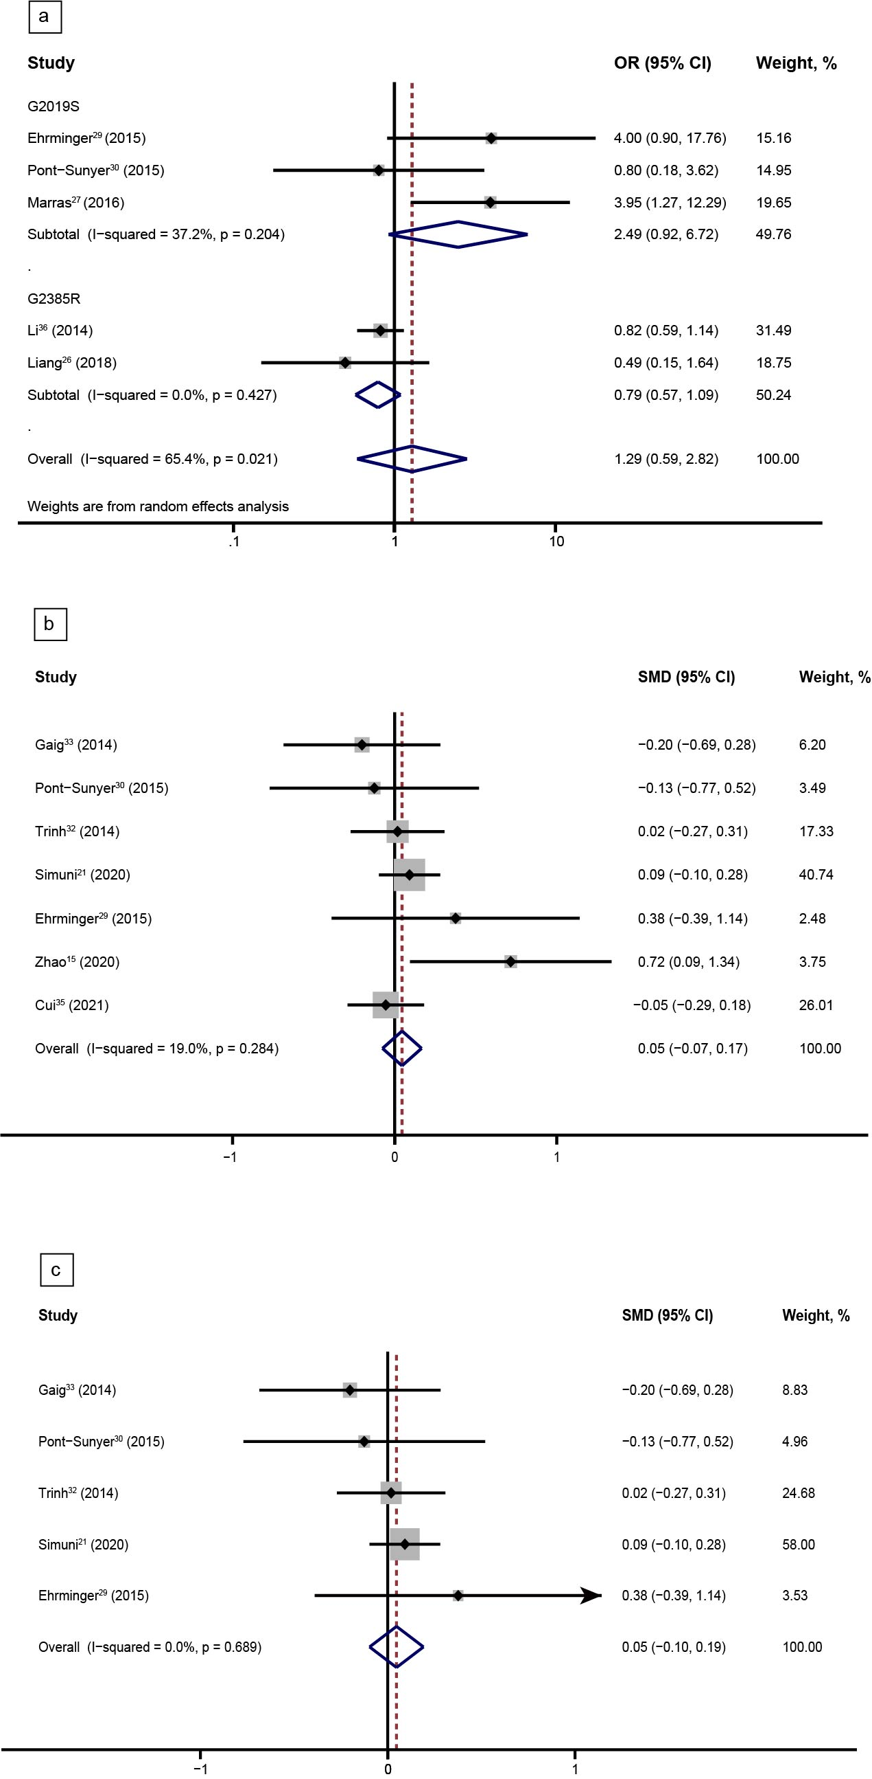
Figure S3 PDSS score (a) and risk of RLS (b) in PD patients with and without LRRK2 variants
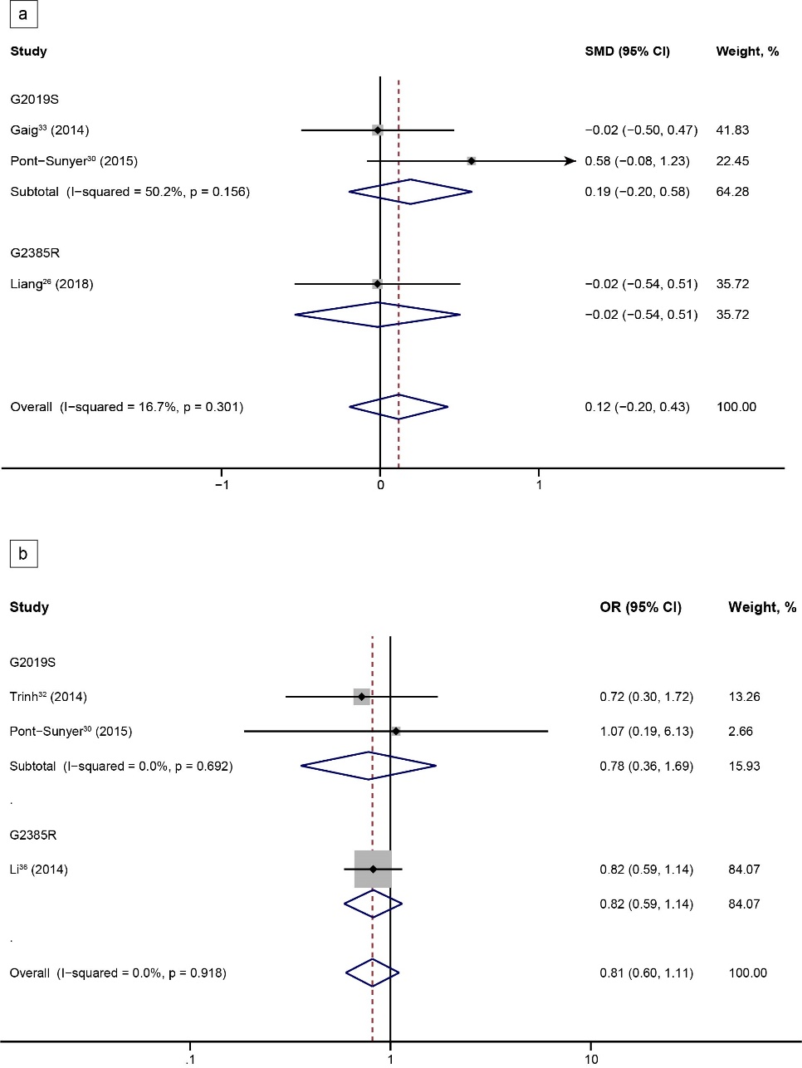
Figure S4 Funnel plots for the risk of RBD in PD patients with LRRK2 variants

Figure S5 Risk (a) and severity (b) of RBD in PD patients with PRKN variants
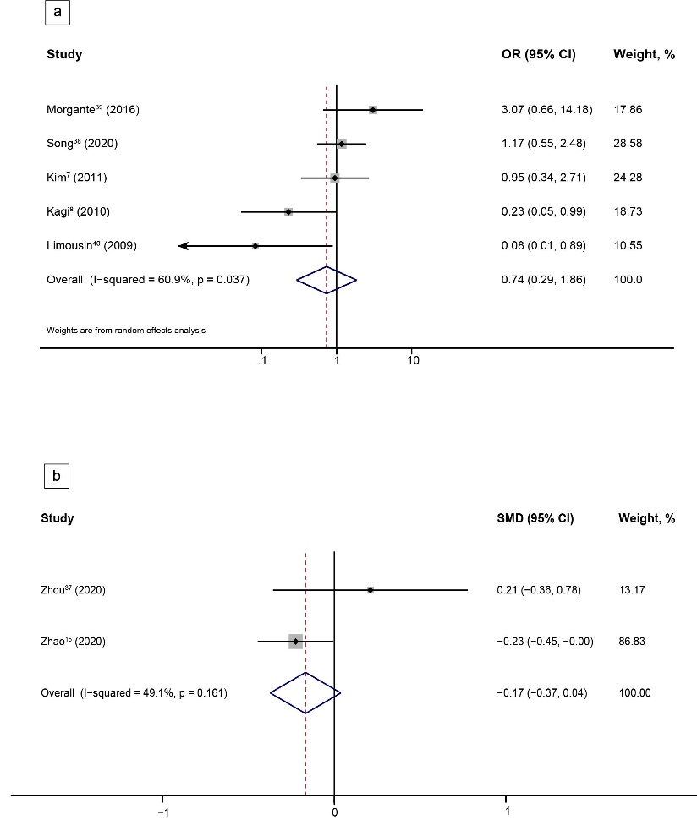
Figure S6 Risk (a) and severity (b) of EDS in PD patients with PRKN variants
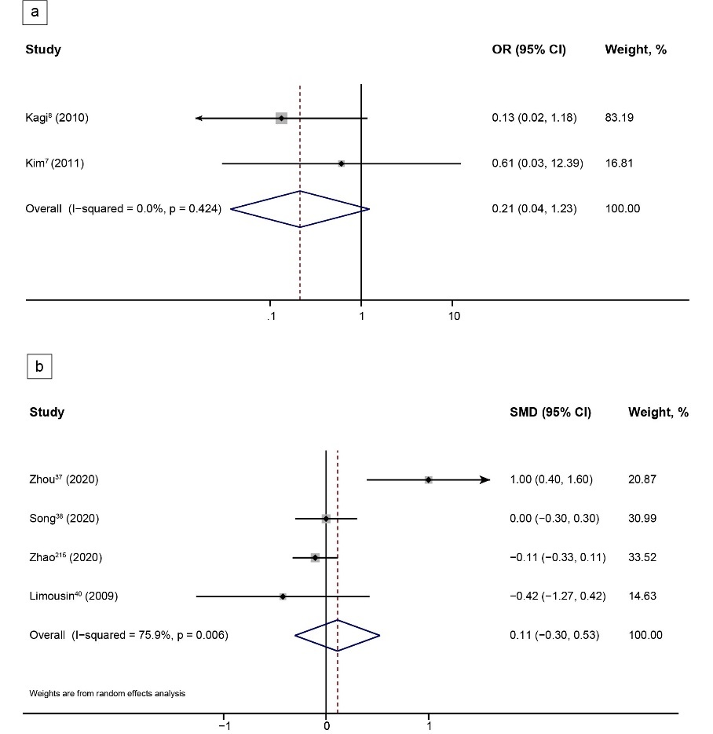
Figure S7 Risk of RLS in PD patients with and without PRKN variants

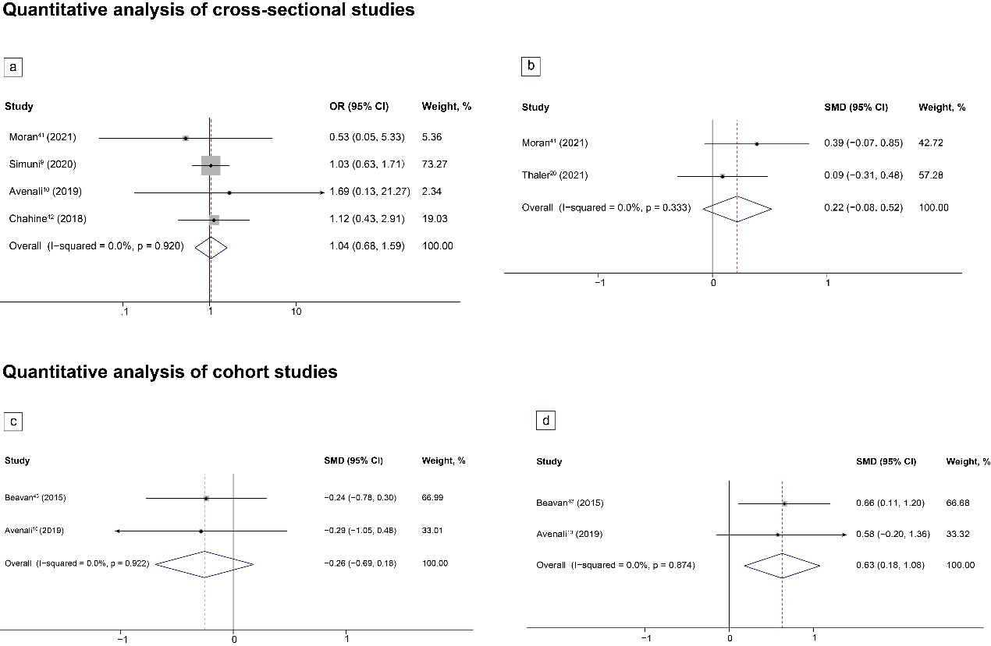
Figure S8 Risk (a) and severity (b) of RBD in asymptomatic carriers with GBA variant and HCs

Forest plots display meta-analysis results of cross-sectional studies on the risk (a) and severity (b) in asymptomatic carriers with GBA variants compared with non-carrier HC and the meta-analysis results of longitudinal cohort studies on the severities in asymptomatic carriers with GBA variants compared with non-carrier HC (c, baseline; d, follow-up).

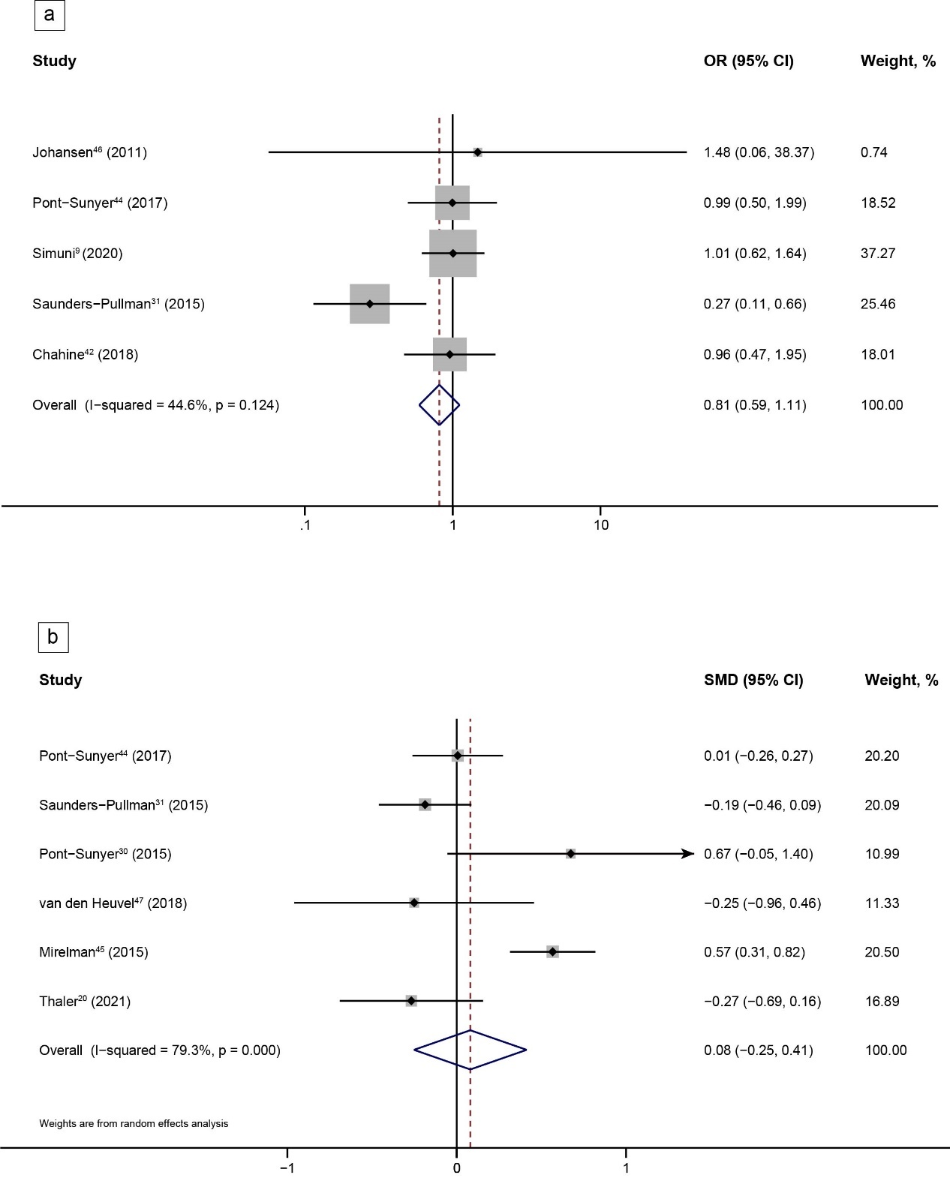
Figure S9 Risk (a) and severity (b) of RBD in asymptomatic carriers with LRRK2 G2019S and HCs

Figure S10 Risk (a) and severity (b) of EDS in asymptomatic carriers with LRRK2 G2019S and HCs


