Table of Contents
Supplementary Table S1. Excluded studies and reasons for exclusion 2
Supplementary Table S2. Appraisal of the included studies based on criteria for internal validity 3
Supplementary Table S3. Appraisal of the included studies based on criteria for external validity 4
Supplementary Table S4. Predictive parameters of various STOP-Bang cut-offs for different OSA severities in surgical patients 5
Supplementary Table S5. Meta-regression and sensitivity analysis of various subgroups for AHI ≥ 15 6
Supplementary Table S6. Meta-regression and sensitivity analysis of various subgroups for AHI ≥ 30 7
Supplementary Figure S1. Leave one study out analysis 8
Appendix 1. MEDLINE Search Strategy 9

Supplementary Table S1. Excluded studies and reasons for exclusion

Study | Exclusion Reason
Vasu et al. 2010 | No sleep study
Lockhart et al. 2013 | Did not report predictive parameters
Kulkarni et al. 2014 | Did not report predictive parameters
Seet et al. 2015 | No sleep study
Dixon et al. 2016 | No sleep study
Reed et al. 2016 | Did not report predictive parameters
Bamgbade et al. 2017 | Did not report predictive parameters
Lakdawala et al. 2018 | No sleep study
Mason etn al. 2018 | No sleep study
Krishnasamy et al. 2019 | Did not report predictive parameters
Sankar et al. 2019 | No sleep study
Carr et al. 2020 | Did not report predictive parameters
Duarte et al. 2020 | Did not report predictive parameters
Kara et al. 2020 | No sleep study
Sangkum et al. 2021 | No sleep study
Spielmanns et al. 2021 | Did not report predictive parameters

Supplementary Table S2. Appraisal of the included studies based on criteria for internal validity

Internal Criteria | Valid reference standard | Definition of the disease based on reference standard | Blind execution of index test and reference test | Index test interpreted independently of clinical information | Study design
Definition | Laboratory PSG (Lab PSG) or  Home Sleep Apnea Testing (HSAT) | OSA diagnosed based on the PSG results | PSG readings blinded to the questionnaire results and vice versa | The questionnaire interpreted independently of clinical information | Prospective or Retrospective
Chung et al. 2012 [37] | Standard PSG and HSAT | F | F | U | Prospective
Nunes et al. 2014 [38] | Lab PSG | F | N | U | Prospective
Deflandre et al. 2017 [39] | Lab PSG | F | N | U | Prospective
Devaraj et al. 2017 [40] | HSAT | F | F | F | Prospective
Glazer et al. 2018 [41] | Lab PSG | F | F | U | Retrospective
Horvath et al. 2018 [42] | Respiratory Polygraphy | F | N | U | Retrospective
Spence et al. 2018 [43] | HSAT | F | N | U | Prospective
Kreitinger et al. 2020 [44] | PSG and HSAT | F | N | U | Retrospective
Lazaro et al. 2020 [45] | HSAT | F | F | U | Prospective
Waseem et al. 2021 [46] | HSAT | F | F | F | Prospective

F: Full meeting criteria; P: Partially meeting criteria; U: Unsure if meeting criteria in subgroups; not sure; N: Not meeting criteria in subgroups; N/A: Not applicable

Supplementary Table S3. Appraisal of the included studies based on criteria for external validity

External Criteria | Spectrum of diseases | Settings | Previous screening | Demographic information | Explication of cut-off point of index test | Percentage missing | Missing data management | Subject selection for reference test
Definition | Inclusion and exclusion criteria mentioned | Enough information to identify setting | No pre-screening before application of the questionnaire | Age, gender, BMI data provided | Results presented for AHI ≥5 or RDI≥15 | Percentage missing mentioned | Analysis of missing data for basic characteristics | All subjects were invited or randomly selected to do PSG
Chung et al. 2012 [37] | F | F | F | F | F | F | F | F
Nunes et al. 2014 [38] | F | F | F | F | F | P | N | F
Deflandre et al. 2017 [39] | P | F | F | F | F | F | N | N
Devaraj et al. 2017 [40] | F | F | F | F | F | F | F | F
Glazer et al. 2018 [41] | F | F | F | F | F | N | N | F
Horvath et al. 2018 [42] | F | F | F | F | F | N | N | F
Spence et al. 2018 [43] | F | F | F | F | F | N | N | F
Kreitinger et al. 2020 [44] | F | F | F | F | F | N | N | F
Lazaro et al. 2020 [45] | F | F | F | F | F | F | N | F
Waseem et al. 2021 [46] | F | F | F | F | F | F | N | F

F: Full meeting criteria; P: Partially meeting criteria; U: Unsure if meeting criteria in subgroups; not sure; N: Not meeting criteria in subgroups; N/A: Not applicable

Supplementary Table S4. Predictive parameters of various STOP-Bang cut-offs for different OSA severities in surgical patients

STOP-Bang Cut-offs | Number of study groups | Sample Size | Prevalence | Sensitivity | Specificity | PPV | NPV
All OSA
≥ 3 | 4 | 1,160 | 65.2 (62.3 – 67.9) | 85 (82 – 88) | 47 (42 – 52) | 74.9 (71.8 – 77.7) | 62.7 (56.9 – 68.1)
≥ 4 | 2 | 896 | 71.9(68.8- 74.8) | 65.5(61.7- 69.1) | 59.5(53.2- 65.6) | 80.5(76.8- 83.8) | 40.3(35.3- 45.5)
≥ 5 | 3 | 978 | 70.2(67.1- 73) | 43.3(39.6- 47.1) | 79.4(74.2- 83.8) | 83.2(78.8- 86.8) | 37.3(33.5- 41.3)
≥ 6 | 2 | 896 | 71.9(68.8- 74.8) | 23.4(20.2- 27) | 90.4(86- 93.7) | 86.3(80- 90.8) | 31.6(28.2- 35.1)
≥ 7 | 2 | 896 | 71.9(68.8- 74.8) | 10(7.9- 12.7) | 92(87.8- 95) | 76.5(65.6- 84.7) | 28.6(25.5- 31.9)
≥ 8 | 2 | 896 | 71.8(68.8- 74.8) | 1.7(0.9- 3.1) | 98.8(96.2- 99.9) | 78.6(48.8- 94.3) | 28.2(25.3- 31.3)
Moderate-to-severe OSA
≥ 3 | 12 | 2,812 | 37.7 (35.9 – 39.5) | 88 (85 – 89) | 29 (27 – 32) | 42.9 (40.8– 45) | 79.6 (76.2 – 82.6)
≥ 4 | 10 | 2,648 | 35.3(33.5- 37.1) | 74.1(71.1- 76.8) | 55.7(53.3- 58) | 47.7(45.1- 50.1) | 79.8(77.4- 82)
≥ 5 | 10 | 2,478 | 36.6(34.7- 38.5) | 49.7(46.4- 53) | 78(75.8- 80) | 56.5(53- 60) | 72.9(70.7- 75)
≥ 6 | 9 | 2,396 | 36.8(34.9- 38.8) | 25.1(22.4- 28.2) | 92.4(90.9- 93.7) | 65.9(60.5- 70.9) | 67.9(65.9- 69.9)
≥ 7 | 4 | 977 | 42.8(39.7- 50) | 12.9(9.9- 16.6) | 96.2(94.2- 97.6) | 72(60.3- 81.5) | 59.6(56.4- 62.8)
≥ 8 | 2 | 896 | 42.4(39.1- 45.7) | 4.2(2.5- 6.8) | 98.6(97- 99.4) | 69.6(47- 85.9) | 58.3(54.9- 61.6)
Severe OSA
≥ 3 | 8 | 2,447 | 17 (15.5 – 18.6) | 90 (87 – 93) | 27 (25 – 29) | 20.3 (18.5 – 22.2) | 93.2 (90.9 – 95.1)
≥ 4 | 6 | 2,101 | 16(14.6- 17.8) | 83.1(78.7- 86.9) | 50.8(48.4- 3.1) | 24.5(22.1- 27.1) | 94(92.2- 95.3)
≥ 5 | 7 | 2,183 | 15.8(14.3- 17.4) | 61.4(56- 66.5) | 75.1(73- 77) | 31.6(28.2- 35.4) | 91.2(89.6- 92.5)
≥ 6 | 6 | 2,101 | 16.1(14.6- 17.8) | 33.3(28.4- 38.7) | 90.7(89.2- 92) | 40.9(35.1- 47) | 87.6(86- 89)
≥ 7 | 2 | 896 | 22(19.3- 24.9) | 19.8(14.6- 26.1) | 95.4(93.5- 96.8) | 54.9(42.7- 66.6) | 80.8(78- 83.4)
≥ 8 | 1 | 150 | 42(34- 50) | 7.9(2.9- 18.2) | 97.7(91.1- 99.6) | 71.4(30.2- 94.9) | 59.4(50.9- 67.5)

Supplementary Table S5. Meta-regression and sensitivity analysis of various subgroups for AHI ≥ 15
 | Sensitivity |  |  | Specificity |  |  | Diagnostic Odds Ratio- Log scale
Co-variate  (Number of study groups) | Point Estimate  (95% CI) | Coefficient (SE) | p-value | Point Estimate  (95% CI) | Coefficient (SE) | p-value | Point Estimate  (95% CI) | Coefficient (SE) | p-value
Apnea Hypopnea Index (AHI) ≥ 15 (12)
Age (12) | 90.1 (83.7- 94.1) | -0.00 (0.05) | 0.87 | 28.8 (22- 36.7) | 0.00 (0.02) | 0.71 | 1.21 (0.98- 1.43) | -0.00 (0.05) | 0.91
Male gender (12) | 90.1 (83.7- 94.1) | 0.28 (0.16) | 0.07 | 28.8 (22- 36.7) | -0.07 (0.10) | 0.46 | 1.21 (0.98- 1.43) | 0.20 (0.19) | 0.29
BMI (12) | 90.1 (83.7- 94.1) | 1.62 (1.17) | 0.16 | 28.8 (22- 36.7) | 0.05 (0.72) | 0.95 | 1.21 (0.98- 1.43) | 1.58 (1.41) | 0.26
Neck circumference (12) | 90.1 (83.7- 94.1) | -4.77 (3.89) | 0.22 | 28.8 (22- 36.7) | -0.31 (2.36) | 0.90 | 1.21 (0.98- 1.43) | -4.70 (4.66) | 0.31
Sample Size (12) | 90.1 (83.7- 94.1) | 0.00 (0.00) | 0.34 | 28.8 (22- 36.7) | 0.00 (0.00) | 0.48 | 1.21 (0.98- 1.43) | 0.00 (0.00) | 0.27
Prevalence (12) | 90.1 (83.7- 94.1) | 0.16 (0.14) | 0.24 | 28.8 (22- 36.7) | 0.04 (0.09) | 0.67 | 1.21 (0.98- 1.43) | 0.18 (0.17) | 0.29
Study type  • Prospective (10)  • Retrospective (02) | 90 (87.7- 91.9)  76 (70- 82) | 0.18 (1.70) | 0.91 | 27.5 (22.9- 32.7)  43 (37- 49) | -0.59 (0.67) | 0.38 | 1.23 (0.97- 1.49)  3.44 (2.64-  4.47) * | -1.33 (1.87) | 0.47
Validation tool  • Lab PSG (04)  • Home PSG (06)  • Both (02) | 78 (73- 83)  89.7 (86.2- 92.3)  91 (87- 93) | 3.97 (5.32)  8.12 (7.45) | 0.45  0.27 | 43 (36- 49)  29.4 (23.7- 35.9)  29 (25- 33) | 2.55 (3.24)  2.58 (4.63) | 0.43  0.59 | 2.86 (1.84-  4.45) *  1.18 (0.82- 1.54)  3.91 (2.65-  5.77) * | 5.89 (6.41)  9.77 (9.06) | 0.35  0.28

*Pooled Diagnostic Odds Ratio (Model results)
Abbreviations: CI, confidence interval; SE, standard error.

Supplementary Table S6. Meta-regression and sensitivity analysis of various subgroups for AHI ≥ 30

 | Sensitivity |  |  | Specificity |  |  | Diagnostic Odds Ratio- Log scale
Co-variate  (Number of study groups) | Point Estimate  (95% CI) | Coefficient (SE) | p-value | Point Estimate  (95% CI) | Coefficient (SE) | p-  value | Point Estimate  (95% CI) | Coefficient (SE) | p-  value
Apnea Hypopnea Index (AHI) ≥ 30 (8)
Age (8) | 93.3 (82.4- 97.7) | 0.09 (0.18) | 0.59 | 28 (20.7- 36.7) | -0.04 (0.03) | 0.12 | 1.39 (1.00- 1.78) | 0.04 (0.18) | 0.89
Male gender (8) | 93.3 (82.4- 97.7) | 0.16 (0.24) | 0.62 | 28 (20.7- 36.7) | -0.02 (0.05) | 0.73 | 1.39 (1.00- 1.78) | 0.14 (0.23) | 0.57
BMI (8) | 93.3 (82.4- 97.7) | 0.64 (0.93) | 0.49 | 28 (20.7- 36.7) | 0.01 (0.18) | 0.94 | 1.39 (1.00- 1.78) | 0.66 (0.94) | 0.49
Neck circumference (8) | 93.3 (82.4- 97.7) | -1.94 (2.99) | 0.52 | 28 (20.7- 36.7) | -0.15 (0.56) | 0.79 | 1.39 (1.00- 1.78) | -2.11 (3.04) | 0.49
Sample Size (8) | 93.3 (82.4- 97.7) | -0.00 (0.00) | 0.59 | 28 (20.7- 36.7) | -0.000 (<0.001) | 0.45 | 1.39 (1.00- 1.78) | -0.00 (0.00) | 0.45
Prevalence (8) | 93.3 (82.4- 97.7) | 0.03 (0.02) | 0.16 | 28 (20.7- 36.7) | -0.00 (0.00) | 0.55 | 1.39 (1.00- 1.78) | 0.03 (0.02) | 0.21
Study type  • Prospective (07)  • Retrospective (01) | 95 (92.1- 96.9)  64.8 (52.5- 75.5) | -2.81 (0.76) | <0.001 | 24.7 (20.8- 29)  56.5 (49.2- 63.5) | 1.91 (0.38) | <0.001 | 1.80 (1.29- 2.31) | -0.90 (0.83) | 0.28
Validation tool  • Lab PSG (2)  • Home PSG (05)  • Both (1) | 80 (72- 86)  94.6 (89.4- 97.4)  94.8 (89.1- 97.7) | 0.52 (0.82)  -0.03 (0.54) | 0.53  0.96 | 43.9 (38.1- 50)  25.2 (20.4- 30.8)  27.6 (24.1- 31.4) | -0.69 (0.36)  -0.16 (0.19) | 0.06  0.40 | 2.81 (1.42- 5.57) *  1.68 (0.93- 2.43) | -0.17 (0.87)  -0.26 (0.55) | 0.85  0.64
*Pooled Diagnostic Odds Ratio (Model results)
Abbreviations: CI, confidence interval; SE, standard error.

Supplementary Figure S1. Leave one study out analysis

Moderate-to-severe OSA (AHI>=15)
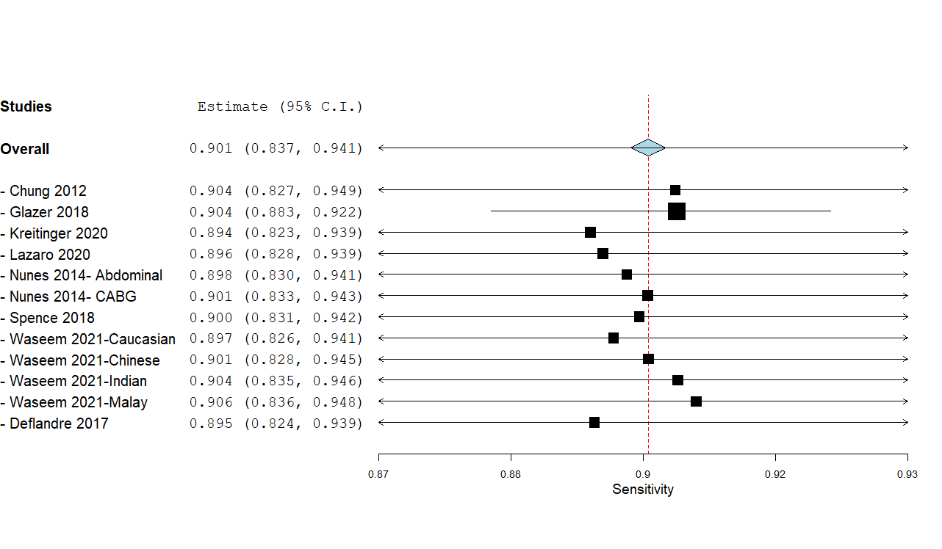
Severe OSA (AHI>=30)
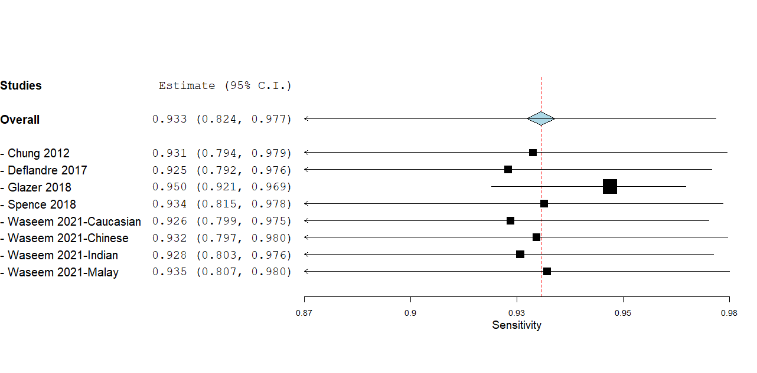

Appendix 1. MEDLINE Search Strategy
Date completed: May 13, 2021

# | Searches | Results
1 | "stop-bang".mp,kw,kf. | 2154
2 | "stopbang".mp,kw,kf. | 258
3 | "stop-bang".af. | 2268
4 | "stopbang".af. | 260
5 | 1 or 2 or 3 or 4 | 2411
6 | remove duplicates from 5 | 1583
7 | "Delayed Emergence from Anesthesia"/ | 545
8 | Anesthesia Recovery Period/ | 19331
9 | co.xs. and post*.mp. [Complications exploded floating subheading] | 299921
10 | exp "Anesthesia and Analgesia"/ | 1384189
11 | exp Intraoperative Complications/ | 118589
12 | exp Intraoperative Period/ | 299904
13 | exp Postoperative Care/ | 193335
14 | exp Postoperative Complications/ | 1518748
15 | exp Postoperative Period/ | 778649
16 | exp Specialties, Surgical/ | 6919318
17 | exp Surgeons/ | 234219
18 | exp Surgical Procedures, Operative/ | 10076420
19 | Operating Room Nursing/ | 16985
20 | Operating Rooms/ | 69198
21 | Operative Blood Salvage/ | 1538
22 | Operative Time/ | 135977
23 | Perioperative Care/ | 87336
24 | Perioperative Medicine/ | 370
25 | Perioperative Nursing/ | 14780
26 | Perioperative Period/ | 78134
27 | Postanesthesia Nursing/ | 2127
28 | Postoperative Cognitive Complications/ | 2205
29 | Reoperation/ | 202718
30 | Salvage Therapy/ | 45810
31 | su.fs. [ Surgery floating subheading ] | 4381539
32 | tr.fs. [ Transplant floating subheading ] | 148935
33 | (after adj6 (operation? or operative??)).mp,kw. | 388246
34 | (after adj6 (surgery or surgeries or surgical*)).mp,kw. | 1238387
35 | (aneurysm* adj2 repair*).mp,kw. | 40329
36 | (cardiac adj2 catheter* adj2 ablat*).mp,kw. | 410
37 | (carotid adj2 endarterectom*3).mp,kw. | 42412
38 | (consequen* adj6 (surgery or surgeries or surgical*)).mp,kw. | 16176
39 | (coronary adj2 catheter* adj2 ablat*).mp,kw. | 44
40 | (coronary adj2 radiofrequenc* adj2 ablat*).mp,kw. | 27
41 | (coronary adj3 bypass*).mp,kw. | 221001
42 | (coronary adj3 catheteri*).mp,kw. | 6892
43 | (follow* adj6 (operation? or operative??)).mp,kw. | 99848
44 | (follow* adj6 (surgery or surgeries or surgical*)).mp,kw. | 424736
45 | (heart adj2 radiofrequenc* adj2 ablat*).mp,kw. | 85
46 | (heart adj2 valve? adj2 repair*).mp,kw. | 344
47 | (heart adj2 valve? adj2 replac*).mp,kw. | 20607
48 | (hybrid-maze adj2 procedure*).mp,kw. | 13
49 | (mitral valve? adj2 repair*).mp,kw. | 23017
50 | (mitral valve? adj2 reparat*).mp,kw. | 32
51 | (near adj2 miss*).mp,kw. | 8736
52 | (open adj1 reduction?).mp,kw. | 44292
53 | (perioperat* or peri-operat*).mp,kw. | 381771
54 | (post* adj3 pain).mp,kw. | 266700
55 | (readmi* or re-admi*).mp,kw. | 186003
56 | (respiratory adj2 aspirat*).mp,kw. | 3184
57 | (subsequent* adj6 (operation? or operative??)).mp,kw. | 12360
58 | (subsequent* adj6 (surgery or surgeries or surgical*)).mp,kw. | 48248
59 | (transmyocardia* adj3 revasculari*).mp,kw. | 1693
60 | (transmyocardia* adj5 ablat*).mp,kw. | 11
61 | adenectom*.mp,kw. | 964
62 | adrenalectom*.mp,kw. | 69352
63 | an?esthe*.mp,jw,in. | 2165904
64 | angioplast*3.mp,kw. | 215354
65 | appendectom*.mp,kw. | 49046
66 | arthrectom*.mp,kw. | 130
67 | arthroplast???.mp,kw. | 278852
68 | atherectom*3.mp,kw. | 13306
69 | CABG.mp,kw. | 67929
70 | caesarean*.mp,kw. | 77678
71 | cardiac ablat*.mp,kw. | 1112
72 | cardiomyoplast*3.mp,kw. | 2764
73 | cervicectom*.mp,kw. | 930
74 | cesarean*.mp,kw. | 239878
75 | cholecystectom*.mp,kw. | 121546
76 | colectom*.mp,kw. | 52435
77 | coronary artery bypass surger*.mp,kw. | 40751
78 | cystectom*.mp,kw. | 60337
79 | cytokine release syndrome?.mp,kw. | 7805
80 | delayed emergence.mp,kw. | 1414
81 | discectom*.mp,kw. | 23454
82 | diskectom*.mp,kw. | 18529
83 | duodenectom*.mp,kw. | 2303
84 | emergence deliri???.mp,kw. | 1858
85 | esophagectom*.mp,kw. | 34756
86 | fundectom*.mp,kw. | 293
87 | gastrectom*.mp,kw. | 139319
88 | gerionco*.mp,kw. | 1
89 | glossectom*.mp,kw. | 4876
90 | gonadectom*.mp,kw. | 11668
91 | hemiarthroplast???.mp,kw. | 11774
92 | hemi-arthroplast???.mp,kw. | 579
93 | hemicolectom*.mp,kw. | 19219
94 | hemi-colectom*.mp,kw. | 477
95 | hepatectom*.mp,kw. | 82587
96 | hypophysectom*.mp,kw. | 36567
97 | iridectom*.mp,kw. | 5602
98 | jejunectom*.mp,kw. | 254
99 | laparoscop*.mp,kw. | 485272
100 | laparotom*.mp,kw. | 205962
101 | laryngectom*.mp,kw. | 32148
102 | lobectom*.mp,kw. | 82070
103 | lumpectom*.mp,kw. | 14310
104 | lymphadenectom*.mp,kw. | 69707
105 | lymph-adenectom*.mp,kw. | 215
106 | lymphectom*.mp,kw. | 129
107 | mandibulectom*.mp,kw. | 2626
108 | mastectom*.mp,kw. | 136418
109 | mastoidectom*.mp,kw. | 11515
110 | maxillectom*.mp,kw. | 4320
111 | mesohepatectom*.mp,kw. | 193
112 | meso-hepatectom*.mp,kw. | 6
113 | metastasectom*.mp,kw. | 7903
114 | MIDCAB.mp,kw. | 1249
115 | myectom*.mp,kw. | 5055
116 | myomectom*.mp,kw. | 16665
117 | necrosectom*.mp,kw. | 3833
118 | nephrectom*.mp,kw. | 144306
119 | neurosurg*.mp,kw. | 229700
120 | obstetr*.mp,in,kw,kf. | 1378104
121 | obstetr*.mp,kw. | 477163
122 | oesophagectom*.mp,kw. | 5282
123 | oncosurg*.mp,kw. | 669
124 | onco-surg*.mp,kw. | 167
125 | oncosurg*.mp. | 669
126 | onco-surg*.mp. | 167
127 | oophorectom*.mp,kw. | 30988
128 | operati*.mp,kw. | 3151994
129 | orchidectom*.mp,kw. | 8527
130 | orchiectom*.mp,kw. | 44925
131 | pancreatectom*.mp,kw. | 42536
132 | pancreaticoduodenectom*.mp,kw. | 40754
133 | pancreatico-duodenectom*.mp,kw. | 797
134 | parathyroidectom*.mp,kw. | 25812
135 | para-thyroidectom*.mp,kw. | 41
136 | peroperativ*.mp,kw. | 100504
137 | pharyng*esophagectom*.mp,kw. | 363
138 | pharyngectom*.mp,kw. | 2546
139 | pharyngolaryngoesophagectom*.mp,kw. | 299
140 | pneumonectom*.mp,kw. | 46856
141 | post*an?esth*.mp,kw. | 15975
142 | post-*an?esth*.mp,kw. | 9765
143 | post*cardiac.mp,kw. | 2468
144 | post*ectom*.mp,kw. | 39092
145 | post-*ectom*.mp,kw. | 510
146 | post*laparoscop*.mp,kw. | 403
147 | post-*laparoscop*.mp,kw. | 1267
148 | post*laparotom*.mp,kw. | 189
149 | post-*laparotom*.mp,kw. | 322
150 | post*microsurg*.mp,kw. | 6
151 | post-*microsurg*.mp,kw. | 21
152 | post-*operat*.mp,kw. | 298170
153 | post*ostom*.mp,kw. | 738
154 | post-*otom*.mp,kw. | 114
155 | post*pericardiot*.mp,kw. | 1254
156 | post*pex*.mp,kw. | 53
157 | post-*pex*.mp,kw. | 23
158 | post*plast*.mp,kw. | 3315
159 | post-*plast*.mp,kw. | 72
160 | post-*procedur*.mp,kw. | 37396
161 | post*reconstruct*.mp,kw. | 723
162 | post-*reconstruct*.mp,kw. | 1098
163 | post*scop*.mp,kw. | 2439
164 | post-*scop*.mp,kw. | 168
165 | post-*surg*.mp,kw. | 71624
166 | post*surger*.mp,kw. | 18144
167 | post-*surger*.mp,kw. | 40454
168 | post*transplant*.mp,kw. | 52407
169 | post-*transplant*.mp,kw. | 95545
170 | postintervention*.mp,kw. | 37474
171 | post-intervention*.mp,kw. | 83737
172 | postoperat*.mp,kw. | 2514567
173 | post-operat*.mp,kw. | 298165
174 | postpericardio*.mp,kw. | 1271
175 | post-pericardio*.mp,kw. | 391
176 | postproced*.mp,kw. | 24607
177 | postprocedur*.mp,kw. | 24596
178 | post-procedur*.mp,kw. | 37392
179 | postsurg*.mp,kw. | 61721
180 | post-surg*.mp,kw. | 71547
181 | proctocolectom*.mp,kw. | 14268
182 | prostatect*.mp,kw. | 126192
183 | quadrantectom*.mp,kw. | 1737
184 | re-*operat*.mp,kw. | 20476
185 | reoperat*.mp,kw. | 253405
186 | re-operat*.mp,kw. | 20475
187 | reresect*.mp,kw. | 551
188 | resect*.mp,kw. | 1218717
189 | rhinectom*.mp,kw. | 305
190 | salpingectom*.mp,kw. | 10758
191 | salpingo-oophorectom*.mp,kw. | 15414
192 | second look*.mp,kw. | 16429
193 | second-look*.mp. | 16429
194 | segmentectom*.mp,kw. | 14156
195 | sequelae.mp,kw. | 196733
196 | splenectom*.mp,kw. | 90570
197 | subsegmentectom*.mp,kw. | 663
198 | sub-segmentectom*.mp,kw. | 48
199 | surgeon*.mp,kw. | 726546
200 | surger*.mp,kw. | 7661852
201 | surger???.mp,kw. | 7661117
202 | surgical*.mp,kw. | 3994250
203 | takeback?.mp. | 118
204 | take-back?.mp. | 1211
205 | thymectom*.mp,kw. | 26994
206 | thyroidectom*.mp,kw. | 89186
207 | tonsillectom*.mp,kw. | 36900
208 | transfusion*.mp,kw. | 528540
209 | transplant*.mp,kw. | 1992432
210 | trauma*.mp,kw. | 1377045
211 | trisegmentectom*.mp,kw. | 991
212 | tri-segmentectom*.mp,kw. | 35
213 | tumorectom*.mp,kw. | 2846
214 | unanticipat*.mp,kw. | 23440
215 | undesired.mp,kw. | 24524
216 | unintended.mp,kw. | 50147
217 | uretectom*.mp,kw. | 25
218 | uvulectom*.mp,kw. | 263
219 | vaginectom*.mp,kw. | 936
220 | vulvectom*.mp,kw. | 4137
221 | exp surgery/ [ embase ] | 6827125
222 | exp surgeon/ | 223683
223 | or/7-222 [ PERIOPERATIVE OR SURGERY OR POSTOPERATIVE INCLUDING SURGERY OR POST*Ectom* ] | 19023856
224 | 5 and 223 | 1193
225 | remove duplicates from 224 | 768
226 | 225 use medall | 256
227 | 225 use emczd | 431
228 | 225 use psyh | 34
229 | 225 use emcr | 14
230 | 225 use cctr | 33
231 | 225 use coch | 0

