Supplementary Figures
Figures excluding Japanese articles from Fig. 2-4

(a)
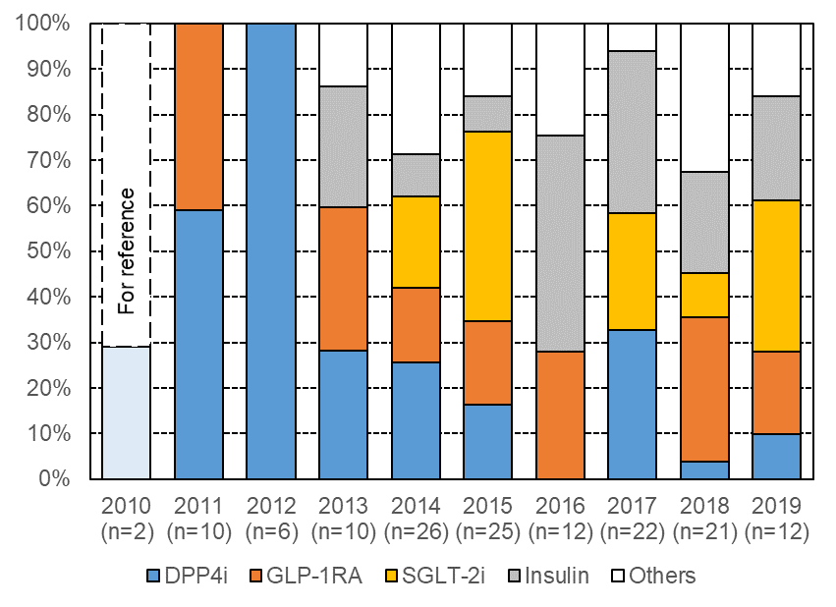
(b)
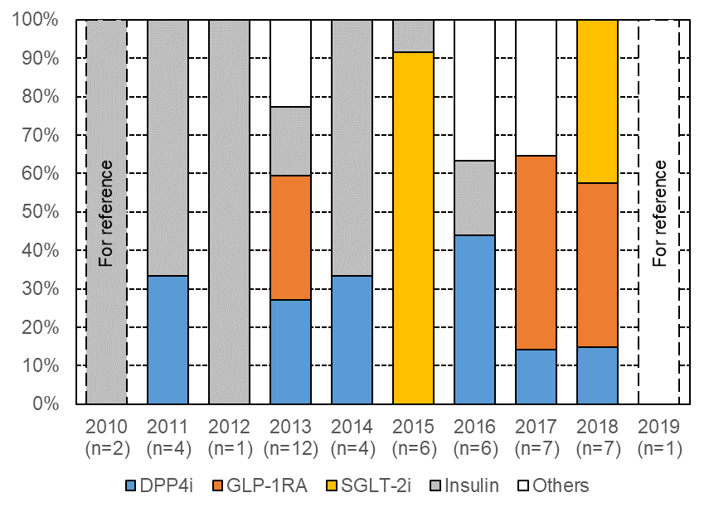
Supplementary Fig. 1 Changes over the past 10 years in the percentage of arms with the 4 major regimens (including their combination therapies) in a) RCTs and b) non-RCTs excluding Japanese articles.
DPP-4i, dipeptidyl peptidase-4 inhibitors; GLP-1RA, glucagon-like peptide 1 receptor agonists; SGLT-2i, sodium-glucose cotransporter-2 inhibitors; RCT, randomized controlled trial; non-RCT, non-randomized controlled trial.
(a)
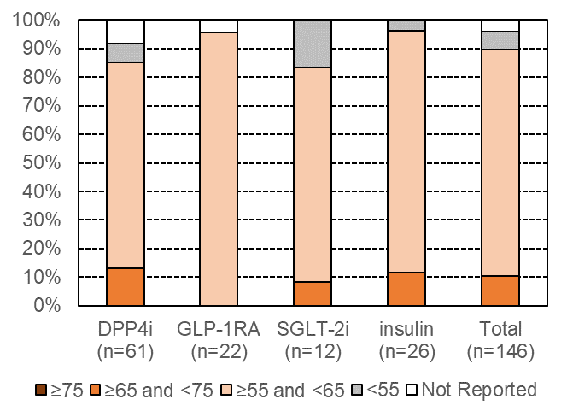
(b)
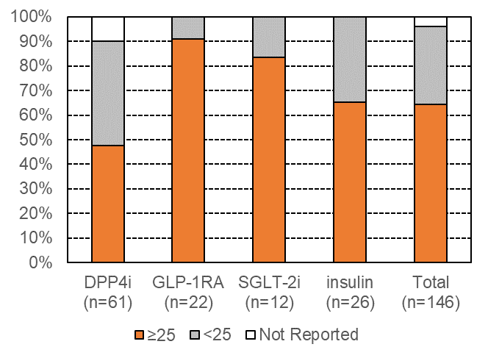
(c)
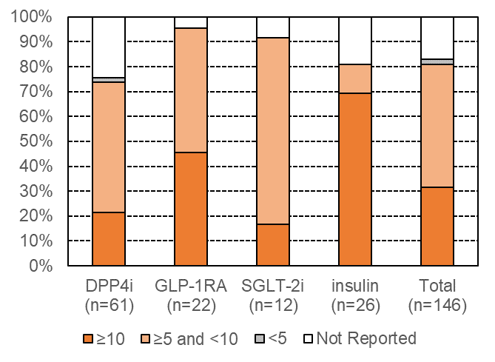
Supplementary Fig. 2 The percentage of arms in RCTs excluding Japanese articles: a) with older adults (mean baseline age of 65 or older) for the 4 major regimens (including their combination therapies); b) with obesity (mean baseline BMI of 25 or higher) for the 4 major regimens; c) with mean baseline disease duration of 10 years or longer for the 4 major regimens.
BMI, body mass index; DPP-4i, dipeptidyl peptidase-4 inhibitors; GLP-1RA, glucagon-like peptide 1 receptor agonists; SGLT-2i, sodium-glucose cotransporter-2 inhibitors; RCT, randomized controlled trial; non-RCT, non-randomized controlled trial.

(a)
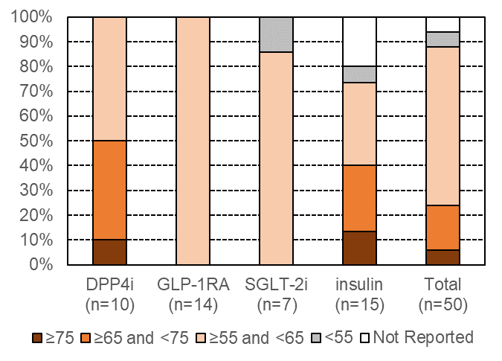
(b)
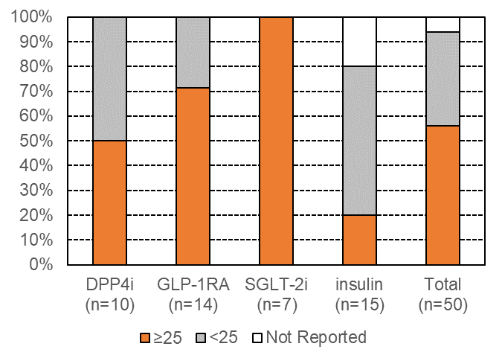
(c)
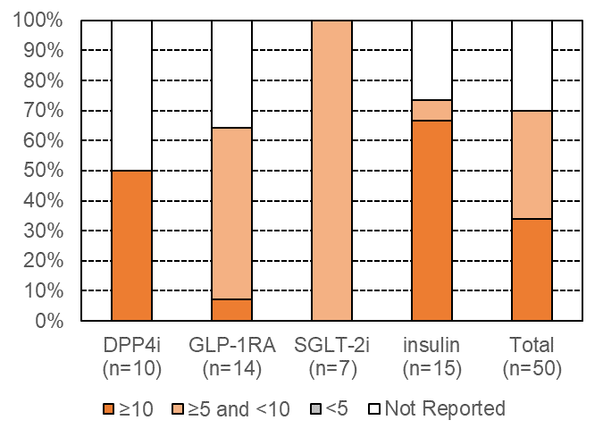
Supplementary Fig. 3 The percentage of arms in non-RCTs excluding Japanese articles: a) with older adults (mean baseline age of 65 or older) for the 4 major regimens (including their combination therapies); b) with obesity (mean baseline BMI of 25 or higher) for the 4 major regimens; c) with mean baseline disease duration of 10 years or longer for the 4 major regimens.
BMI, body mass index; DPP-4i, dipeptidyl peptidase-4 inhibitors; GLP-1RA, glucagon-like peptide 1 receptor agonists; SGLT-2i, sodium-glucose cotransporter-2 inhibitors; RCT, randomized controlled trial; non-RCT, non-randomized controlled trial.

