Supplementary document 1

PICO Worksheet and Search Strategy Protocol

- Define your question using PICO by identifying: Patient/Problem, Intervention, Comparison group and Outcome: Patient/Problem: Frailty older adults with COVID-19
Intervention: None Comparison: None
Outcome: Mortality

Write out your question:

In older adults infected with COVID-19 with or without frailty, is frailty suitable to predict the mortality rate among these populations?
- Type of question/problem:

Circle one: Therapy / Prevention / Diagnosis / Etiology / Prognosis
- Type of studies/publications to include in the search: Check all that apply:
Meta-analysis Systematic review
Clinical practice guidelines Randomized controlled trial
Research studies or articles  √ Cohort study or cross-sectional study
Research report or other grey literature

- List main topics and alternate terms from your PICO question that can be used for your search:

Main topics | Alternate terms
Frailty older adults with COVID 19 | Frail* older adults, older people, elderly, older patients, geriatric, COVID 19, coronavirus disease 2019, cov-19, sars-cov-2, coronavirus, novel coronavirus
Mortality | Mortality, death
- Write out your search strategy:
Frail*
AND older adults OR older people OR elderly OR older patients OR geriatric
AND COVID-19 OR coronavirus disease 2019 OR cov-19 OR sars-cov-2 OR coronavirus OR novel coronavirus
AND Mortality OR death
- List any limits that may apply to your search:
Age: Older adults (≥ 65 years)
Year(s) of publication: December 1st 2019 to March 17th 2021 Language(s): English
- List the databases you will search:
CINAHL, Google scholar, PubMed (MEDLINE), and Web of Science
This form is adapted from: Miller, S.A. (2001). PICO worksheet and search strategy. US National Center for Dental Hygiene Research.
Supplementary document 2
a)

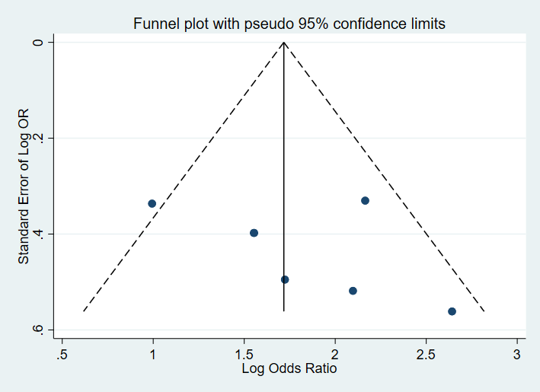

b)
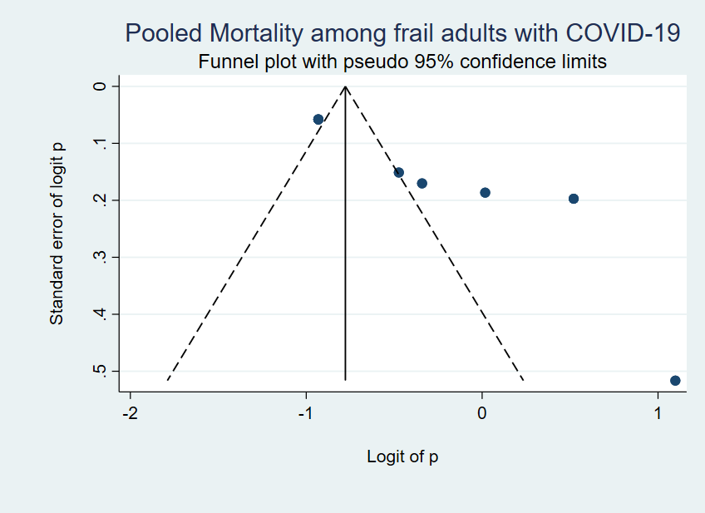

c)

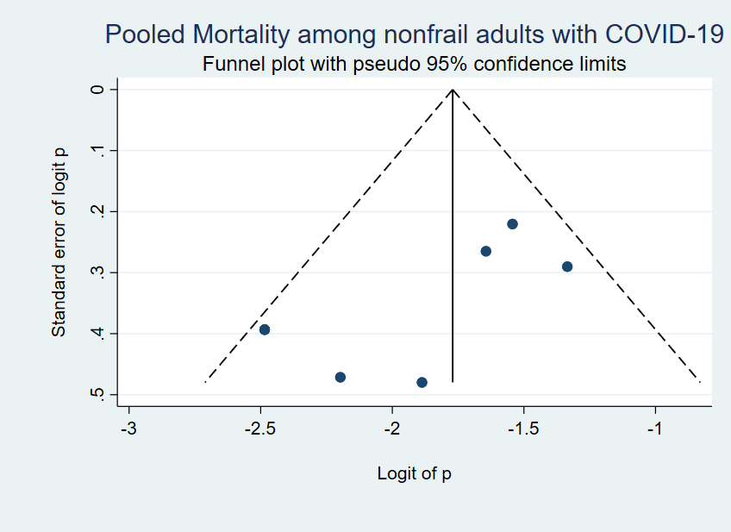

Figure 5. Funnel plot of; a) mortality among frail versus non-frail older adults with COVID-19, b) prevalence of mortality among frail older adults with COVID-19, c) prevalence of mortality among non-frail older adults with COVID-19

