Supplementary Figure 1. Funnel plot for included studies
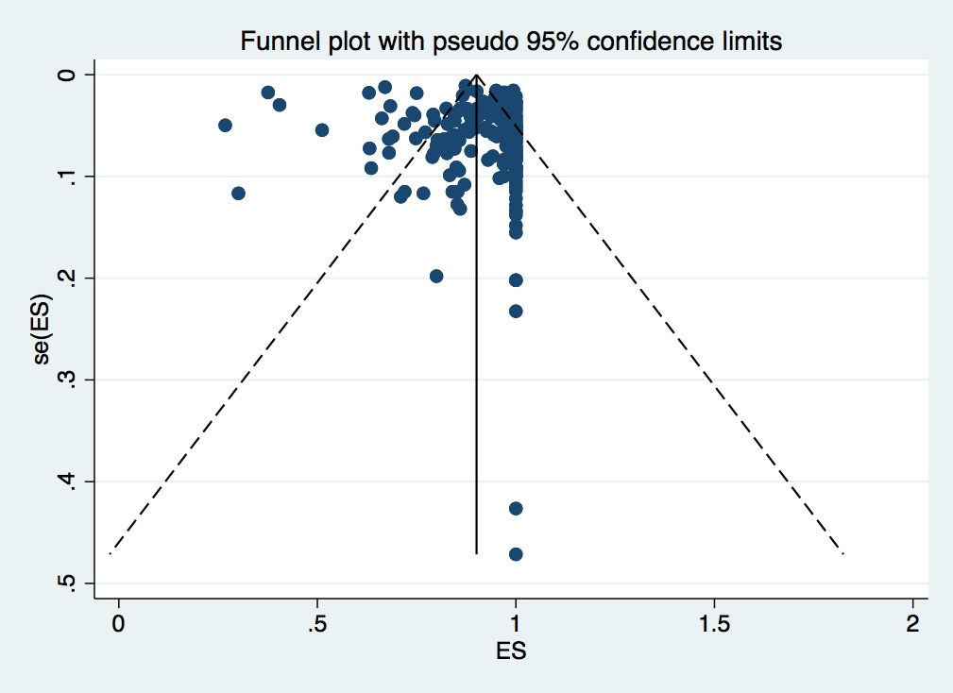
Egger’s test = 0.028

