Supplementary Material

Search Strategy
- "Kidney Diseases"[Mesh] OR "Renal Dialysis"[Mesh] OR renal[tiab] OR kidney[tiab] OR nephro*[tiab] OR hemodialysis[tiab] OR haemodialysis[tiab]
- Biopsy[Mesh] OR "Bone Density"[Mesh] OR "bone mineral density"[tiab] OR "x-ray absorptiometry"[tiab] OR DXA[tiab]
- Alendronate[Mesh] OR "Etidronic Acid"[Mesh] OR Teriparatide[Mesh] OR Raloxifene[Mesh] OR bisphosphonate*[tiab] OR pamidronate[tiab] OR alendronate[tiab] OR teriparatide[tiab] OR raloxifene[tiab] OR denosumab[tiab] OR risedronate[tiab]
- Calcium/blood[Mesh] OR Parathyroid Hormone[Mesh] OR Phosphorus/blood[Mesh] OR (serum[tiab] AND (phosphorus[tiab] OR calcium[tiab] OR PTH[tiab] OR "parathyroid hormone"[tiab] OR phosphate[tiab]))
- "Calcium Carbonate"[Mesh] Or "Calcium Citrate"[Mesh] OR Lanthanum[Mesh] OR "aluminum hydroxide"[tiab] OR "calcium acetate"[tiab] OR "calcium carbonate"[tiab] OR "calcium citrate"[tiab] OR "calcium ketoglutarate"[tiab] OR "calcium gluconate"[tiab] OR "ferric citrate"[tiab] OR "magnesium/calcium carbonate"[tiab] OR " calcium acetate/magnesium carbonate "[tiab] OR sevelamer[tiab] OR lanthanum[tiab] OR "sucroferric oxyhydroxide"[tiab] OR ((phosphorus* OR phosphate*[tiab]) AND (binder*[tiab] OR binding*[tiab]))
- "Phosphorus, dietary"[Mesh] OR (diet*[tiab] AND (phosphate[tiab] OR phosphorus[tiab]) AND (restrict*[tiab] OR limit*[tiab]))
- "Vitamin D"[Mesh] OR "vitamin D"[tiab] OR cholecalciferol*[tiab] OR ergocalciferol*[tiab] OR ercalcidiol*[tiab] OR calcidiol*[tiab] OR calcitriol*[tiab] OR doxercalciferol*[tiab] OR paricalcitol*[tiab] OR alfacalcidol*[tiab] OR falecalcitriol*[tiab] OR maxacalcitol*[tiab]
- #1 AND #2
- #1 AND #3
- #1 AND #4
- #1 AND #5
- #1 AND #6
- #1 AND #7
- #8 OR #9 OR #10 OR #11 OR #12 OR #13
- #14 AND ("systematic review"[ti] OR "meta-analysis"[ti])
- #14 NOT #15
- #16 AND Eng[la] NOT (animal[mh] NOT human[mh]) Filters: from 2017 - 2020

Supplementary Figures and Tables

Supplementary Figures
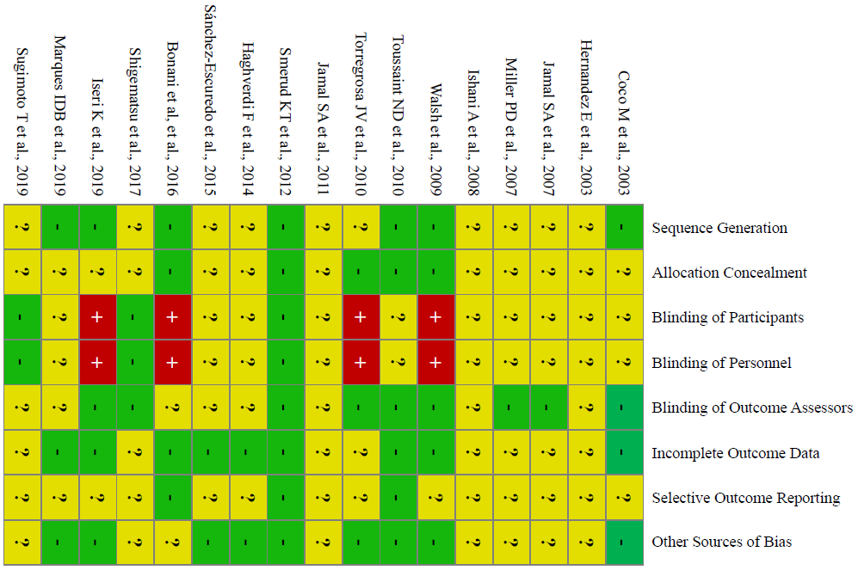
Supplementary Figure 1. Assessment of risk of bias in the included trials

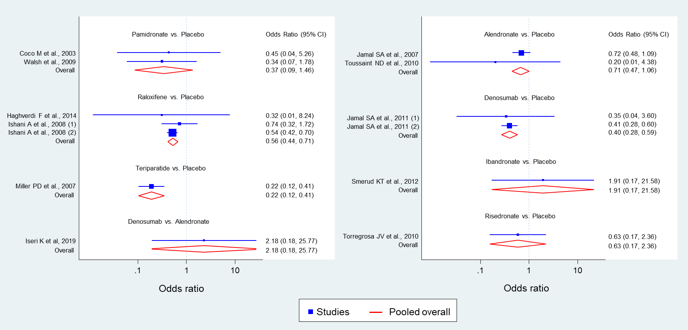
Supplementary Figure 2. Summary of the head-to-head comparisons of relative risk of vertebral or clinical fractures for the treatment of osteoporosis in patients with CKD or underwent kidney transplantation.

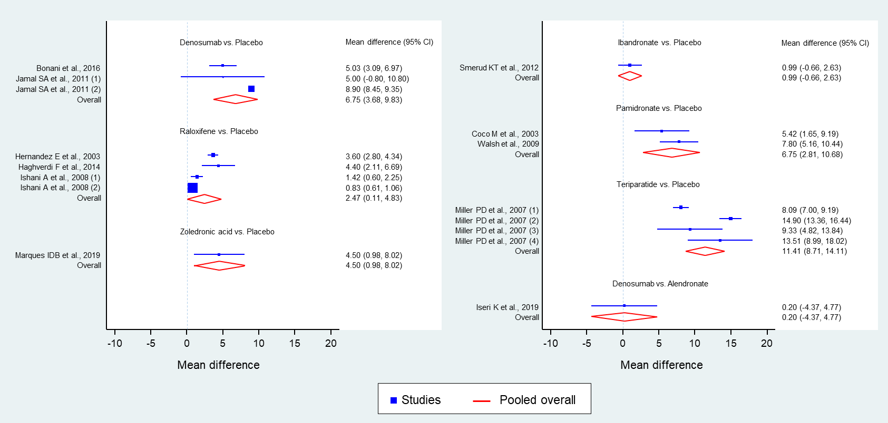
Supplementary Figure 3. Summary of the head-to-head comparisons of mean difference percentage change of vertebral BMD for the treatment of osteoporosis in patients with CKD or underwent kidney transplantation.

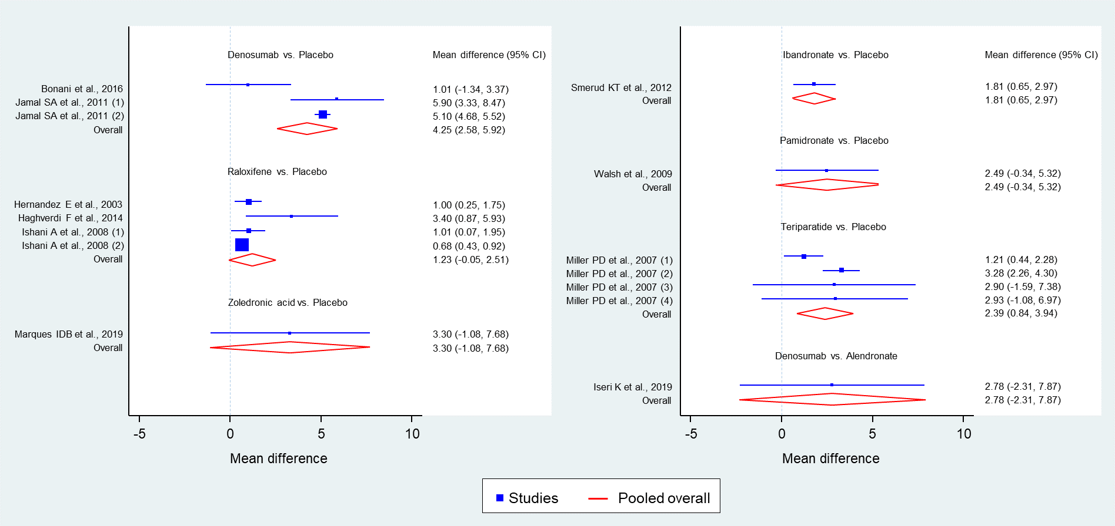
Supplementary Figure 4. Summary of the head-to-head comparisons of mean difference percentage change of femoral neck BMD for the treatment of osteoporosis in patients with CKD or underwent kidney transplantation.

Supplementary Tables
Supplementary Table 1. Summary of the Number of Adverse Events in Selected Randomized Controlled Trials
Study, Year | Death | CVD | Infections | Renal adverse events | Musculoskeletal pain
Coco M et al., 2003 | Not reported | Not reported | Not reported | Not reported | Not reported
Hernandez E et al., 2003 | Not reported | Not found | Not reported | Not reported | Not reported
Jamal SA et al., 2007 | The incidence of death was 1.6% in patients with eGFR<45mL/minute compared with 1.9% in patients with eGFR ≧45mL/minute. | The incidence of CV events was 2.6% in patients with eGFR < 45mL/minute compared with 3.2% in patients with eGFR ≧45mL/minute. | Not reported | The increase in serum creatinine was the same compared with placebo. | Not reported
Miller PD et al., 2007 | Not reported | Not reported | Not reported | No significant difference of teriparatide 20mcg or 40mcg daily compared with placebo among patients with GFR 30-80 ml/minute in the incidence of renal-related adverse events. | No significant differences of teriparatide 20mcg or 40mcg daily compared with placebo among patients with GFR 30-80 ml/minute in the incidence of arthralgia.
Ishani A et al., 2008 | 11.05% patients with eGFR <60 ml/minute discontinued treatment because of an adverse event or death. | Not reported | Not reported | Not reported | Not reported
Walsh et al.,2009 | Not reported | Not reported | Not reported | The acute rejection episodes, non-rejection acute deterioration in kidney function, and serum creatinine level did not differ between the two groups. | Not reported
Toussaint ND et al., 2010 | Each group had 1 death episode | Not reported | Not reported | No significant difference compared with placebo in the decline of renal function. | Not reported
Torregrosa JV et al., 2010 | One death episode in control group | Not reported | Not reported | Not found | Not reported
Jamal SA et al., 2011 | Not found | No significant difference compared with placebo (6.36% vs. 6.37%) | No significant difference compared with placebo (4.43% vs. 3.50%) | There were no significant differences compared with placebo in the change in serum creatinine by stage 3 and 4 of CKD from baseline to year 1 and year 2. From baseline to year 3, a small but significant difference in the change of serum creatinine (<2 mmol/L) by stage 3 of CKD was found compared with placebo. | Not reported
Smerud KT et al., 2012 | Three death episodes in placebo group | Not found | IV Ibandronate vs. placebo  CMV infection, n (%)  14 (21.2%) vs. 21 (33.3%)  UTI, n (%)  13 (19.7%) vs. 12 (19.0%)  Pneumonia, n (%)  2 (3.0%) vs. 3 (4.8%) | IV Ibandronate vs. placebo  Biopsy verified transplant rejections, n (%)  18 (27.3%) vs. 22 (34.9%)  Elevated serum creatinine, n (%)  5 (7.6%) vs. 10 (15.9%)  Mean change in serum creatinine, mM  -2.1±27.7 vs. 4.2±21.6 | Not reported
Haghverdi F et al., 2014 | No treatment-related death occurred in both groups. | No deep and superficial  Thrombophlebitis, arteriovenous fistula, graft, dialysis catheter thrombosis, and vasomotor symptoms were reported in both groups. | Not reported | Not reported | Not reported
Sánchez-Escuredo et al.,  2015 | Not reported | Not reported | Not reported | No significant increasing in serum creatinine was found over the study period for Ibandronate or risedronate groups. | Not reported
Bonani et al.,  2016 | Not found | Not found | There was a higher number of infection in the denosumab group compared with control group (146 vs 99, p<0.05). | No significant differences compared with control group in the rate of acute rejection (10.9% vs.6.8%), loss of graft function (2.2% vs. 0%) and the change in eGFR. | Leg pain occurred in 9 patients (19.6%) with denosumab group versus 9 patients (20.5%) with control group (p>0.05).
Shigematsu et al., 2017 | Not reported | Not reported | Not reported | The incidence of urinary- and kidney function-related adverse events with CKD stage G3 patients was 3.1%. | Not reported
Iseri K et al., 2019 | No significant difference in the incidence between denosumab (n=2) and alendronate (n=1) groups. | No significant difference in the incidence of stroke, heart failure and Idiopathic intracranial hypertension between denosumab (n=2) and alendronate (n=3) groups. | No significant difference in the incidence of pneumonia and arteriovenous graft infection between denosumab (n=2) and alendronate (n=1) groups. | Not reported | No significant difference in the incidence between denosumab (n=2) and alendronate (n=2) groups.
Marques IDB et al., 2019 | Not reported | Not reported | Not reported | No significant difference in eGFR was found between zoledronate-treated and control groups | Not reported
Sugimoto T et al., 2019 | Not reported | Not reported | Not reported | Two persons (4.9%) in risedronate group with CKD stage G3 developed renal and urinary disorders. | Not reported

Supplementary Table 1. Summary of the Number of Adverse Events in Selected Randomized Controlled Trials (cont.)
Study, Year | Gastrointestinal adverse events | Hypercalcemia | Hypocalcemia | Hyperphosphatemia | Hypophosphatemia | Hypersensitivity reactions | Osteonecrosis of the jaw
Coco M et al., 2003 | Not reported | No significant difference between the two groups | No significant difference between the two groups | No significant difference between the two groups | No significant difference between the two groups | Not reported | Not reported
Hernandez E et al., 2003 | Not reported | Not reported | Not reported | Not reported | Not reported | Not reported | Not reported
Jamal SA et al., 2007 | The incidence of GI events was 4.5% in patients with eGFR < 45mL/minute compared with 5.2% in patients with eGFR ≧45mL/minute. | Not reported | Not reported | Not reported | Not reported | Not reported | Not reported
Miller PD et al., 2007 | Not reported | There was significant difference by the incidence of hypercalcemia of teriparatide 20mcg/day or 40mcg/day among patients with GFR 30-80 ml/minute compared with placebo. | Not reported | Not reported | Not reported | Not reported | Not reported
Ishani A et al., 2008 | Not reported | Not reported | Not reported | Not reported | Not reported | Not reported | Not reported
Walsh et al., 2009 | Not reported | Not reported | Five patients (8.6%) experienced transient hypocalcemia in pamidronate group. | Not reported | Not reported | Not reported | Not reported
Toussaint ND et al., 2010 | One patient in alendronate group developed GI adverse events. | No significant difference between the two groups | No significant difference between the two groups. | Not reported | No significant difference between the two groups | Not reported | Not reported
Torregrosa JV et al., 2010 | Dyspepsia occurred in one patient of risedronate group. | Hypercalcemia occurred in one patient of risedronate group. | Not reported | Not reported | Not reported | Not reported | Not reported
Jamal SA et al., 2011 | Not reported | Not reported | Not reported | Not reported | Not reported | Not reported | Not reported
Smerud KT et al., 2012 | Gastroenteritis occurred in 1 patient (1.5%) of ibandronate group versus 6 patients (9.5%) of placebo group (p>0.05). | Hypercalcemia occurred in 11 patients (16.7%) of ibandronate group versus 13 patients (20.6%) of placebo group (p>0.05). | Not reported | Not reported | Not reported | Not reported | Not reported
Haghverdi F et al., 2014 | No dyspepsia reported in both groups. | Not found. | Not found. | Not found. | Not found. | Not reported | Not reported
Sánchez-Escuredo et al.,  2015 | Five patients in risedronate group developed GI intolerance. | No significant difference between the two groups | No significant difference between the two groups | Not reported | Not reported | Not reported | Not reported
Bonani et al.,  2016 | More diarrhea events occurred in denosumab group (50.0%) comparing control group (29.5%) with significant difference (p < 0.05). | Less frequent episodes of hypercalcemia (>2.6 mmol/L) in the denosumab group (37 vs. 55). | More frequent episodes of asymptomatic and transient hypocalcemia (<1.9 mmol/L) in the denosumab group (12 vs. 1). | Not reported | Not reported | Not reported | Not reported
Shigematsu et al., 2017 | The incidence of GI symptoms–relate adverse events with CKD stage G3 patients was 38.6%. | Not found. | Not found. | Not found. | Not found. | Not reported | Not found.
Iseri K et al., 2019 | Two episodes of ileus and cholecystitis happened in alendronate group. | Higher incidence of hypercalcemia in alendronate group (37.5%) during the first 2 weeks compared with denosumab group (9.1%) with significant difference (p<0.05). | Higher incidence of hypocalcemia in denosumab group (27.3%) during the first 2 weeks compared with alendronate group (4.2%) with significant difference (p<0.05). | No significant difference between the two groups | No significant difference between the two groups | Not reported | Not reported
Marques IDB et al., 2019 | Not reported | Not found. | Not found. | Not found. | Not found. | Not reported | Not reported
Sugimoto T et al., 2019 | The incidence of GI disorders was range from 2.4 to 41.5%. | Not found. | Not found. | Not found. | Not found. | Not reported | Not found.

