Excluded study | Peto OR | 95% CI | I², χ² P value | P value
/ | 2.12 | 1.57, 2.86 | 0%, 0.98 | P < 0.00001
NCT 02513394  Mayer (2021)  PALLAS | 2.08 | 1.52, 2.85 | 0%, 0.96 | P < 0.00001
NCT 03155997  Johnston (2020)  MONARCHE | 1.94 | 1.19, 3.15 | 0%, 0.97 | P = 0.07
NCT 02675231  Tolaney (2020)  MONARCHER | 2.12 | 1.56, 2.87 | 0%, 0.96 | P < 0.00001
NCT 02763566  Zhang (2020)  MONARCH plus | 2.18 | 1.59, 2.97 | 0%, 0.97 | P < 0.00001
NCT 02422615  Slamon (2019)  MONALEESA-3 | 2.16 | 1.59, 2.3 | 0%, 0.97 | P < 0.00001
NCT 02278120  Im (2019)  MONALEESA-7 | 2.11 | 1.56, 2.84 | 0%, 0.97 | P < 0.00001
NCT 02246621  Goetz (2017)  MONARCH-3 | 2.11 | 1.57, 2.85 | 0%, 0.96 | P < 0.00001
NCT 01740427  PALOMA-2 | 2.11 | 1.56, 2.84 | 0%, 0.97 | P < 0.00001
NCT 02107703  MONARCH-2 | 2.09 | 1.54, 2.82 | 0%, 0.98 | P < 0.00001
NCT 02499120 | 2.14 | 1.59, 2.89 | 0%, 0.97 | P < 0.00001
NCT 02450539 | 2.14 | 1.58, 2.89 | 0%, 0.96 | P < 0.00001
NCT 02152631  JUNIPER | 2.20 | 1.62, 2.98 | 0%, 0.99 | P < 0.00001
Table S1. Sensitive analyses of included studies.

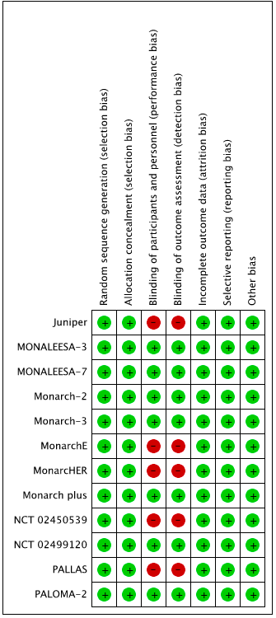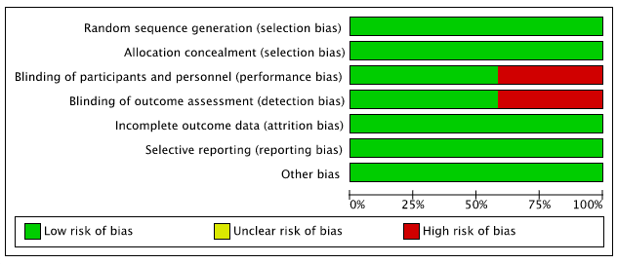
Figure S1. Risk of bias of included studies.

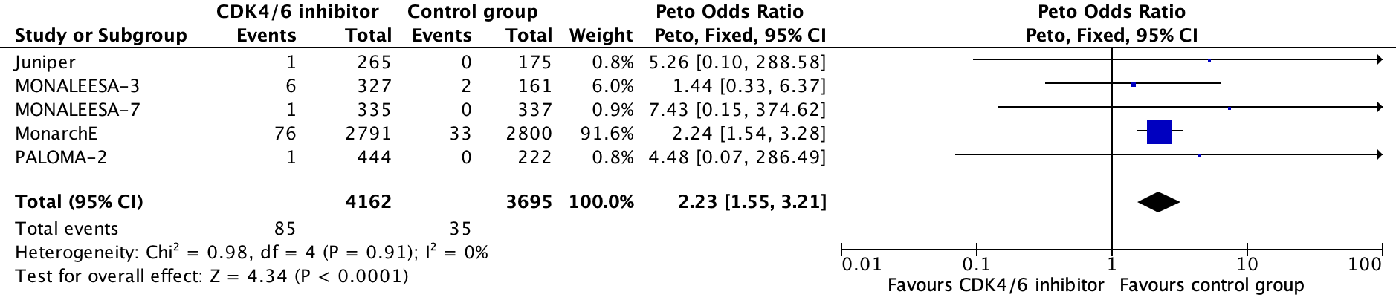
Figure S2. Pooled Peto odds ratio for all-grade ILD in the treatment group compared to the control group.
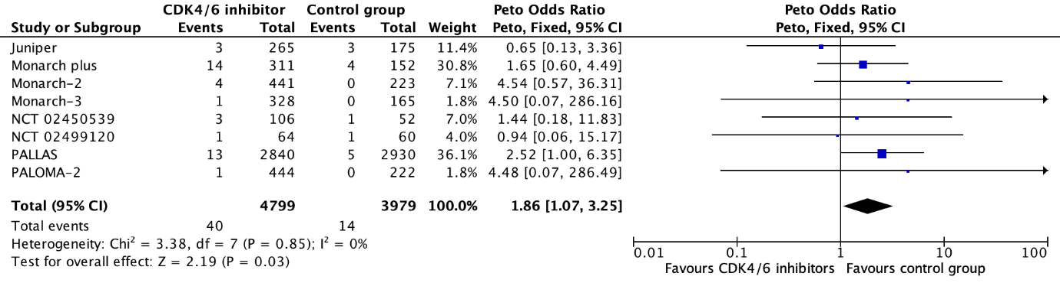
Figure S3. Pooled Peto odds ratio for all-grade pneumonitis in the treatment group compared to the control group.

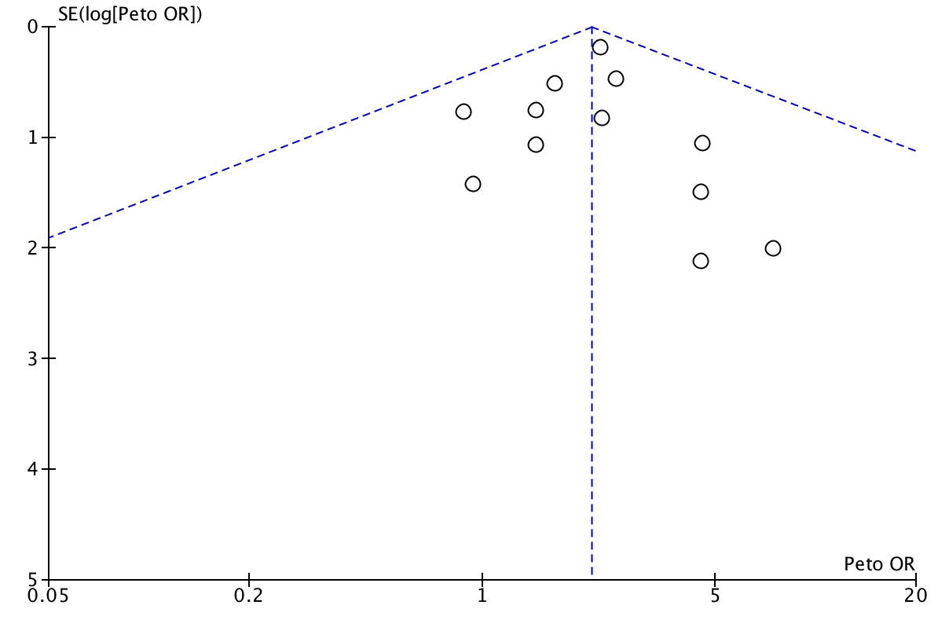
Figure S4. Funnel plot of included studies.

