Additional File
Efficacy of urate-lowering therapy agents in asymptomatic hyperuricemia: systematic review and network meta-analysis of randomized controlled trials

Legends for Supplementary Tables and Figures | Page
Table S1. General search terms | 1
Table S2. Excluded studies | 2
Table S3. Risk of bias of the included studies by RoB 2:  a revised Cochrane risk-of-bias tool for randomized trials | 8
Table S4. Description of heterogeneity and publication bias assessments for pairwise meta-analysis | 9
Table S5. Description of heterogeneity exploration by adjustment of covariates in meta-regression | 10
Table S6. Mixed relative treatment effects on estimated glomerular filtration rates by dosage | 12
Table S7. Mixed relative treatment effects on serum urate level | 13
Table S8. Mixed relative treatment effects on systolic blood pressure | 14
Table S9. Mixed relative treatment effects on systolic blood pressure by dosage | 15
Table S10. Sensitivity analysis excluding rasburicase: mixed relative treatment effects on composite renal events | 16
Table S11. Sensitivity analysis excluding rasburicase: mixed relative treatment effects on serum urate level | 17
Table S12. Surface under the cumulative ranking curve for highest efficacy and lowest adverse events of urate-lowering agents. | 18
Table S13. Confidence in Network Meta-Analysis | 19
Figure S1. Forest plots of composite renal events | 22
Figure S2. Forest plots of major adverse cardiovascular events | 23
Figure S3. Forest plots of serum urate level | 24
Figure S4. Forest plots of estimated glomerular filtration rate | 26
Figure S5. Forest plots of systolic blood pressure | 28
Figure S6. Forest plots of adverse events | 30
Figure S7. Forest plots: subgroup analysis of serum urate level by proportion of patients with hypertension | 32
Figure S8. Forest plots: sensitivity analysis of serum urate level excluding study containing all hypertensive patients. | 33
Figure S9. Network maps of primary outcomes | 34
Figure S10. Network maps of secondary outcomes | 35
Figure S11. Comparison-adjusted funnel plots | 36
Figure S12. Scatter plot of the surface under the cumulative ranking curve for highest efficacy and lowest adverse events of urate-lowering agents | 37
Figure S13. Network forest plot | 38

Table S1. General search terms
Population | Intervention/  Comparator | Surrogate Outcome |  | Clinical Outcome
Hyperuricemia  Hyperuricaemia | Allopurinol  Febuxostat  Topiroxostat  Benzbromarone  Probenecid  Sulfinpyrazone  Rasburicase  Pegloticase  Lesinurad  Anakinra  Canakinumab  Urate lower*  Urate-lower* | Uric acid blood level  Uric  Urate  Kidney function  “glomerular filtration rate”  Creatinine  Proteinuria  *Albuminuria  Microalbuminuria  Blood sugar  “Blood glucose”  “Blood sugar”  “Plasma glucose”  “Glucose blood”  “Hemoglobin a1c”  “Glycosylated hemoglobin”  Hba1c | Blood pressure  “Blood pressure”  hypertension  Endothelial function  “Endothelial function”  “Endothelial *function”  “Flow mediated”  Flow-mediated  “Homeostatic model”  Homa* | Cardiovascular disease  “Cardiovascular disease*”  “Cerebrovascular disease*”  “Cerebrovascular accident”  stroke  Heart  “Ischemic heart” “coronary heart” “coronary artery disease*”  “acute coronary”  Arrhythmia  “Heart failure”  “Cardiac failure”  “Peripheral vascular disease*”  “peripheral artery disease” | Diabetes mellitus  “Diabetes mellitus”  “Diabetic nephropath*”  “Diabetic kidney”  “Diabetic neuropath*”  “Diabetic peripheral neuropath*”  “Diabetic retinopath*”  Kidney stone  “Kidney stone*”  “Nephrolithiasis”  “renal stone”  “renal calcu*”  Adverse event  “Adverse drug”  “Adverse event*”  “Drug allerg*”  “Drug hypersensitivity*”

Table S2. Excluded studies
Not met study population | Feig DI, Soletsky B, Johnson RJ. Effect of allopurinol on blood pressure of adolescents with newly diagnosed essential hypertension: A randomized trial. J Am Med Assoc. 2008;300(8):924-32.
Not met study population | Alshahawey M, Shaheen SM, Elsaid T, Sabri NA. Effect of febuxostat on oxidative stress in hemodialysis patients with endothelial dysfunction: a randomized, placebo-controlled, double-blinded study. International Urology and Nephrology. 2019 Sep;51(9):1649-57.
Not met study population | Wu JY, Chang YT, Lin YC, Lee CH, Loh EW, Wu MY, et al. Efficacy and Safety of Lesinurad in Patients with Hyperuricemia Associated with Gout: A Systematic Review and Meta-Analysis of Randomized Controlled Trials. Pharmacotherapy. 2018;38(11):1106-19.
Not met study population | Song GG, Lee YH. Comparative efficacy and safety of lesinurad 200 mg and 400 mg combined with a xanthine oxidase inhibitor in hyperuricemic patients with gout: A Bayesian network meta-analysis of randomized controlled trials. Int J Clin Pharmacol Ther. 2019;57(7):345-52.
Not met study population | Shi Y, Chen W, Jalal D, Li Z, Chen W, Mao H, et al. Clinical outcome of hyperuricemia in IgA nephropathy: A retrospective cohort study and randomized controlled trial. Kidney Blood Press Res. 2012;35(3):153-60.
Not met study population | Chen JH, Lan JL, Cheng CF, Liang WM, Lin HY, Tsay GJ, et al. Effect of urate-lowering therapy on all-cause and cardiovascular mortality in hyperuricemic patients without gout: A case-matched cohort study. PLoS ONE. 2015;10(12).
Not met study population | Matzkies F. Lasting normalisation of uric acid levels after treatment of patients with gout and hyperuricaemia with a combination of 300 mg allopurinol and 60 mg benzbromarone. Med Klin. 1992;87(9):460-2.
Not met study population | Becker MA, Schumacher HR, Jr., Wortmann RL, MacDonald PA, Palo WA, Eustace D, et al. Febuxostat, a novel nonpurine selective inhibitor of xanthine oxidase: a twenty-eight-day, multicenter, phase II, randomized, double-blind, placebo-controlled, dose-response clinical trial examining safety and efficacy in patients with gout. Arthritis Rheum. 2005;52(3):916-23.
Not met study population | Jomori T, Saitoh K, Hosoya T. Effects of topiroxostat on the serum urate levels and urinary albumin excretion in concomitant therapy or in primary disease of chronic kidney disease: -A post hoc analysis of multicenter, randomized, placebo-controlled, double-blind study in hyperuricemic stage 3 chronic kidney disease patients with or without gout. Jpn Pharmacol Ther. 2015;43(1):39-50.
Not met study population | Schumacher HR, Jr., Becker MA, Wortmann RL, Macdonald PA, Hunt B, Streit J, et al. Effects of febuxostat versus allopurinol and placebo in reducing serum urate in subjects with hyperuricemia and gout: a 28-week, phase III, randomized, double-blind, parallel-group trial. Arthritis Rheum. 2008;59(11):1540-8.
Not met study population | So M, Maeda T, Kashiwagi N, Takada M, Ishikawa T, Sato Y, et al. Safety and efficacy of topiroxostat for hyperuricemic patients with or without gout. Ther Res. 2017;38(8):793-804.
Not met study population | Hosoya T, Ohno I, Nomura S, Hisatome I, Uchida S, Fujimori S, et al. Effects of topiroxostat on the serum urate levels and urinary albumin excretion in hyperuricemic stage 3 chronic kidney disease patients with or without gout. Clin Exp Nephrol. 2014;18(6):876-84.
Not met study population | Terkeltaub R, Malamet R, Bos K, Li J, Goldfarb DS, Pillinger M, et al. Renal safety of lesinurad: A pooled analysis of phase III and extension studies. Ann Rheum Dis. 2017;76:379-80.
Not met study population | Akhondzadeh S, Milajerdi MR, Amini H, Tehrani-Doost M. Allopurinol as an adjunct to lithium and haloperidol for treatment of patients with acute mania: A double-blind, randomized, placebo-controlled trial. Bipolar Disorders. 2006;8(5 I):485-9.
Not met study population | Siu YP, Leung KT, Tong MK, Kwan TH. Use of allopurinol in slowing the progression of renal disease through its ability to lower serum uric acid level. American journal of kidney diseases : the official journal of the National Kidney Foundation. 2006;47(1):51-9.
Not met study population | Kanbay M, Ozkara A, Selcoki Y, Isik B, Turgut F, Bavbek N, et al. Effect of treatment of hyperuricemia with allopurinol on blood pressure, creatinine clearence, and proteinuria in patients with normal renal functions. Int Urol Nephrol. 2007;39(4):1227-33.
Not met study population | Allopurinol reduces blood pressure in adolescents with mild hypertension. Nat Clin Pract Nephrol. 2008;4(12):644-5.
Not met study population | Hernandez-Divers SJ, Martinez-Jimenez D, Bush S, Latimer KS, Zwart P, Kroeze EJBV. Effects of allopurinol on plasma uric acid levels in normouricaemic and hyperuricaemic green iguanas (Iguana iguana). Vet Rec. 2008;162(4):112-5.
Not met study population | Schumacher HR, Jr., Becker MA, Wortmann RL, Macdonald PA, Hunt B, Streit J, et al. Effects of febuxostat versus allopurinol and placebo in reducing serum urate in subjects with hyperuricemia and gout: a 28-week, phase III, randomized, double-blind, parallel-group trial. Arthritis Rheum. 2008;59(11):1540-8.
Not met study population | Wu AH, Ghali JK, Neuberg GW, O'Connor CM, Carson PE, Levy WC. Uric acid level and allopurinol use as risk markers of mortality and morbidity in systolic heart failure. Am Heart J. 2010;160(5):928-33.
Not met study population | Yiǧiner O, Özçelik F, Aparci M, Işilak Z, Uz O. The beneficial effects of allopurinol in cardiology practice: Decrease in uric acid and vascular oxidative stress/ the effects of lowering uric acid levels using allopurinol on markers of metabolic syndrome in end-stage renal disease patients: A pilot study. Anadolu Kardiyoloji Derg. 2010;10(3):294-5.
Only abstract available | McLean, L., L. Gunamardhana, U. Thienel, J. Wu, and G. Smithson. "FRI0241 The effect of febuxostat on inflammatory and cardiovascular biomarkers in hyperuricemic hypertensive patients." (2018): 661-661.
Only abstract available | Ivanov D, Ivanova M, Bevzenko T. Febuxostat improves GFR and BP in non-diabetic adults with CKD 2-3: 6 years treatment and follow-up. InNephrology Dialysis Transplantation 2018 May 1 (Vol. 33). GREAT CLARENDON ST, OXFORD OX2 6DP, ENGLAND: OXFORD UNIV PRESS.
Only abstract available | De Mier VP, Vergara N, Santamaria R, Buendia P, Martinez-Moreno J, Jimenez-Moral M, Muñoz-Castañeda J, Rodriguez J, Aljama P. Effect of allopurinol on endothelial function, blood pressure, arterial stiffness and renal damage in patients with chronic kidney disease and asymptomatic hyperuricemia. Journal of Hypertension. 2018 Jun 1;36:e184.
Only abstract available | Santamaria R, Buendia P, De Mier VP, Martinez-Moreno J, Vergara N, Jimenez-Moral M, Muñoz-Castañeda J, Rodriguez J, Aljama P. EFFECT OF TREATMENT WITH ALLOPURINOL ON MARKERS OF MICROINFLAMMATION AND VASCULAR DAMAGE AND REPAIR IN PATIENTS WITH CHRONIC KIDNEY DISEASE AND ASYMPTOMATIC HYPERURICEMIA. Journal of Hypertension. 2018 Jun 1;36:e121.
Only abstract available | Stack A, Dronamraju N, Parkinson J, Johansson S, Johnsson E, Erlandsson F, Terkeltaub R. SP262 THE IMPACT OF URATE-LOWERING DRUGS VERINURAD AND FEBUXOSTAT ON ALBUMINURIA IN TYPE 2 DIABETES. Nephrology Dialysis Transplantation. 2019 Jun 1;34(Supplement_1):gfz103-SP262.
Only abstract available | Gaffo, Angelo, David Calhoun, Elizabeth Rahn, Suzanne Oparil, Paul Muntner, L. I. Peng, David Redden et al. "OP0208 EFFECT OF SERUM URATE LOWERING WITH ALLOPURINOL ON BLOOD PRESSURE IN YOUNG ADULTS." (2019): 180-180.
Only abstract available | Arakawa J, Ayaori M, Nishida T, Sasaki M, Komatsu T, Suenaga Y, Nita R, Uto-Kondo H, Sakurada M, Ikewaki K. A Xanthine Oxidase Inhibitor Febuxostat Improves Endothelial Function as Evaluated by Flow-Mediated Vasodilatation in Hyperuricemic Patients. Circulation. 2018 Nov 6;138(Suppl_1):A14447-.
Only abstract available | Ogino K, Kinugasa Y, Kato M, Yamamoto K, Hamada T, Hisatome I. Uric-acid lowering treatment by a xanthine oxidase inhibitor improved the diastolic function in patients with hyperuricemia. Journal of Cardiac Failure. 2019 Aug 1;25(8):S26.
Only abstract available | Nagaraju SP, Attur RP, Rangaswamy D, Rao I, Rao SP, Kaza S, Shenoy S, Saraf K, Bhojaraja M, Ramaswamy A, Koulmane Laxminarayana SL. SP296 effect of febuxostat versus allopurinol on hyperuricemia and progression of chronic kidney disease. Nephrology Dialysis Transplantation. 2017 May 1;32(suppl_3):iii205-6.
Only abstract available | Suzuki S, Yoshihisa A, Sato A, Shimizu T, Sato T, Sakamoto N, Nakazato K, Tsuda T, Tsuda A, Goto J, Ishibashi T. Multicenter Randomized Controlled Trial Between Febuxostat and Allopurinol in Chronic Heart Failure Patients With Hyperuricemia. Circulation. 2017 Nov 14;136(suppl_1):A14509-.
On urate lowering agents prior to enrollment | Ohta Y, Ishizuka A, Arima H, Hayashi S, Iwashima Y, Kishida M, Yoshihara F, Nakamura S, Kawano Y. Effective uric acid-lowering treatment for hypertensive patients with hyperuricemia. Hypertension Research. 2017 Mar;40(3):259-63.
On urate lowering agents prior to enrollment | Mizukoshi T, Kato S, Ando M, Sobajima H, Ohashi N, Naruse T, et al. Renoprotective effects of topiroxostat for Hyperuricaemic patients with overt diabetic nephropathy study (ETUDE study): A prospective, randomized, multicentre clinical trial. Nephrology. 2018;23(11):1023-30.
On urate lowering agents prior to enrollment | Hanvivadhanakul P, Akkasilpa S, Deesomchok U. Efficacy of benzbromarone compared to allopurinol in lowering serum uric acid level in hyperuricemic patients. J Med Assoc Thailand. 2002;85(SUPPL. 1):S40-S7.
On urate lowering agents prior to enrollment | Akkasilpa S, Osiri M, Deesomchok U, Avihingsanon Y. The efficacy of combined low dose of allopurinol and benzbromarone compared to standard dose of allopurinol in hyperuricemia. J Med Assoc Thailand. 2004;87(9):1087-91.
On urate lowering agents prior to enrollment | Reinders MK, van Roon EN, Houtman PM, Brouwers JRBJ, Jansen TLTA. Biochemical effectiveness of allopurinol and allopurinol-probenecid in previously benzbromarone-treated gout patients. Clin Rheumatol. 2007;26(9):1459-65.
On urate lowering agents prior to enrollment | Bantia S, Harman L, Parker C, Papac D, Maetzel A, Taubenheim B, et al. Ulodesine (BCX4208) add-on therapy to allopurinol 300mg lowers hypoxanthine and xanthine plasma levels in a dose-dependent fashion: Results from a 12-week randomized controlled trial in patients with gout. Arthritis Rheum. 2012;64:S698.
On urate lowering agents prior to enrollment | Suzuki S, Yoshihisa A, Sato A, Shimizu T, Sato T, Sakamoto N, et al. Multicenter randomized controlled trial between febuxostat and allopurinol in chronic heart failure patients with hyperuricemia. Circulation. 2017;136.
On urate lowering agents prior to enrollment | Bardin T, Karra RG, So A, Tausche AK, Wild I, Hagedorn H, et al. Lesinurad (LESU) adjunctive therapy with allopurinol (ALLO) in patients not responding to allo monotherapy: Pooled post hoc safety and efficacy analysis in a patient subgroup using concomitant diuretics at baseline (BL). Ann Rheum Dis. 2018;77:1050-1.
No data for pooling | Gunawardhana L, McLean L, Punzi HA, Hunt B, Palmer RN, Whelton A, Feig DI. Effect of febuxostat on ambulatory blood pressure in subjects with hyperuricemia and hypertension: a phase 2 randomized placebo‐controlled study. Journal of the American Heart Association. 2017 Nov 4;6(11):e006683.
No data for pooling | Ibrahim SE, Helmi A, Yousef TM, Hassan MS, Farouk N. Association of asymptomatic hyperuricemia and endothelial dysfunction in psoriatic arthritis. Egypt Rheumatol. 2012;34(2):83-9.
No data for pooling | Walter-Sack I, de Vries JX, Ernst B, Frei M, Kolb S, Kosmowski J, Priebe U, Schroder HE, Slotty C, Voss A, Weber A. Uric acid lowering effect of oxipurinol sodium in hyperuricemic patients-therapeutic equivalence to allopurinol. The Journal of Rheumatology. 1996 Mar 1;23(3):498-501.
No data for pooling | Mertz DP, Eichhorn R. Does benzbromarone in therapeutic doses raise renal excretion of oxipurinol?. Klinische Wochenschrift. 1984 Dec;62(24):1170-2.
No data for pooling | Wu TH, Chen LC, Yang LL. Hypouricemic effect and regulatory effects on autonomic function of Shao-Yao Gan-Cao Tang, a Chinese herbal prescription, in asymptomatic hyperuricemic vegetarians. Rheumatol Int. 2007;28(1):27-31.
No data for pooling | A Randomised Study of Allopurinol on Endothelial Function and eGFR in Asymptomatic Hyperuricemic Subjects with Normal Renal Function(Clinical Journal of the American Society of Nephrology, (August 2011), 8, (887-894),doi: 10.2215/CJN.10801011). Clin J Am Soc Nephrol. 2011;6(12):2901-2.
No data for pooling | Shiramoto M, Sugeno M, Liu S, Shen Z, Hall J. Pharmacodynamics, pharmacokinetics, and safety of verinurad in combination with febuxostat versus febuxostat alone and verinurad alone in japanese adults with gout or asymptomatic hyperuricemia: A phase 2a open-label study. Arthritis Rheum. 2016;68:252-3.
No data for pooling | Huang Y, Meng J, Sun B, Xiang T, Zhou X, Xu B, et al. Acupuncture for serum uric acid in patients with asymptomatic hyperuricemia: A randomized, double-blind, placebo-controlled trial. Int J Cardiol. 2017;232:227-32.
Observational studies | Levy G, Shi JM, Cheetham TC, Rashid N. Urate-lowering therapy in moderate to severe chronic kidney disease. The Permanente Journal. 2018;22.
Observational studies | Pai BS, Swarnalatha G, Ram R, Dakshinamurty KV. Allopurinol for prevention of progression of kidney disease with hyperuricemia. Indian Journal of Nephrology. 2013 Jul;23(4):280.
Observational studies | Song K, Wang Y, Wang G, Zhang Q, Jiao H, Huang G, Lu W. Does decreasing serum uric acid level prevent hypertension?–a nested RCT in cohort study: rationale, methods, and baseline characteristics of study cohort. BMC public health. 2013 Dec;13(1):1-7.
Observational studies | Bayram D, Tuğrul Sezer M, Inal S, Altuntaş A, Kıdır V, Orhan H. The effects of allopurinol on metabolic acidosis and endothelial functions in chronic kidney disease patients. Clinical and experimental nephrology. 2015 Jun;19(3):443-9.
Ongoing studies | Sakuma M, Toyoda S, Arikawa T, Koyabu Y, Kato T, Adachi T, Suwa H, Narita JI, Anraku K, Ishimura K, Yamauchi F. The effects of xanthine oxidase inhibitor in patients with chronic heart failure complicated with hyperuricemia: a prospective randomized controlled clinical trial of topiroxostat vs allopurinol—study protocol. Clinical and experimental nephrology. 2018 Dec;22(6):1379-86.
Ongoing studies | Yokota T, Fukushima A, Kinugawa S, Okumura T, Murohara T, Tsutsui H. Randomized Trial of Effect of Urate-Lowering Agent Febuxostat in Chronic Heart Failure Patients with Hyperuricemia (LEAF-CHF) Study Design. International heart journal. 2018:17-560.
Ongoing studies | Hosoya T, Kimura K, Itoh S, Inaba M, Uchida S, Tomino Y, et al. The effect of febuxostat to prevent a further reduction in renal function of patients with hyperuricemia who have never had gout and are complicated by chronic kidney disease stage 3: Study protocol for a multicenter randomized controlled study. Trials. 2014;15(1).
Ongoing studies | Collantes E, Anon J, Tinahones F, Sanchez P. Lipid profile associated with asymptomatic hyperuricemia. Protocolized study of 77 subjects. REV ESP REUMATOL. 1989;16(5):129-31.
Ongoing studies | Sakuma M, Toyoda S, Arikawa T, Koyabu Y, Kato T, Adachi T, et al. The effects of xanthine oxidase inhibitor in patients with chronic heart failure complicated with hyperuricemia: a prospective randomized controlled clinical trial of topiroxostat vs allopurinol—study protocol. Clin Exp Nephrol. 2018;22(6):1379-86.
Single arm studies | Ferreira M, Jiménez C, Lopez MO, González E, Santana MJ, Selgas R. Short-term efficacy and safety of treatment with febuxostat in kidney transplant recipient. An unicentric observational study. Nefrología (English Edition). 2018 May 1;38(3):331-2.
Single arm studies | Meléndez-Ramírez G, Pérez-Méndez O, López-Osorio C, Kuri-Alfaro J, Espinola-Zavaleta N. Effect of the treatment with allopurinol on the endothelial function in patients with hyperuricemia. Endocrine research. 2012 Feb 1;37(1):1-6.
Single arm studies | Nishizawa T, Taniura T, Nomura S. Effects of febuxostat on platelet-derived microparticles and adiponectin in patients with hyperuricema. Blood Coagulation & Fibrinolysis. 2015 Dec;26(8):887.
Single arm studies | Yelken B, Caliskan Y, Gorgulu N, Altun I, Yilmaz A, Yazici H, Oflaz H, Yildiz A. Reduction of uric acid levels with allopurinol treatment improves endothelial function in patients with chronic kidney disease. Clinical nephrology. 2012 Apr 1;77(4):275-82.

Table S3. Risk of bias of the included studies by RoB 2: a revised Cochrane risk-of-bias tool for randomized trials
Authors | Year | Randomization process | Deviations from intended interventions | Missing outcome data | Measurement of the outcome | Selection of the reported result | Overall
Doehner | 2002
Siu | 2006
Ogino | 2009
Kanbay | 2011
Ejaz | 2012
Jalalzadeh | 2012
Taheraghdam | 2014
Goicoechea | 2015
Liu | 2015
Sircar | 2015
Takir | 2015
Nakagomi | 2015
Sezai | 2015
Tani | 2015
Tsurata | 2015
Beddhu | 2016
Kojima | 2016
Golmohammadi | 2017
McMullan | 2017
Jalal | 2018
Kimura | 2018
Mukri | 2018
Kojima | 2019
 |  |  | low  risk |  | some concerns |  | high risk

Table S4. Description of heterogeneity and publication bias assessments for pairwise meta-analysis
Comparison | Composite renal events |  | Major adverse cardiovascular events |  | Serum urate level |  | Estimated glomerular filtration rate |  | Systolic blood pressure |  | Adverse events
 | I² (%) | Egger’s test  P-value | I² (%) | Egger’s test  P-value | I² (%) | Egger’s test  P-value | I² (%) | Egger’s test  P-value | I² (%) | Egger’s test  P-value | I² (%) | Egger’s test  P-value
Allopurinol vs placebo/no ULT | 38.2 | 0.3 | 0.0 | - | 98.7 | 0.7 | 0.0 | 1.0 | 83.1 | 0.4 | 25.7 | 0.2
Febuxostat vs placebo/no ULT | 0.0 | 0.7 | 28.2 | 0.7 | 91.1 | 0.2 | 19.5 | 0.8 | 0.0 | 0.0 | 71.4 | 0.0
Febuxostat vs allopurinol | - | - | 0.0 | - | 99.4 | 0.2 | 0.0 | 0.3 | 62.4 | - | 58.5 | -

ULT, urate-lowering therapy.
Table S5. Description of heterogeneity exploration by adjustment of covariates in meta-regression
Outcome/  Comparison | None |  | Duration |  | Age |  | %M |  | BMI
Outcome/  Comparison | Studies | I² (%) | Studies | I² (%) | Studies | I² (%) | Studies | I² (%) | Studies | I² (%)
Composite renal events  Allopurinol vs placebo/no ULT | 3 | 80.8 | 3 | 89.3 | 3 | 88.7 | - | - | - | -
MACE  Febuxostat vs placebo/no ULT | 3 | 74.1 | 3 | 77.2 | 3 | 86.9 | 3 | 29.9 | - | -
SU  Allopurinol vs placebo/no ULT | 9 | 95.3 | 9 | 95.1 | 8 | 94.5 | 8 | 95.7 | 6 | 93.6
SU  Febuxostat vs placebo/no ULT | 6 | 91.1 | 6 | 79.3 | 6 | 92.8 | 6 | 92.6 | 4 | 95.5
SU  Febuxostat vs allopurinol/no ULT | 3 | 99.4 | 3 | 99.3 | 3 | 93.2 | 3 | 99.2 | - | -
SBP  Allopurinol vs placebo/no ULT | 7 | 82.9 | 7 | 85.6 | 7 | 85.7 | 6 | 87.3 | 5 | 88.5
AEs  Allopurinol vs placebo/no ULT | 6 | 94.6 | 6 | 93.5 | 6 | 95.7 | 5 | 96.6 | 3 | 96.0
AEs  Febuxostat vs placebo/no ULT | 3 | 98.7 | 3 | 97.7 | 3 | 99.3 | 3 | 0.0 | - | -

Outcome/  Comparison | % HT |  | % DM |  | % CKD |  | % CVD |  | Dose
Outcome/  Comparison | Studies | I² (%) | Studies | I² (%) | Studies | I² (%) | Studies | I² (%) | Studies | I² (%)
Composite renal events  Allopurinol vs placebo/no ULT | - | - | - | - | - | - | - | - | 3 | 85.7
MACE  Febuxostat vs placebo/no ULT | 3 | 86.7 | - | - | 3 | 74.1 | 3 | 86.9 | 3 | 86.6
SU  Allopurinol vs placebo/no ULT | 3 | 88.4 | 3 | 98.6 | 4 | 97.3 | 3 | 95.6 | 8 | 95.3
SU  Febuxostat vs placebo/no ULT | 6 | 27.6 | 5 | 93.9 | 6 | 81.5 | 6 | 89.2 | 6 | 90.4
SU  Febuxostat vs allopurinol/no ULT | 3 | 99.1 | 3 | 99.3 | - | - | - | - | - | -
SBP  Allopurinol vs placebo/no ULT | - | - | - | - | 4 | 89.3 | - | - | 7 | 84.1
AEs  Allopurinol vs placebo/no ULT | - | - | 3 | 65.4 | 3 | 57.5 | 3 | 0.0 | 6 | 94.5
AEs  Febuxostat vs placebo/no ULT | 3 | 99.3 | - | - | 3 | 98.7 | 3 | 98.9 | 3 | 98.7

AEs, adverse events; BMI, body mass index; CKD, chronic kidney disease; CVD, cardiovascular disease; DM, diabetes mellitus; HT, hypertension; M, male; MACE, major adverse cardiovascular events; SBP, systolic blood pressure; SU, serum urate level; ULT, urate-lowering therapy.

Table S6. Mixed relative treatment effects on estimated glomerular filtration rates by dosage
placebo  /no ULT | -4.38  (-7.25, -1.52) | -0.50  (-9.72, 8.72) | -2.19  (-6.61, 2.24) | -3.08  (-5.51, -0.66)
4.38  (1.52 ,7.25) | low-dose allopurinol | 3.88  (-5.77, 13.54) | 2.19  (-2.52, 6.90) | 1.30  (-1.28, 3.88)
0.50  (-8.72 ,9.72) | -3.88  (-13.54, 5.77) | low-dose febuxostat | -1.69  (-11.91, 8.54) | -2.58  (-12.12, 6.95)
2.19  (-2.24, 6.61) | -2.19  (-6.90, 2.52) | 1.69  (-8.54, 11.91) | high-dose allopurinol | -0.90  (-5.02, 3.23)
3.08  (0.66, 5.51) | -1.30  (-3.88, 1.28) | 2.58  (-6.95, 12.12) | 0.90  (-3.23, 5.02) | high-dose febuxostat

ULT, urate-lowering therapy.
Testing of inconsistency, χ² = 4.33, P-value = 0.1145. Results are mean differences (95% confidence intervals) between each pair of treatments from network meta-analysis. Comparisons are read counterclockwise. Low-dose allopurinol was defined as < 300 mg/day, high-dose allopurinol as ≥ 300 mg/day, low-dose febuxostat as < 40 mg/day, and high-dose febuxostat as ≥ 40 mg/day.

Table S7. Mixed relative treatment effects on serum urate level
placebo  /no ULT | -1.63  (-2.51, -0.74) | -2.45  (-3.85, -1.04) | -2.49  (-3.66, -1.31) | -4.30  (-6.32, -2.27) | -2.45  (-3.21, -1.70) | -3.29  (-4.07, -2.51)
1.63  (0.74, 2.51) | low-dose allopurinol | -0.82  (-2.48, 0.84) | -0.86  (-2.31, 0.59) | -2.67  (-4.88, -0.46) | -0.83  (-1.96, 0.30) | -1.66  (-2.73, -0.60)
2.45  (1.04, 3.85) | 0.82  (-0.84, 2.48) | low-dose febuxostat | -0.04  (-1.87, 1.79) | -1.85  (-4.31, 0.62) | -0.01  (-1.60, 1.59) | -0.84  (-2.45, 0.76)
2.49  (1.31, 3.66) | 0.86  (-0.59, 2.31) | 0.04  (-1.79, 1.87) | uricosuric agents | -1.81  (-4.15, 0.53) | 0.03  (-1.13, 1.19) | -0.80  (-2.15, 0.54)
4.30  (2.27, 6.32) | 2.67  (0.46, 4.88) | 1.85  (-0.62, 4.31) | 1.81  (-0.53, 4.15) | rasburicase | 1.84  (-0.32, 4.00) | 1.01  (-1.17, 3.18)
2.45  (1.70, 3.21) | 0.83  (-0.30, 1.96) | 0.01  (-1.59, 1.60) | -0.03  (-1.19, 1.13) | -1.84  (-4.00, 0.32) | high-dose allopurinol | -0.83  (-1.75, 0.08)
3.29  (2.51, 4.07) | 1.66  (0.60, 2.73) | 0.84  (-0.76, 2.45) | 0.80  (-0.54, 2.15) | -1.01  (-3.18, 1.17) | 0.83  (-0.08, 1.75) | high-dose febuxostat

ULT, urate-lowering therapy.
Testing of inconsistency, χ² = 1.39, P-value = 0.92. Results are mean differences (95% confidence intervals) between each pair of treatments from network meta-analysis. Comparisons are read counterclockwise. Low-dose allopurinol was defined as < 300 mg/day, high-dose allopurinol as ≥ 300 mg/day, low-dose febuxostat as < 40 mg/day, and high-dose febuxostat as ≥ 40 mg/day. Uricosuric agents consist of probenecid and benzbromarone.
Table S8. Mixed relative treatment effects on systolic blood pressure
placebo  /no ULT | -3.45  (-9.07, 2.17) | -2.23  (-8.90, 4.45) | 0.18  (-12.81, 13.17)
3.45  (-2.17, 9.07) | allopurinol | 1.22  (-6.13, 8.57) | 3.63  (-9.37, 16.62)
2.23  (-4.45, 8.90) | -1.22  (-8.57, 6.13) | febuxostat | 2.41  (-11.82, 16.63)
-0.18  (-13.17, 12.81) | -3.63  (-16.62, 9.37) | -2.41  (-16.63, 11.82) | probenecid

ULT, urate-lowering therapy.
Testing of inconsistency, χ² = 2.12, P-value = 0.35. Results are mean differences (95% confidence intervals) between each pair of treatments from network meta-analysis. Comparisons are read counterclockwise.

Table S9. Mixed relative treatment effects on systolic blood pressure by dosage
placebo  /no ULT | 9.50  (-0.29, 19.29) | -1.52  (-15.14, 12.10) | -2.19  (-24.01, 19.64) | 1.39  (-11.64, 14.42) | 4.87  (-17.30, 27.03)
-9.50  (-19.29, 0.29) | low-dose allopurinol | -11.01  (-27.80, 5.78) | -8.11  (-24.39, 8.18) | -9.39  (-25.60, 6.81) | -11.80  (-31.85, 8.26)
1.52  (-12.10, 15.14) | 11.01  (-5.78, 27.80) | low-dose febuxostat | 2.90  (-15.94, 21.75) | 1.62  (-17.13, 20.36) | -0.78  (-22.97, 21.40)
2.19  (-19.64, 24.01) | 8.11  (-8.18, 24.39) | -2.90  (-21.75, 15.94) | probenecid | -1.29  (-19.61, 17.03) | -3.69  (-25.51, 18.13)
-1.39  (-14.42, 11.64) | 9.39  (-6.81, 25.60) | -1.62  (-20.36, 17.13) | 1.29  (-17.03, 19.61) | high-dose allopurinol | -2.40  (-24.14, 19.33)
-4.87  (-27.03, 17.30) | 11.80  (-8.26, 31.85) | 0.78  (-21.40, 22.97) | 3.69  (-18.13, 25.51) | 2.40  (-19.33, 24.14) | high-dose febuxostat

ULT, urate-lowering therapy.
Testing of inconsistency, χ² = 0.19, P-value = 0.91. Results are mean differences (95% confidence intervals) between each pair of treatments from network meta-analysis. Comparisons are read counterclockwise. Low-dose allopurinol was defined as < 300 mg/day, high-dose allopurinol as ≥ 300 mg/day, low-dose febuxostat as < 40 mg/day, and high-dose febuxostat as ≥ 40 mg/day.
Table S10. Sensitivity analysis excluding rasburicase: mixed relative treatment effects on composite renal events
placebo  /no ULT | 0.39  (0.23, 0.66) | 0.68  (0.46, 0.99) | 0.37  (0.05, 2.69)
2.55  (1.51, 4.30) | allopurinol | 1.72  (0.94, 3.17) | 0.95  (0.14, 6.55)
1.48  (1.01, 2.17) | 0.58  (0.32, 1.07) | febuxostat | 0.55  (0.07, 4.09)
2.68  (0.37, 19.27) | 1.05  (0.15, 7.21) | 1.81  (0.24, 13.37) | probenecid

ULT, urate-lowering therapy.
Testing of inconsistency, χ² = 3.16, P-value = 0.20. Results are relative risks (95% confidence intervals) between each pair of treatments from network meta-analysis. Comparisons are read counterclockwise.

Table S11. Sensitivity analysis excluding rasburicase: mixed relative treatment effects on serum urate level
placebo  /no ULT | -1.63  (-2.51, -0.74) | -2.45  (-3.85, -1.04) | -2.49  (-3.66, -1.31) | -3.29  (-4.07, -2.51) | -2.45  (-3.21, -1.70)
1.63  (0.74, 2.51) | low-dose allopurinol | -0.82  (-2.48, 0.84) | -0.86  (-2.31, 0.59) | -1.66  (-2.73, -0.60) | -0.83  (-1.96, 0.30)
2.45  (1.04, 3.85) | 0.82  (-0.84, 2.48) | low-dose febuxostat | -0.04  (-1.87, 1.79) | -0.84  (-2.45, 0.76) | -0.01  (-1.60, 1.59)
2.49  (1.31, 3.66) | 0.86  (-0.59, 2.31) | 0.04  (-1.79, 1.87) | uricosuric  agents | -0.80  (-2.15, 0.54) | 0.03  (-1.13, 1.19)
3.29  (2.51, 4.07) | 1.66  (0.60, 2.73) | 0.84  (-0.76, 2.45) | 0.80  (-0.54, 2.15) | high-dose febuxostat | 0.83  (-0.08, 1.75)
2.45  (1.70, 3.21) | 0.83  (-0.30, 1.96) | 0.01  (-1.59, 1.60) | -0.03  (-1.19, 1.13) | -0.83  (-1.75, 0.08) | high-dose allopurinol

ULT, urate-lowering therapy.
Testing of inconsistency, χ² = 1.39, P-value = 0.92. Results are mean differences (95% confidence intervals) between each pair of treatments from network meta-analysis. Comparisons are read counterclockwise. Low-dose allopurinol was defined as < 300 mg/day, high-dose allopurinol as ≥ 300 mg/day, low-dose febuxostat as < 40 mg/day, high-dose febuxostat as ≥ 40 mg/day. Uricosuric agents consist of probenecid and benzbromarone.

Table S12. Surface under the cumulative ranking curve for highest efficacy and lowest adverse events of urate-lowering agents.

ULT | Adverse events | MACE | Composite renal events | eGFR | Serum urate | SBP
Placebo | 53.30 | 15.00 | 20.00 | 0.00 | 0.00 | 29.50
Allopurinol | 50.00 | 50.00 | 100.00 | 85.00 | 35.00 | 74.30
Febuxostat | 40.00 | 85.00 | 66.70 | 65.00 | 70.00 | 38.20
Probenecid | 76.70 |  | 13.30 |  | 45.00
Rasburicase |  |  |  |  | 100.00

eGFR; estimated glomerular filtration rates, MACE; major adverse cardiovascular events, SBP; systolic blood pressure, ULT; urate lowering therapy agents.

Table S13. Confidence in Network Meta-Analysis
Outcomes | Number of studies | Within-study bias | Reporting bias | Indirectness | Imprecision | Heterogeneity | Incoherence | Confidence rating | Reason(s) for downgrading
MACE
Allopurinol vs Placebo/no-ULT | 2 | Some concerns | Some concerns | No concerns | Major concerns | No concerns | No concerns | Very low | Within-study bias,  Reporting bias, Imprecision
Febuxostat vs Placebo/no-ULT | 3 | Some concerns | Some concerns | No concerns | Some concerns | Some concerns | No concerns | Low | Within-study bias, Reporting bias, Imprecision, Heterogeneity
Allopurinol vs Febuxostat | 2 | Some concerns | Some concerns | Some concerns | Major concerns | No concerns | No concerns | Very low | Within-study bias, Reporting bias, Indirectness, Imprecision
Composite renal events
Allopurinol vs Placebo/no-ULT | 3 | Some concerns | Some concerns | No concerns | No concerns | No concerns | No concerns | Low | Within-study bias,  Reporting bias
Febuxostat vs Placebo/no-ULT | 3 | No concerns | Some concerns | No concerns | No concerns | Major concerns | No concerns | Very Low | Reporting bias, Heterogeneity
Rasburicase vs Placebo/no-ULT | 1 | No concerns | Some concerns | Some concerns | Major concerns | No concerns | No concerns | Very Low | Reporting bias, Indirectness, Imprecision
Allopurinol vs Febuxostat | 1 | Some concerns | Some concerns | No concerns | Major concerns | No concerns | No concerns | Very Low | Within-study bias, Reporting bias, Imprecision
Allopurinol vs Rasburicase | 0 | No concerns | Some concerns | No concerns | No concerns | Major concerns | No concerns | Very Low | Reporting bias, Heterogeneity
Febuxostat vs Rasburicase | 0 | No concerns | Some concerns | No concerns | Major concerns | No concerns | No concerns | Very Low | Reporting bias, Imprecision
Serum urate levels
Low-dose allurinol vs Placebo/no-ULT | 4 | Some concerns | Low risk | No concerns | No concerns | Some concerns | No concerns | Low | Within-study bias, Heterogeneity
Low-dose febuxostat vs Placebo/no-ULT | 2 | Some concerns | Low risk | No concerns | No concerns | No concerns | No concerns | Moderately | Within-study bias
Uricosurics vs Placebo/no-ULT | 2 | Some concerns | Low risk | No concerns | No concerns | No concerns | No concerns | Moderately | Within-study bias
Rasburicase vs Placebo/no-ULT | 1 | No concerns | Low risk | Some concerns | No concerns | No concerns | No concerns | Moderately | Indirectness
High-dose allopurinol vs Placebo/no-ULT | 5 | Some concerns | Low risk | No concerns | No concerns | No concerns | No concerns | Moderately | Within-study bias
High-dose febuxostat vs Placebo/no-ULT | 4 | Some concerns | Low risk | No concerns | No concerns | No concerns | No concerns | Moderately | Within-study bias
High-dose febuxostat vs Low-dose allopurinol | 1 | Some concerns | Low risk | No concerns | No concerns | No concerns | No concerns | Moderately | Within-study bias
High-dose allopurinol vs Uricosurics | 2 | Some concerns | Low risk | No concerns | No concerns | Major concerns | No concerns | Very low | Within-study bias, Heterogeneity
High-dose febuxostat vs High-dose allopurinol | 2 | Some concerns | Low risk | No concerns | No concerns | Some concerns | No concerns | Low | Within-study bias, Heterogeneity
Low-dose febuxostat vs Low-dose allopurinol | 0 | Some concerns | Low risk | No concerns | Some concerns | Some concerns | No concerns | Low | Within-study bias, Imprecision, Heterogeneity
Uricosurics vs Low-dose allopurinol | 0 | Some concerns | Low risk | No concerns | Some concerns | Some concerns | No concerns | Low | Within-study bias, Imprecision, Heterogeneity
Rasburicase vs Low-dose allopurinol | 0 | Some concerns | Low risk | No concerns | No concerns | No concerns | No concerns | Moderately | Within-study bias
High-dose allopurinol vs Low-dose allopurinol | 0 | Some concerns | Low risk | No concerns | No concerns | Some concerns | No concerns | Low | Within-study bias, Heterogeneity
Uricosurics vs Low-dose febuxostat | 0 | Some concerns | Low risk | No concerns | Major concerns | No concerns | No concerns | Very low | Within-study bias, Imprecision
Rasburicase vs Low-dose febuxostat | 0 | Some concerns | Low risk | No concerns | No concerns | Some concerns | No concerns | Low | Within-study bias, Heterogeneity
High-dose allopurinol vs Low-dose febuxostat | 0 | Some concerns | Low risk | No concerns | Major concerns | No concerns | No concerns | Very low | Within-study bias, Imprecision
High-dose febuxostat vs Low-dose febuxostat | 0 | Some concerns | Low risk | No concerns | Some concerns | Some concerns | No concerns | Low | Within-study bias, Imprecision, Heterogeneity
Rasburicase vs Uricosurics | 0 | Some concerns | Low risk | No concerns | No concerns | Some concerns | No concerns | Low | Within-study bias, Heterogeneity
High-dose febuxostat vs Uricosurics | 0 | Some concerns | Low risk | No concerns | Some concerns | Some concerns | No concerns | Low | Within-study bias, Imprecision, Heterogeneity
High-dose allopurinol vs Rasburicase | 0 | No concerns | Low risk | No concerns | No concerns | Some concerns | No concerns | Moderately | Heterogeneity
High-dose febuxostat vs Rasburicase | 0 | No concerns | Low risk | No concerns | Some concerns | Some concerns | No concerns | Low | Imprecision, Heterogeneity
estimated Glomerular filtration rates
Allopurinol vs Placebo/no-ULT | 4 | Some concerns | Some concerns | No concerns | No concerns | No concerns | Major concerns | Very low | Within-study bias,  Reporting bias, Incoherence
Febuxostat vs Placebo/no-ULT | 4 | Some concerns | Some concerns | No concerns | No concerns | Some concerns | Some concerns | Low | Within-study bias, Reporting bias, Heterogeneity, Incoherence
Allopurinol vs Febuxostat | 3 | Major concerns | Some concerns | No concerns | Major concerns | No concerns | Some concerns | Very low | Within-study bias, Reporting bias, Imprecision, Incoherence
Systolic blood pressure
Allopurinol vs Placebo/no-ULT | 7 | Some concerns | Some concerns | No concerns | Major concerns | No concerns | Some concerns | Very low | Within-study bias, Reporting bias, Imprecision, Incoherence
Febuxostat vs Placebo/no-ULT | 4 | Some concerns | Some concerns | No concerns | Major concerns | No concerns | Some concerns | Very low | Within-study bias, Reporting bias, Imprecision, Incoherence
Probenecid vs Placebo/no-ULT | 1 | Some concerns | Some concerns | No concerns | Major concerns | No concerns | No concerns | Very low | Within-study bias,  Reporting bias, Imprecision
Allopurinol vs Febuxostat | 2 | Some concerns | Some concerns | Some concerns | Major concerns | No concerns | No concerns | Very low | Within-study bias, Reporting bias, Indirectness, Imprecision
Probenecid vs Allopurinol | 1 | Some concerns | Some concerns | No concerns | Major concerns | No concerns | No concerns | Very low | Within-study bias,  Reporting bias, Imprecision
Probenecid vs Febuxostat | 0 | Some concerns | Some concerns | No concerns | Major concerns | No concerns | No concerns | Very low | Within-study bias,  Reporting bias, Imprecision
Adverse events
Allopurinol vs Placebo/no-ULT | 6 | Some concerns | Some concerns | No concerns | Major concerns | No concerns | No concerns | Very low | Within-study bias,  Reporting bias, Imprecision
Febuxostat vs Placebo/no-ULT | 3 | Some concerns | Some concerns | No concerns | Major concerns | No concerns | No concerns | Very low | Within-study bias, Reporting bias, Imprecision
Probenecid vs Placebo/no-ULT | 1 | Some concerns | Some concerns | No concerns | Major concerns | No concerns | No concerns | Very low | Within-study bias, Reporting bias, Imprecision
Allopurinol vs Febuxostat | 2 | Some concerns | Some concerns | Some concerns | Major concerns | No concerns | No concerns | Very low | Within-study bias, Reporting bias, Indirectness, Imprecision
Probenecid vs Allopurinol | 1 | Some concerns | Some concerns | No concerns | Major concerns | No concerns | No concerns | Very low | Within-study bias, Reporting bias, Imprecision
Probenecid vs Febuxostat | 0 | Some concerns | Some concerns | No concerns | Major concerns | No concerns | No concerns | Very low | Within-study bias, Reporting bias, Imprecision

Figure S1. Forest plots of composite renal events
a) allopurinol vs placebo/no ULT
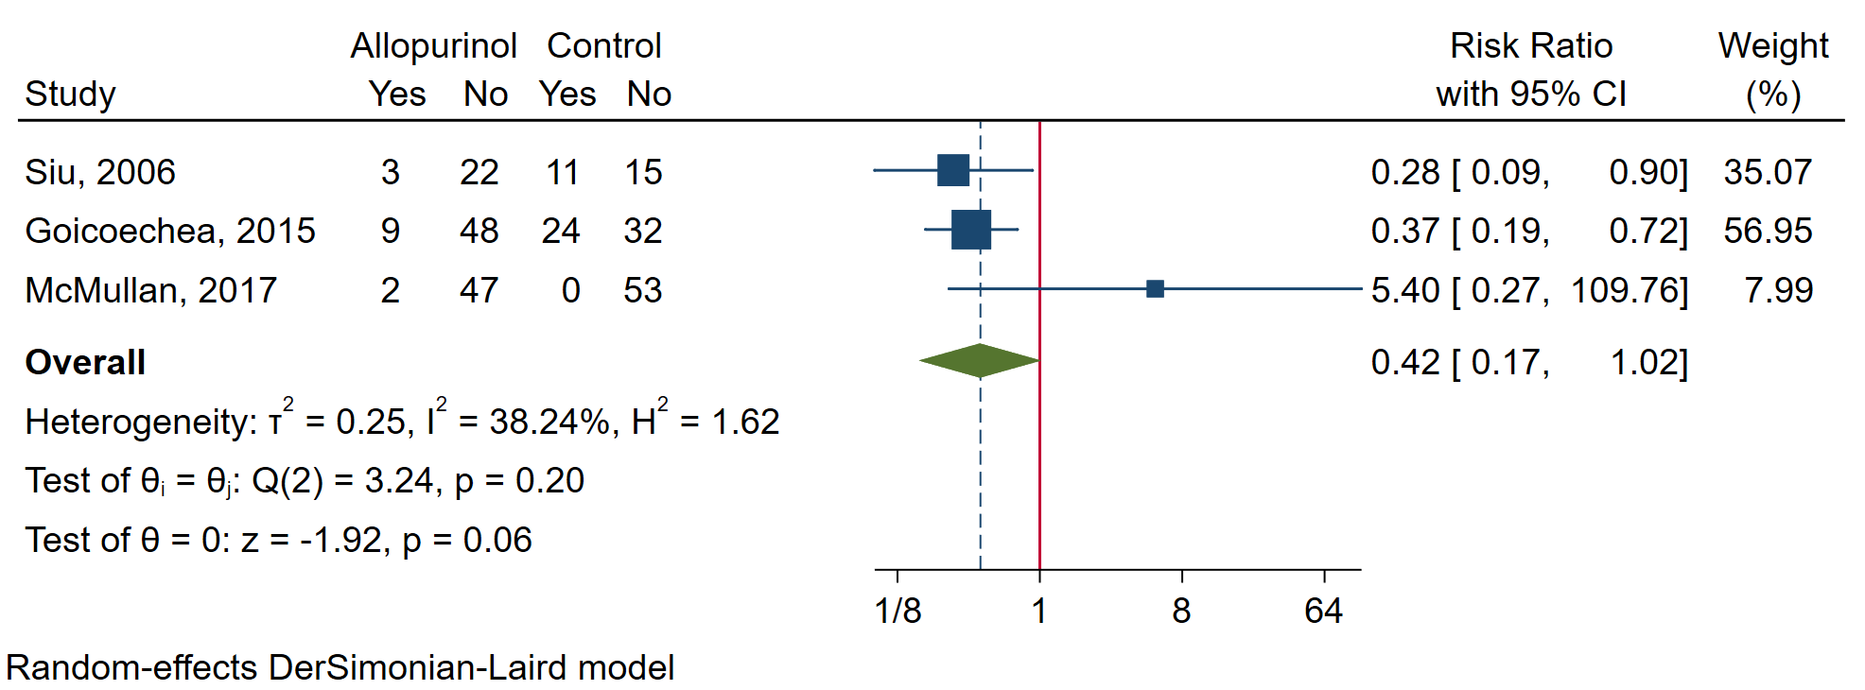
b) febuxostat vs placebo/no ULT
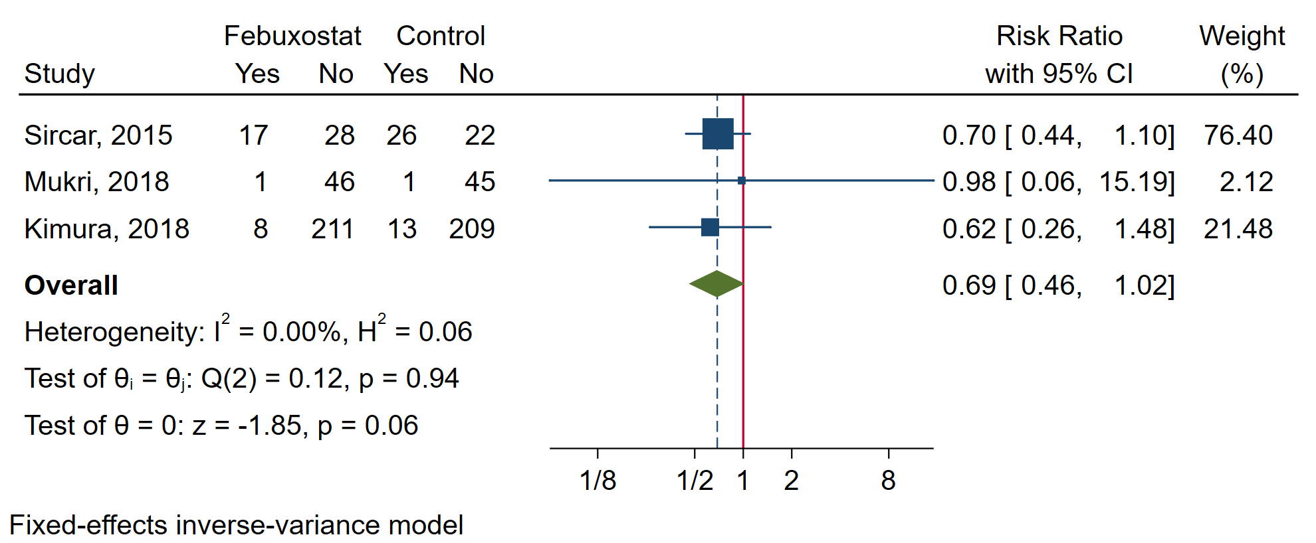
CI, confidence interval; ULT, urate-lowering therapy.

Figure S2. Forest plots of major adverse cardiovascular events
a) allopurinol vs placebo/no ULT
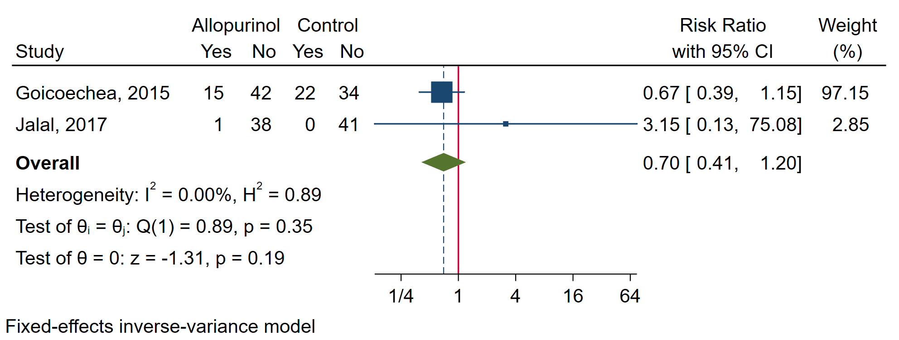
b) febuxostat vs placebo/no ULT
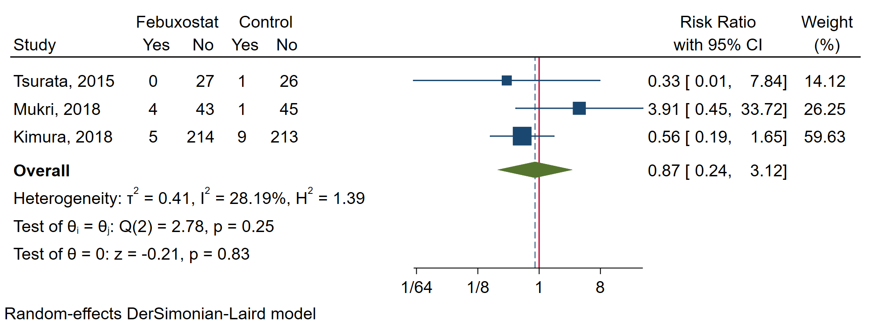
c) febuxostat vs allopurinol
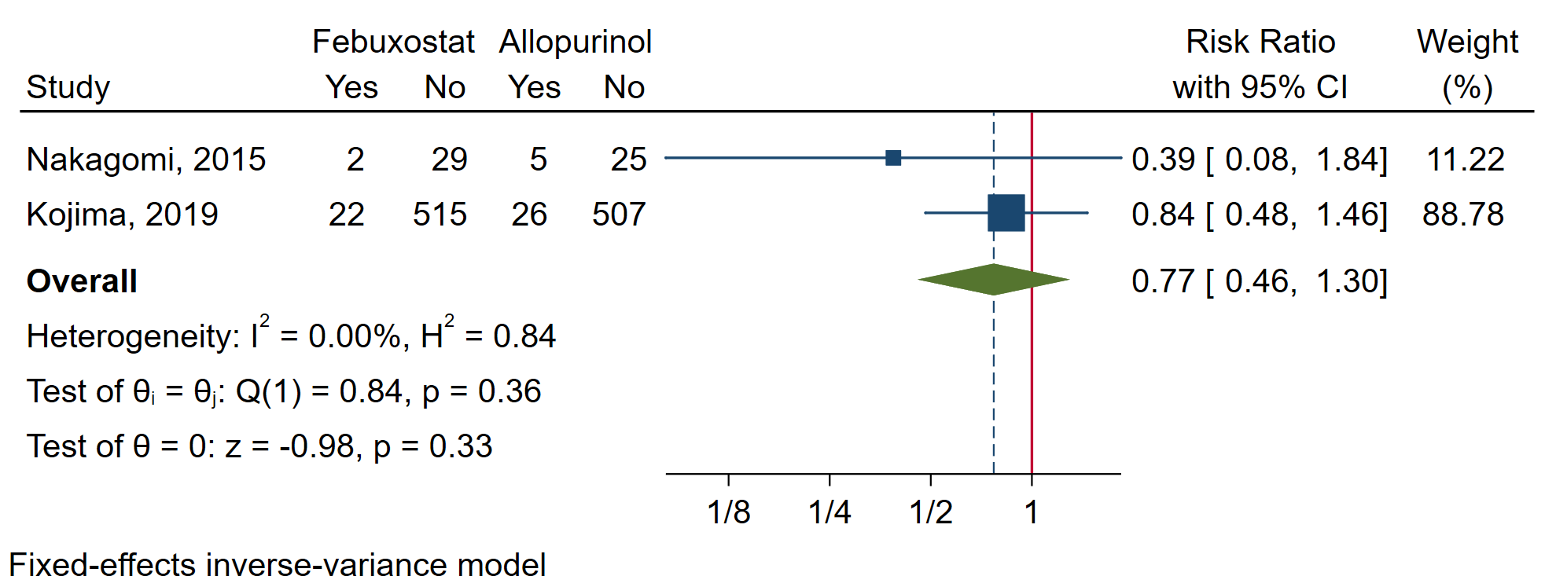
CI, confidence interval; ULT, urate-lowering therapy.

Figure S3. Forest plot of serum urate level
a) allopurinol vs placebo/no ULT
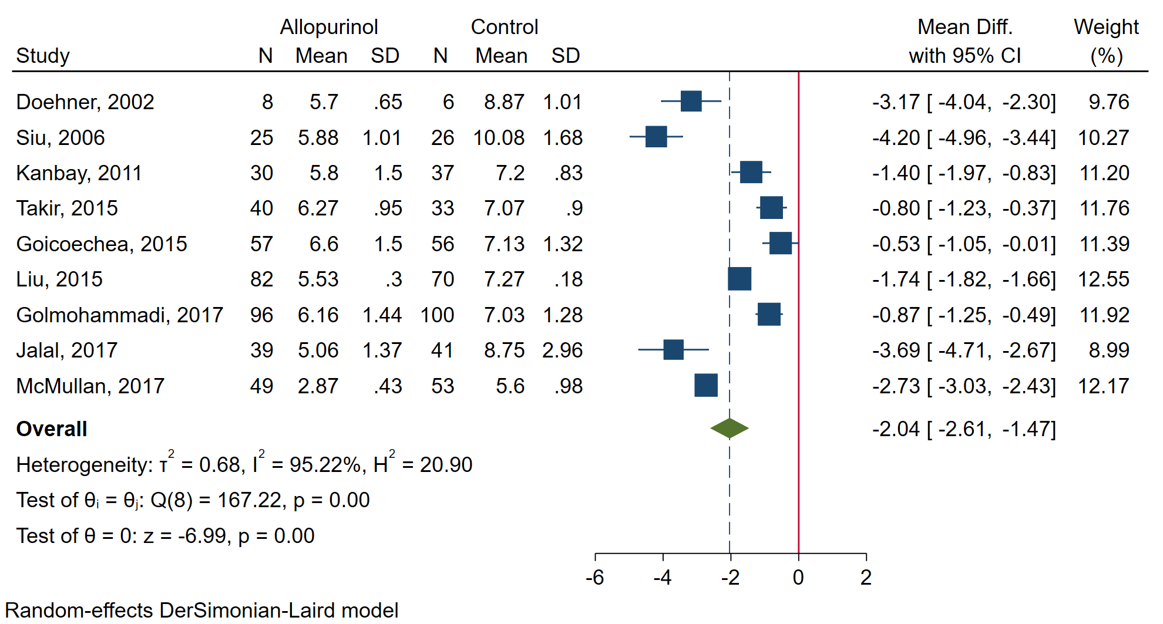
b) febuxostat vs placebo/no ULT
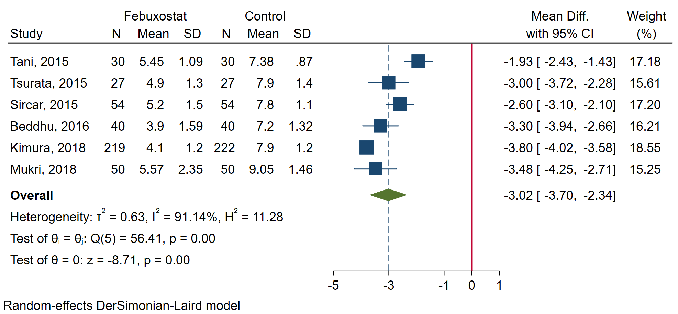

c) febuxostat vs allopurinol
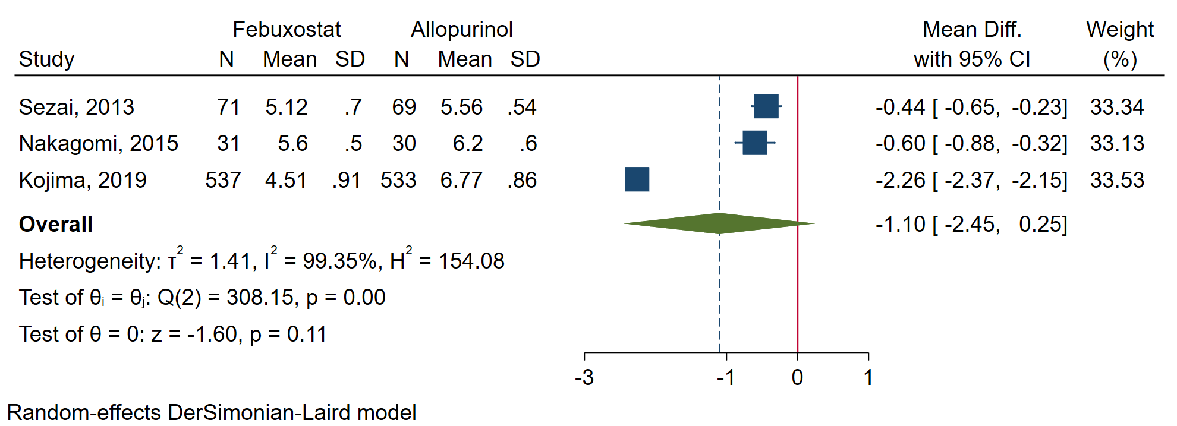
CI, confidence interval; Mean Diff., mean difference; SD, standard deviation; ULT, urate-lowering therapy.

Figure S4. Forest plot of estimated glomerular filtration rate
a) allopurinol vs placebo/no ULT
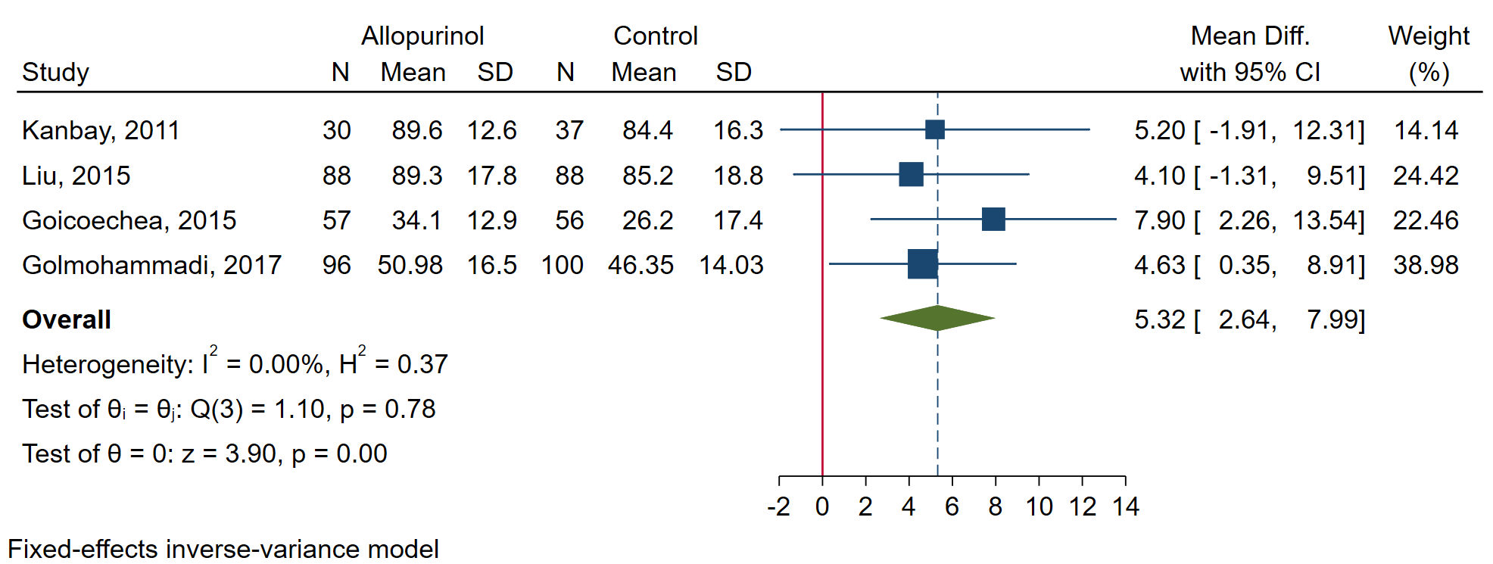
b) febuxostat vs placebo/no ULT
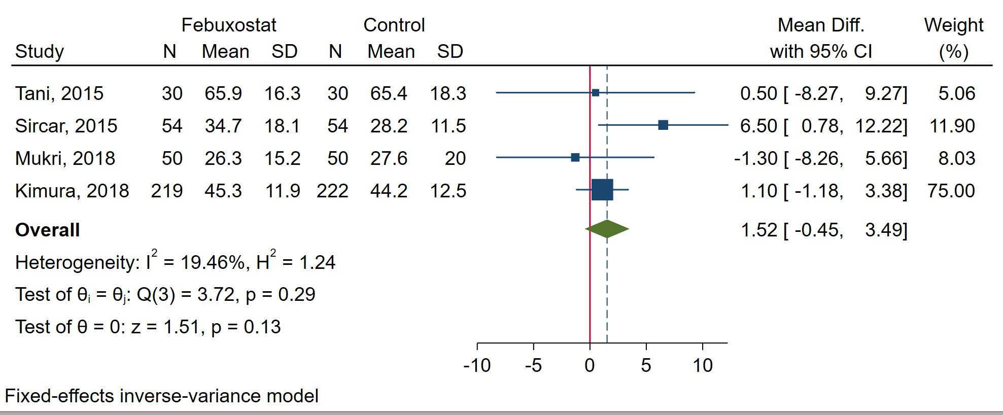

c) febuxostat vs allopurinol
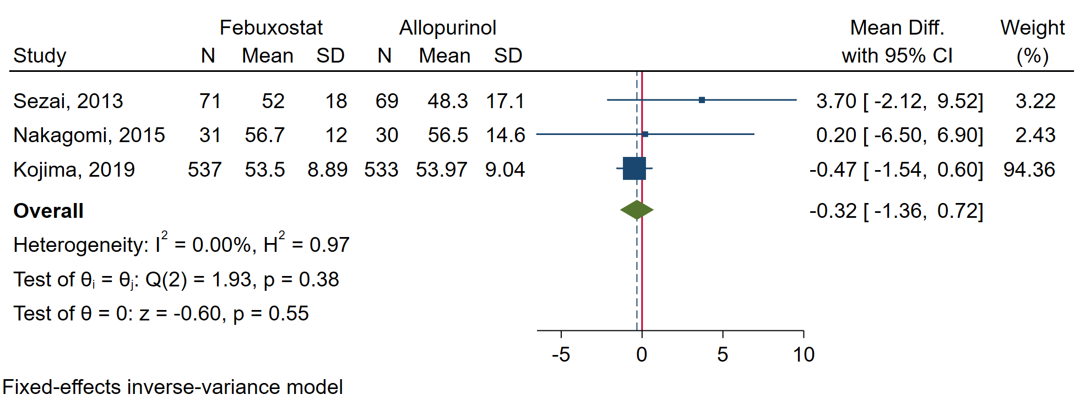
CI, confidence interval; Mean Diff., mean difference; SD, standard deviation; ULT, urate-lowering therapy.

Figure S5. Forest plots of systolic blood pressure
a) allopurinol vs placebo/no ULT
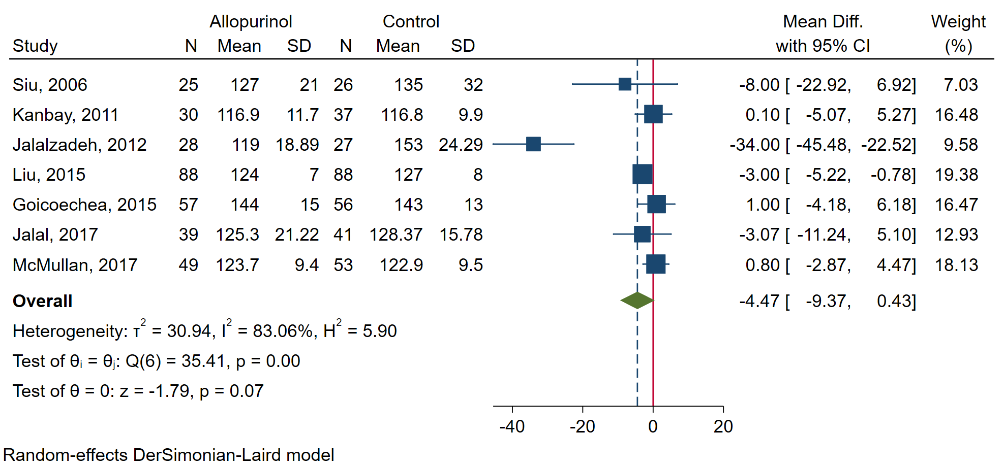
b) febuxostat vs placebo/no ULT
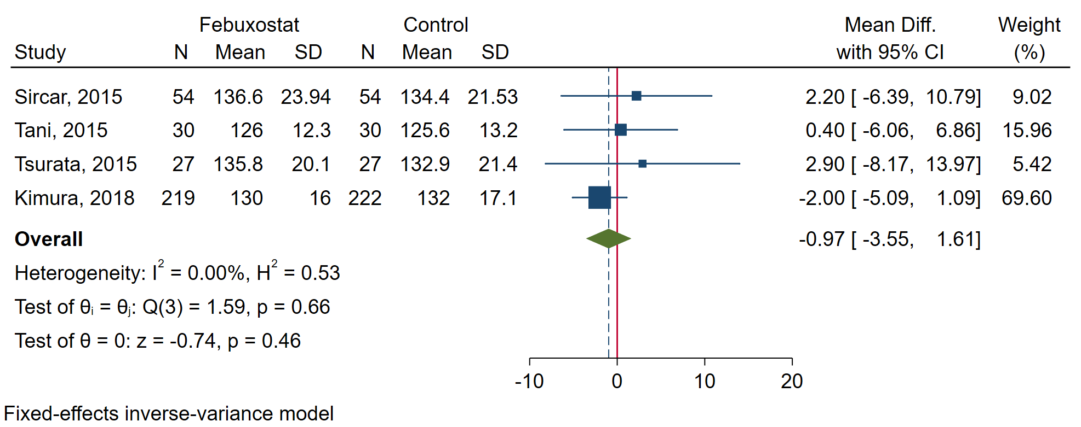

c) febuxostat vs allopurinol
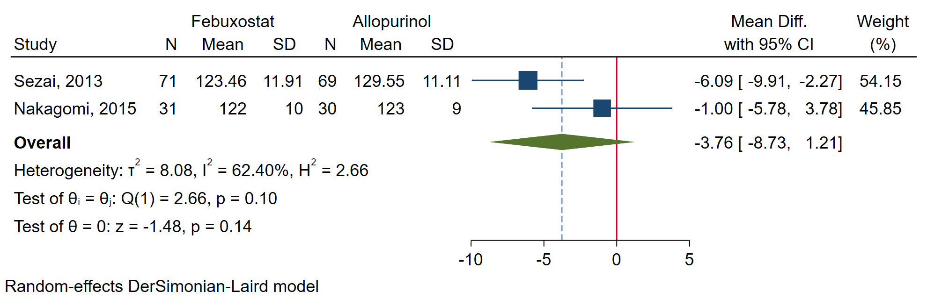
CI, confidence interval; Mean Diff., mean difference; SD, standard deviation; ULT, urate-lowering therapy.

Figure S6. Forest plots of adverse events
a) allopurinol vs placebo/no ULT
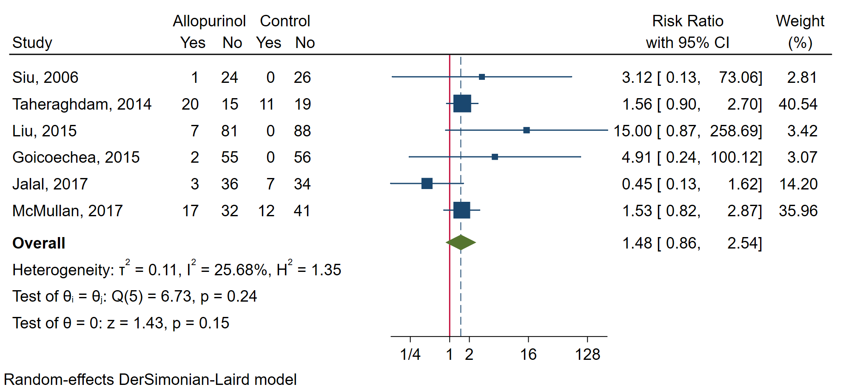
b) febuxostat vs placebo/no ULT
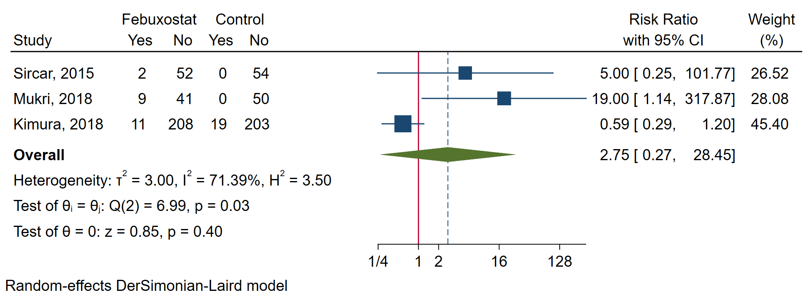

c) febuxostat vs allopurinol
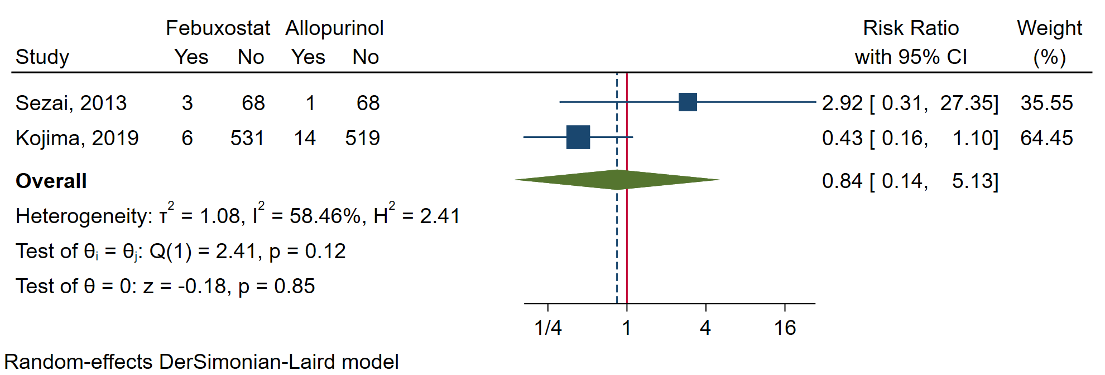
CI, confidence interval; ULT, urate-lowering therapy.

Figure S7. Forest plots: subgroup analysis of serum urate level by proportion of patients with hypertension
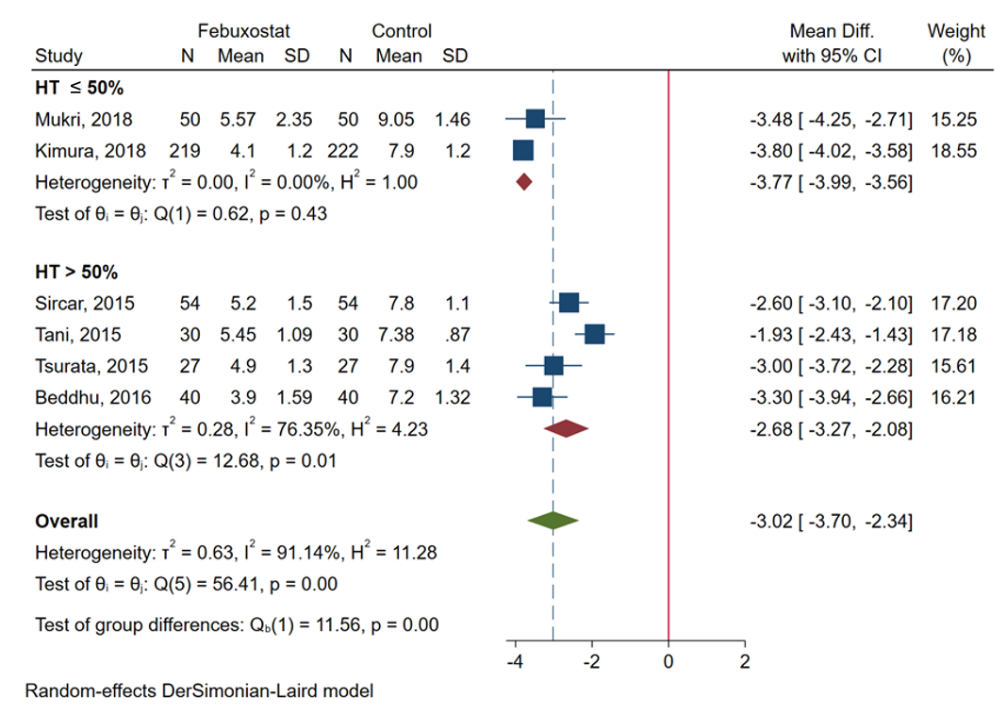
CI, confidence interval; HT, hypertension; Mean Diff., mean difference; SD, standard deviation

Figure S8. Forest plots: sensitivity analysis of serum urate level excluding study containing all hypertensive patients.

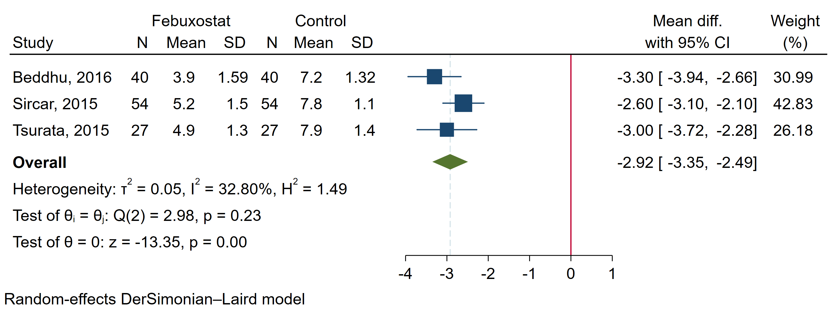
CI, confidence interval; HT, hypertension; Mean Diff., mean difference; SD, standard
Figure S9. Network maps of primary outcomes
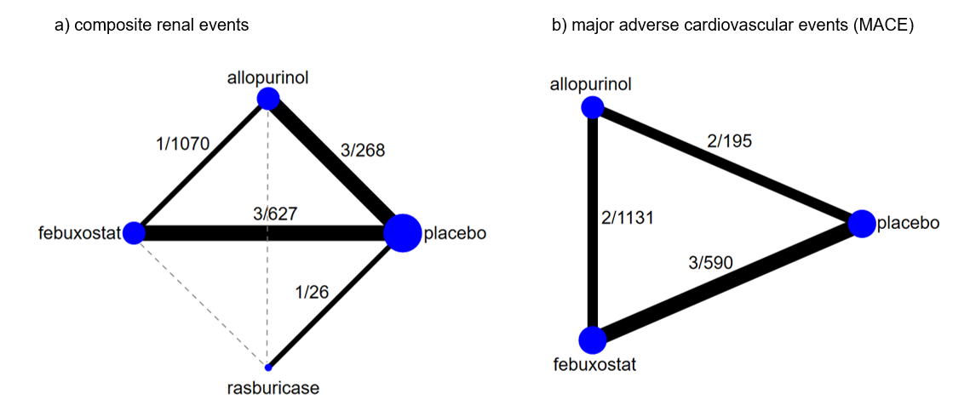
Network maps of composite renal events and MACE. Size of nodes was weighted by number of studies. Size of edges was weighted by number of subjects in each comparison. Each number on plots represents numbers of comparison arms and subjects contributing to the corresponding comparison. Dashed edges represent indirect comparison by network.

Figure S10. Network maps of secondary outcomes
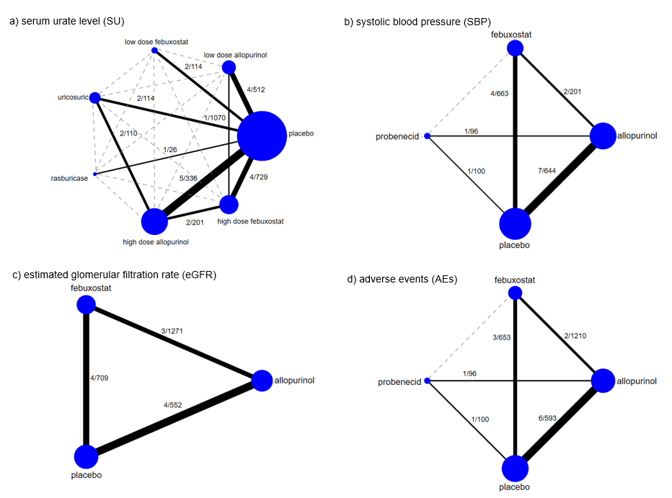
Network maps of SU, SBP, eGFR, and AEs. Size of nodes was weighted by numbers of studies. Size of edges was weighted by number of subjects in each comparison. Each number on plots represents numbers of comparison arms and subjects contributing to the corresponding comparison. Dashed edges represent indirect comparison by network.

Figure S11. Comparison-adjusted funnel plots
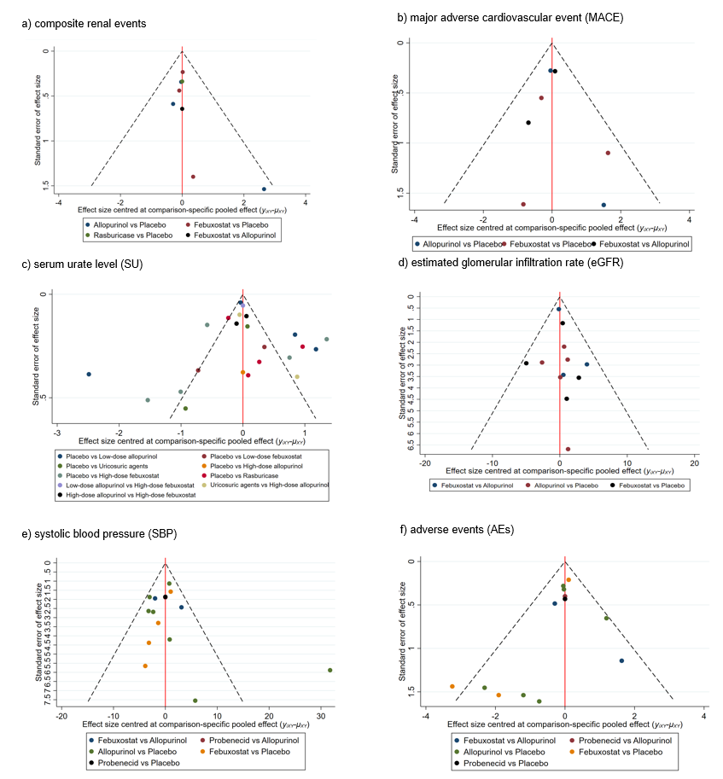

Figure S12. Scatter plot of the surface under the cumulative ranking curve for highest efficacy and lowest adverse events of urate-lowering agents
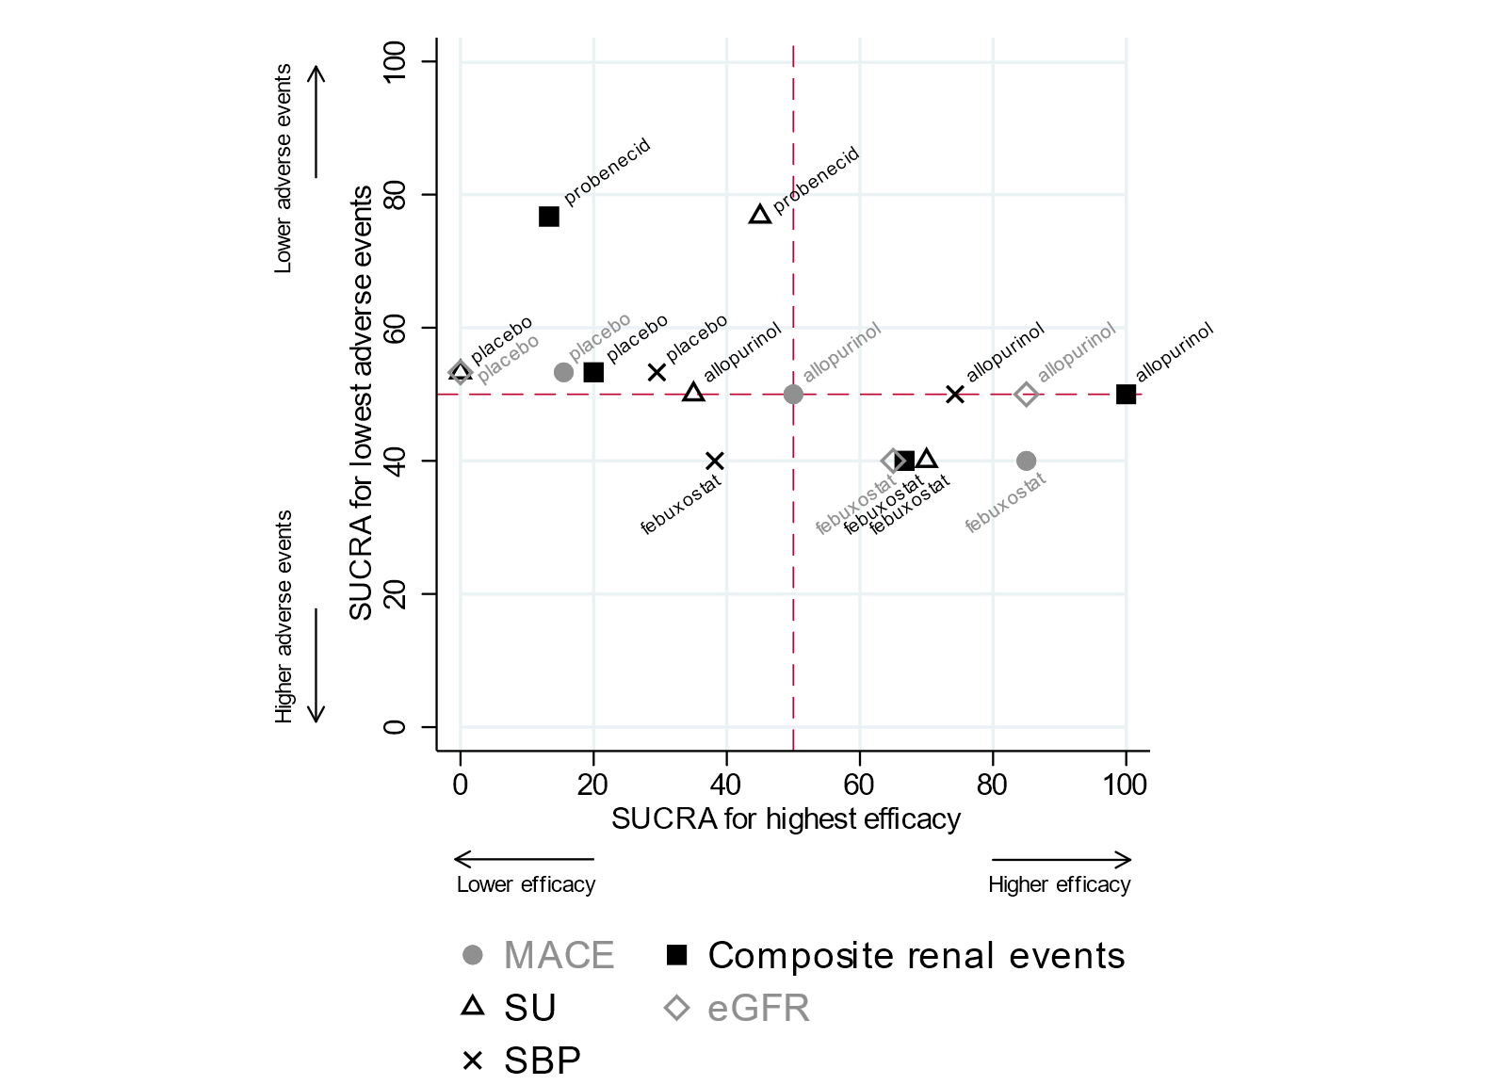
eGFR, estimated glomerular filtration rate; MACE, major adverse cardiovascular events; SBP, systolic blood pressure; SU, serum urate level; SUCRA, surface under the cumulative ranking curve.

Figure S13. Network forest plot


