Supplementary Appendix
Cigarette Smoking and Risk of Different Pathologic Types of Stroke: A Comprehensive Systematic Review and Dose-response Meta-analysis

Catalogue

Appendix 1： Search strategy 3
Online Figure 1： Forest plot of cigarette smoking on stroke mortality in meta-analysis 5
Online Figure 2： Forest plot of cigarette smoking on Ischemic Stroke in meta-analysis 6
Online Figure 3： Forest plot of cigarette smoking on Hemorrhagic Stroke in meta-analysis 7
Online Figure 4： Forest plot of cigarette smoking on Intracerebral Hemorrhage in meta-analysis 8
Online Figure 5： Forest plot of cigarette smoking on Subarachnoid Hemorrhage in meta-analysis 9
Online Table 1: univariable and multiple regression analysis for the risk of stroke morbidity 10
Online Figure 6: leave-one-out sensitivity analyses for the risk of stroke morbidity 11
Online Figure 7: sensitivity analysis by excluding non-high-quality studies for Stroke morbidity 12
Online Figure 8: sensitivity analysis by excluding non-high-quality studies for stroke mortality 13
Online Figure 9: Definitions of Former Smoker in Meta-analysis 14

Appendix 1： Search strategy
Search strategy of the PubMed, Embase, Books@Ovid, Journals@Ovid, Your Journals@Ovid, Joanna Briggs Institute EBP Database -, ACP Journal Club, CCTR, CDSR, CCA, CLCMR, DARE, CLHTA, CLEED, AMED, Ovid Emcare, HAPI, HealthSTAR, Ovid MEDLINE(R) by using Ovid.
1. (stroke$ or poststroke or apoplex$ or cerebral vasc$ or brain vasc$ or cerebrovasc$ or cva$ or SAH).tw.
2. exp brain h?ematoma/ or exp carotid artery disease/ or exp cerebral artery disease/ or exp cerebral small vessel disease/ or exp cerebrovascular accident/ or exp intracranial aneurysm/ or exp brain hemangioma/ or exp moyamoya/ or exp lacunar stroke/ or exp vertebrobasilar insufficiency/ or exp vasospasm/
3.((brain$ or cerebr$ or cerebell$ or intracerebral or intracran$ or parenchymal or intraparenchymal or intraventricular or brainstem or infratentorial or supratentorial or basal gangli$ or putaminal or putamen or posterior fossa or hemispher$ or subarachnoid) adj5 (h?emorrhag$ or h?ematoma$ or bleed$)).tw.
4.((brain or cerebr$ or cerebell$ or vertebrobasil$ or hemispher$ or intracerebral or intracran$ or brainstem or infratentorial or supratentorial or middle cerebral artery or MCA$ or anterior circulation or posterior circulation or basilar artery or vertebral artery or space occupying) adj5 (isch?emi$ or infarct$ or thrombo$ or emboli$ or occlus$ or hypoxi$)).tw.
5.(hemipleg$ or hemipar$ or paresis or paretic or paralysis).tw.
6.1 or 2 or 3 or 4 or 5
7.exp Prospective-Studies/
8.exp Evaluation-Studies/ or Program-Evaluation.mp.
9.exp Cross-Sectional-Studies/
10.Comparative study/
11.exp Behavior-therapy/
12.exp Health-Promotion/
13.exp Community-Health-Services/
14.exp Health-Behavior/ or exp Health-Education/
15.exp Vital Statistics/
16.exp epidemiology/
17.7 or 8 or 9 or 10 or 11 or 12 or 13 or 14 or 15 or 16
18.smoking cessation.mp. or exp Smoking Cessation/
19.tobacco cessation.mp. or "Tobacco-Use-Cessation"/
20.exp Smoking/
21."Tobacco-Use-Disorder"/
22.Tobacco-Smokeless/
23.exp Tobacco-Smoke-Pollution/
24.Smoking reduction/ or Smoking reduction.mp.
25.Smoking prevention/
26. Vaping/ or vaping.mp.
27. Electronic Nicotine Delivery Systems/
28. electronic cigar*.mp.
29. exp Pipe smoking/ or exp Tobacco smoking/ or exp Tobacco Products/
30. ((quit$ or stop$ or ceas$ or giv$ or abstain* or abstinen*) adj5 (smoking or smoke* or tobacco)).ti,ab.
31.exp Tobacco/ or exp Nicotine/
32.18 or 19 or 20 or 21 or 22 or 23 or 24 or 25 or 26 or 27 or 28 or 29 or 30 or 31
33.32 and 17
34.6 and 33
35.(humans not animals).sh.
36.34 and 35

Online Figure 1： Forest plot of cigarette smoking on stroke mortality in meta-analysis

Online Figure 2： Forest plot of cigarette smoking on Ischemic Stroke in meta-analysis

Online Figure 3： Forest plot of cigarette smoking on Hemorrhagic Stroke in meta-analysis

Online Figure 4： Forest plot of cigarette smoking on Intracerebral Hemorrhage in meta-analysis

Online Figure 5： Forest plot of cigarette smoking on Subarachnoid Hemorrhage in meta-analysis

Online Table 1: univariable and multiple regression analysis for the risk of stroke morbidity
comparison | odds ratio（95% CI） | P value
comparison | odds ratio（95% CI） | Univariable  meta-regression | Multiple  meta-regression
subgroup by continental
North America | 1.213（1.134 to 1.291） | 0.374 | 0.747
Europe | 1.456（1.415 to 1.498） | 0.374 | 0.747
Asia | 1.254（1.210 to 1.298） | 0.374 | 0.747
subgroup by female sex ratio
＜25% | 1.282（1.238 to 1.326） | 0.265 | 0.425
25%-75% | 1.335（1.270 to 1.400） | 0.265 | 0.425
＞75% | 1.411（1.366 to 1.456） | 0.265 | 0.425
subgroup by follow years
＜10 | 1.301（1.261 to 1.341） | 0.005 | 0.013

Online Figure 6: leave-one-out sensitivity analyses for the risk of stroke morbidity

Online Figure 7: sensitivity analysis by excluding non-high-quality studies for Stroke morbidity

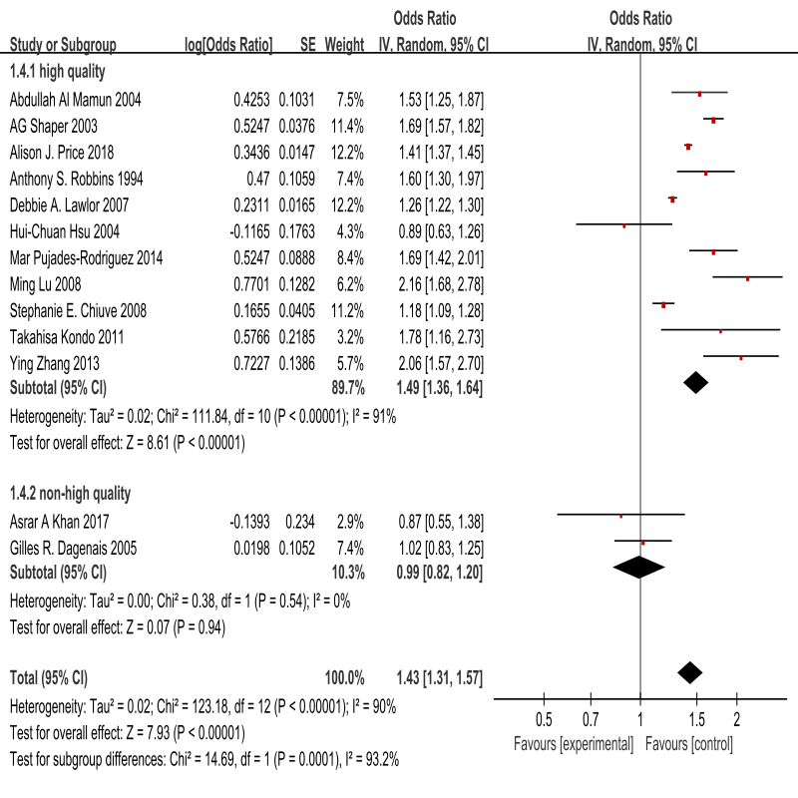

Online Figure 8: sensitivity analysis by excluding non-high-quality studies for stroke mortality
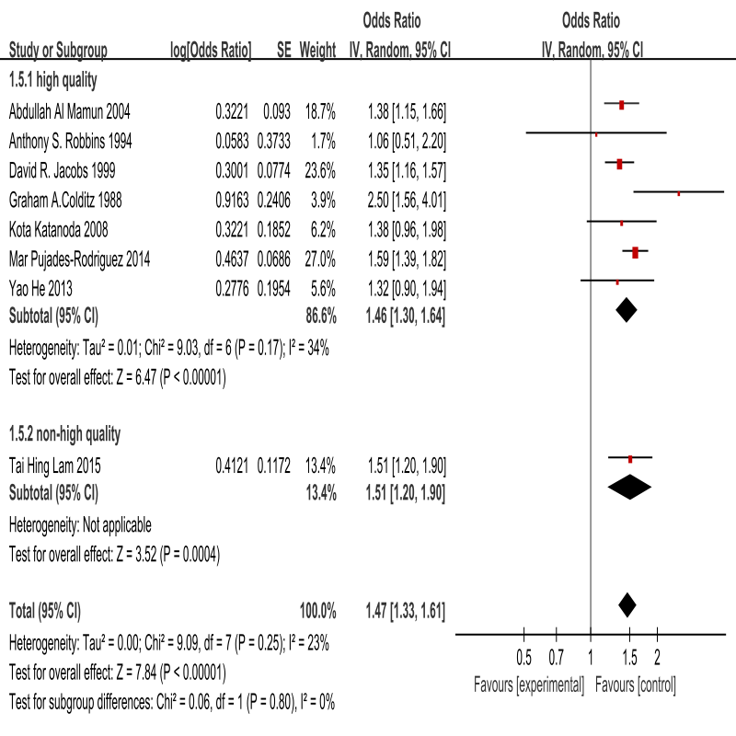

Online Figure 9: Definitions of Former Smoker in Meta-analysis

