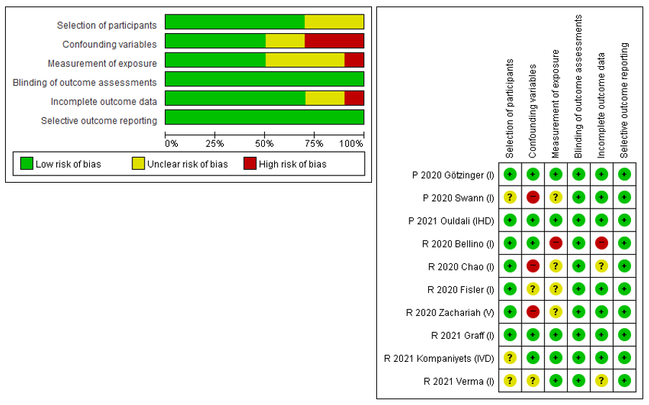
Supplementary Fig. 1. Risk of bias of included studies in this meta-analysis.
P = prospective study, R = retrospective study, I = intensive care unit care, V = mechanical ventilator support, D = death, H = hemodynamic support.

