Supplemental Material: Appendices

Biofire FilmArray Meningitis/Encephalitis panel for the aetiological diagnosis of central nervous system infections. A Systematic Review and Diagnostic Test Accuracy Meta-analysis

Authors
Juliana Trujillo-Gómez, Sofia Tsokani, Catalina Arango-Ferreira, Santiago Atehortúa-Muñoz, Maria José Jimenez-Villegas, Carolina Serrano-Tabares, Areti-Angeliki Veroniki, Ivan D. Florez.

Appendix 1: Search Strategies

PUBMED
(((((((filmarray[Title/Abstract]) OR multiplex PCR panel[Title/Abstract]) OR real-time multiplex PCR[Title/Abstract]) OR multiplex PCR[Title/Abstract]) OR multiplex polymerasa chain reaction[Title/Abstract]) OR biofirefilmarray[Title/Abstract])) AND ((((((((meningitis/encephalitis[Title/Abstract]) OR meningitis[Title/Abstract]) OR encephalitis[Title/Abstract]) OR central nervous system[Title/Abstract]) OR central nervous system infection[Title/Abstract])) OR "Meningitis/diagnosis"[Mesh]) OR (("Encephalitis/diagnosis"[Mesh]) OR "Central Nervous System Infections/diagnosis"[Mesh]))

EMBASE
'encephalitis'/exp OR 'encephalitis'/exp OR 'central nervous system infection'/exp OR 'central nervous system disease'/exp AND 'filmarray'/exp OR 'multiplex polymerase chain reaction'/exp OR 'real-time multiplex pcr' OR 'biofirefilmarray'

WEB OF SCIENCE
(filmarray OR Multiplex PCR OR multiplex polymerase) AND (meningitis OR encephalitis OR meningoencephalitis OR central nervous system OR cerebrospinal fluid OR neurologic*infection)

Appendix 2. Risk of bias assessment methodological details (QUADAS 2)

We applied the four key domains of the Quality Assessment of Diagnostic Accuracy Studies (QUADAS-2) (Whitng et al 2011). The domains are patient selection, index test, reference test, and time flow using the recommended signalling questions. As we used two different reference tests, some criteria, and conditions for answering the signalling questions are specific for each reference test as explained below.

Reference test 1
For bacteria (CSF culture or blood culture), in the signalling question of the QUADAS domain 3: Is the reference standard likely to correctly classify the target condition? our answer was “yes” only if it was clear that the CSF or blood samples were taken before the start of antimicrobial therapy, or if the researchers used additional molecular diagnostic methods for bacteria. In this case, a “no” answer would result in a judgement of a high risk of bias in the reference standard domain, for reference test 1.

Reference test 2
We acknowledge the adjudication for the diagnosis is, especially for bacteria, when the reference test may be limited (e.g., previous antimicrobial therapy). However, the diagnostic accuracy of this adjudication should be blinded to the result of the index test. Therefore, in the signalling question: Were the reference standard results interpreted without knowledge of the results of the index test? our answer was “yes”, only if it was clear that the decision was blinded to the index test result. In this case, a “no” answer would result in a judgement of a high risk of bias in this domain for in the reference standard domain for reference test 2. Lastly, we did not make a formal assessment of publication bias but, to the best of our knowledge publication bias is not suspected in this clinical area, and our search was very comprehensive with no language or date restrictions.

Reference
Whitng P, Rutjes A, Marie W, Mallet S, Deeks J, Reitsma J, et al. QUADAS-2: A Revised Tool for the Quality Assessment of Diagnostic Accuracy Studies. Ann Intern Med. 2011;155:529–36.
Appendix 3. Excluded articles (n=45)

Study reference | Exclusion reason
Nestor D, Hedberg ST, Lignell M, Skovbjerg S, Molling P, Sundqvist M. Evaluation of the FilmArray (TM) Meningitis/Encephalitis panel with focus on bacteria and Cryptococcus spp. Journal of Microbiological Methods. 2019;157:113-6. | Convenience sampling using colonies of specific organisms.
Anshu Rohatgi, Chand Wattal, Neeraj Goel, YatinSagvekar, Neha Pandita, Virti Shah Dhiren, Swarn Lata. Evaluation of BioFire Film Array Meningitis/ Encephalitis (ME) panel in testing of CSF specimen of patients of meningoencephalitis in Indian scenario. Neurology , 2019; 92 | Abstract. We tried contacting authors by email but did not receive a response.
Carolina Geadas, Archana Asundi, Rotem Lapidot, Nancy Mille. Clinical Use of a Multiplex PCR Meningitis/Encephalitis Panel at an Urban Tertiary Care Center.Open ForumInfectDis. 2018 (Suppl 1): S135 | Poster (Presented in ID Week 2018-San Francisco). We tried contacting author by email but did not receive a response. We could not define its eligibility with the available information
Jeanette Taveras ,Tibisay Villalobos-Fry. The Use of Multiplex PCR Panel in the Diagnosis of Meningitis in Children. OPEN FORUM INFECTIOUS DISEASE 2018 (Suppl 1): S135. | Poster (Presented in ID Week 2018-San Francisco). We tried contacting author by email but did not receive a response. We could not define its eligibility with the available information
DiDiodato G, Bradbury N. Cerebrospinal Fluid Analysis With the BioFireFilmArray Meningitis/Encephalitis Molecular Panel Reduces Length of Hospital Stay in Patients With Suspected Central Nervous System Infections. Open ForumInfectiousDiseases. 2019;6(4):3 | Clinical impact study. Incomplete data for calculating of diagnostic accuracy
Mina Y, Schechner V, Savion M, Yahav D, Bilavsky E, Sorek N, et al. Clinical benefits of FilmArray meningitis-encephalitis PCR assay in partially-treated bacterial meningitis in Israel. BMC Infect Dis. 2019;19(1):713. | Article did not have explicit comparison with other diagnostic tests.
Kwon E, Kim SY, Yun JY, Cho SY, Han D, Jeong JH, et al. Clinical performance of the BioFireFilmArray Meningitis/Encephalitis panel in Korean adult patients with central nervous system infection. Neurology. 2018;90:2. | Abstract. We tried contacting the authors by email but did not receive a response. We could not define its eligibility with the available information
Koller R, Barbani MT, Luthi AU, Zurcher S, Steinlin-Schopfer JF, Leib SL, et al. Comparison of respiratory and Meningitis/Encephalitis viruses detected by FilmArray (R) multiplex PCR versus real-time PCR. Journal of ClinicalVirology. 2016;82:S39-S. | Poster-Abstract (Presented in European Society  for ClinicalVirology 2016). We tried contacting author by email but did not receive a response. We could not define its eligibility with the available information
Kim TH, Minejima E, Spellberg B, Shulman I, Holtom P, Kang T, et al. Evaluation of the filmarray meningitis/encephalitis molecular panel in a tertiary care public county hospital. Open Forum Infectious Diseases. 2017;4:S596. | Poster-Abstract (Presented in ID Week 2018—San Diego). We tried contacting author by email but did not receive a response. We could not define its eligibility with the available information
Alshehri A, Aljohani S. Performance Evaluation of BioFireFilmArray Meningitis/Encephalitis Panel for Detection of Bacteria, Viruses, and Yeast in Cerebrospinal Fluid Specimens. Journal of Infection and Public Health. 2019;12(1):109 | Poster-Abstract (Presented in Third Gulf Congress of Clinical Microbiology and Infectious Diseases GCCMID 2018-United Arab Emirates). We tried contacting author by email but did not receive a response. We could not define its eligibility with the available information
von Allmen N, Edelmann A, Kuehn S. Performance comparison of the new filmarray meningitis/encephalitis panel with routine diagnostic methods. Journal of Clinical Virology. 2016;82:S33-S. | Poster-Abstract.  (Presented in Nineteenth European Society for Clinical Virology – ESCV 2016). We tried contacting author by email but did not receive a response. We could not define its eligibility with the available information
Rhein J, Bahr NC, Hemmert AC, Cloud JL, Bellamkonda S, Oswald C, et al. Diagnostic performance of a multiplex PCR assay for meningitis in an HIV-infected population in Uganda. Diagn Microbiol Infect Dis. 2016;84(3):268-73. | Study on HIV patients
Sisham Ingnam,; Philip Goldstein; Lynn Wardlow,; Joan-Miquel Balada-Llasat. Implementation of FilmArray Meningitis/Encephalitis Panel at a Tertiary Medical Center | Poster (Presented in ID Week 2018-San Francisco). We tried contacting author by email but did not receive a response. We could not define its eligibility with the available information
Chong BSW, Kennedy J.Comparison of the biofire film array meningitis/encephalitis panel to established laboratory methods for the diagnosis of meningoencephalitis Pathology (2019), 51(S1) | Abstract. Incomplete information. We could not define its eligibility with the available information
Merlin T et al.How Do Advanced Molecular Tests Compare to Routine Clinical Laboratory Evaluation of CSF in Meningoencephalitis? A Study in 10 Urban Emergency Departments Across the USA. Open Forum Infect Dis. 2017; 4(Suppl 1): S8–S9.(1) | Abstract. Incomplete information. It is not clear comparative tests used.
Sall O, et al. Etiology of Central Nervous System Infections in a Rural Area of Nepal Using Molecular Approaches. Am. J. Trop. Med. Hyg., 101(1), 2019, pp. 253–259(2) | Method of reference (reference test) that was used had different criteria
Graf EH, Farquharson MV, Cárdenas AM. Comparative evaluation of the FilmArray meningitis/encephalitis molecular panel in a pediatric population. Diagn Microbiol Infect Dis. 2017 Jan;87(1):92–4 | Case control study. Highly selected samples with positive FA result or alternate method.
Naccache SN, Lustestica M, Fahit M  Mestas J, Dien Bard J, Barda JD, et al.  One year in the life of a rapid syndromic  panel for meningitis/encephalitis: a  pediatric tertiary care facility’s experience.  J Clin Microbiol. 2018;56(5):1–11. | We could not find a comparative method between samples.
Messacar K, Breazeale G, Robinson CC, Dominguez SR. Potential Clinical Impact of The Filmarray Meningitis Encephalitis Panel In Children With Suspected Central Nervous System Infections. Diagn Microbiol Infect Dis. 2017;86(1):118–20. | Highly selected samples (HSV-EV positive or negative culture).
Launes C, Casas-Alba D, Fortuny C, Valero-rello A, Cabrerizo M, Muñoz-Almagro C. Utility of FilmArray meningitis/encephalitis panel during outbreak of brainstem encephalitis caused by enterovirus in catalonia in 2016. J Clin Microbiol. 2017;55(1):336–8. | Highly selected samples (negative previous studies including PCR in house EV)
Wootton SH, Aguilera E, Salazar L, Hemmert AC, Hasbun R. Enhancing pathogen identification in patients with meningitis and a negative Gram stain using the BioFire FilmArray ®Meningitis / Encephalitis panel. Ann Clin Microbiol Antimicrob. 2016;15(1):26–9. | It remains unclear which and how many samples had a comparative test done.
Liesman RM, Strasburg AP, Heitman AK, Theel ES, Patel R, Binnicker MJ. Evaluation of a commercial multiplex molecular panel for diagnosis of infectious meningitis and encephalitis. J Clin Microbiol. 2018;56(4):1–9. | Highly selected samples already positive for some microorganism.
Lee CK, Chiu L, Yan G, Chew KL, Yan B, Jureen R, et al. False negative results caused by erroneous automated result interpretation algorithm on the FilmArray 2.0 instrument. Clin Chem Lab Med. 2018;56(2):e43–6. | It remains unclear which and how many samples had a comparative test done.
Ordonez K, Alzate J, Suarez O, Orozco D,  Baron LM, Bonilla IC, et al. Poster Impact  of the Biofire® Film Array (FA) Meningitis  Encephalitis (ME) Panel in Colombia.  Open forum Infect Dis. 2018;5(1). | Study with two cohorts: one with and one without FA/ME. High percentage of HIV positive patients (47%). Presented in ID Week 2018—San Diego. Unpublished paper.
O’Brien MP, Francis JR, Marr IM, Baird  RW. Impact of Cerebrospinal Fluid  Multiplex Assay on Diagnosis and  Outcomes of Central Nervous System  Infections in Children: A Before and After  Cohort Study. Pediatr Infect Dis J.  2018;37(9):868–71. | FA only detected viruses and the comparative PCR was only done in some cases.
Lee SH, Chen SY, Chien JY, Lee TF, Chen JM, Hsueh PR. Usefulness of the FilmArray meningitis/encephalitis (M/E) panel for the diagnosis of infectious meningitis and encephalitis in Taiwan. J Microbiol Immunol Infect. 2019;52(5):760–8. | FA detected mainly viruses and the comparative PCR was only done in some cases
Cailleaux M, Pilmis B, Mizrahi A, Lourtet-Hascoet J, Van JCN, Alix L, et al. Impact of a multiplex PCR assay (FilmArray (R)) on the management of patients with suspected central nervous system infections. European Journal of Clinical Microbiology & Infectious Diseases. 2020;39(2):293-7. | Clinical impact study. Incomplete data for systematic review of diagnostic tests.
Dack K, Pankow S, Ablah E, Zackula R, Assi M. Contribution of the BioFire(Â®) FilmArray(Â®) Meningitis/Encephalitis Panel: Assessing Antimicrobial Duration and Length of Stay. Kans J Med. 2019;12(1):1-3 | Clinical impact study. Cohort study.
Hagen A, Eichinger A, Meyer-Buehn M, Schober T, Huebner J. Comparison of antibiotic and acyclovir usage before and after the implementation of an on-site FilmArray meningitis/encephalitis panel in an academic tertiary pediatric hospital: a retrospective observational study. Bmc Pediatrics. 2020;20(1):10. | Cohort study. Patients were included in another study already analyzed in the present systematic review.
Messacar K, Gaensbauer JT, Birkholz M, Palmer C, Todd JK, Tyler KL, et al. Impact of FilmArray meningitis encephalitis panel on HSV testing and empiric acyclovir use in children beyond the neonatal period. Diagnostic Microbiology and Infectious Disease. 2020;97(4):3 | Clinical impact study. Incomplete data for calculating the diagnostic accuracy measurement
Mostyn A, Lenihan M, O'Sullivan D, Woods S, O'Hara M, Powell J, et al. Assessment of the FilmArrayÂ® multiplex PCR system and associated meningitis/encephalitis panel in the diagnostic service of a tertiary hospital. Infection Prevention in Practice. 2020;2(2) | Incomplete data for calculating the diagnostic accuracy measurement
Nabower AM, Miller S, Biewen B, Lyden E, Goodrich N, Miller A, et al. Association of the FilmArray meningitis/ encephalitis panel with clinical management. Hospital Pediatrics. 2019;9(10):763-9. | Incomplete data for calculating the diagnostic accuracy measurement
Pfefferle S, Christner M, Aepfelbacher M, Lutgehetmann M, Rohde H. Implementation of the FilmArray ME panel in laboratory routine using a simple sample selection strategy for diagnosis of meningitis and encephalitis. Bmc Infectious Diseases. 2020;20(1):9. | Incomplete data for systematic review of diagnostic tests. An email was sent to clarify missing data, no response was obtained.
Precit MR, Yee R, Pandey U, Fahit M, Pool C, Naccache SN, et al. Cerebrospinal Fluid Findings Are Poor Predictors of Appropriate FilmArray Meningitis/Encephalitis Panel Utilization in Pediatric Patients. Journal of Clinical Microbiology. 2020;58(3):13 | Incomplete data for calculating the diagnostic accuracy measurement
Samarasekara H, Thai W, Balgahom R, Branley J. An assessment of the clinical impact of positive biofire filmarray Meningitis/Encephalitis (ME) panel results. Pathology. 2020;52:S126 | Clinical impact study. Incomplete data for calculating the diagnostic accuracy measurement
Barros Domingues R, Mendes-Correa MC, Vilela de Moura Leite FB, Vega Dos Santos M, Senne Soares CA. Evaluation of the Utilization of FilmArray Meningitis/Encephalitis in Children With Suspected Central Nervous System Infection: A RetrospectiveCase Series.Pediatric emergency care. 2021 | Incomplete data for calculating the diagnostic accuracy measurement
Bridge S, Hullsiek K, Boulware D, Rhein J. Evaluation of the BioFire FilmArray meningitis/encephalitis multiplex PCR panel in Uganda. Academic Emergency Medicine. 2021;28(SUPPL 1):S241. | High percentage of HIV positive patients, Cohort study
Ekambaram M, Nabower AM, Ampofo K, Gollehon NS, Goodrich N, McCulloh R, et al. Evaluation of discordant results between filmarray meningitis/encephalitis panel and conventional testing in pediatric patients: A multi-site retrospective cohort study. OpenForumInfectious Diseases. 2020;7(SUPPL 1):S154-S5. | Abstract. Highly selected samples already positive for some microorganism.
McDonald D, Gagliardo C, Chiu S, Di Pentima MC. Impact of a Rapid Diagnostic Meningitis/Encephalitis Panel on Antimicrobial Use and Clinical Outcomes in Children. ANTIBIOTICS-BASEL. 2020;9(11). | Clinical impact study
Mori T, Koda Y, Kato J, Sakurai M, Uwamino Y, Hasegawa N. Usefulness of the FilmArray Meningitis/Encephalitis Panel in diagnosis of central nervous system infection after allogeneic hematopoietic stem cell transplantation. SUPPORTIVE CARE IN CANCER.2021 | Study on patients after allogeneic hematopoietic stem cell transplantatio (immunosuppression)
Park SE, Lim TJ, Nam SO, Chang CL, Byun SY, Ko A, et al.Clinical utility of the FilmArray meningitis/encephalitis panel in children at a tertiary center in South Korea. BRAIN & DEVELOPMENT. 2021;43(2):234-43. | Highly selected patients and incomplete data for calculating the diagnostic accuracy measurement
Riordan A, Wade L, Waugh L, Shaw F. Clinical impact of rapid identification of pathogensin csf of general paediatric patients. Archives of Disease in Childhood. 2020;105(SUPPL 1):A217 | Incomplete data for calculating the diagnostic accuracy measurement, and the comparative method was not done in all samples
Vanood A, Hospodar A, Carpenter CF. Diagnostic utility of a multiplex PCR meningitis/encephalitis panel and impact on antibiotic use. Open Forum Infectious Diseases. 2020;7(SUPPL 1):S65 | The comparative method was not done in all samples
Waldrop G, Radmard S, Thakur KT, Zucker J, Boubour A, Green DA. Clinical Significance of Positive Results of the BioFire Cerebrospinal Fluid FilmArray Meningitis/Encephalitis Panel at a Tertiary Medical Center in the United States. Archives ofpathology&laboratory medicine. 2021. | Highly selected samples already positive for some microorganism.
Walker M, Taylor K, Beaulieu R, Laurent M, Hamer D, O'Neal C. The Clinical Impact of the FilmArray Meningitis/Encephalitis (ME) Panel on Antimicrobial Utilization in a Tertiary Hospital Setting. AMERICAN JOURNAL OF THE MEDICAL SCIENCES. 2021;361(4):550-2. | Clinical impact study

Appendix 4. Characteristics of the included articles (n=19)

Study | Country//Type of study /Funding | Inclusion criteria | Number of patients/ Mean age | Number of patients for the meta-analysis | Microorganisms analyzed in the meta-analyses and reference tests used | Use of antimicrobials before LP | Method employed to resolve disagreement between FA/ME and reference test 1.
Leber 2016 | United Stated of America/  Prospective/  Funding: BioFire Diagnostics | Samples that were obtained in a clinical situation that includes culture and that became available in the next seven days. | 1560 patients  Neonates, children and adults.  41% were children and 58% were older than 18 years. | 1560 for virus and bacteria analyses | Bacteria: culture  Viruses  Enterovirus: PCR LDT assay target 5utr1/5utr2  HSV-1 y HSV-2: PCR LDT assay target UL30 UL42  VZV: PCR LDT assay target ORF 62 /ORF63 | 46 patients (34% of the positive results). | *Re-testing with film array or comparative method.  *Additional independent molecular assay P.EJE.coliPCR (neuC) H. influenzae second target PCR (OMP P6), S.agalactiae PCR (cfb), S.pneumoniae 2nd target PCR (α fucosidase), EV 2nd target PCR (5’UTR), HSV 1 2nd target PCR (US7), HSV 2 2nd target PCR (US2), VZV PCR (ORF17)  *Additional clinical information  *CSF characteristics
Hanson  2016 | United Stated of America /  Retrospective/  Funding: National Institute of allergy and infectious disease | Frozen samples of CSF that were studied with at least one conventional method and that there was remaining sample left | 342 patients  Children (145) & Adults (197) | 145 patients for bacteria analyses | Bacteria: Culture  Virus analysis was not performed because it was not clear which had specific PCR performed (there were 191 PCR LDT in total between all the viruses). | Uncertain | Additional independent molecular assay.
Arora 2017 | United Stated of America /  Prospective (not clear)  Funding: BioFire Diagnostics yThe Sarnaik Endowment Fund for Fellow Research at the Children’s Research Center of Michigan | Neonates that had LP performed because of suspected sepsis and had bacteremia, abnormal CSF, leukocytosis, leucopenia or fever. | 62 patients  Children from 0 to 3 months. | 62 patients for bacteria analyses. | Bacteria: CSF and blood cultures. | 50 patients (80%). | Clinical information and CSF characteristics.
Blaschkeª  2018 | United Stated of America /  Retrospective/  Funding: BioFireDiagnostics | Subgroup of the study with children 1-60 days old. | 145 patients.  Children between 0-2 months. | 145 for bacteria analyses  97 for Enterovirus analyses. | Bacteria: culture  Virus (enterovirus) PCR LDT | Uncertain | Equal as Leber 2016
Piccirilli 2018 | Italy/  Prospective and retrospective/  Funding: BioFireDiagnostics | Samples of patients with suspected central nervous system infection.  For meta-analysis: 14 patients of prospective group that had comparative tests performed. | 77 patients: 63 retrospective (not included in the meta-analysis because they selected samples) and 14 prospective (for meta-analysis)  Adults and children. | 14 patients from the bacteria and virus prospective analyses | Bacteria: CSF culture, molecular test.  Virus: Specific molecular assay. | Uncertain | Bacterias: EsepScreec and for S.pneumoniae also inmunochromatographic test.  Did not have disagreement with viral tests.
Barnes 2018 | Ethiopia/  Prospective/  Funding: Research Council of Norway | Patients with suspected meningitis with available CSF. | 213 patients.  Neonates, children and adults.  Mean age for children and adults: 2.2 & 34.5 years, respectively | 213 patients for bacteria analyses. | Bacteria: CSF and blood cultures. | Five which had some microorganism isolated in FA received antibiotics. | CSF characteristics.
Leli 2019 | Italia/  Retrospective/  Funding: None-no data | CSF samples processed as rutine clinical care and that cellularity and basic parameters studied. | 109 patients  Adults mean age: 60 years (41.5 to 71) | 109 for bacteria analyses. | Bacteria: CSF culture | Uncertain | CSF characteristics.
Lopez-Amor 2019 | Spain/  Prospective/  Funding: None. No data. | Patients admitted to an ICU consecutively with a clinical suspicion of meningitis-encephalitis. | 21 patients/  Adults: mean age 58.4 years. | 21 patients for bacteria analyses | Bacteria: CSF and blood cultures.  Viruses: We did not include viruses in the analyses because it was no clear to which viruses, they applied specific PCR. | They report empiric antibiotic therapy on 17 patients. It is not clear in which patients it was given before LP. | There was disagreement with pneumococcus they applied urinary antigen, CSF characteristics, and PCR of 16S bacterial ribosomal subunit codifying gene.
Radmard 2019 | United Stated of America /  Retrospective/  Funding: National Institute of Health (NIH) | Patients that had both LP and FA/ME performed. | 705 patients/  Adults and children.  Mean age: 20 years. | 705 patients for bacteria analyses | Bacteria: CSF culture.  Viruses: PCR LDR was used. This data was not included in the meta-analysis because PCR were only performed to FA/ME positive samples. | They report empiric antimicrobial therapy to 414 patients (59%). It is not clear in which patients it was given before LP. | Clinical information and CSF characteristics.
Tarai^{b} 2019 | India/  Prospective/  Funding: None-no data | Samples of patients with suspected CNS infection. | 969 patients  Adults and children.  <17 years: 157(16.2%)  18-64 years: 507 (52.3%)  >65 years: 305 (31.5%) | 969 patients for bacteria analyses. For the meta-analysis data was complete only for S. pneumoniae | Bacteria: CSF culture and bacterial antigens. | Uncertain. | CSF characteristics.
Bailu 2019 | China/  Restrospective/  Funding: Love Charity Foundation Research Project in Shanghai Children’s Medical Center. - Collaborative Innovation Center for Translational Medicine at Shanghai Jiao Tong University | Samples of patients with suspected CNS infection | 68 patients  Children.  Mean age: 2.7 years. | 68 patients for bacteria analyses. | Bacteria: Gram, CSF culture. Blood cultures, bacterial antigens. | 50 (73.5%) | Bacterial PCR target y PCR 16S rDNA to some of the samples.
Eichinger 2019 | Germany/  Retrospective/  Funding: None-no data | Patients that had an LP performed for infection without a clear source or suspected CNS infection. | 187 patients  Children (50% infants y 50% older children) | 187 patients for bacteria analyses. | Bacteria: CSF and blood cultures. | Uncertain | Did not have disagreements.
Boudet 2019 | France/  Retrospective/  Funding: Hospital Universitario de Nimes | CSF samples that had FA/ME ordered by a physician or microbiologist. | 708 patients.  Adults and children  Mean age: 44 years (range 1-98 years) | 708 patients for bacteria analyses. | Bacteria: CSF and blood cultures. | Two of those that had disagreement had FA positive and negative culture. | Clinical information and CSF characteristics.
Domingues  2019 | Brasil/  Prospective? /  Funding: None-no data | CNS infection suspected with altered CSF (>10 leukocytes) in private hospitals of Sao Paulo. | 436 patients  Adults and children  32.7 ± 29.4 years | 436 patients for bacteria analyses. | Bacteria: CSF and blood cultures. | Uncertain | CSF characteristics.
Vincent 2020 | France/  Prospective/  Funding: French government. | Patients with fever and meningeal signs that had CSF samples performed. | 1124 patients  Adults (815) and children (309). | 1,124 patients for bacteria and viruses’ analyses. | Bacteria: CSF culture, PCR LDT for S. pneumoniae and N. meningitidis  Viruses: PCR LDT | Uncertain. | Clinical information and CSF characteristics.
Lindstrom^{C}, 2021 | Sweden/  Prospective/  Funding: Sweden government | CNS infection suspected | 4199 samples from 3571 patients  Neonates, children, and adults.  Mean age: 32 years (0-96) | 4199 samples from 3571 patients | Viruses: PCR LDT | N/A | Clinical information and CSF characteristics
Ena, 2021 | Spain/  Retrospective/  Funding: None | CNS infection suspected with altered CSF | 46 patients  Mean age: 45 years (13-73) | 46 patients for bacteria analyses | Bacteria: CSF culture | They report empiric antibiotic therapy in 42 patients (91%). It is not clear in which patients it was given before LP | CSF characteristics
Penata^{d}, 2020 | Colombia/  Prospective/  Funding: research unit of Hospital Universitario San Vicente Fundación. | CNS infection suspected | Mean age: 24 years old (Neonate- to 87 years old) | 638 patients for bacteria analyses | Bacteria: CSF culture. | Uncertain | Not enough information
Chong, 2021 | Australia/  Prospective?  Funding: none | CNS infection suspected | 147 samples  Adults and children  < 12 months: 54 (36.7%)  1–16 years: 18 (12%)  > 16 years: 75 (51%) | 147 patients for bacteria analyses | Bacteria: CSF culture | Uncertain | Clinical information and CSF characteristics  PCR LDT for N. meningitidis,  Pneumococcal antigen
No: Number; FA/ME: Film Array/Meningitis encephalitis panel; PCR: Polymerase chain reacting; LP: lumbar puncture; CSF: Cerebrospinal fluid; LDT: Lab developed testing
¶ References are provided below (page 10)
a. Patients in this study are a subgroup of Leber 2016 so they were not included in “all bacteria” meta-analysis.

b. In this study we only obtained information for S.pneumoniae, there was not detailed information available for other bacteria. It was not included in “all bacteria meta-analysis. It was also included in the analysis of false positives and true positives of every bacterium discriminated by reference test 1 vs reference test 2.
c. In this study we only obtained information for virus, there was not detailed information available for bacteria
d. In this study we only obtained information for bacteria-reference test 1, there was not detailed information available for reference test 2

Full citations of the Included studies

1. Arora HS, Asmar BI, Salimnia H, Agarwal P, Chawla S, Abdel-Haq N. Enhanced Identification of Group B Streptococcus and Escherichia Coli in Young Infants with Meningitis Using the Biofire Filmarray Meningitis/Encephalitis Panel. Pediatr Infect Dis J. 2017;36(7):685–7.
2. Bailu Du, Hua C, Xia Y, Li J, Xie Y, Tao Y, et al. Evaluation of the BioFire FilmArray meningitis/encephalitis panel for the detection of bacteria and yeast in Chinese children. Ann Transl Med. 2019;7(18):437–437
3. Bårnes GK, Gudina EK, Berhane M, Abdissa A, Tesfaw G, Abebe G, et al. New molecular tools for meningitis diagnostics in Ethiopia - a necessary step towards improving antimicrobial prescription. BMC Infect Dis. 2018;18(1):684.
4. Blaschke AJ, Holmberg KM, Daly JA, Leber AL, Dien Bard J, Korgenski EK, et al. Retrospective evaluation of infants aged 1 to 60 days with residual cerebrospinal fluid (CSF) tested using the FilmArray meningitis/encephalitis (ME) panel. J Clin Microbiol. 2018;56(7):1–9
5. Boudet A, Pantel A, Carles MJ, Boclé H, Charachon S, Enault C, et al. A review of a 13-month period of FilmArray Meningitis/Encephalitis panel implementation as a first-line diagnosis tool at a university hospital. PLoS One. 2019;14(10):1–14.
6. Domingues RB, Santos MV dos, Leite FBV de M, Senne C. FilmArray Meningitis/Encephalitis (ME) panel in the diagnosis of bacterial meningitis. Brazilian J Infect Dis. 2019;23(6):468–70.
7. Eichinger A, Hagen A, Meyer-Bühn M, Huebner J. Clinical benefits of introducing real-time multiplex PCR for cerebrospinal fluid as routine diagnostic at a tertiary care pediatric center. Infection. 2019;47(1):51–8.
8. Ena J, Afonso R, Bou M, Reyes MD, Navarro R, Haedo D, et al. Evaluation of FilmArray ME panel for the rapid diagnosis of meningitis–encephalitis in emergency. Intern Emerg Med. 2021;16:1289–95
9. Hanson KE, Slechta ES, Killpack JA, Heyrend C, Lunt T, Daly JA, et al. Preclinical Assessment of a Fully Automated Multiplex PCR Panel for. Richter SS, editor. J Clin Microbiol. 2016;54(3):785–7.
10. Chong BSW, Kennedy KJ. Comparison of a commercial real-time PCR panel to routine laboratory methods for the diagnosis of meningitis-encephalitis. Pathology [Internet]. 2021;53(5):635–8.
11. Leber AL, Everhart K, Balada-llasat J, Cullison J, Daly J, Holt S, et al. Multicenter Evaluation of BioFire FilmArray Meningitis / Encephalitis Panel for Detection of Bacteria , Viruses , and Yeast in Cerebrospinal Fluid Specimens. J Clin Microbiol. 2016;54(9):2251–61.
12. Leli C, Gotta F, Vay D, Calcagno L, Callegari T, Cassinari M, et al. Diagnostic accuracy of a commercial multiplex pcr for the diagnosis of meningitis and encephalitis in an italian general hospital. Infez Med. 2019;27(2):141–8.
13. Lindström J, Elfving K, Lindh M, Westin J, Studahl M. Assessment of the FilmArray ME panel in 4199 consecutively tested cerebrospinal fluid samples. Clin Microbiol Infect. 2021. In PRESS-
14. López-Amor L, Escudero D, Fernández J, Martín-Iglesias L, Viña L, Fernández-Suárez J, et al. Diagnóstico de meningitis/encefalitis en UCI con sistema de PCR múltiple. ¿Es tiempo de cambio? Rev Esp Quimioter. 2019;32(3):246–53.
15. Peñata A, Mesa S, Leal A, Castaño T, Bustamante J, Ospina S. Molecular diagnosis of meningitis and meningoencephalitis with an automated real-time multiplex polymerase chain reaction in a tertiary reference complex in Medellín, Colombia. Rev Inst Med Trop São Paulo. 2020;62(e77):1–9
16. Piccirilli G, Chiereghin A, Gabrielli L, Giannella M, Squarzoni D, Turello G, et al. Infectious meningitis/encephalitis: Evaluation of a rapid and fully automated multiplex PCR in the microbiological diagnostic workup. New Microbiol. 2018;41(2):118–25.
17. Radmard S, Reid S, Ciryam P, Boubour A, Ho N, Zucker J, et al. Clinical Utilization of the FilmArray Meningitis/Encephalitis (ME) Multiplex Polymerase Chain Reaction (PCR) Assay. Front Neurol. 2019;10:281.
18.Tarai B, Das P. FilmArray® meningitis/encephalitis (ME) panel, a rapid molecular platform for diagnosis of CNS infections in a tertiary care hospital in North India: one-and-half-year review. Neurol Sci. 2019;40(1):81–8.
19.Vincent JJ, Zandotti C, Baron S, Kandil C, Levy PY, Drancourt M, et al. Point-of-care multiplexed diagnosis of meningitis using the FilmArray® ME panel technology. Eur J Clin Microbiol Infect Dis. 2020;39(8):1573–80.

Appendix 5. Forest plots and SROC curves per bacterium

5.1 Forest Plot S pneumoniae with reference test 1

5.2 S-ROC S. pneumoniae with reference test 1

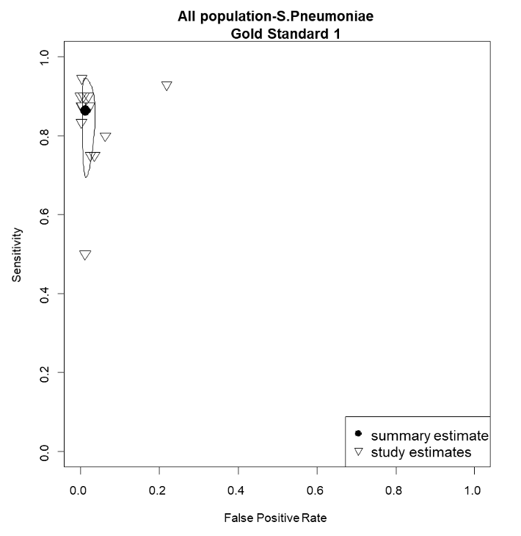

5.3. Forest Plot S. pneumoniae with reference test 2

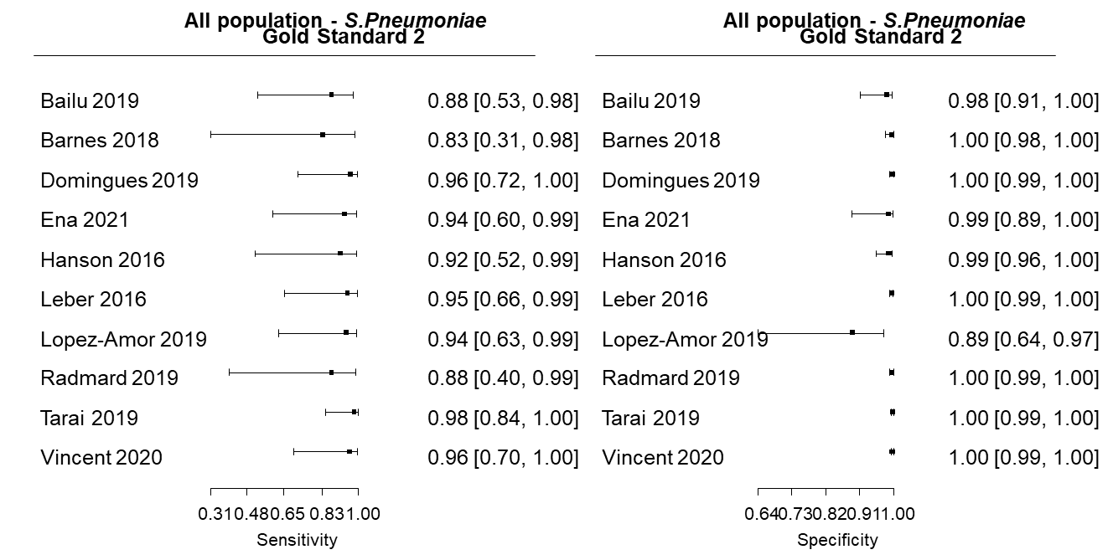

5.4. S-ROC S. pneumoniae with reference test 2

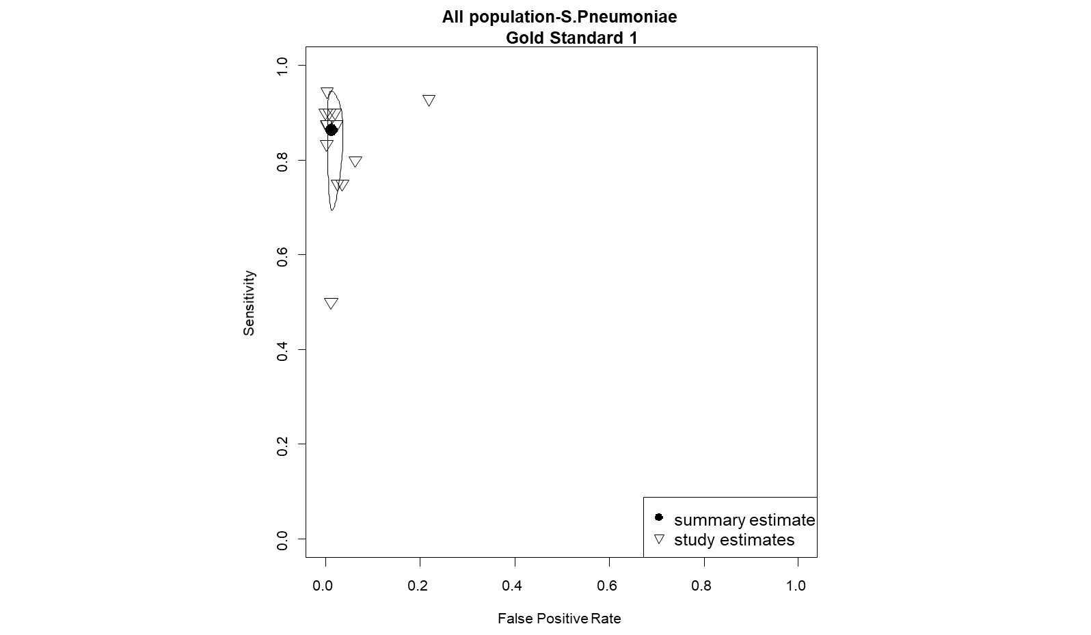

5.5. Forest Plot S. agalactiae with reference test 1

5.6. S-ROC for S. agalactiae with reference test 1

0.0
0.2
0.4
0.6
0.8
1.0
0.0
0.2
0.4
0.6
0.8
1.0
All population -S.Agalactiae
Gold Standard 1
False Positive Rate
Sensitivity
summary estimate
study estimates

5.7. Forest Plot for S. agalactiae with reference test 2

5.8 S-ROC for S. agalactiae with reference test 2

5.9 Forest Plot for E. coli with reference test 1

5.10 S-ROC for E. coli with reference test 1

5.11. Forest Plot for E. coli with reference test 2

5.12. S-ROC for E. coli with reference test 2

5.13 Forest Plot for H. influenzae with reference test 1

5.14. S-ROC for H. influenzae with reference test 1

5.15. Forest Plot for H. influenzae with reference test 2

5.16. S-ROC for H. influenzae with reference test 2

5.17. Appendix 21. Forest Plot for L. monocytogenes with reference test 1

5.18. S-ROC for L. monocytogenes with reference test 1

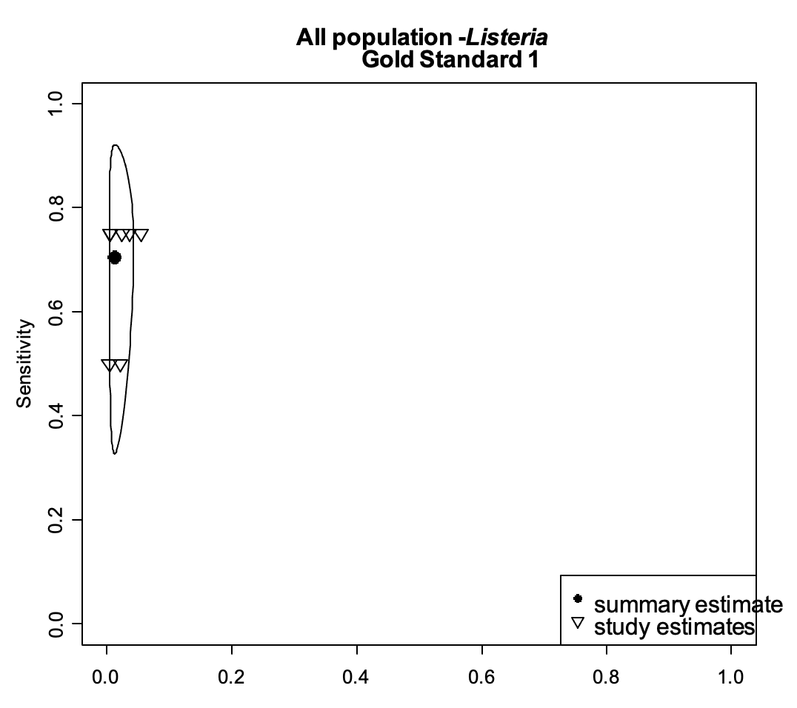

5.19. Forest Plot for L. monocytogenes with reference test 2

5.20. S-ROC for L. monocytogenes with reference test 2

5.21. Forest Plot for N. meningitidis with reference test 1

5.22. S-ROC for N. meningitidis with reference test 1

5.23. Forest Plot for N. meningitidis with reference test 2

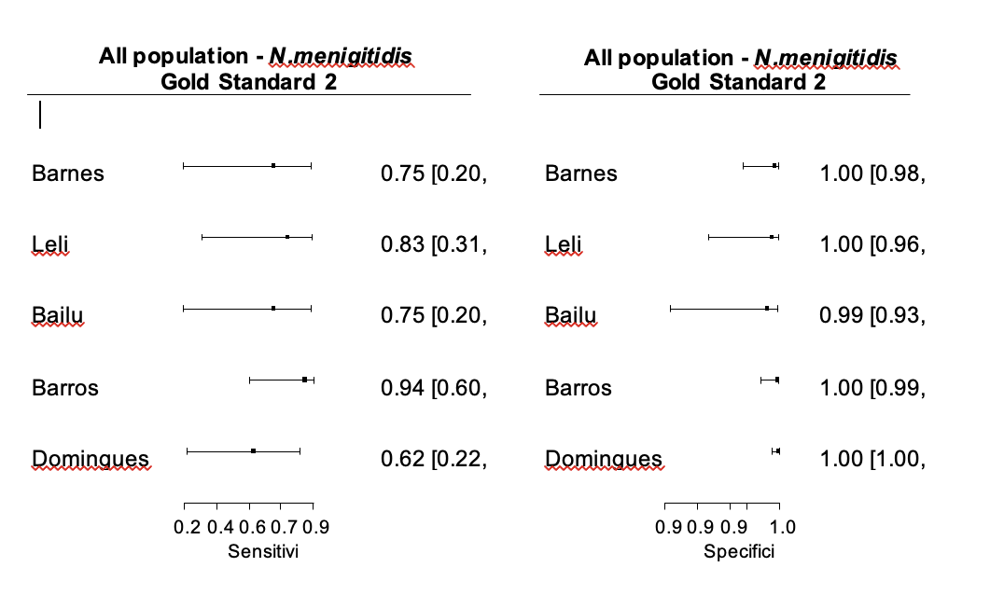

5.24. S-ROC for N. meningitidis with reference test 2
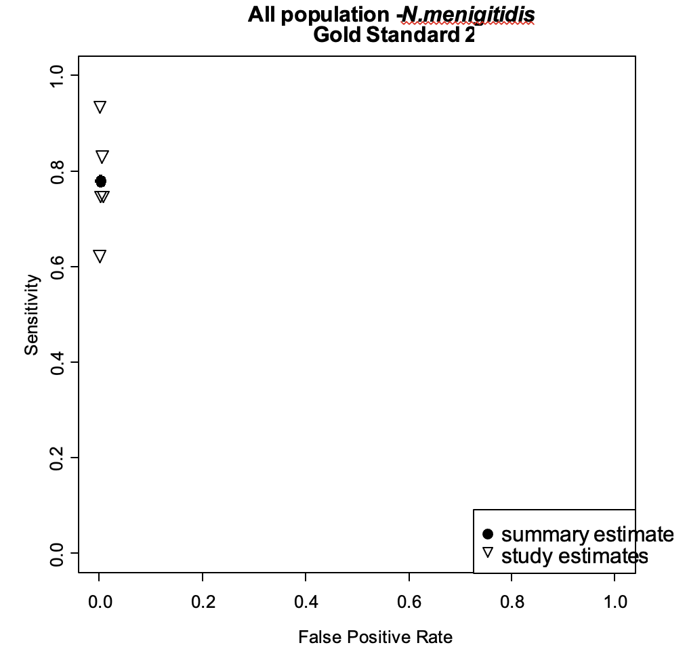

Appendix 6. Results TP/FP of every bacterium discriminated by reference test 1 and reference test 2.

 | Study | Reference test 1 |  |  |  |  | Reference test 2 |  |  |  | Additional analysis to resolve disagreement between FA/ME and cultures.
 |  | TP  #(%) | FP  #(%) |  | Total positives |  | TP  #(%) |  | FP  #(%)
S.pneumoniae | Leber | 4 | 12 |  | 16 |  | 9 |  | 7 |  | Re-testing, additional PCR, Clinical information, CSF characteristics
S.pneumoniae | Hanson | 3 | 3 |  | 6 |  | 5 |  | 1 |  | Additional PCR
S.pneumoniae | Barnes | 0 | 2 |  | 2 |  | 2 |  | 0 |  | CSF characteristics
S.pneumoniae | Lopez amor | 6 | 3 |  | 9 |  | 8 |  | 1 |  | Urinary antigen for pneumococcus. Additional PCR.
S.pneumoniae | Radmard | 3 | 1 |  | 4 |  | 3 |  | 1 |  | Clinical information, CSF characteristics
S.pneumoniae | Tarai | 1 | 25 |  | 26 |  | 26 |  | 0 |  | CSF characteristics
S.pneumoniae | Bailu | 4 | 4 |  | 8 |  | 7 |  | 1 |  | Additional PCR
S.pneumoniae | Domingues | 4 | 8 |  | 12 |  | 12 |  | 0 |  | CSF characteristics
S.pneumoniae | Vincent | 8 | 4 |  | 12 |  | 11 |  | 1 |  | Clinical information and CSF characteristics
S.pneumoniae | Ena | 4 | 3 |  | 7 |  | 7 |  | 0 |  | CSF characteristics
S.pneumoniae | Piccirilli, Leli, Eichinguer, Boudet, Chong | 13 | 0 |  | 13 |  | 13 |  | 0 |  | There were no disagreements.
Total (%) |  | 50(43.4%) | 65(56.5%) |  | 115 |  | 103(89.5%) |  | 12(10.4%)
H. influenzae | Leber | 1 | 1 |  | 2 |  | 2 |  | 0 |  | Re-testing, additional PCR, Clinical information, CSF characteristics
H. influenzae | Hanson | 4 | 1 |  | 5 |  | 5 |  | 0 |  | Additional PCR
H. influenzae | Barnes | 0 | 2 |  | 2 |  | 2 |  | 0 |  | CSF characteristics
H. influenzae | Boudet | 1 | 2 |  | 3 |  | 2 |  | 1 |  | Clinical information, CSF characteristics
H. influenzae | Domingues | 1 | 3 |  | 4 |  | 4 |  | 0 |  | Caract. LCR
H. influenzae | Lopez Amor, Vincent | 2 | 0 |  | 2 |  | 2 |  | 0 |  | There were no disagreements.
Total (%) |  | 9(50%) | 9(50%) |  | 18 |  | 17(94.4%) |  | 1(5.5%)
S. agalactiae | Leber | 0 | 1 |  | 1 |  | 0 |  | 1 |  | Re-testing, additional PCR, Clinical information, CSF characteristics
S. agalactiae | Hanson | 1 | 4 |  | 5 |  | 3 |  | 2 |  | Additional PCR
S. agalactiae | Arora | 6 | 1 |  | 7 |  | 7 |  | 0 |  | Clinical information, CSF characteristics
S. agalactiae | Bailu | 3 | 3 |  | 6 |  | 5 |  | 1 |  | Additional PCR
S. agalactiae | Boudet | 4 | 1 |  | 5 |  | 5 |  | 0 |  | CSF characteristics
S. agalactiae | Leli, Rarmard, Vincent, Chong | 6 | 0 |  | 6 |  | 6 |  | 0 |  | There were no disagreements.
Total (%) |  | 20(66.6%) | 10 (33.3%) |  | 30 |  | 26 (86.6%) |  | 4(13.3%)
N. meningitidis | Barnes | 0 | 1 |  | 1 |  | 1 |  | 0 |  | CSF characteristics
N. meningitidis | Leli | 1 | 1 |  | 2 |  | 2 |  | 0 |  | CSF characteristics
N. meningitidis | Bailu | 0 | 1 |  | 1 |  | 1 |  | 0 |  | Additional PCR
N. meningitidis | Domingues | 4 | 3 |  | 7 |  | 7 |  | 0 |  | CSF characteristics
 | Hanson,Piccirilli, Boudet, Vincent, Ena | 9 | 0 |  | 9 |  | 9 |  | 0 |  | There were no disagreements.
Total (%) |  | 14(70%) |  | 6(30%) |  | 20 |  | 20(100%) |  | 0
L. monocytogenes | Bailu | 0 |  | 1 |  | 1 |  | 1 |  | 0 |  | Additional PCR
L. monocytogenes | Domingues | 0 |  | 1 |  | 1 |  | 1 |  | 0 |  | CSF characteristics
L. monocytogenes | Ena | 1 |  | 2 |  | 3 |  | 3 |  | 0 |  | CSF characteristics
L. monocytogenes | Piccirilli, Leli, Lopez Amor | 3 |  | 0 |  | 3 |  | 3 |  | 0 |  | There were no disagreements.
Total (%) |  | 4(50%) |  | 4(50%) |  | 8 |  | 8(100%) |  | 0
E. coli | Leber | 2 |  | 1 |  | 3 |  | 2 |  | 1 |  | Re-testing, additional PCR, Clinical information, CSF characteristics
E. coli | Barnes | 0 |  | 1 |  | 1 |  | 1 |  | 0 |  | CSF characteristics
E. coli | Bailu | 7 |  | 1 |  | 8 |  | 7 |  | 1 |  | Additional PCR
E. coli | Boudet | 1 |  | 1 |  | 2 |  | 1 |  | 1 |  | CSF characteristics
E. coli | Hanson,Arora,  Radmard,Eichinguer  Domingues | 6 |  | 0 |  | 6 |  | 6 |  | 0 |  | There were no disagreements.
Total (%) |  | 16(80%) |  | 4(20%) |  | 20 |  | 17(85%) |  | 3(15%)
Total of all bacteria in all the studies (%) |  | 113  (53.5%) |  | 98  (46.4%) |  | 211 |  | 191 (90.5%) |  | 20  (9.4%)
Info: Information; CSF: Cerebrospinal fluid; PCR: polymerase chain reaction; TP: True positive; FP: False positive
Appendix 7. Forest plots and SROC curves per virus

7.1 Forest Plot for HSV-1 with reference test 1

7.2. Forest Plot for HSV-1 with reference test 2

7.3 Forest Plot for HSV-2 with reference test 1

7.4. Forest Plot for HSV-2 with reference test 2

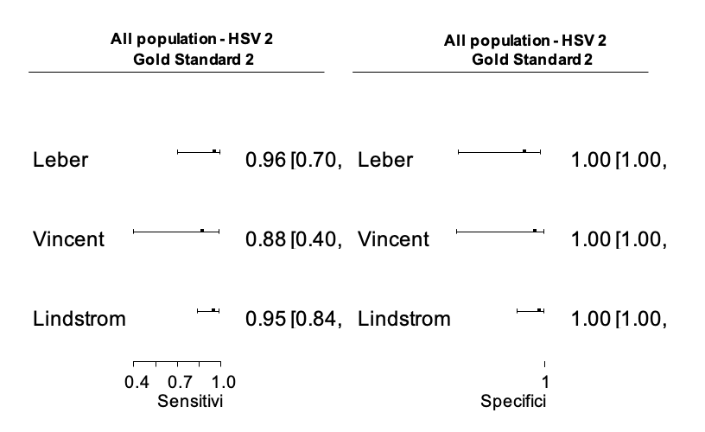

7.5. Forest Plot for enterovirus with reference test 1

7.6. Forest Plot for enterovirus with reference test 2

7.7 Forest Plot for VSZ with reference test 1

7.8. S-ROC for VSZ with reference test 1

7.9. Forest Plot for VSZ with reference test 2

Appendix 8. Sensitivity analyses

8.1 Sensitivity analysis based on Risk of Bias 1 analysis.

8.1.2. Forest Plot for “All bacteria”, only studies with low RoB (analysis 1*) and reference test 1 (7 studies)

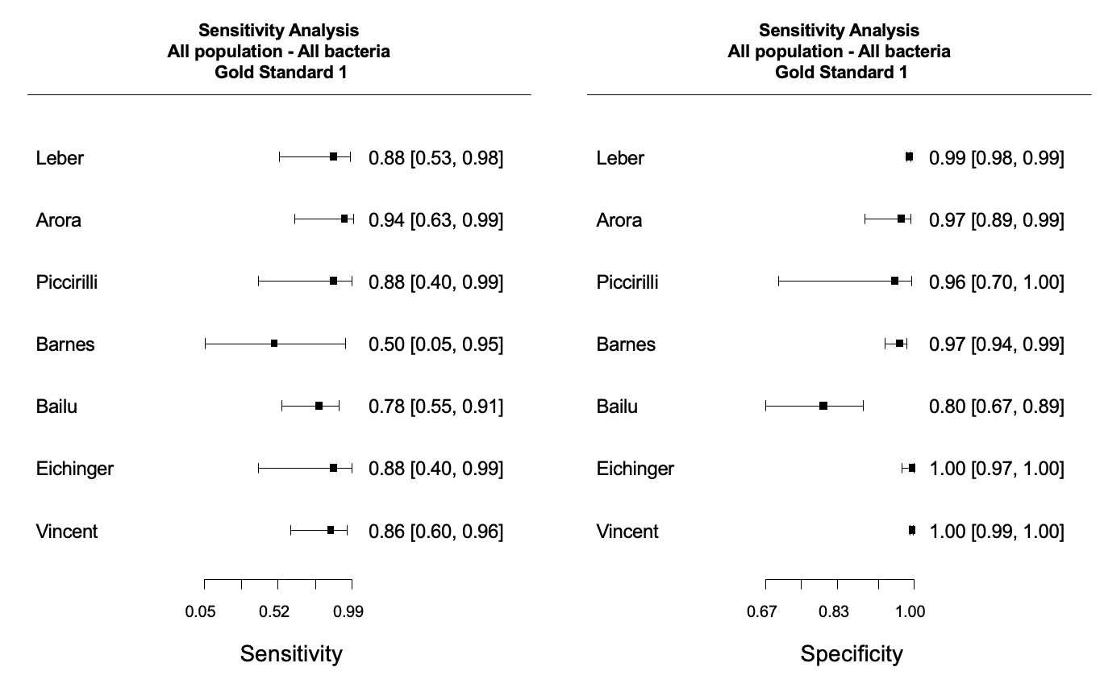

*Analysis 1 was restricted only to studies that had three or more QUADAS criteria judged as low.

8.1.3. S-ROC for “All bacteria”, only studies with low RoB (analysis 1*) and reference test 1 (7 studies)

8.2. Sensitivity analysis based on Risk of Bias analysis 2.

8.2.1. Forest Plot “All bacteria”, only studies with low RoB (analysis 2*) and reference test 1 (3 studies)

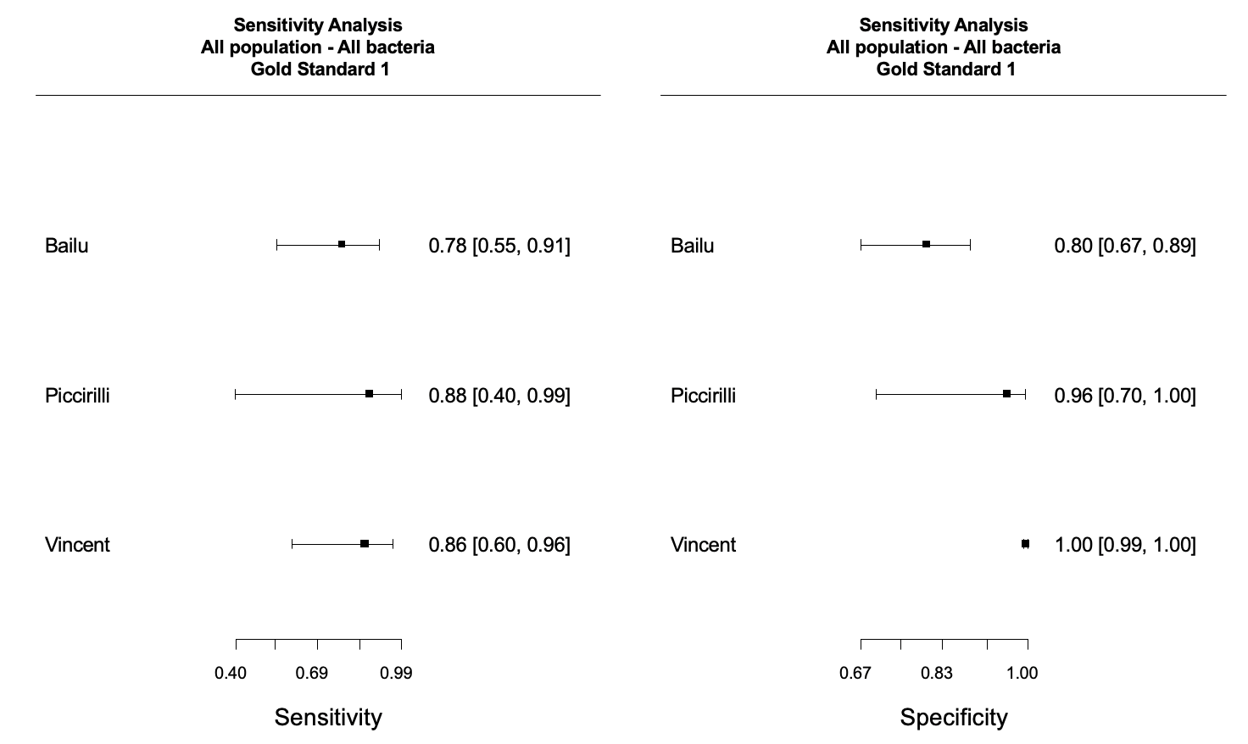

*Analysis 2 was restricted only to studies that had all QUADAS criteria judged as low.

8.2.2. S-ROC “All bacteria”, only studies with low RoB (analysis 2*) and reference test 1 (3 studies)

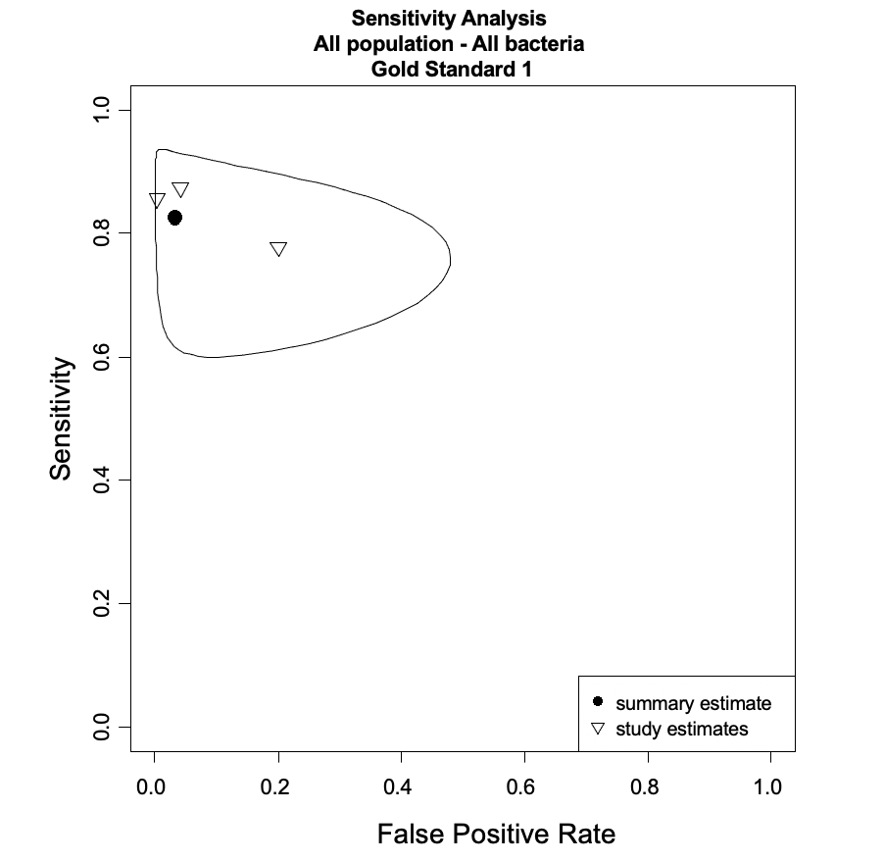

Appendix 9. Subgroup analyses

9.1 Subgroup analysis of infants & children’s studies

9.1.1. Forest Plot for “Infants and children-All bacteria” with reference test 1

9.1.2. S-ROC for “Infants and children-All bacteria” with reference test 1

9.1.3 Forest Plot “Infants and children-All bacteria” with reference test 2

9.1.4. S_ROC “Infants and children-All bacteria” with reference test 2

9.1.5. Forest Plot for “Infants and children-S. pneumoniae” with reference test 1

9.1.6. S_ROC for “Infants and children-S. pneumoniae” with reference test 1

9.1.7. Forest Plot “Infants and children-S. pneumoniae” with reference test 2

9.1.8. Forest Plot “Infants and children-S. pneumoniae” with reference test 2

9.2 Subgroup analysis of infants “0-3 months

9.2.1. Forest Plot “0-3 months-All bacteria” with reference test 1

9.2.1 S_ROC for “0-3 months-All bacteria” with reference test 1

9.3. Subgroup analysis of participants with previous antibiotics use

9.3.1. Forest Plot “All population-All Bacteria-previous use of antibiotics” with reference test 1

9.3.2. S_ROC for “All population-All Bacteria-previous use of antibiotics” with reference test 1

9.4. Subgroup analysis of participants with abnormal CSF.

9.4.1. Forest Plot “All population-All Bacteria-Abnormal CSF” with reference test 1

All population, All bacteria, abnormal CSF
Gold Standard 1
Sensitivity
Domingues 2019
Ena 2021
0.95 [0.68, 1.00]
0.86 [0.49, 0.97]
0.49
0.74
1.00
All population, All bacteria, abnormal CSF
Gold Standard 1
Specificity
Domingues 2019
Ena 2021
0.96 [0.94, 0.98]
0.87 [0.73, 0.94]
0.73
0.86
0.98

