Supplementary Table S1. Search strategy and selection criteria
Search termsª | Pubmed database:  ("Renal Insufficiency, Chronic"[Mesh] OR ESRD[tiab] OR ESRF[tiab] OR ESKD[tiab] OR ESKF[tiab] OR ((end-stage[tiab] OR endstage[tiab] OR advanced[tiab] OR stage 4[tiab] OR stage 5[tiab] OR stage IV[tiab] OR stage V[tiab]) AND (CKD[tiab] OR kidney disease[tiab] OR renal disease[tiab] OR kidney failure[tiab] OR renal failure[tiab] OR kidney insufficiency[tiab] OR renal insufficiency[tiab]))) AND ("Renal replacement therapy"[Mesh] OR renal replacement therap*[tiab] OR dialysis[tiab] OR kidney replacement therap*[tiab] OR hemodialysis[tiab] OR haemodialysis[tiab] OR hemofiltration[tiab] OR haemofiltration[tiab] OR hemodiafiltration[tiab] OR haemodiafiltration[tiab] OR HD[tiab] OR PD[tiab] OR CAPD[tiab] OR CCPD[tiab]) AND ("Palliative Care"[Mesh] OR “Palliative Medicine”[Mesh] OR "Watchful Waiting"[Mesh] OR conservative[tiab] OR palliative[tiab] OR nondialytic[tiab] OR non-dialytic[tiab] OR supportive care[tiab] OR non-dialysis[tiab] OR watchful waiting[tiab])
Inclusion criteria | - Patients with advanced chronic kidney disease (stage 4/5)  - Comparison of non-dialytic conservative care versus a dialysis pathway  - Conservative care: patients in whom a decision was made to treat end-stage kidney disease conservatively, including all interventions except dialysis, with the intention to provide it until death (not just to postpone dialysis; irrespective of how or by whom the decision was made)  - Dialysis pathway: patients in whom a decision was made to treat end-stage kidney disease with dialysis, including patients who had chosen but not yet started dialysis, and patients being treated with dialysis  - Study design: randomised controlled trials, observational studies including prospective cohorts, retrospective cohorts, case-control studies, or case reports with >5 patients included per patient group  - Outcomes of interest: patient-reported outcomes on health-related quality of life and/or symptoms
Exclusion criteria | - Patients with acute kidney injury  - No comparison group: not including both a conservative care patient group and dialysis patient group  - No treatment decision yet: patients with advanced chronic kidney disease in whom no decision was made on intended treatment for end-stage kidney disease  - No outcomes of interest, including: patient education, pharmocokinetics, economic evaluations, and studies on treatment decision-making  - No original research, including: reviews, letters, opinion papers, abstracts only, and study protocols  - Pediatric (<18 years)  - Not human  - Not English
Searches performed up to February 25th, 2021, in PubMed, EMBASE, The Cochrane Library, CINAHL Plus, and PsycINFO.
ª A proposal on search terms and databases to be searched was reviewed and pilot tested by an external clinical librarian.

Supplementary Table S2. Results of contact with authors to clarify their patient group designated as conservative care or non-dialysis group

Study | Response | Authors’ explanation of their non-dialysis or conservative care-like patient group | Decision on inclusion
Bonner; Journal of Renal Care 2018 [1] | Yes | Mix of patients in stage 4 chronic kidney disease (too early to make a decision), and patients in stage 5 chronic kidney disease where a decision had been made into one non-dialysis group; no subgroup analysis | Excluded
Martinez Echevers; Nefrologia 2016 [2] | No | - | Excluded; most likely patients being not on dialysis yet, no reporting on treatment decision-making
Reindl-Schwaighofer; PloS One 2017 [3] | Yes | No patient had been started on dialysis; no data on treatment decision-making | Excluded; most likely patients who died before dialysis was initiated or a treatment decision was made
Kurella Tamura; JASN 2018 [4] | Yes | Medical management included all patients who were not treated with dialysis | Excluded; time prior to dialysis initiation was designated as “conservative care”
Tam Tham; Kidney Int 2018 [5] | Yes | No data on treatment decision-making; not aware if a treatment decision had been made | Excluded
First three studies identified through database searching; last two studies identified through checking citations via Scopus.

Supplementary Figure 1: Funnel plot to assess publication bias in effect estimates in adjusted mortality outcomes. In this figure we used fixed-effects to allow presenting 95% confidence intervals.

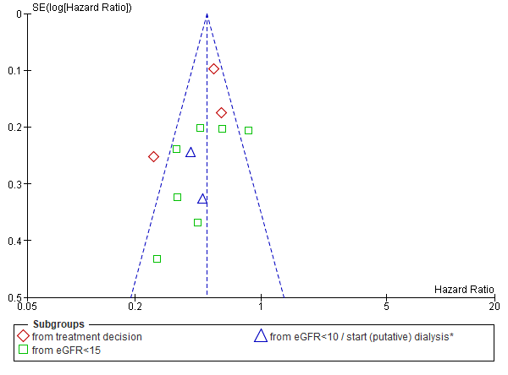

Supplementary Table S3. Risk of bias assessment per included study, the Risk Of Bias In Non-randomised Studies -of Interventions (ROBINS-I)[6,7]
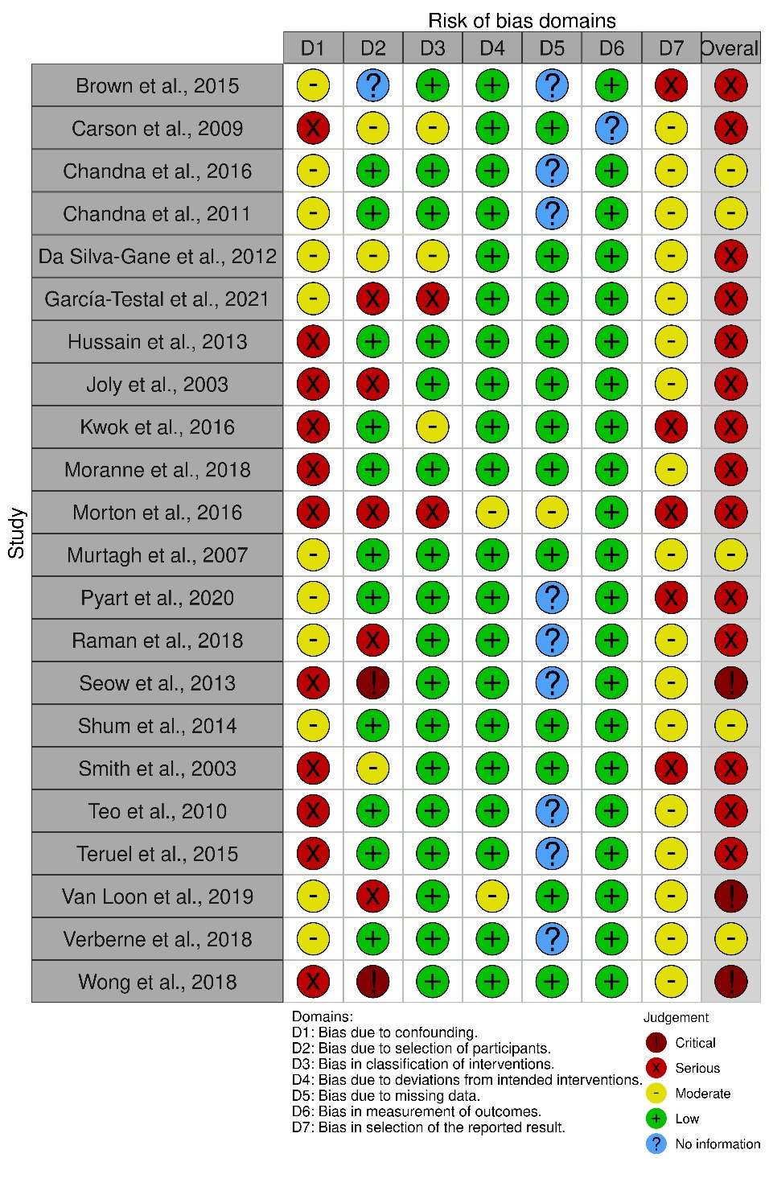
Domains:
D1: Bias due to confounding, to assess whether confounding is expected, appropriately measured and controlled for. Confounding was expected in all studies and therefore moderate at minimum. If outcomes were not controlled for age, sex and/or comorbidities, it was deemed serious at minimum.
D2: Bias due to selection of participants, to assess whether all eligible patients were included and start of follow up and intervention coincided. If a potential important amount of follow-up time was missing from analysis (lead time or immortal time bias), it was deemed serious.
D3: Bias in classification of interventions, to assess whether intervention status was well defined, including risk of misclassification.
D4: Bias due to deviations from intended interventions, to assess if any deviations from usual practice were likely to impact on the outcome, including switches to an intervention that was not of interest for the research question (such as kidney transplantation).
D5: Bias due to missing data, to assess how missing data and loss-to-follow-up were handled.
D6: Bias in measurement of outcomes, to assess whether methods of outcome assessment were comparable across groups, and objectively measured.
D7: Bias in selection of the reported result, to assess whether outcomes were described as planned per published protocol, and defined similarly in methods and results. If there was no available protocol it was deemed moderate at minimum.

Table S4: Baseline characteristic of frailty, functional- and cognitive status in the included studies
Study | Number of patients |  | Functional status  %, mean(sd), median (iqr) |  |  | Frailty  % or mean (sd) |  |  | Cognitive status  % or mean (sd)
 | D | CC | D | CC | definition | D | CC | definition | D | CC | definition
Brown et al. [8] | 273 | 122 | NR | NR |  | NR | NR |  | 0.4% * | 11.5% * | Clinical dementia
Carson et al. [9] | 173 | 37 | NR | NR |  | NR | NR |  | NR | NR
Chandna et al. 2011 [10] | 689 | 155 | NR | NR |  | NR | NR |  | NR | NR
Chandna et al. 2016 [11] | 92 | 158 | NR | NR |  | NR | NR |  | NR | NR
Da Silva-Gane et al.[12] | HD: 80  PD: 44 | 30 | 18% *  2% * | 66% * | Karnofsky score<70 | NR | NR |  | 5.5 (3.6) *  4.7 (4.0) * | 5.2 (3.3) * | HADS-Depression
García-Testal et al.[13] | 33 | 54 | NR | NR |  | NR | NR |  | NR | NR
Hussain et al.[14] | 269 | 172 | 2.0 (0.7)* | 2.4 (0.7) * | WHO score | NR | NR |  | 1% * | 7% * | Dementia
Joly et al. [15] | 101 | 43 | 63 (20) * | 55 (18) * | Karnofsky score |  |  |  | 6% | 8% | Overt dementia
Kwok et al. [16] | 126 | 432 | 65% *  29% *  6% * | 38% *  40% *  23% * | Independent walker  assisted walker  chairbound/bedridden | NR | NR |  | 2% *  96% *  4% *  0% * | 13% *  73% *  18% *  9%* | Dementia  Mental status: full,  limited,  incapacitated
Moranne et al. [17] | 215 | 54 | 95% * | 85% * | Walks without help | NR | NR |  | 3%* | 13% * | Behavioural disorder or dementia
Morton et al. [18] | 619ª | 102ª | NR | NR |  | NR | NR |  | NR | NR
Murtagh et al. [19] | 52 | 77 | NR | NR |  | NR | NR |  | NR | NR
Pyart et al. [20] | 841 | 375 | NR | NR |  | 5 (4-5) ^{c}  20% * | 5 (4-6) ^{c}  42% * | CFS ^{c}  CFS ≥ 6 | NR | NR
Raman et al. [21] | 123 | 81 | 88 (8) | 88 (9) | Karnofsky score | NR | NR |  | NR | NR
Seow et al. [22] | 38 | 63 | 60 (50-80) | 60 (40-70) | Karnofsky score | NR | NR |  | NR | NR
Shum et al. [23] | 157 | 42 | 78%  22%  91%  5%  2% | 76%  24%  90%  7%  5% | Independent BADL  Impaired BADL  Independent walker  assisted walker  chairbound/bedridden | NR | NR |  | 2.5% | 2.4% | Dementia
Smith et al. [24] | 258^{b} | 63^{b} | 85 (14) * | 55 (9) * | Karnofsky (modified) | NR | NR |  | NR | NR
Teo et al. [25] | HD:102, PD:41 | 16 | NR | NR |  | NR | NR |  | NR | NR
Teruel et al. [26] | 142 | 90 | 0% *  1% *  3% *  96% *  0% *  9% *  91% * | 9% *  12% *  18% *  61% *  18% *  34% *  48% * | Barthel index: full dep.  severely dependent  moderately dep.  non-relevant dep.  Gait acute disorder  moderate (FAC2/3)  non-relevant (FAC 4/5) | NR | NR

Table S4 (continued)
Study | Number of patients |  | Functional status  %, mean(sd), median (iqr) |  |  | Frailty  % or mean (sd) |  |  | Cognitive status  % or mean (sd)
 | D | CC | D | CC | definition | D | CC | definition | D | CC | definition
Van Loon et al. [27] | 192 | 89 | NR | NR |  | 77% | 88% | ≥2 geriatric impairments | NR | NR
Verberne et al. [28] | 240 | 126 | NR | NR |  | NR | NR |  | NR | NR
Wong et al. [29] | 503 (not started)  12756 (started) | 812 | NR | NR |  | NR | NR |  | 3.6% *  1.8% * | 9.0% * | Dementia
BADL, basic activities of daily living; CC, conservative care group; CFS, Clinical Frailty Scale; D, patients who chose or started with dialysis; FAC, FAC scale for gait abnormalities (acute discorder: patient cannot walk [0] or walks with difficulty held by another person [1], moderate: needs support from another person to walk [2] or can walk only under supervision [3], non-relevant: patient can walk independently anywhere [5] or on level ground, but requires help on stairs [4]); FFI, Fried frailty index; HADS, Hospital Anxiety and Depression Scale; HD, haemodialysis; IQR, inter-quartile range; NR, not reported; PD, peritoneal dialysis; SD, standard deviation; IQR, inter-quartile range.
* p<0.05
ª For dialysis and conservative care respectively n=571 and n=92 were included in the survival analysis, but no separate baseline data was provided. ^{b} For survival analysis, n=186 dialysis patients and n=36 conservative care patients (including n=10 patients with a conservative care recommendation that were eventually dialysed) were included but no separate baseline data was provided.^{c} Only a subgroup had enough data available to estimate Clinical Frailty Scale in choice for dialysis group (n=288) and choice for CC group (n=198).

Table S5. Study results on unadjusted survival (median, one- two- five- year survival) by kidney function
CKD stage | Study | Age | Kidney function at start of survival analysis | Number of patients |  | Median survival time, months |  |  | One year survival, % |  | Two year survival, % |  | Five year survival |  |  | Notes:
 |  |  | Kidney function at start of survival analysis | D | CC | D | CC |  | D | CC | D | CC | D
eGFR <20ml/min/1.73m²
 | Hussain et al. [14] | >70 | eGFR <20 | 164 | 142 | 55 | 26 |  | 72 | 58 | 46 | 20 | 50 ª | 20 ª | unadjusted
 | Verberne et al. [28] | ≥70 | eGFR <20 | 226 | 109 | 52 | 29 |  | 91ª | 84ª | 79ª | 60ª | 47ª | 18ª | unadjusted
 | Moranne et al. [17] | >75 | eGFR <20 | 215 | 54 | 40 | 25 |  | 87 | 74 | 72 | 54 | 31 | 20 | unadjusted
Treatment decision
 | Brown et al. [8] | NA | stage G4/G5 | 273 | 122 | NA  33 (32-34)^{d} | 16 (7-39)  20 (17-23)^{d} |  | 93 | 53 | 89 ª | 38 ª | NA | NA | adjusted for ?
 | Pyart et al. [20] | ≥70 | stage G4/G5 | 841 | 375 | 48 (43-53) | 24 (21-28) |  | NR | NR | NR | NR | 87 | 63 | unadjusted
 | Verberne et al. [28] | ≥70 | stage G4/G5 | 240 | 126 | 38 | 17 |  | 81ª | 64ª | 65ª | 40ª | 30ª | 15ª | unadjusted
eGFR<15ml/min/1.73m²
 | Brown et al. [8] | NA | eGFR<15 | 118 | 53 | 20^{d} | 13^{d} |  | NA | NA | NA | NA | NA | NA
 | Chandna et al. [10] | NA | eGFR<15 | 689 | 155 | 67 | 21 |  | 92 ª | 76 ª | 81 ª | 45 ª | 55 ª | 12 ª | unadjusted
 | Da Silva-Gane et al. [12] | NA | recruitment ^{b}  (late stage G4/G5) | HD: 80  PD: 44 | 30 | HD: 43  PD: 46 | 30 |  | 88ª  90ª | 76ª | 73ª  77ª | 51ª | NA | NA | adjusted for high comorbidity, dependency, age >75, propensity scores
 | García-Testal et al.[13] | >80 | eGFR<15 | 33 | 54 | 38 (21-52) | 14 (6-31) |  | 97 ª | 71 ª | 87 ª | 43 ª | 54 ª | 7 ª | unadjusted
 | Hussain et al.[14] | >70 | eGFR <15 | 264 | 169 | 46ª | 21ª |  | 79 ª | 68 ª | 67 ª | 46 ª | 40 ª | 14 ª | unadjusted
 | Kwok et al. [16] | >65 | eGFR<15 (TD) | 126 | 432 | 45 | 10 |  | 79 | 40 | 54 | 13 | 11 | 1 | unadjusted
 | Murtagh et al. [19] | >75 | eGFR<15 | 52 | 77 | NR | 22ª |  | 84 | 68 | 76 | 47 |  |  | unadjusted
 | Raman et al. [21], | ≥75 | eGFR<15 | 123 | 81 | 42 (33-50) | 31 (21-41) |  | 90^{c} | 85^{c} | 76^{c} | 64^{c} | 31^{c} | 14^{c} | adjusted for age, peripheral vascular disease, and living alone
 | Shum et al. [23] | ≥65 | eGFR<15 | 157 | 42 | 45 | 28 |  | 96ª | 77ª | 86ª | 55ª | 48ª | 18ª | unadjusted
 | Teo et al. [25] | NA | ESKD diagnosis | HD:102  PD: 41^{b} | 16 | NA | 6 ª |  | 80  78 | 31 | NA | NA | NA | NA | unadjusted
 | Teruel et al. [26] | NA | eGFR<15 | 142 | 90 | NR | NR |  | 96e | 60e | NA | NA | NA | NA | unadjusted mortality rate: 0.6 vs. 8.2 per 100 patients-months (p<0.001)
 | Verberne et al. [28] | ≥70 | eGFR<15 | 191 | 84 | 37 | 15 |  | 85 ª | 61 ª | 69 ª | 41 ª | 35 ª | 11 ª
 | Wong et al. [29] | adults | eGFR<15 | not started: 503  started: 12.756 | 812 | 7  32 | 6 |  | NR | NR | NR | NR | NR | NR | Patients who survived were excluded

Table S5 (continued)
CKD stage |  | Study |  | Age |  | Kidney function at start of survival analysis | Number of patients |  |  |  |  | Median survival time, months |  |  |  | One year survival, % |  |  |  | Two year survival, % |  |  |  | Five year survival |  |  |  |  | Notes:
 |  |  |  |  |  | Kidney function at start of survival analysis | D |  |  | CC |  | D |  | CC |  | D |  | CC |  | D |  | CC |  | D
eGFR around <10ml/min/1.73m² / (putative) start dialysis
 | Morton et al. [18] |  | NA |  | eGFR<15 / start dialysis |  |  | 571 | 92 |  | NR |  | NR |  |  |  | 86 |  | 55 |  | 79 |  | 36 |  | NR |  | NR |  |  | unadjusted HR 4.07 (3.08-5.37)
 | Van Loon et al. [27] |  | ≥65 |  | eGFR<15 / start dialysis |  |  | 192 | 89 |  | NA |  | NA |  |  |  | 92 |  | 66 |  | NA |  | NA |  | NA |  | NA |  |  | adjusted for age, comorbidity, eGFR
 | Carson et al. [9] |  | >70 |  | (putative) start dialysis |  |  | 121 | 29 |  | 42 |  | 14 |  |  |  | 79 ª |  | 56 ª |  | 67 ª |  | 17 ª |  | 39 ª |  | NR |  |  | unadjusted
 | Hussain et al.[14] |  | >70 |  | eGFR <12 |  |  | 172 | 110 |  | 41ª |  | 16ª |  |  |  | 74ª |  | 59ª |  | 64ª |  | 41ª |  | 43ª |  | 21ª |  |  | unadjusted
 | Joly et al. [15] |  | >80 |  | Start dialysis vs decision |  |  | 101 | 43 |  | 29 (24-38) |  | 9 (4-10) |  |  |  | 74 |  | 29 |  | 60 |  | 15 |  |  |  |  |  |  | unadjusted
 | Raman et al. [21] |  | ≥75 |  | eGFR <10 |  |  | 73 | 42 |  | 36 (25-47) |  | 12 (0-5) |  |  |  | 89^{c} |  | 53^{c} |  | 65^{c} |  | 31^{c} |  | 32^{c} |  | 4^{c} |  |  | Adjusted for age, peripheral vascular disease
 | Seow et al. [22] |  | >75 or CCI≥8 |  | Started on dialysis or chose CC |  |  | 38 | 63 |  | NR |  | NR |  |  |  | NR |  | NR |  | 62 |  | 13 |  | NR |  | NR |  |  | unadjusted
 | Smith et al. [24] |  | 16-92 |  | ‘from putative dialysis’ |  |  | 186 | 26 |  | NA |  | 6
 | Verberne et al. [28] |  | ≥70 |  | eGFR<10 |  |  | 132 | 42 |  | 34 |  | 6 |  |  |  | 75 ª |  | 30 ª |  | 62 ª |  | 19 ª |  | 29 ª |  | NR
TD: treatment decision; NR: not reported; NA: not applicable. ª derived from Kaplan Meier curve; ^{b} decisions on modality choice took place throughout the recruitment phase an up to an additional 15 months. Survival analysis was based on planned modality group composition after this 15 month-period. ^{c} derived from cumulative incidence curve ^{d} mean survival time was given ^{e} derived from number of deceased persons after one year follow-up.

Supplementary Table S6: Survival outcomes for severe comorbidity

Study | Age | Survival from | Definition severe comorbidity | Number of patients |  | Median survival time, months |  |  | One year survival (%) |  | Two year survival (%) |  | HR (95% CI): D vs CC | Adjusted for
 |  |  |  | D | CC | D | CC | p-value | D | CC | D | CC
Brown et al. [8] | -  >75 | eGFR<15  eGFR<15 | ≥2  ≥2, incl. CHF/IHD | 58  18 | 37  52 |  |  |  |  |  |  |  | 0.16 (0.08-0.34, p<0.001) 0.48 (0.21-1.09, p=0.08) | Age, sex, diabetes, IHD  Age, sex, diabetes?
Chandna et al.[11] | >75 | eGFR<15 | Score of 4ª | 27 | 69 |  |  |  |  |  |  |  | 0.65 (0.47-0.89, p=0.093) | Age, gender, ethnicity, diabetes
Chandna et al. [10] | >75 | eGFR<15 | Score of 4ª | 17 | 54 | 26 | 20 | p=0.83 | 80^{b} | 73^{b} | 56^{b} | 41^{b} |  | unadjusted
Hussein et al. [14] | >70 | eGFR<15 | CCI >8 | 79 | 84 | 53^{b} | 22^{b} | p=0.01 | 76^{b} | 63^{b} | 67^{b} | 47^{b} |  | unadjusted
Kwok et al. [16] | ≥65 | eGFR<15 | mCCI ≥11 | 112 | 9 | 24^{b} | 7^{b} | p=0.09 | 67^{b} | 37^{b} | 37^{b} | 17^{b} |  | unadjusted
Murtagh et al. [19] | >75 | eGFR<15 | Davies 2 | 10 | 14 | 23^{b} | 22^{b} | p=0.98 | 60^{b} | 63^{b} | 45^{b} | 40^{b} |  | unadjusted
Pyart et al. [20] | >80 | TD | CCI >4 | 94 | 109 |  |  |  | 88^{d} | 72^{d} | 72^{d} | 52^{d} | 0.64 (0.47-0.88, p=0.007) | unadjusted
Shum et al. [23] | ≥65 | eGFR<15 | mCCI≥6 | 29^{c} | 13^{c} | 34^{b} | 20^{b} | p=0.08 | 97^{b} | 54^{b} | 72^{b} | 31^{b} |  | unadjusted
Verberne et al. [28] | ≥70 | eGFR<15 | Davies ≥ 3 | 57 | 27 | 25^{b} | 10^{b} | p=0.03 | 69^{b} | 39^{b} | 54^{b} | 27^{b} |  | unadjusted
Range |  |  |  |  |  | 23-53 | 10-22 |  | 67-97 | 39-73 | 37-72 | 17-52
CC, choice for conservative care; CCI, Charlson comorbidity index; CHF, cardiac failure; D, choice for dialysis; eGFR, estimated glomerular filtration rate in mL/min/1.73m²; IHD, ischemic heart disease; mCCI, modified Charlson Comorbidity Index; TD, treatment decision.
ª Scores of 0 (no disease) to 4 (advanced disease) were attributed to the following condition categories: cardiac disease, peripheral vascular disease, cerebrovascular disease, respiratory disease and cancer, cirrhosis was scored as a 4. Scores were summed. High comorbidity was designated to patients with scores of 4 in one condition category or with total scores >4 [30]
^{b} derived from Kaplan Meier curve
^{c} personal information from author
^{d} derived from supplementary data-file

Figure S2: Age stratified risk ratio’s for mortality, based on two-year survival.

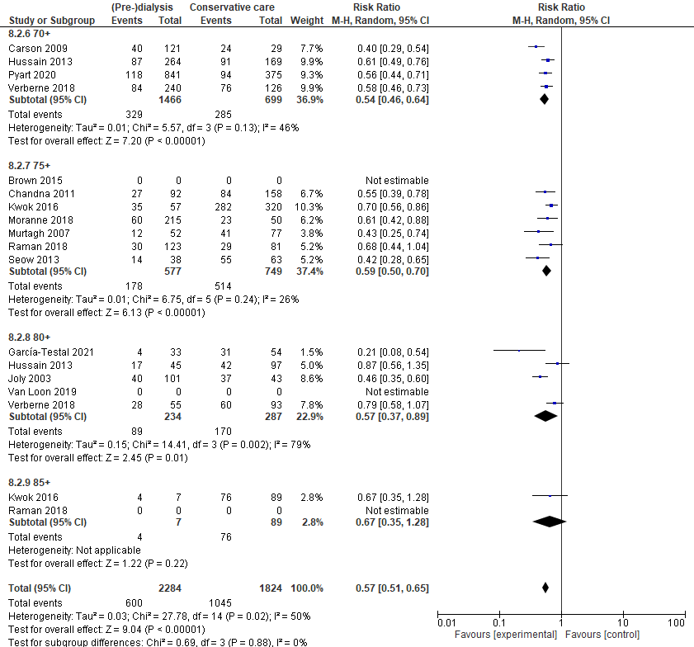

Figure S3: Unadjusted risk ratio’s (RR) restricted to high age

A: RR for mortality among patients 80 years or older, based on one-year survival
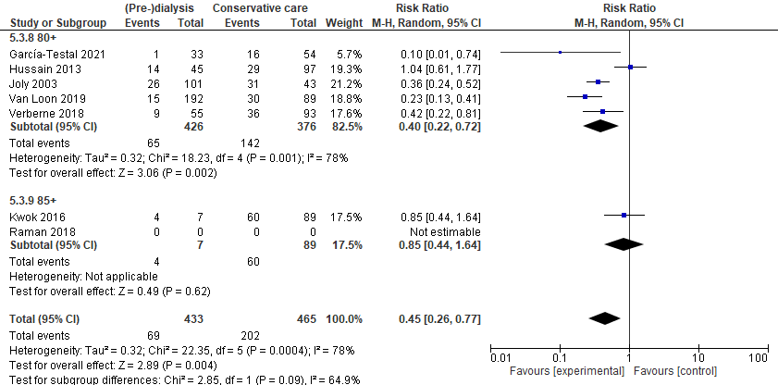

B: RR for mortality among patients 80 years or older, based on two-year survival

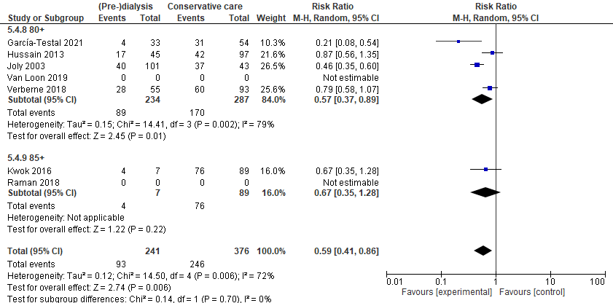

References:

1. Bonner A, Chambers S, Healy H, et al. Tracking patients with advanced kidney disease in the last 12 months of life. J. Ren. Care 2018;44(2):115-122
2. Martínez Echevers Y, Toapanta Gaibor NG, Nava Pérez N, et al. Survival of patients ≥70 years with advanced chronic kidney disease: Dialysis vs. conservative care. Nefrologia 2016;36(3):283-291
3. Reindl-Schwaighofer R, Kainz A, Kammer M, et al. Survival analysis of conservative vs. dialysis treatment of elderly patients with CKD stage 5. PloS one 2017;12(7):e0181345
4. Kurella Tamura M, Desai M, Kapphahn KI, et al. Dialysis versus Medical Management at Different Ages and Levels of Kidney Function in Veterans with Advanced CKD. J Am Soc Nephrol 2018;29(8):2169-2177
5. Tam-Tham H, Quinn RR, Weaver RG, et al. Survival among older adults with kidney failure is better in the first three years with chronic dialysis treatment than not. Kidney Int 2018;94(3):582-588
6. Sterne JA, Hernán MA, Reeves BC, et al. ROBINS-I: a tool for assessing risk of bias in non-randomised studies of interventions. BMJ 2016;355:i4919
7. McGuinness LA, Higgins JPT. Risk-of-bias VISualization (robvis): An R package and Shiny web app for visualizing risk-of-bias assessments. Research Synthesis Methods 2021;12(1):55-61
8. Brown MA, Collett GK, Josland EA, et al. CKD in elderly patients managed without dialysis: survival, symptoms, and quality of life. Clin J Am Soc Nephrol 2015;10(2):260-268
9. Carson RC, Juszczak M, Davenport A, et al. Is maximum conservative management an equivalent treatment option to dialysis for elderly patients with significant comorbid disease? Clin J Am Soc Nephrol 2009;4(10):1611-1619
10. Chandna SM, Da Silva-Gane M, Marshall C, et al. Survival of elderly patients with stage 5 CKD: comparison of conservative management and renal replacement therapy. Nephrol Dial Transplant 2011;26(5):1608-1614
11. Chandna SM, Carpenter L, Da Silva-Gane M, et al. Rate of Decline of Kidney Function, Modality Choice, and Survival in Elderly Patients with Advanced Kidney Disease. Nephron 2016;134(2):64-72
12. Da Silva-Gane M, Wellsted D, Greenshields H, et al. Quality of life and survival in patients with advanced kidney failure managed conservatively or by dialysis. Clin J Am Soc Nephrol 2012;7(12):2002-2009
13. García Testal A, García Maset R, Fornés Ferrer V, et al. Cohort study with patients older than 80 years with stage 5 chronic kidney failure on hemodialysis vs conservative treatment: Survival outcomes and use of healthcare resources. Ther Apher Dial 2021;25(1):24-32
14. Hussain JA, Mooney A, Russon L. Comparison of survival analysis and palliative care involvement in patients aged over 70 years choosing conservative management or renal replacement therapy in advanced chronic kidney disease. Palliat Med 2013;27(9):829-839
15. Joly D, Anglicheau D, Alberti C, et al. Octogenarians reaching end-stage renal disease: cohort study of decision-making and clinical outcomes. J Am Soc Nephrol 2003;14(4):1012-1021
16. Kwok W-H, Yong S-P, Kwok O-L. Outcomes in elderly patients with end-stage renal disease: Comparison of renal replacement therapy and conservative management. Hong Kong J Nephrol 2016;19:42-56
17. Moranne O, Fafin C, Roche S, et al. Treatment plans and outcomes in elderly patients reaching advanced chronic kidney disease. Nephrol Dial Transplant 2018;33(12):2182-2191
18. Morton RL, Webster AC, McGeechan K, et al. Conservative Management and End-of-Life Care in an Australian Cohort with ESRD. Clin J Am Soc Nephrol 2016;11(12):2195-2203
19. Murtagh FE, Marsh JE, Donohoe P, et al. Dialysis or not? A comparative survival study of patients over 75 years with chronic kidney disease stage 5. Nephrol Dial Transplant 2007;22(7):1955-1962
20. Pyart R, Aggett J, Goodland A, et al. Exploring the choices and outcomes of older patients with advanced kidney disease. PloS one 2020;15(6):e0234309
21. Raman M, Middleton RJ, Kalra PA, et al. Outcomes in dialysis versus conservative care for older patients: A prospective cohort analysis of stage 5 Chronic Kidney Disease. PLoS One 2018;13(10):e0206469
22. Seow YY, Cheung YB, Qu LM, et al. Trajectory of quality of life for poor prognosis stage 5D chronic kidney disease with and without dialysis. Am J Nephrol 2013;37(3):231-238
23. Shum CK, Tam KF, Chak WL, et al. Outcomes in older adults with stage 5 chronic kidney disease: comparison of peritoneal dialysis and conservative management. J Gerontol A Biol Sci Med Sci 2014;69(3):308-314
24. Smith C, Da Silva-Gane M, Chandna S, et al. Choosing not to dialyse: evaluation of planned non-dialytic management in a cohort of patients with end-stage renal failure. Nephron Clin Pract 2003;95(2):c40-46
25. Teo BW, Ma V, Xu H, et al. Profile of hospitalisation and death in the first year after diagnosis of end-stage renal disease in a multi-ethnic Asian population. Ann Acad Med Singapore 2010;39(2):79-87
26. Teruel JL, Vion VB, Couto AG, et al. Choosing conservative therapy in chronic kidney disease. Nefrología 2015;35(3):273-279
27. van Loon IN, Goto NA, Boereboom FTJ, et al. Quality of life after the initiation of dialysis or maximal conservative management in elderly patients: a longitudinal analysis of the Geriatric assessment in OLder patients starting Dialysis (GOLD) study. BMC Nephrol 2019;20(1):108
28. Verberne WR, Dijkers J, Kelder JC, et al. Value-based evaluation of dialysis versus conservative care in older patients with advanced chronic kidney disease: a cohort study. BMC Nephrol 2018;19(1):205
29. Wong SP, Margaret KY, Green PK, et al. End-of-life care for patients with advanced kidney disease in the US veterans affairs health care system, 2000-2011. Am J Kidney Dis 2018;72(1):42-49
30. Chandna SM, Schulz J, Lawrence C, et al. Is there a rationale for rationing chronic dialysis? A hospital based cohort study of factors affecting survival and morbidity. Bmj 1999;318(7178):217-223

