Supplementary materials
Supplementary figure 1: Search strategy.
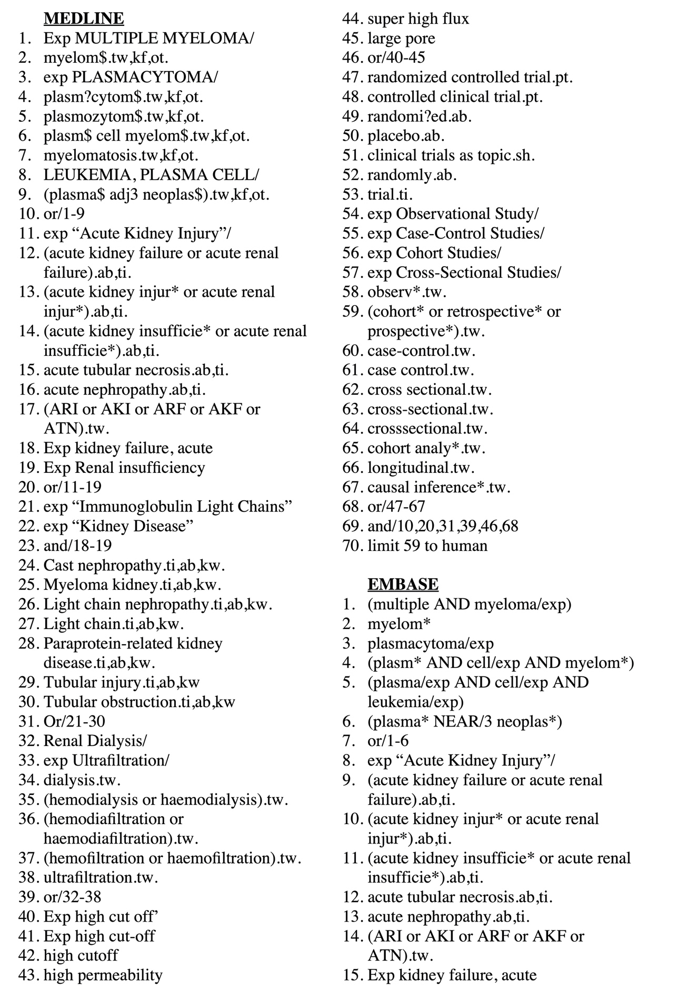
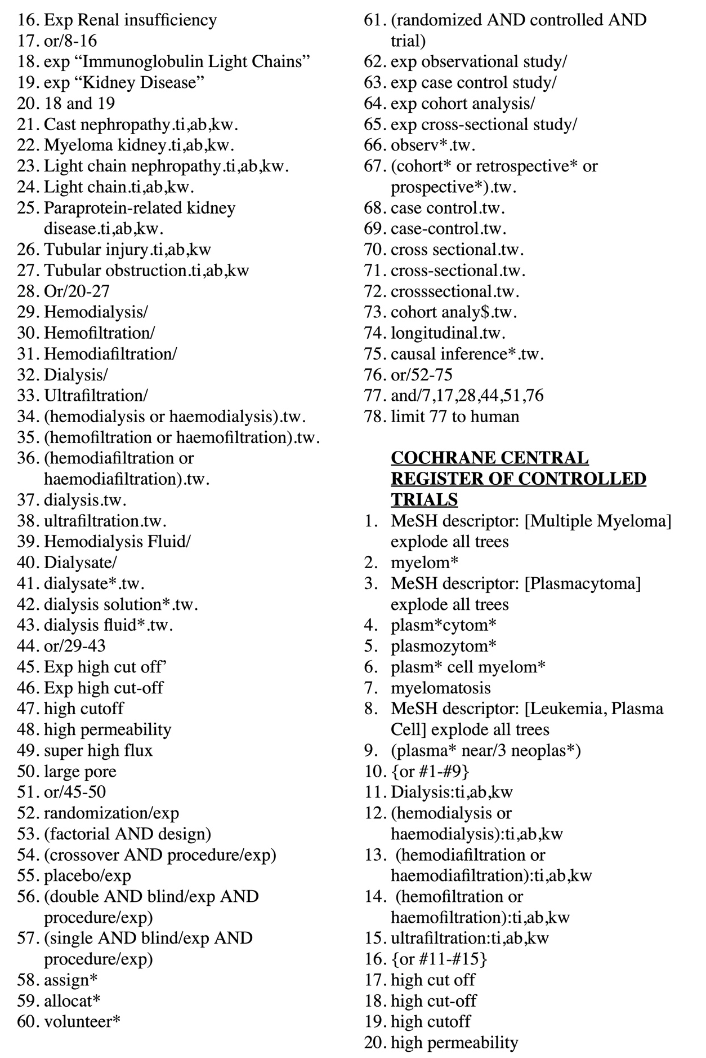

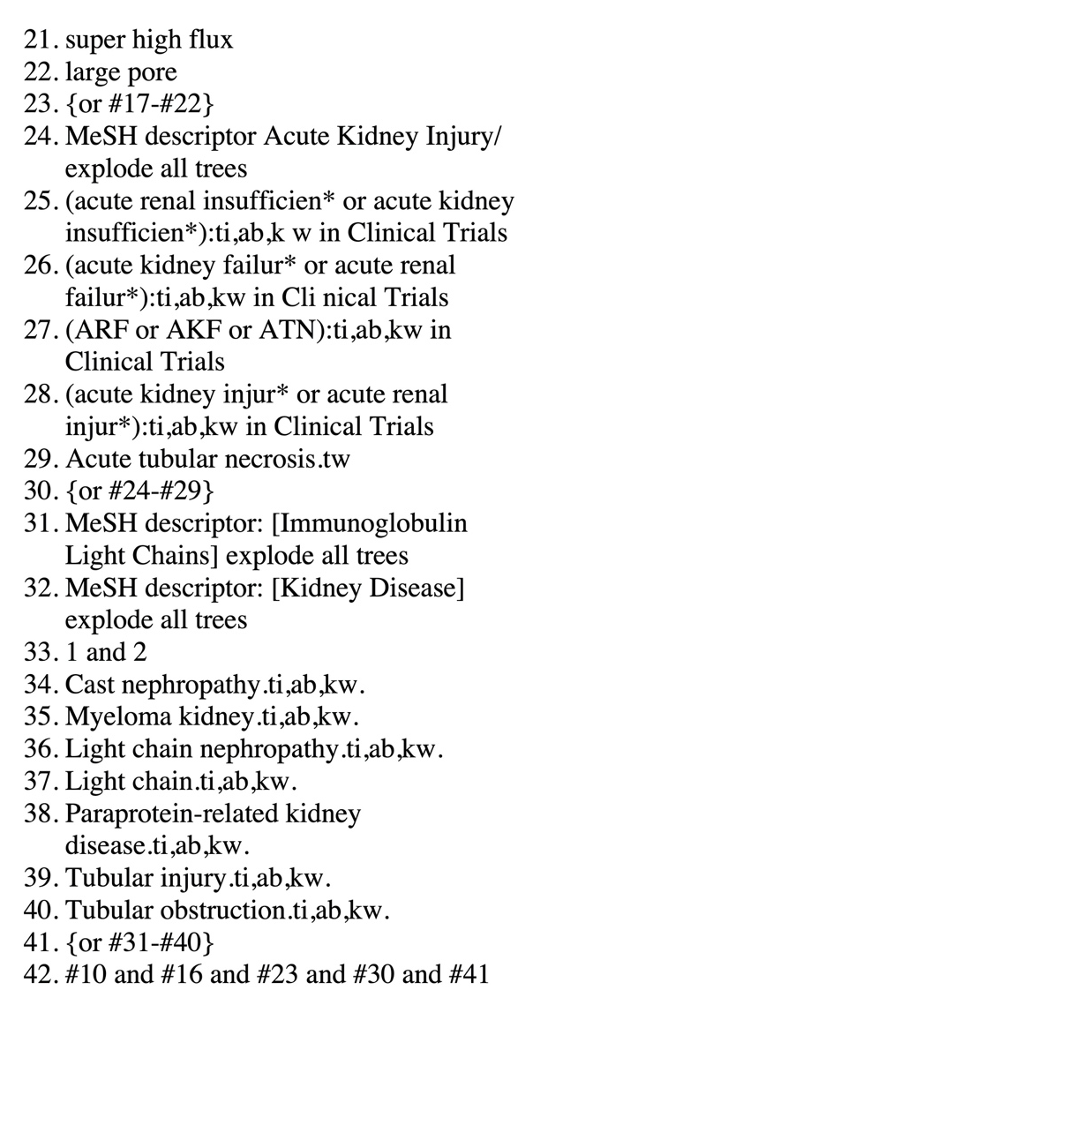

Supplementary figure 2: Impact of high-cutoff hemodialysis on all-cause mortality at 90 days.
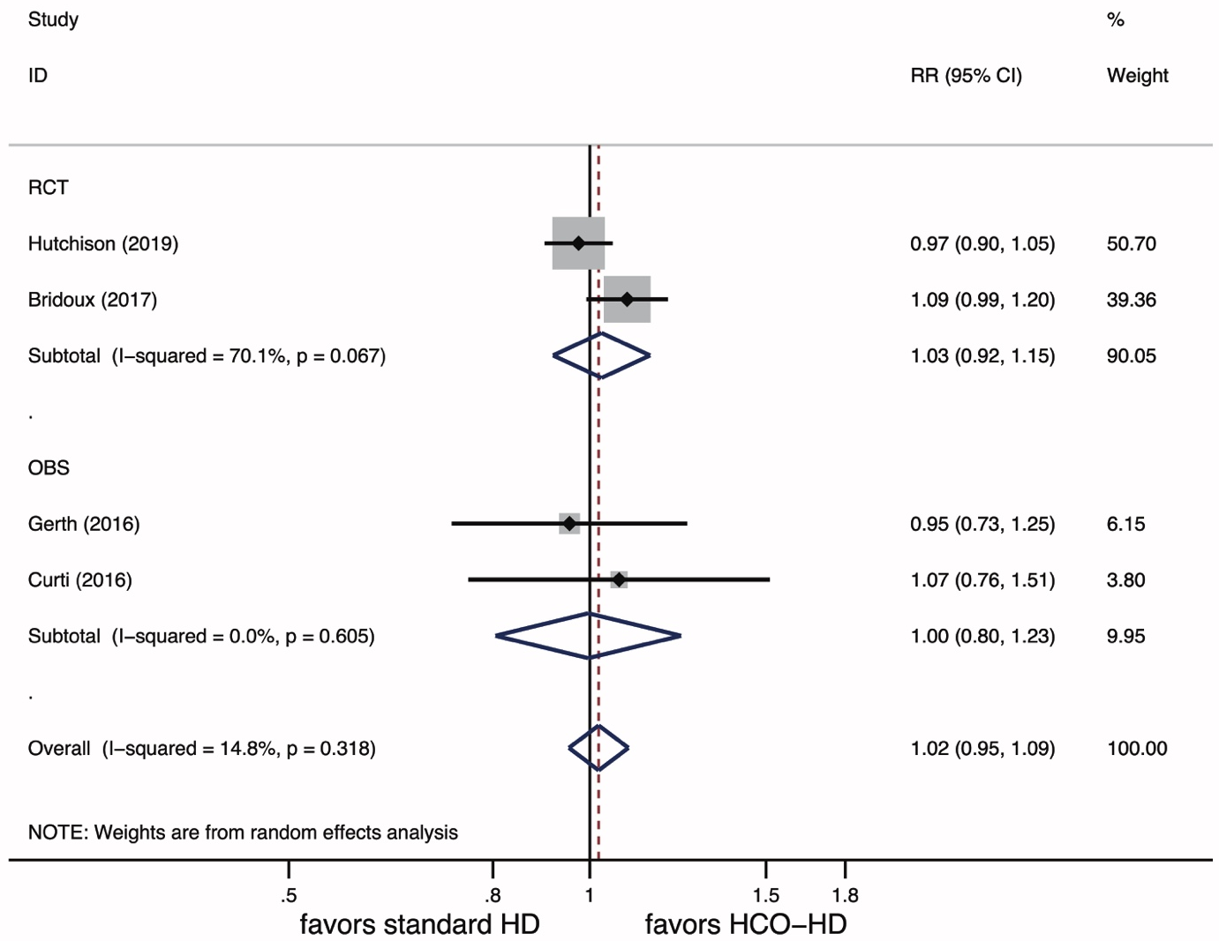
Supplementary figure 3: Impact of high-cutoff hemodialysis on all-cause mortality at 12 months.
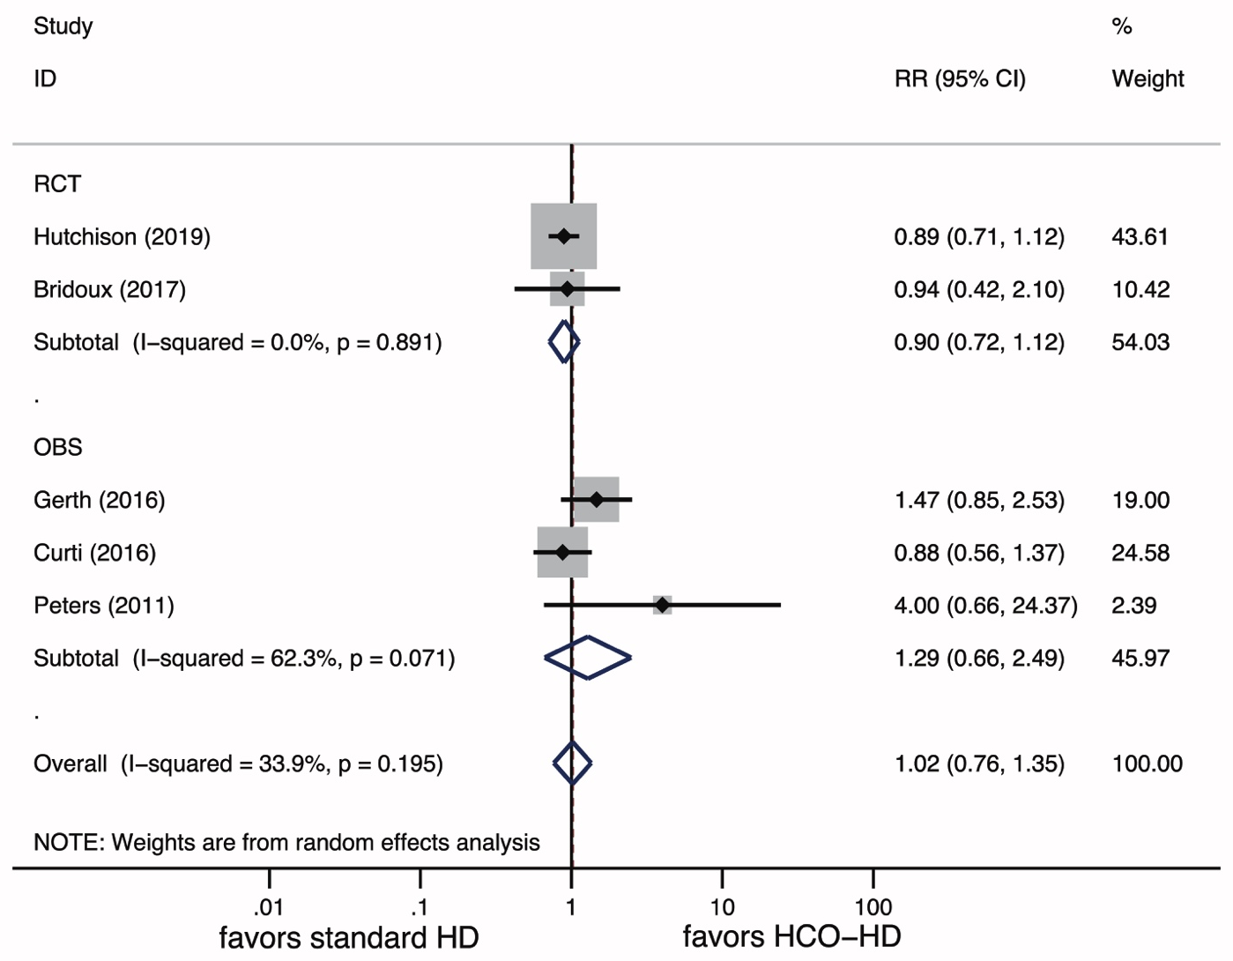
Supplementary figure 4: Impact of high-cutoff hemodialysis on hemodialysis independence at 6 months.

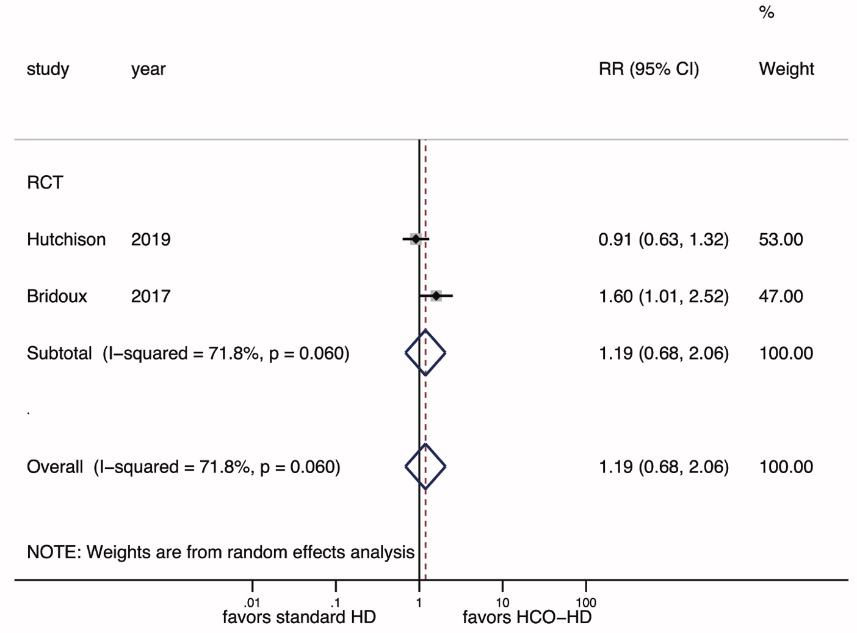
Supplementary figure 5: Impact of high-cutoff hemodialysis on hemodialysis independence at 12 months.
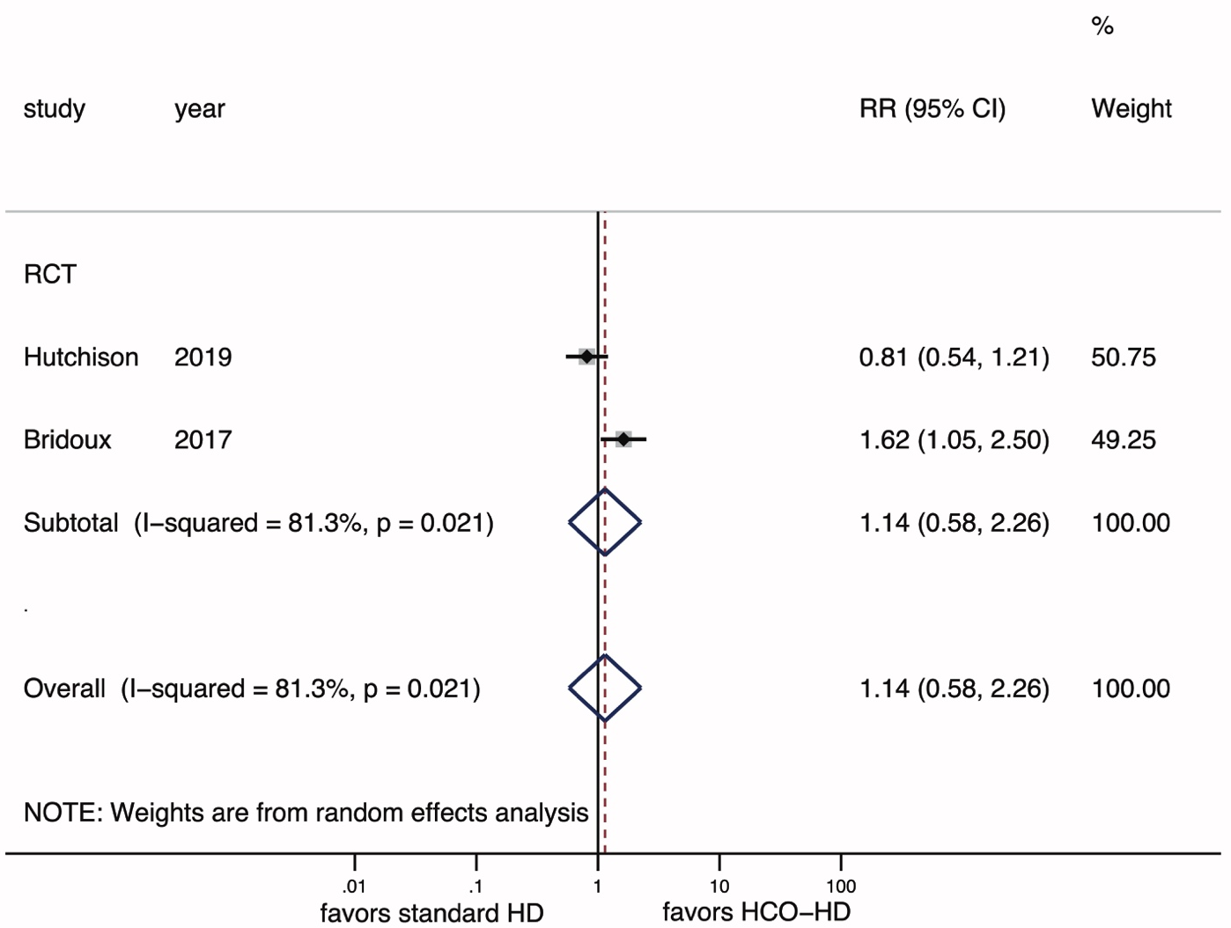
Supplementary figure 6: Impact of high-cutoff hemodialysis on kappa light chain removal.
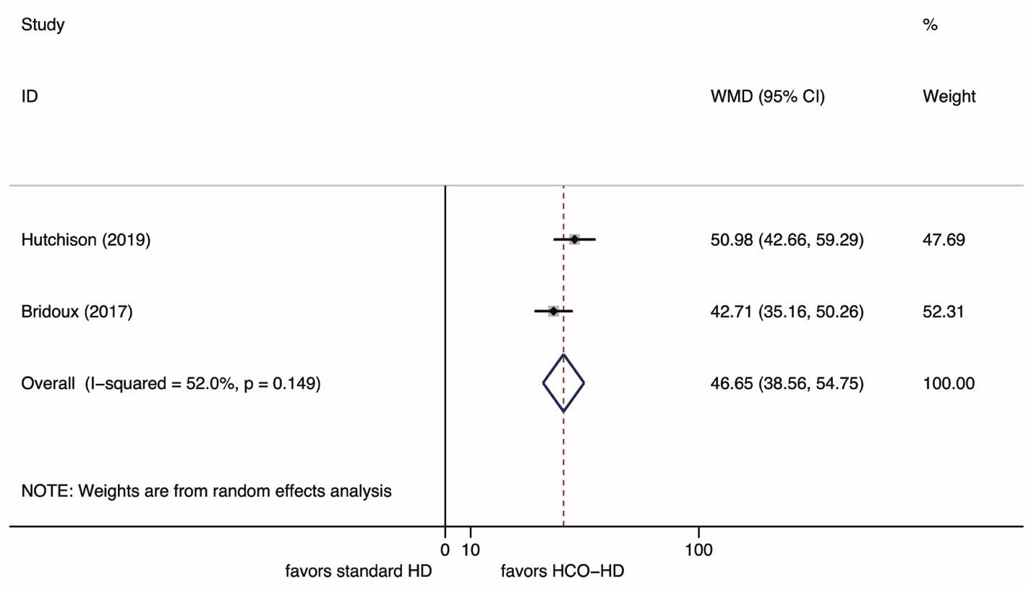
Supplementary figure 7: Impact of high-cutoff hemodialysis on lambda light chain removal.
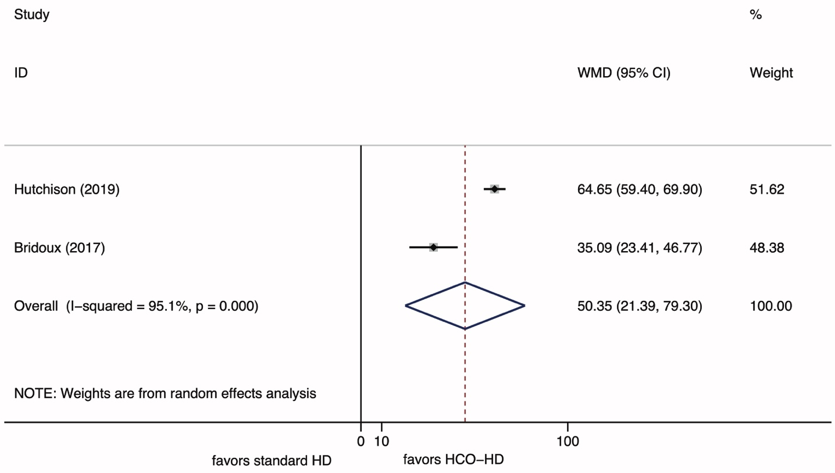
Supplementary figure 8: Risk of bias summary.


