The Forest Plot of subgroup Analysis

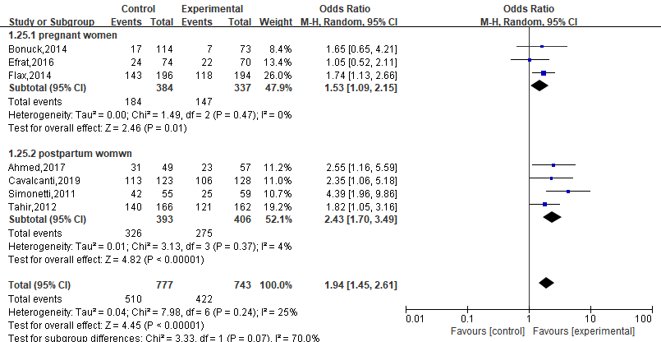
Figure S1. Subgroup Analysis of the Rate of Exclusive Breastfeeding in the First Months after Delivery(participant’s type)
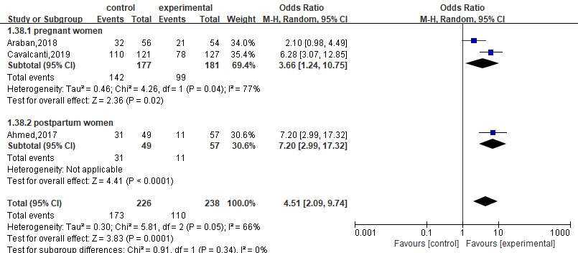
Figure S2. Subgroup Analysis of the Rate of Exclusive Breastfeeding in the Two Months after Delivery(participant’s type)
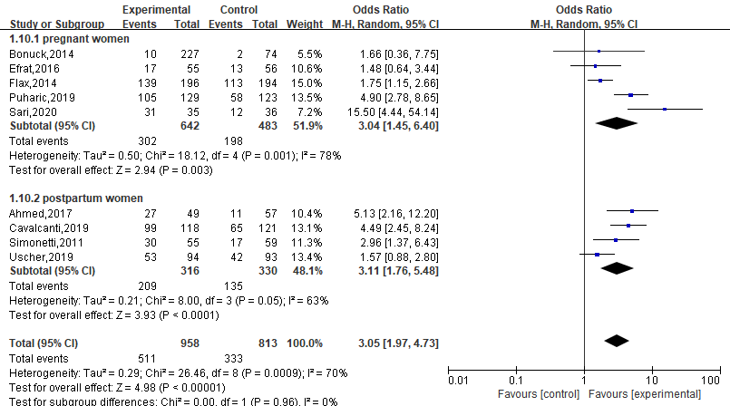
Figure S3. Subgroup Analysis of the Rate of Exclusive Breastfeeding in the Three Months after Delivery (participant’s type)
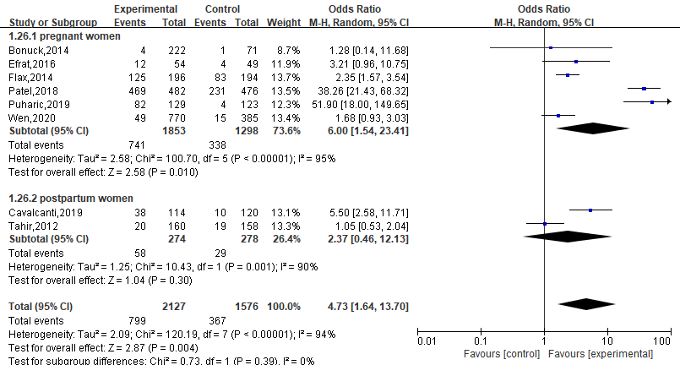
Figure S4. Subgroup Analysis of the Rate of Exclusive Breastfeeding in the Six Months after Delivery(participant’s type)
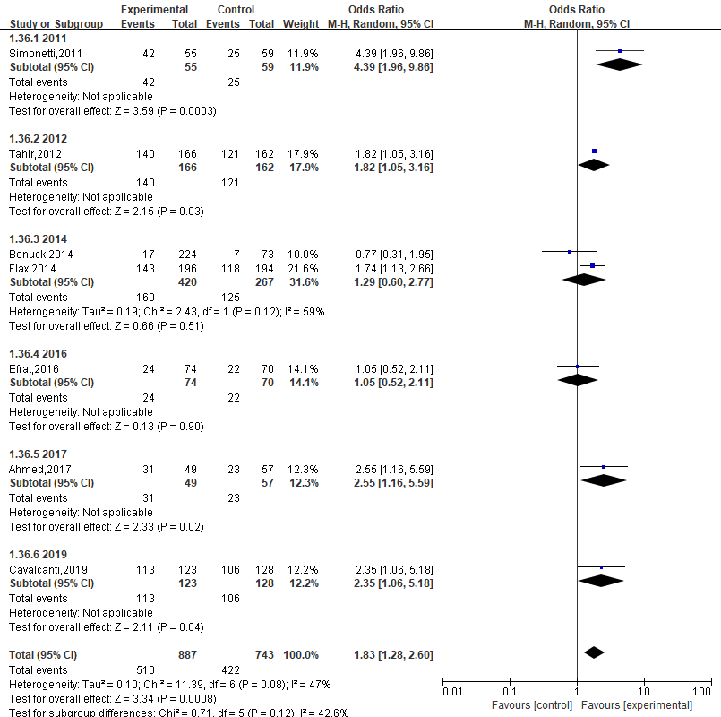
Figure S5. Subgroup Analysis of the Rate of Exclusive Breastfeeding in the First Months after Delivery (publication time)
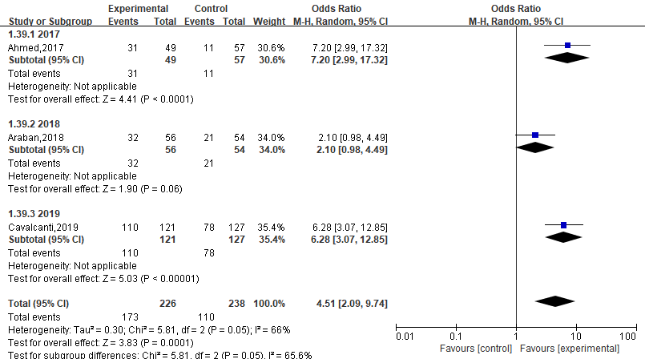
Figure S6. Subgroup Analysis of the Rate of Exclusive Breastfeeding in the Two Months after Delivery(publication time)
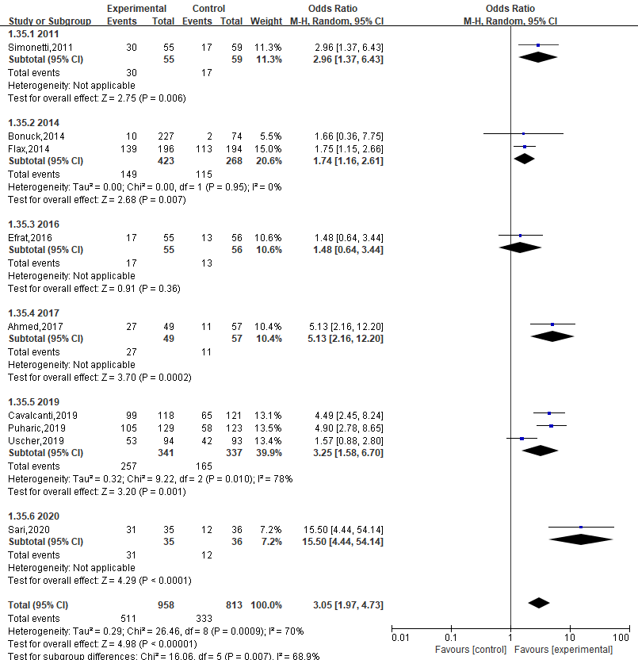
Figure S7. Subgroup Analysis of the Rate of Exclusive Breastfeeding in the Three Months after Delivery (publication time)
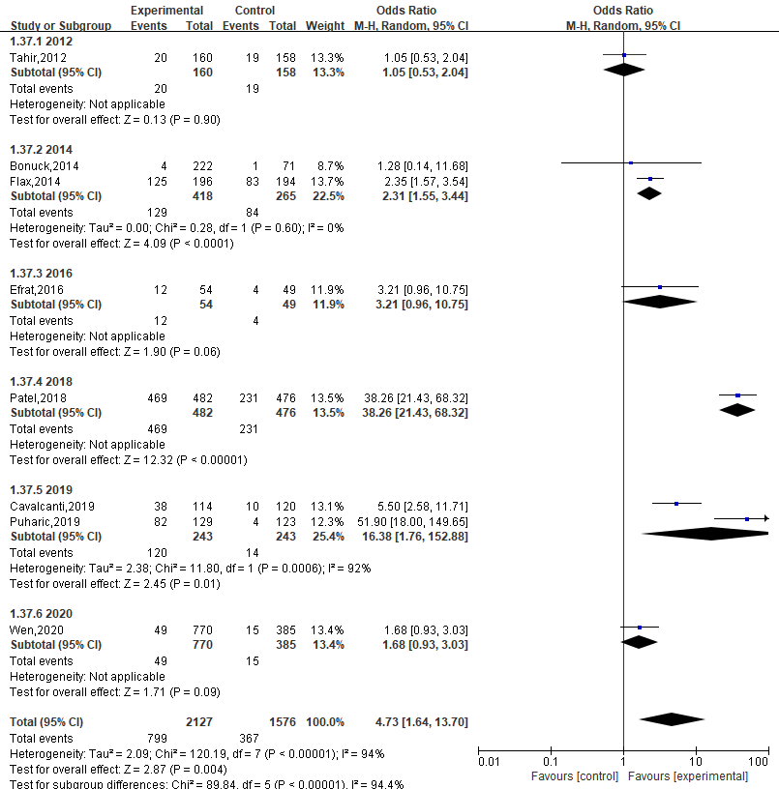
Figure S8. Subgroup Analysis of the Rate of Exclusive Breastfeeding in the Six Months after Delivery(participant’s type)

