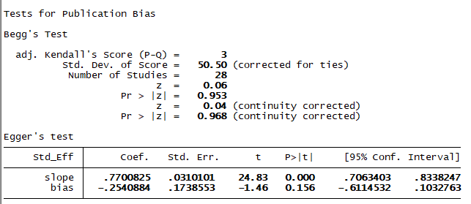
S3 Fig: Eggers test showing publication bias on the effects of therapeutic hypothermia on death among asphyxiated neonates with hypoxic ischemic encephalopathy

