Supplementary Material
Table S1. Detailed infection events reported in each trial
Source | Reported infection events
Jeffrey, A et al, 2010 (TRANSFORMS) | Upper respiratory tract infection (Nasopharyngitis, Upper respiratory tract infection, Sinusitis, Pharyngitis); Lower respiratory tract or lung infection ( Bronchitis); Influenza virus infection; Herpesvirus infection (Oral Herpes); Digestive system infection (Gastroenteritis, Appendicitis); Urinary system infection (Urinary tract infection); Abscess (Bartholin's abscess, Incision site abscess); Other infection (Administration site infection, Encephalitis viral)
Ludwig, K et al, 2010 (FREEDOMS) | Upper respiratory tract infection (Nasopharyngitis, Sinusitis, Acute sinusitis, Pharyngitis, Rhinitis, Pharyngotonsillitis, Tonsillitis); Lower respiratory tract or lung infection ( Bronchitis, Pneumonia); Influenza virus infection; Herpesvirus infection; Digestive system infection (Gastroenteritis, Appendicitis); Urinary system infection (Urinary tract infection, Cystitis, Pyelonephritis, Pyelonephritis acute, Pyelonephritis chronic); Abscess (Abscess jaw, Anal abscess, Bartholin's abscess, Incision site abscess, Peritoneal abscess, Streptococcal abscess, Tooth abscess); Other infection (Clostridial infection, Mastoiditis, Otitis media acute, Urosepsis)
Saida, T et al, 2012 | Upper respiratory tract infection (Nasopharyngitis, Pharyngitis); Lower respiratory tract or lung infection (Bronchitis); Influenza virus infection; Other infection (Tinea pedis)
Calabresi, P.A et al, 2014 (FREEDOMS II) | Upper respiratory tract infection (Nasopharyngitis, Upper respiratory tract infection, Sinusitis, Acute sinusitis); Lower respiratory tract or lung infection (Bronchitis, Pneumonia, Lower respiratory tract infection fungal); Influenza virus infection; Herpesvirus infection; Digestive system infection (Gastroenteritis, Appendicitis, Diverticulitis); Urinary system infection (Urinary tract infection, Kidney infection, Pyelonephritis); Abscess (Cellulitis, Streptococcal abscess); Other infection (Vulvitis, Mastoiditis, Otitis media acute, Lyme disease, Labyrinthitis, Hepatitis C)
Fox, E et al, 2014 (EPOC) | Upper respiratory tract infection (Nasopharyngitis, Sinusitis, Nasopharyngitis); Lower respiratory tract or lung infection (Bronchitis, Pneumonia); Digestive system infection (Appendicitis); Urinary system infection (Urinary tract infection, Kidney infection); Other infection (Urosepsis)
Kappos, L et al, 2015 | Upper respiratory tract infection (Nasopharyngitis, Upper respiratory tract infection, Sinusitis, Acute sinusitis); Herpesvirus infection; Urinary system infection (Urinary tract infection)
Lublin, F et al, 2016 (INFORMS) | Upper respiratory tract infection (Nasopharyngitis, Upper respiratory tract infection, Viral upper respiratory tract infection, Tonsillitis); Lower respiratory tract or lung infection (Bronchitis, Pneumonia, Bronchopneumonia, Tracheobronchitis); Influenza virus infection; Herpesvirus infection; Digestive system infection (Gastroenteritis, Appendicitis, Enterocolitis bacterial, Diverticulitis); Urinary system infection (Urinary tract infection, Cystitis OR bacterial cystitis, Pyelonephritis, Pyelonephritis acute); Other infection (Urosepsis, Myelitis, Septic shock, Systemic mycosis)
Comi, G et al, 2017 (GOLDEN) | Upper respiratory tract infection (Nasopharyngitis); Lower respiratory tract or lung infection (Bronchopneumonia); Urinary system infection (Urinary tract infection, Kidney infection, Pyelonephritis)
Chitnis, T et al, 2018 (PARADIGMS) | Upper respiratory tract infection (Nasopharyngitis, Upper respiratory tract infection, Viral upper respiratory tract infection, Rhinitis, Viral pharyngitis); Influenza virus infection; Digestive system infection (Appendicitis, Gastritis viral, Gastrointestinal infection); Abscess (Abscess oral, Cellulitis, Paronychia)
Bruce, A.C et al, 2018 (PREFERMS) | Upper respiratory tract infection (Nasopharyngitis, Sinusitis); Lower respiratory tract or lung infection (Pneumonia); Digestive system infection (Campylobacter gastroenteritis); Urinary system infection (Urinary tract infection, Pyelonephritis acute); Abscess (Tooth abscess, Cellulitis); Other infection (Bacteraemia, Viral infection)
Biogen Study Medical Director, 2017 (REVEAL) | Upper respiratory tract infection (Upper respiratory tract infection); Urinary system infection (Urinary tract infection)
Novartis Pharmaceutical, 2019 | Upper respiratory tract infection (Bronchitis, Upper respiratory tract infection, Rhinovirus infection); Lower respiratory tract or lung infection (Pneumonia); Digestive system infection (Appendicitis, Clostridium difficile colitis, Gastroenteritis, Diverticulitis, Gastroenteritis viral); Influenza virus infection (Influenza, Parainfluenzae virus infection); Urinary system infection (Urinary tract infection); Abscess (Extradural abscess, Cellulitis); Other infection (Arthritis bacterial, Clostridium difficile colitis, Device related sepsis, Meningitis fungal, Sepsis)

Table S2. Sensitivity analyses with meta-analysis of the risk of infection
Study Omitted | RR | 95%CI
Biogen Study Medical Director, 2017 (REVEAL) | 1.16 | 1.06-1.26
Bruce A.C et al, 2018 (PREFERMS) | 1.12 | 1.04-1.21
Calabresi, P.A et al, 2014 (FREEDOMS II) | 1.21 | 1.07-1.37
Comi, G et al, 2017 (GOLDEN) | 1.13 | 1.04-1.23
Chitnis T et al, 2018 (PARADIGMS) | 1.16 | 1.07-1.27
Fox, E et al, 2014 (EPOC) | 1.14 | 1.05-1.24
Jeffrey A et al, 2010 (TRANSFORMS) | 1.16 | 1.06-1.27
Kappos, L et al, 2015 | 1.18 | 1.07-1.29
Ludwig K et al, 2010 (FREEDOMS) | 1.21 | 1.09-1.35
Lublin F et al,2016 (INFORMS) | 1.22 | 1.09-1.36
Novartis Pharmaceuticals, 2019 | 1.14 | 1.05-1.25
Saida, T et al, 2012 | 1.15 | 1.06-1.26
Excluding studies that were open-label design | 1.10 | 1.02-1.18
Excluding studies that follow-up durations were less than 12 months | 1.14 | 1.05-1.25
Excluding studies that used IFN-β as the comparator | 1.12 | 1.03-1.23
Excluding studies that used IFN-β or GA as the comparators | 1.10 | 1.02-1.18
Excluding studies that used natalizumab as the comparator | 1.16 | 1.06-1.26
Excluding studies that used GA as the comparator | 1.14 | 1.05-1.25
RR: relative risk; CI: confidence interval; GA: glatiramer acetate; studies of open-label design including Biogen Study Medical Director, 2017 (REVEAL), Bruce A.C et al, 2018 (PREFERMS), Comi, G et al, 2017 (GOLDEN), and Fox, E et al, 2014 (EPOC); studies that follow-up duration were less than 12 months including Saida, T et al, 2012, Kappos, L et al, 2015, and Fox, E et al, 2014 (EPOC); studies that used IFN-β as the comparator including Comi, G et al, 2017 (GOLDEN ), Chitnis T et al, 2018 (PARADIGMS), Jeffrey A et al,2010 (TRANSFORMS); studies that used IFN-β or GA as the comparators including Fox, E et al, 2014 (EPOC) and Bruce A.C et al, 2018 (PREFERMS); studies that used Natalizumab as the comparator including Biogen Study Medical Director, 2017 (REVEAL); studies that used GA as the comparator including Novartis Pharmaceuticals, 2019.

Figure S1. Risk of bias summary：review of authors’ judgments about each risk of bias item for each included study. + indicates low risk; , high risk; ?, unclear risk.

Figure S2. Funnel plot to assess publication bias
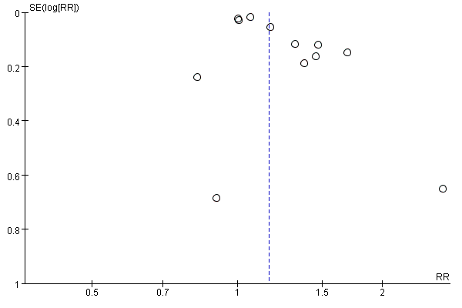
- Total RCTs
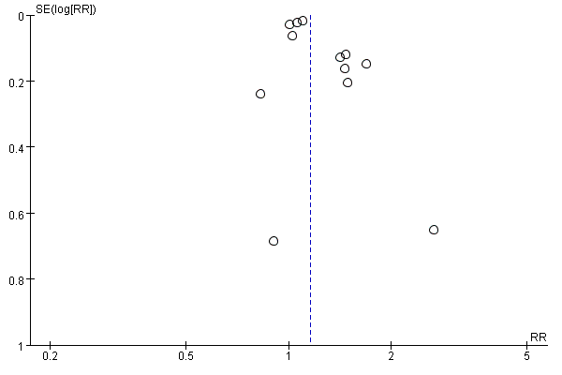
(B) 0.5 mg/daily of Fingolimod

