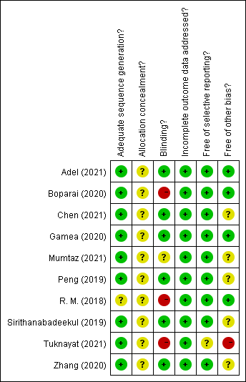
Supplementary Figure.1. Risk of bias and methodological quality were assessed. For clinical controlled trials, Cochrane Collaboration’s “risk of bias” tool was used. The green means low risk of bias. The yellow means unclear risk of bias. The red means high risk of bias.

Supplementary Table. 1. The search strategies for Pubmed, Web of science, Embase, Cochrane library and CNKI.
Search strategies
melasma | #1. "melasma"[MeSH Terms] OR (("Melanosis/therapy"[Majr]) OR "melasma"[All Fields] OR "chloasma"[All Fields]
platelet-rich plasma | #2. "platelet-rich plasma "[MeSH Terms] OR ("platelet-rich "[All Fields] AND " plasma "[All Fields]) OR " platelet-rich plasma "[All Fields] OR ("platelet-rich "[All Fields] AND " plasma "[All Fields]
Pubmed, Web of science, Embase and Cochrane library: #1 AND #2
CNKI: [All Fields] "黄褐斑" AND [All Fields]"富含血小板血浆"

Supplementary Table. 2. The selection criteria
 | Describing the contents
  Items
Inclusion criteria | The inclusion criteria were as follows: (1) human studies; (2) original studies (randomized controlled trials (RCTs), and case-control studies) about treatment for melasma with PRP; (3) PRP treatment either alone or as adjuvant therapy; (4) studies involve one of the melasma outcome measures of the Melasma Area and Severity Index (MASI) and subjective evaluation or satisfaction.
Exclusion criteria | Principal criteria for the exclusion were as follows: (1) any animal studies; (2) in vitro studies; (3) irrelevant topic or overlapping publications; (4) no appropriate or no sufficient data; (5) studies that lacked specific outcome measures.

Supplementary Table. 3. We conducted a subgroup analysis of three factors: “gender”, “treatment modality” and “location”, and displayed P values of intra-group and inter-group heterogeneity in this table.
Subgroup | n | SMD (95% CI) | I2 (%) | P | P for Heterogeneity Between Subgroups
Sex:  Male  Female | 4  5 | -1.37(-1.88, -0.86)  -1.04(-1.37, -0.71) | 70.56  31.9 | 0.024  0.209 | 0.400
Treatment：  Intradermal injection  Microneedling and  Microinjection | 8  2 | -1.13(-1.34, -0.92)  -1.43(-3.03, 0.17) | 0  91.9 | 0.664  0 | 0.779
location:  China  India  Egypt  Thailand  Pakistan | 2  2  3  1  1 | -1.10(-1.43, -0.78)  -1.85(-2.56, -1.14)  -0.87(-1.24, -0.5)  -1.10(-1.43, -0.78)  -0.96(-1.48, -0.44) | 0  67  0  / | 0.685  0.082  0.401  / | 0.400

