Supplementary data
Table S.1: Result of Trim and fill analysis for evaluation of publication bias
Method | Pooled | 95% CI |  | Asymptotic |  | No. of studies
 |  | Lower | Upper | z_value | p_value
LDL | -3.38 | -9.93 | -2.84 | -4.15 | 0.01 | 13
TG | -52.36 | -80.50 | -24.22 | -3.65 | 0.01 | 15

Fig. S1. Random-effects meta-regression plots of the association between WMD of LDL level change and cherry supplementation based on duration.

Fig. S2. Random-effects meta-regression plots of the association between WMD of HDL level change and cherry supplementation based on duration.

Fig. S3. Random-effects meta-regression plots of the association between WMD of cholesterol level change and cherry supplementation based on duration.

Fig. S4. Random-effects meta-regression plots of the association between WMD of triglycerides level change and cherry supplementation based on duration.

Fig. S5. Dose-response analysis between LDL level change and administered dose of cherry. The 95% CI is revealed in the shaded regions.

Fig. S6. Dose-response analysis between HDL level change and administered dose of cherry. The 95% CI is revealed in the shaded regions.

Fig. S7. Dose-response analysis between cholesterol level change and administered dose of cherry. The 95% CI is revealed in the shaded regions.

Fig. S8. Dose-response analysis between triglycerides level change and administered dose of cherry. The 95% CI is revealed in the shaded regions.

Fig. S9. Funnel plot displaying publication bias in the studies reporting the impact of cherry supplementation on LDL level change.

Fig. S10. Funnel plot displaying publication bias in the studies reporting the impact of cherry supplementation on HDL level change.

Fig. S11. Funnel plot displaying publication bias in the studies reporting the impact of cherry supplementation on cholesterol level change.

Fig. S12. Funnel plot displaying publication bias in the studies reporting the impact of cherry supplementation on triglycerides level change.

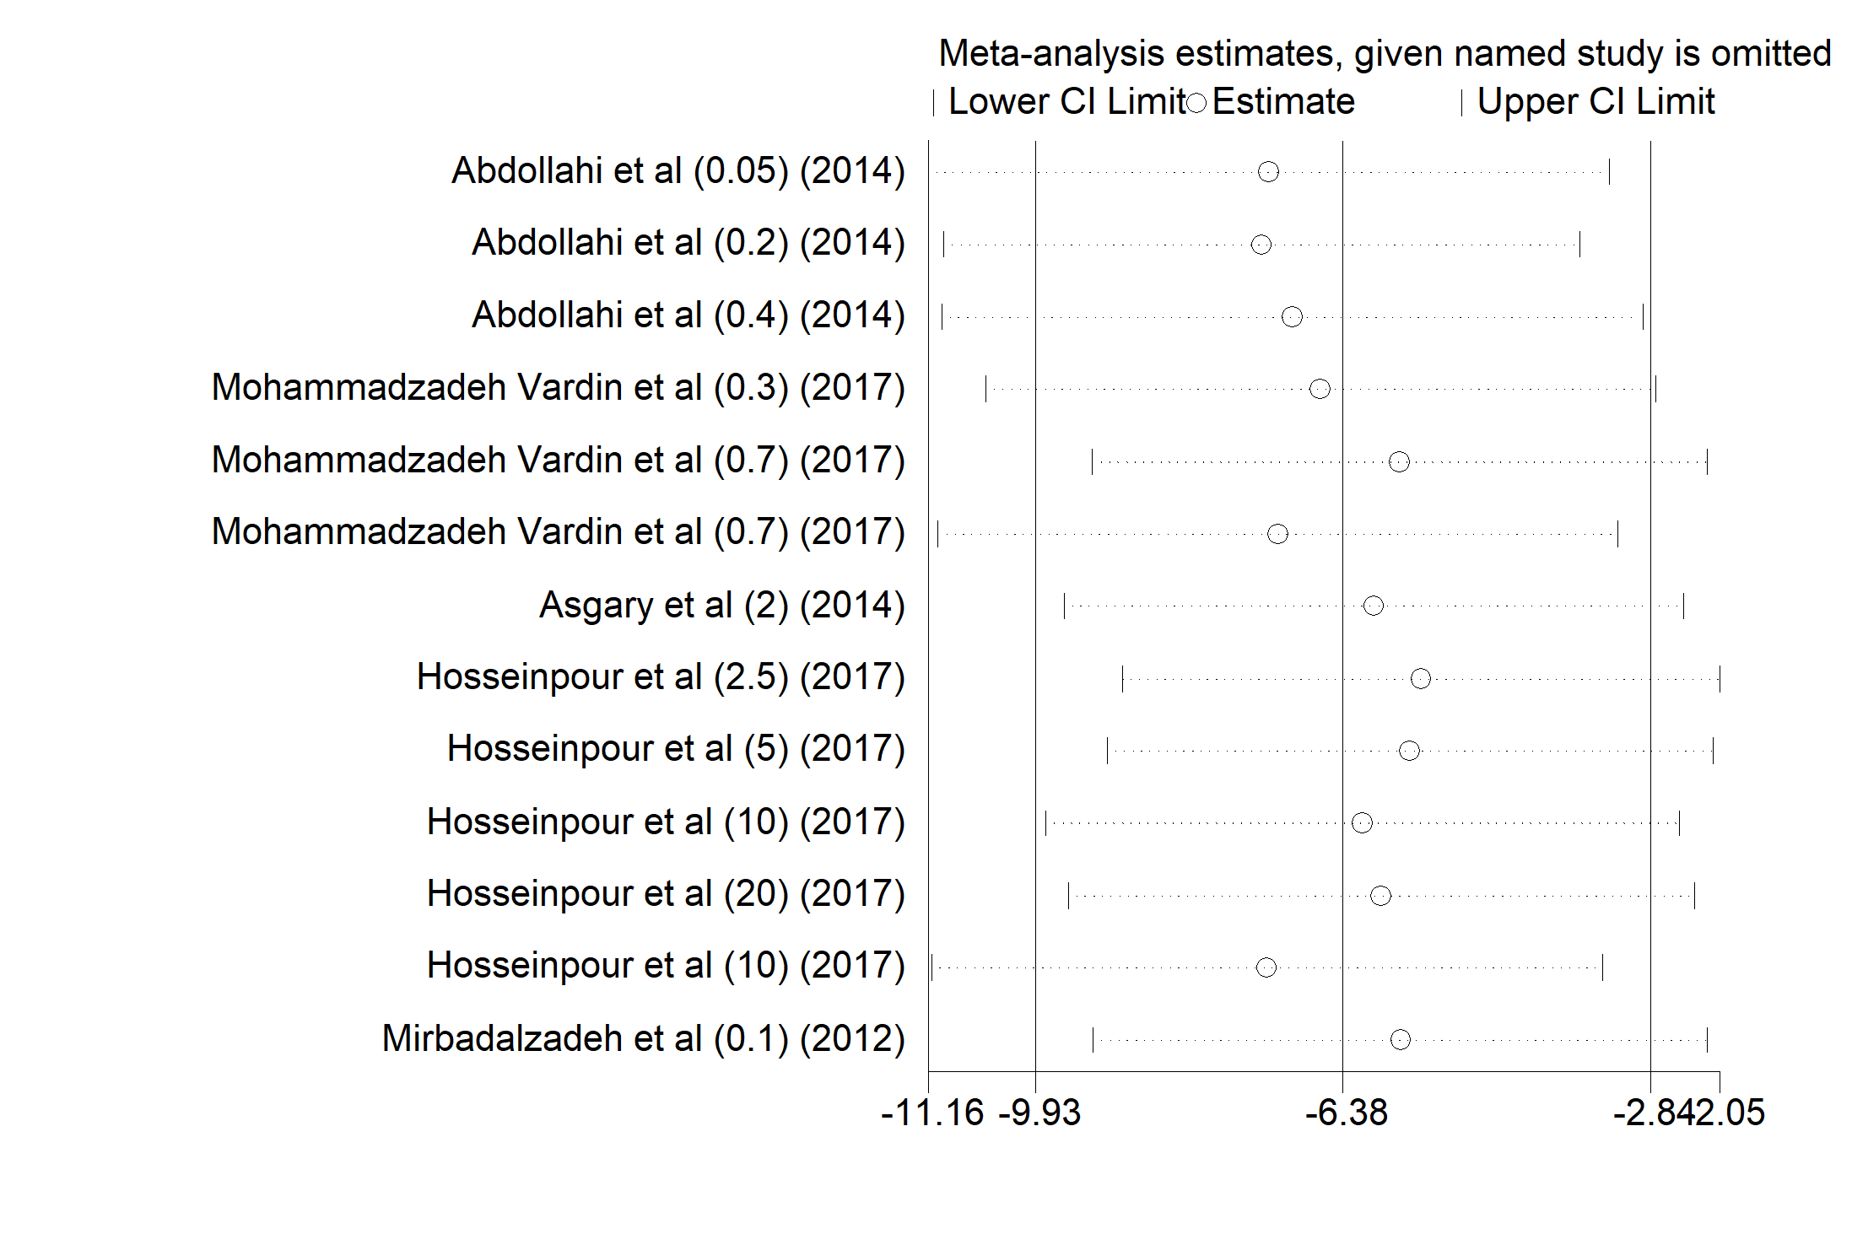
Fig. S13. The sensitivity analysis of calculated combined results for LDL outcome

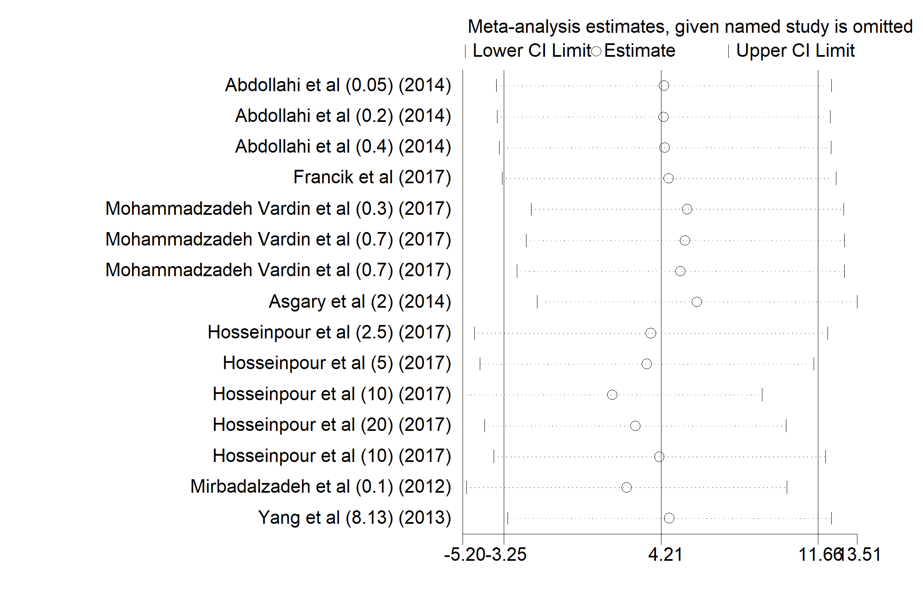
Fig. S14. The sensitivity analysis of calculated combined results for HDL outcome

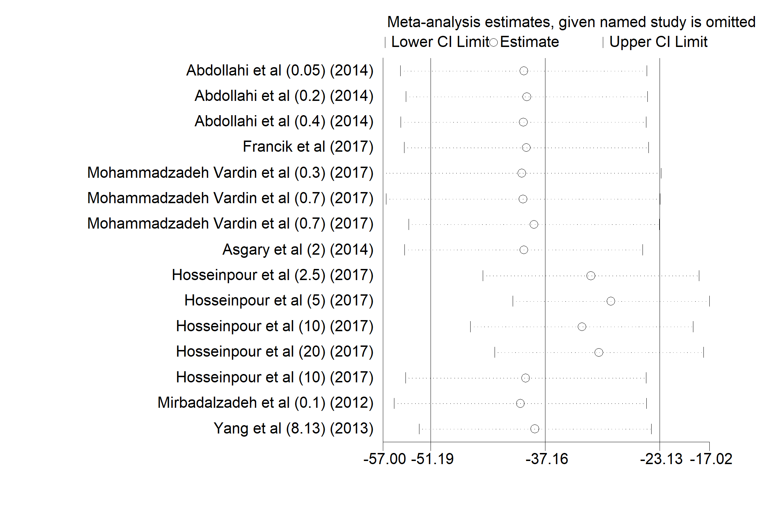
Fig. S15. The sensitivity analysis of calculated combined results for cholesterol outcome

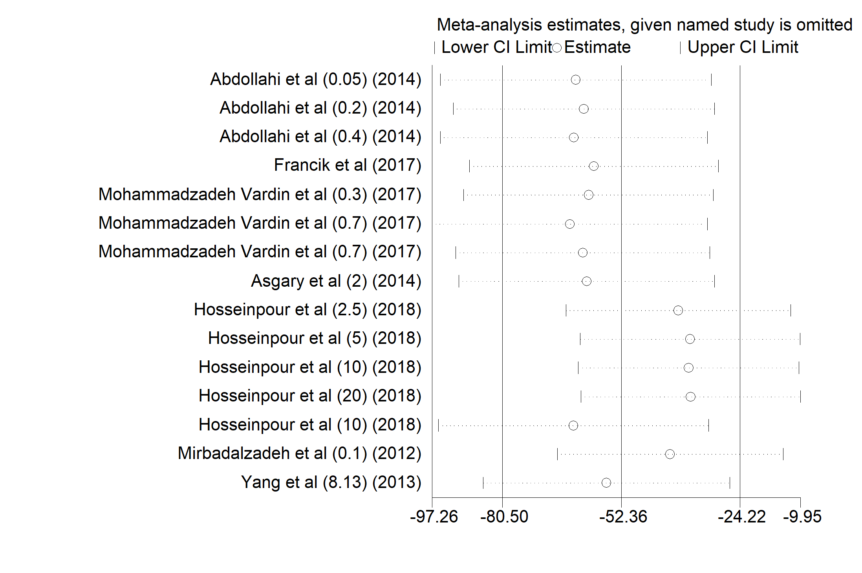
Fig. S16. The sensitivity analysis of calculated combined results for triglyceride outcome

