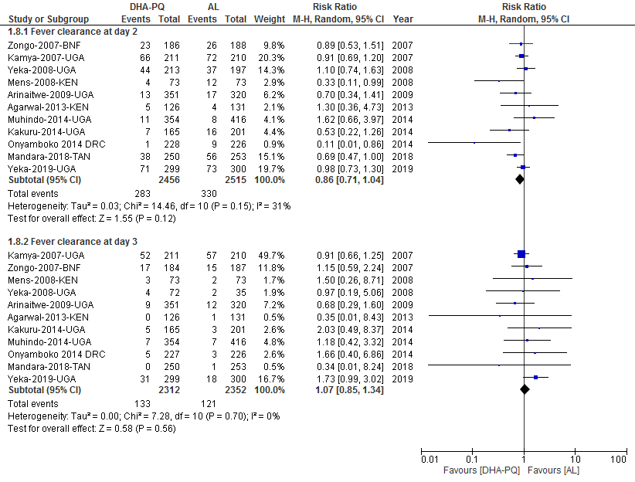
Additional file S10: Forest plot of comparison between dihydroartemisinin-piperaquine and artemether-lumefantrine for treatment of uncomplicated plasmodium falciparum malaria among children in Africa on fever clearance.

