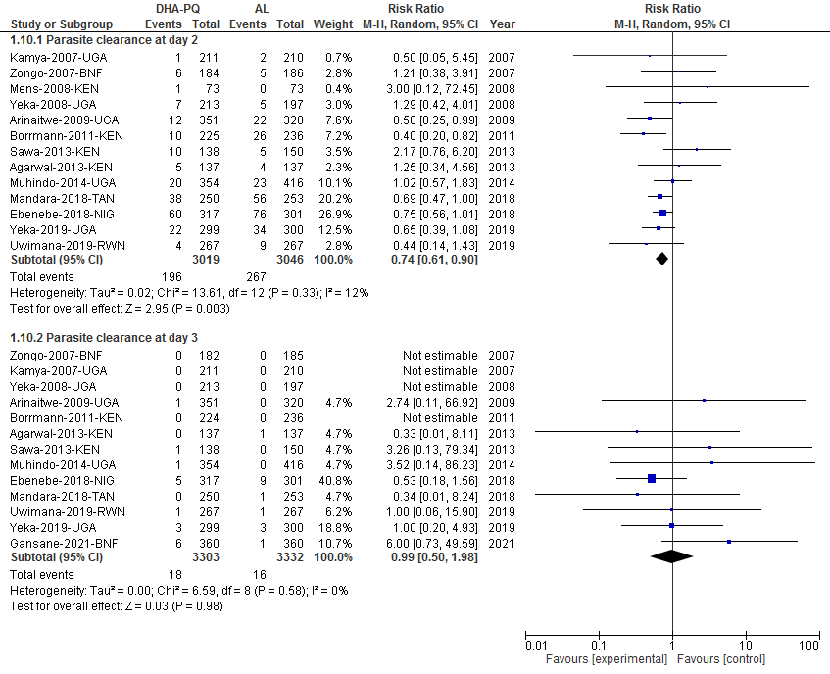
Additional file S11: Forest plot of comparison: dihydroartemisinin-piperaquine versus artemether-lumefantrine for treatment of uncomplicated plasmodium falciparum malaria among children in Africa, outcome: Parasite clearance day 2 and 3.

