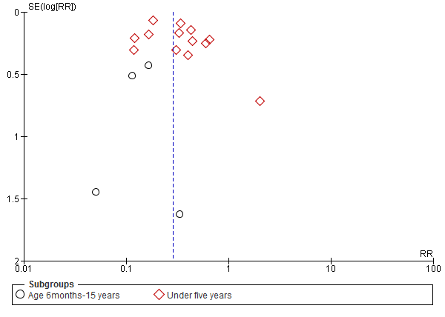
Additional file S7: Funnel plot of comparison: dihydroartemisinin-piperaquine versus artemether-lumefantrine for treatment of uncomplicated plasmodium falciparum malaria among children in Africa, outcome: PCR unadjusted treatment failure at day 28.

