EE
Figure 1.1
E-bike moderate assistance compared with a conventional bike
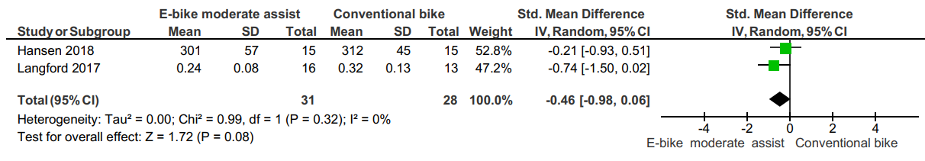
Figure 1.2
E-bike moderate assistance compared with e-bike no assistance
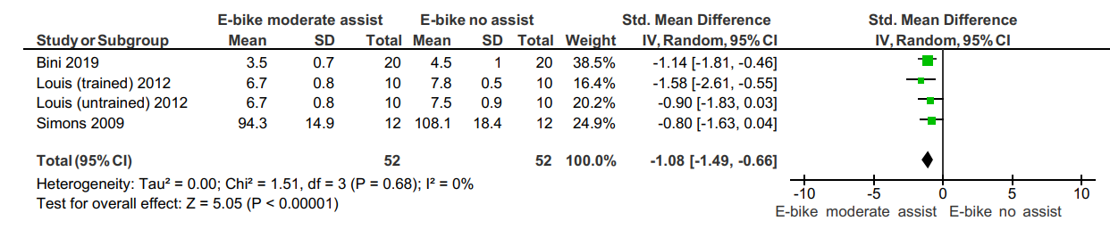
Figure 1.3
E-bike high assistance compared with e-bike no assistance
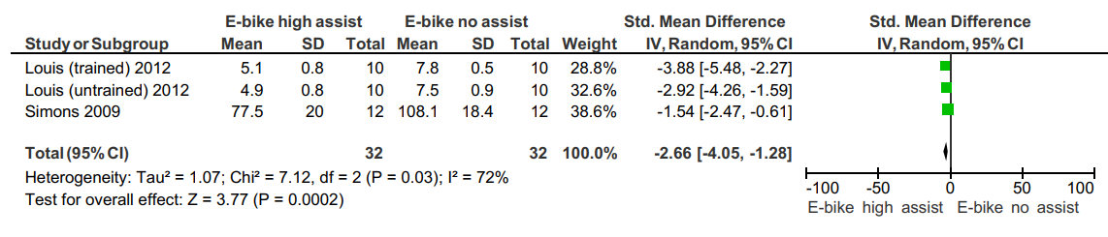
HR
Figure 2.1
E-bike moderate assistance compared with a conventional bike
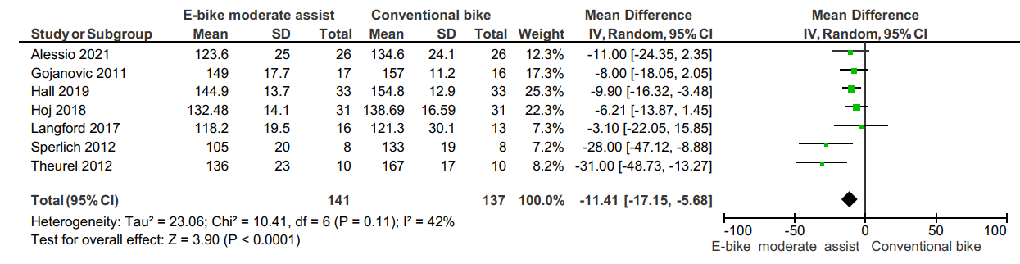
Figure 2.2
E-bike moderate assistance compared with e-bike no assistance
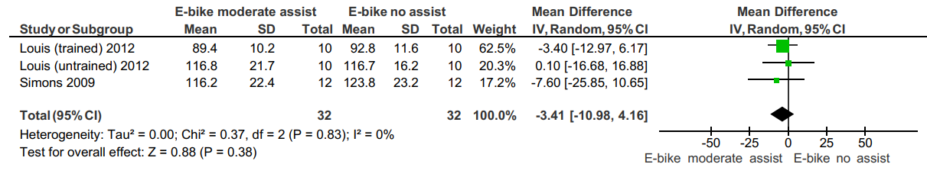
Figure 2.3
E-bike high assist compared with a conventional bike
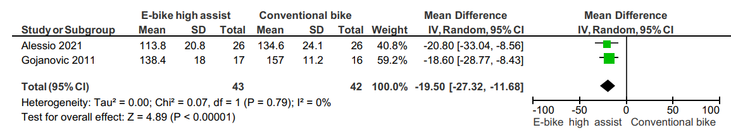
Figure 2.4
E-bike high assistance compared with e-bike no assistance
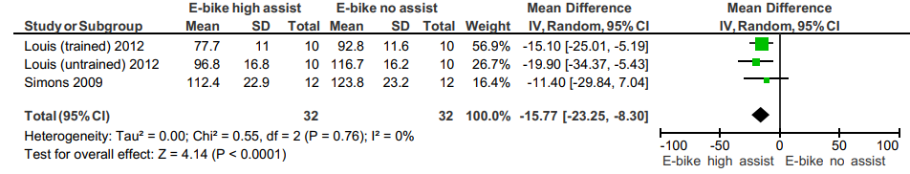
Figure 2.5
E-bike moderate assist compared with walking
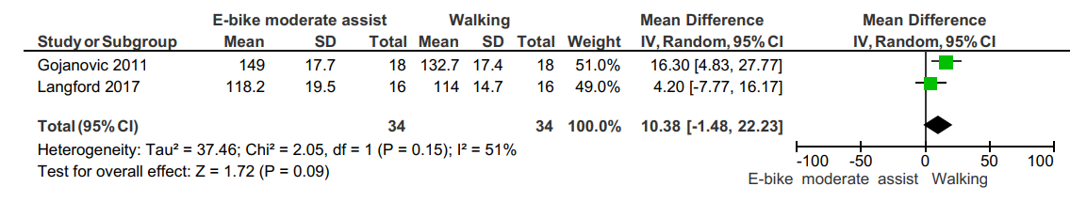
VO₂
Figure 3.1
E-bike moderate assistance compared with a conventional bike
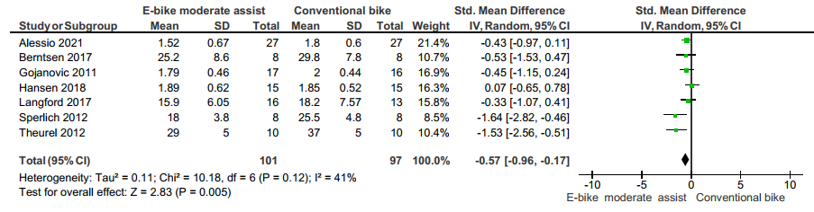
Figure 3.2
E-bike moderate assistance compared with e-bike no assistance
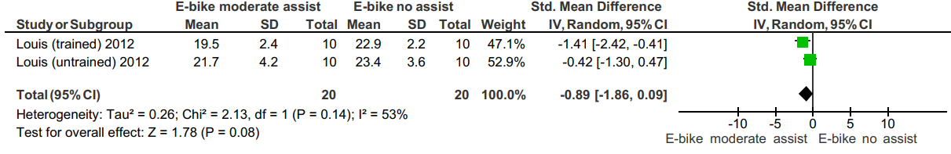
Figure 3.3
E-bike high assistance compared with a conventional bike 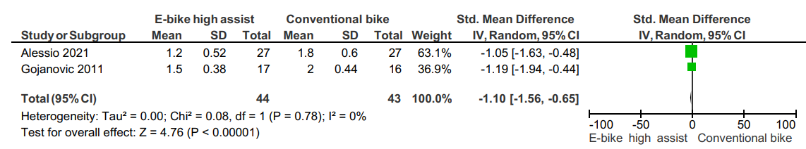
Figure 3.4
E-bike moderate assist compared with walking
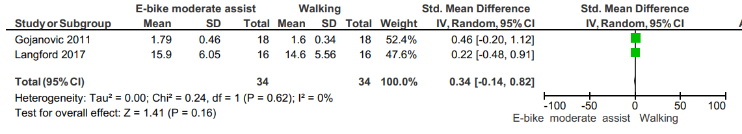
PO
Figure 4.1
E-bike moderate assistance compared with a conventional bike
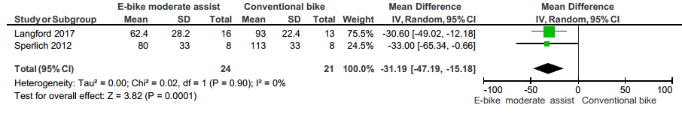

Figure 4.2
E-bike moderate assistance compared with e-bike no assistance
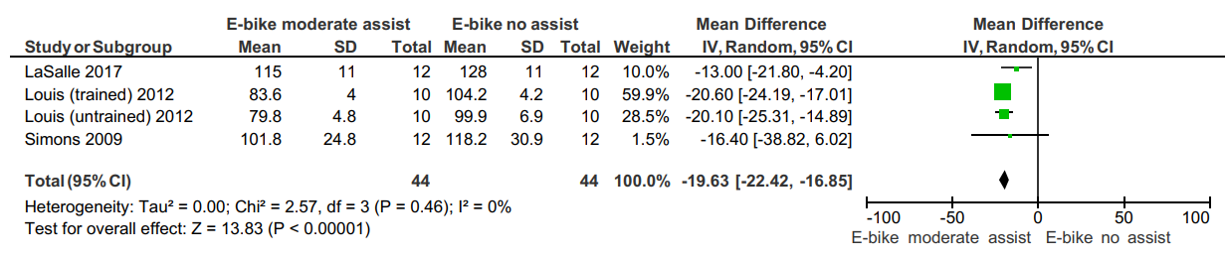
Figure 4.3
E-bike high assistance compared with e-bike no assistance
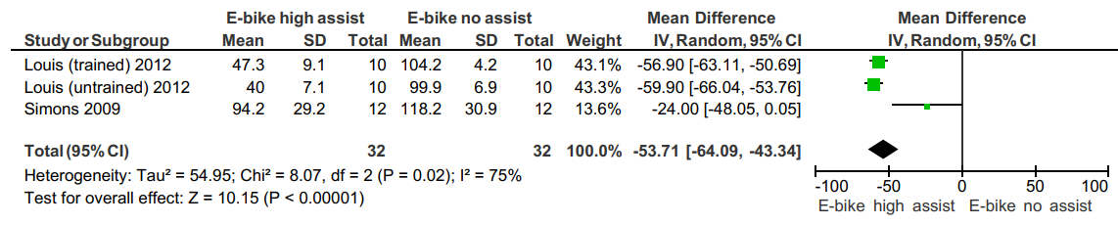
METs
Figure 5.1
E-bike moderate assistance compared with a conventional bike


