Table S2: Results of all the studies by using Multivariate Logistic Regression for adjusting covariates.
Study | Adjustment
Moisey 2013 | Age,sex, Injury Severity Scale score
Ebbeling 2014 | Age, Comorbidities, Abbreviated Injury Scale head
Kaplan 2016 | Age, sex, and comorbidities
Akahoshi 2016 | Age, sex
Shibahashi 2017 | APACHE II score, sex
Hoogt 2018 | NA
Ji 2018 | Age, use of vasopressor, mixed organism, SOFA
Toledo 2018 | NA
Cho 2019 | NA
Kou 2019 | NA
Tanabe 2019 | Age, comorbidity,complications,mechanism of injury, Injury Severity Score, Abbreviated Injury Scale scores
Hwang 2019 | NA
Baggerman 2020 | NA
Joyce 2020 | NA

*Acute Physiology and Chronic Health Evaluation II score
Sequential Organ Failure Assessment score
NA：not available

Table S3: Result of the Newcastle-Ottawa scale quality assessment
Newcastle-Ottawa scale | Selection(1) |  |  |  | Comparability(2) | Outcome(3) |  |  | Total
 | Representativeness  of the exposed cohort | Selection of the non-exposed cohort | Ascertainment of exposure | Demonstration that outcome of interest was not present at start of study | Comparability of cohorts on the basis of the design or analysis | Assessment of outcome | Was follow-up long enough for outcome to occur | Adequacy of follow up of cohorts
Moisey 2013 | 1 | 1 | 1 | 1 | 2 | 1 | 0 | 1 | 8
Hoogt 2018 | 1 | 1 | 1 | 1 | 1 | 1 | 0 | 1 | 7
Ji 2018 | 1 | 1 | 1 | 1 | 1 | 1 | 0 | 1 | 6
Shibahashi 2017 | 1 | 1 | 1 | 1 | 0 | 1 | 0 | 1 | 6
Cho 2019 | 1 | 1 | 1 | 1 | 1 | 1 | 1 | 1 | 8
Toledo 2018 | 1 | 1 | 1 | 1 | 1 | 1 | 0 | 1 | 7
Kou 2019 | 1 | 1 | 1 | 1 | 1 | 1 | 0 | 1 | 7
Tanabe 2019 | 1 | 1 | 1 | 1 | 1 | 1 | 1 | 1 | 8
Kaplan 2016 | 1 | 1 | 1 | 1 | 1 | 1 | 1 | 1 | 8
Ebbeling 2014 | 1 | 1 | 0 | 1 | 1 | 1 | 0 | 1 | 6
Akahoshi 2016 | 0 | 1 | 1 | 1 | 1 | 0 | 0 | 1 | 5
Baggerman 2020 | 1 | 1 | 1 | 1 | 2 | 1 | 0 | 1 | 8
Hwang 2019 | 1 | 1 | 1 | 1 | 1 | 1 | 0 | 1 | 7
Joyce 2020 | 1 | 1 | 1 | 1 | 1 | 1 | 0 | 1 | 7

TableS4
Overall evidence quality

Quality assessment |  |  |  |  |  |  | Number of studies of patients |  | Effect |  | Quality | Importance
Number of studies | Design | Risk of bias | Inconsistency | Indirectness | Imprecision | Other considerations | Sarcopenia | Non-sarcoepnia | Relative  (95% CI) | Absolute | Quality | Importance
Mortality (follow-up median 6 months)
14 | observational studies | serious¹ | no serious inconsistency¹ | no serious indirectness¹ | no serious imprecision | strong association¹ | - | - | OR 2.28 (1.83 to 2.83) | - | ⊕⊕ΟΟ  LOW | CRITICAL

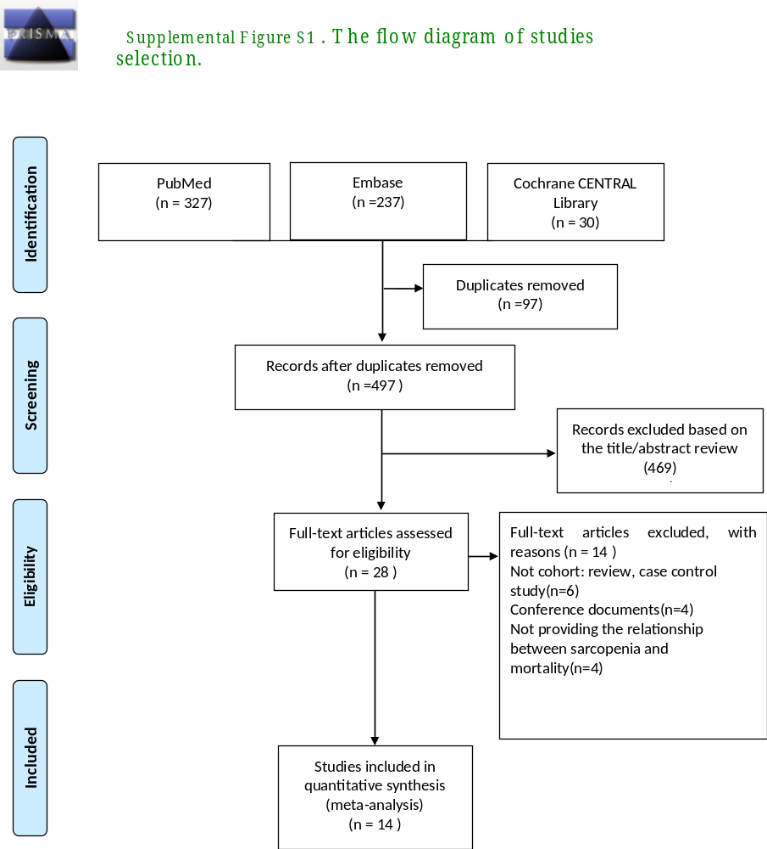

Supplemental Figure S2: The results of trial sequential analysis on mortality
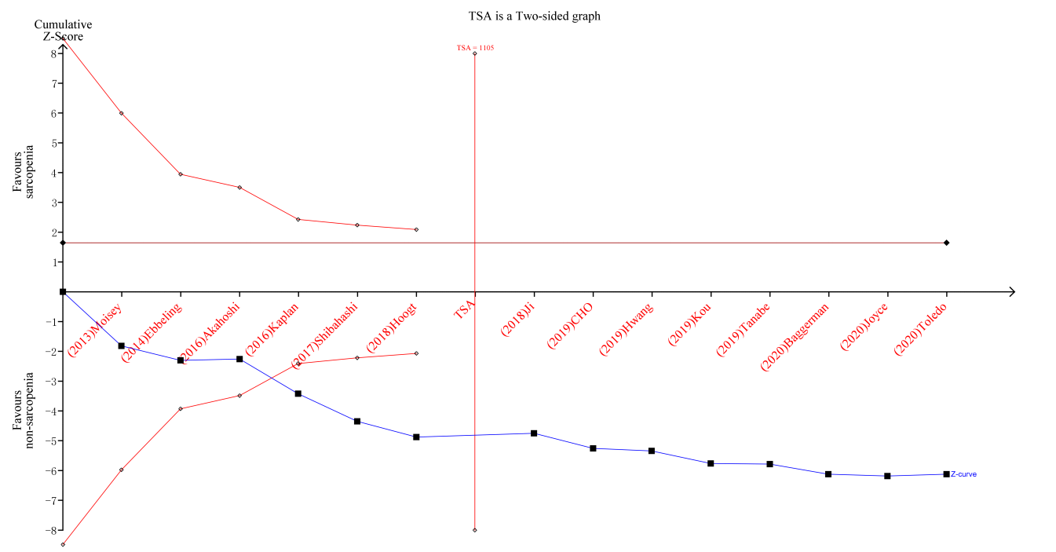

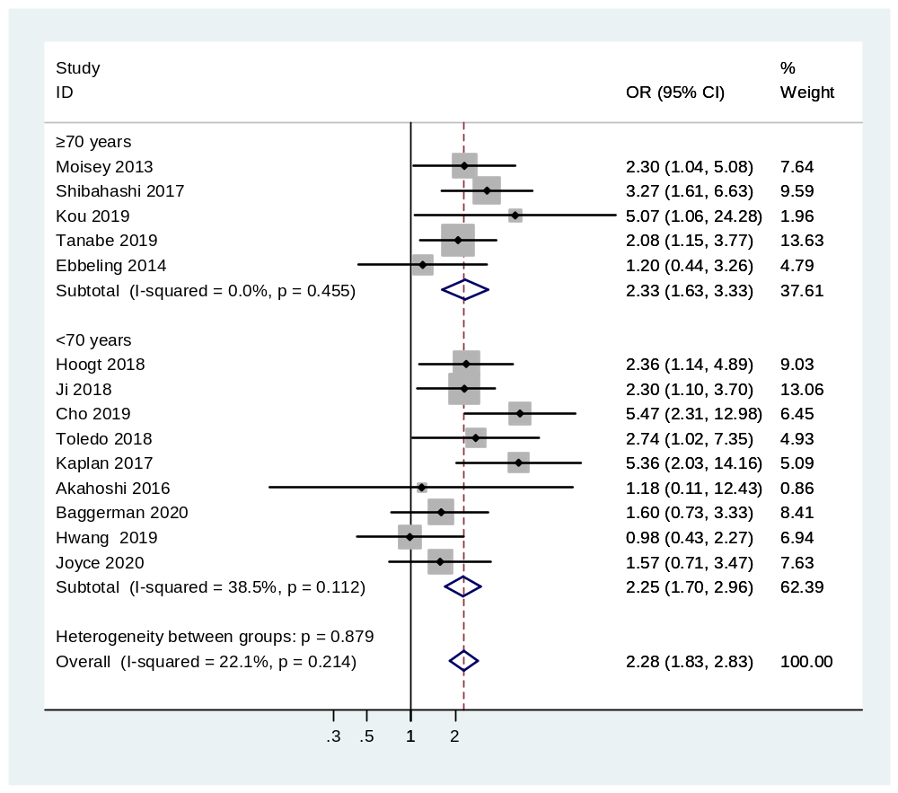

Figure S3: Subgroup meta-analysis of the association between sarcopenia and mortality in critically ill patients between different age

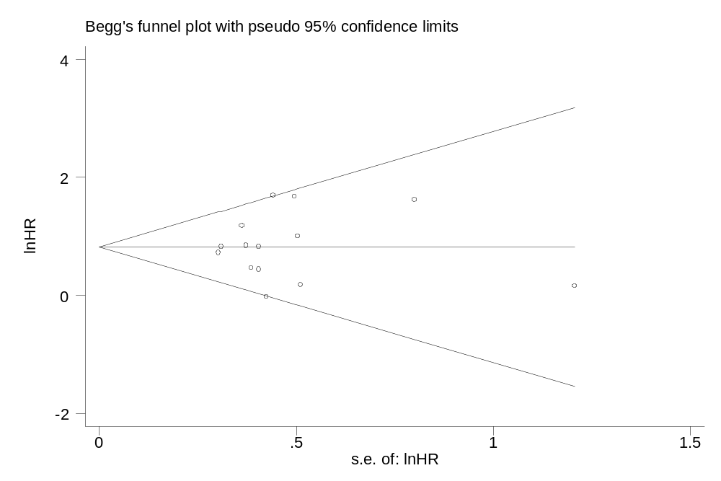

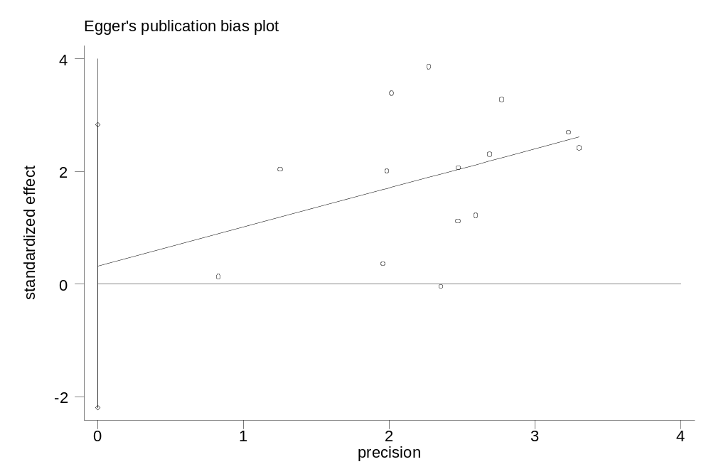
Supplement Figure S4: Begg’s and Egger’s test for publication bias.

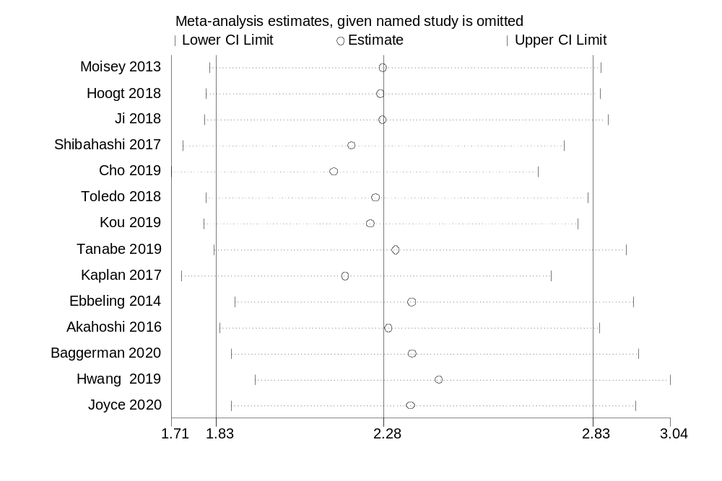
Supplement Figure S5. Sensitivity analysis of all studies.

