Supporting information
Figure S1
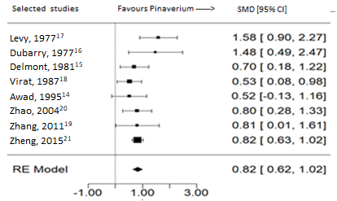
Forest plot of standardized mean difference (SMD) of the evaluation of abdominal pain in the placebo-controlled trials of pinaverium vs placebo in IBS, based on eight selected studies, pooling performed by the random meta-analytical model (RE).

Figure S2
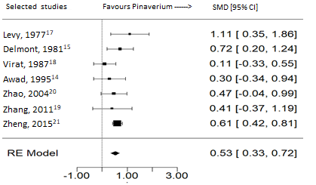
Forest plot of standardized mean difference (SMD) of the evaluation of stool change (consistency/frequency) in the placebo-controlled trials of pinaverium vs placebo in IBS, based on seven selected studies, pooling performed by the random meta-analytical model (RE).

Figure S3
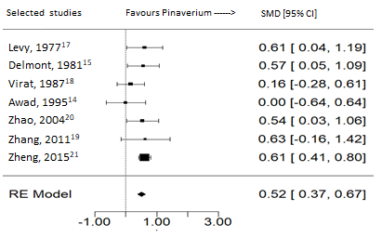
Forest plot of standardized mean difference (SMD) of the evaluation of bloating in the placebo-controlled trials of pinaverium vs placebo in IBS, based on seven selected studies, pooling performed by the random meta-analytical model (RE).

Figure S4
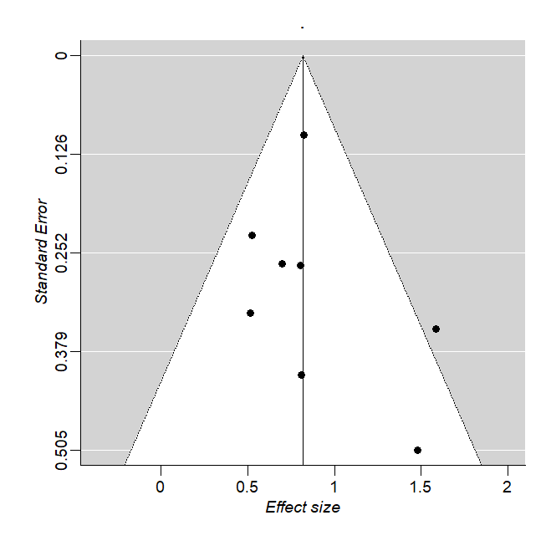
Funnel plot of the individual symptom analysis (abdominal pain). No abnormal value or asymmetry of effect size of each study with respect of the mean pooled effect (0.82) was found.

Figure S5
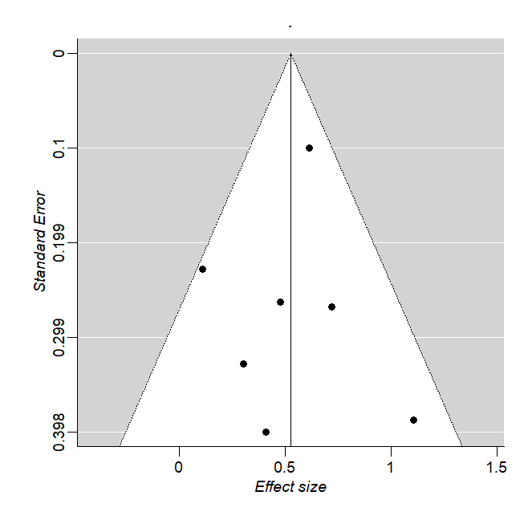
Funnel plot of the individual symptom analysis (stool change). No abnormal value or asymmetry of effect size of each study with respect of the mean pooled effect (0.53) was found.

Figure S6
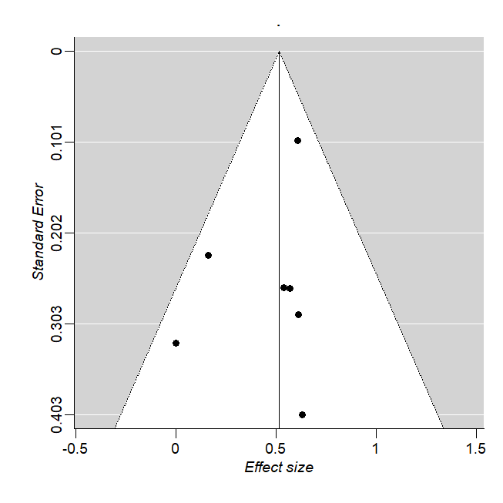
Funnel plot of the individual symptom analysis (bloating). No abnormal value or asymmetry of effect size of each study with respect of the mean pooled effect (0.52) was found.

Figure S7
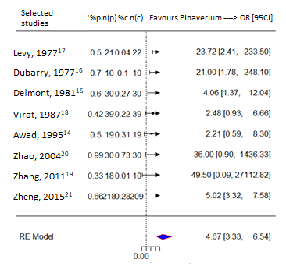
Forest plot of odds ratio (OR) of placebo-controlled trials of pinaverium vs placebo in abdominal pain in IBS, based on eight selected studies, pooling performed by the random meta-analytical model (RE). %p, n(p), %c and n(c) being the proportions and sample sizes of the treatment groups for Pinaverium and control, respectively.

