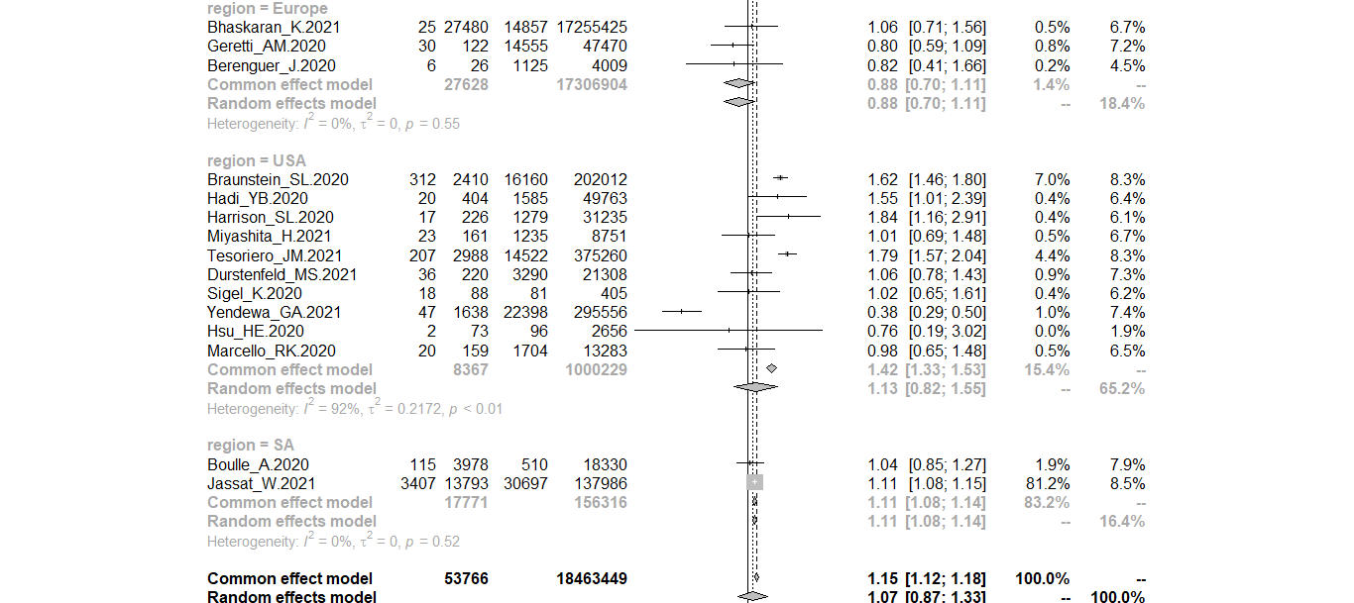

Supplementary File 2: Forest plot of association of HIV coinfection and mortality due to COVID-19 with sub group analysis by geographical location

