Additional meta-analysis data：
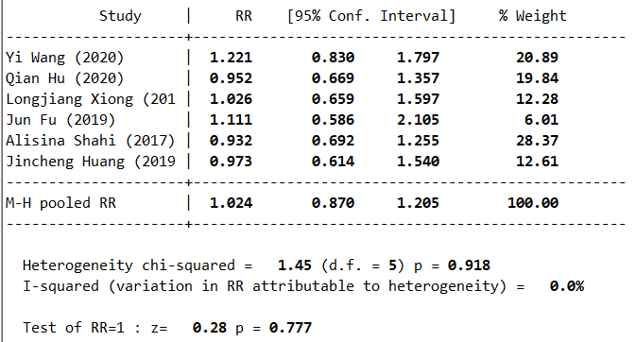
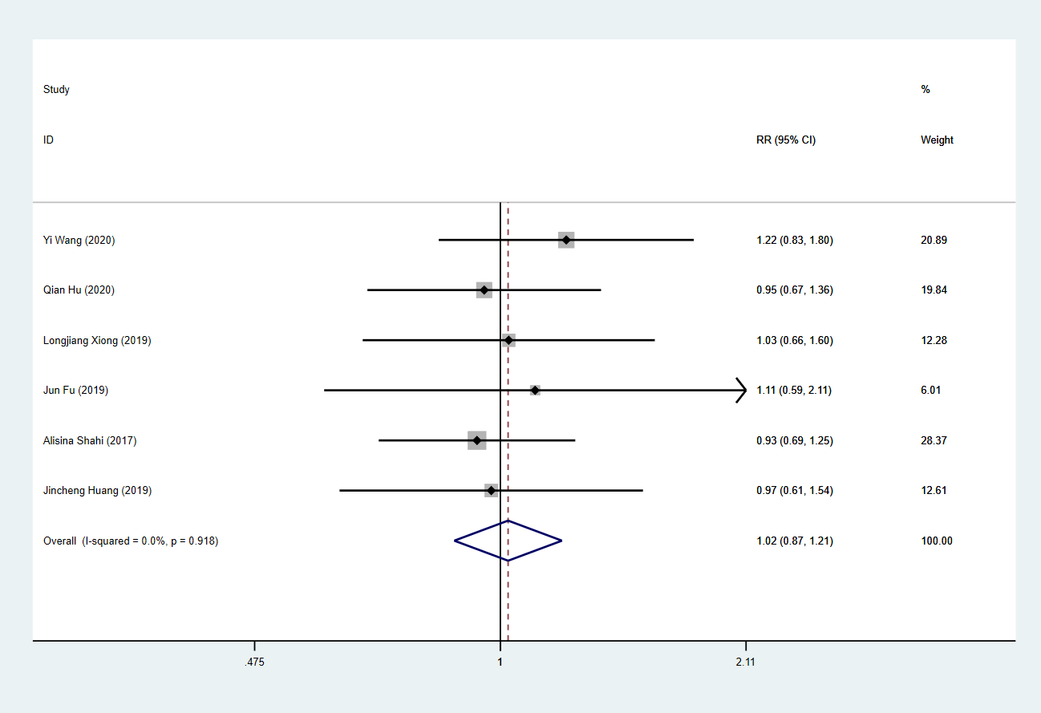
A meta-analysis comparing the sensitivity of CRP and D-dimer in the diagnosis of PJI

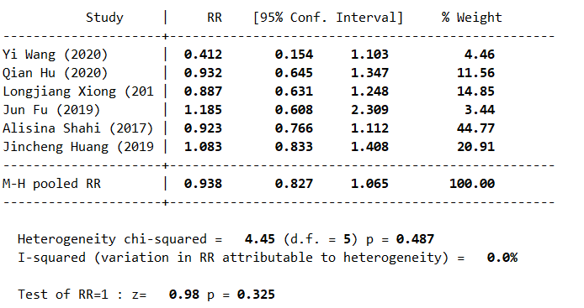
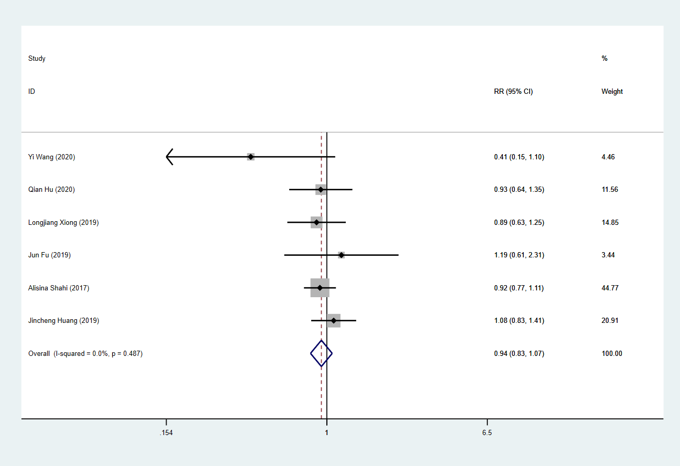
A meta-analysis comparing the specificity of CRP and D-dimer in the diagnosis of PJI

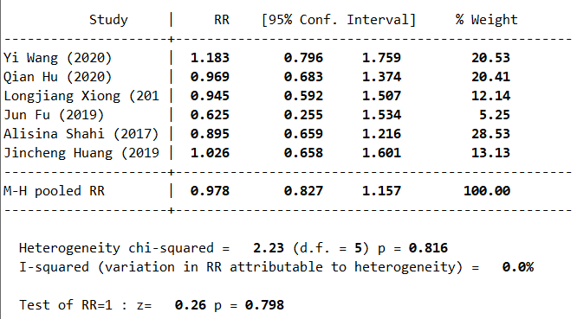
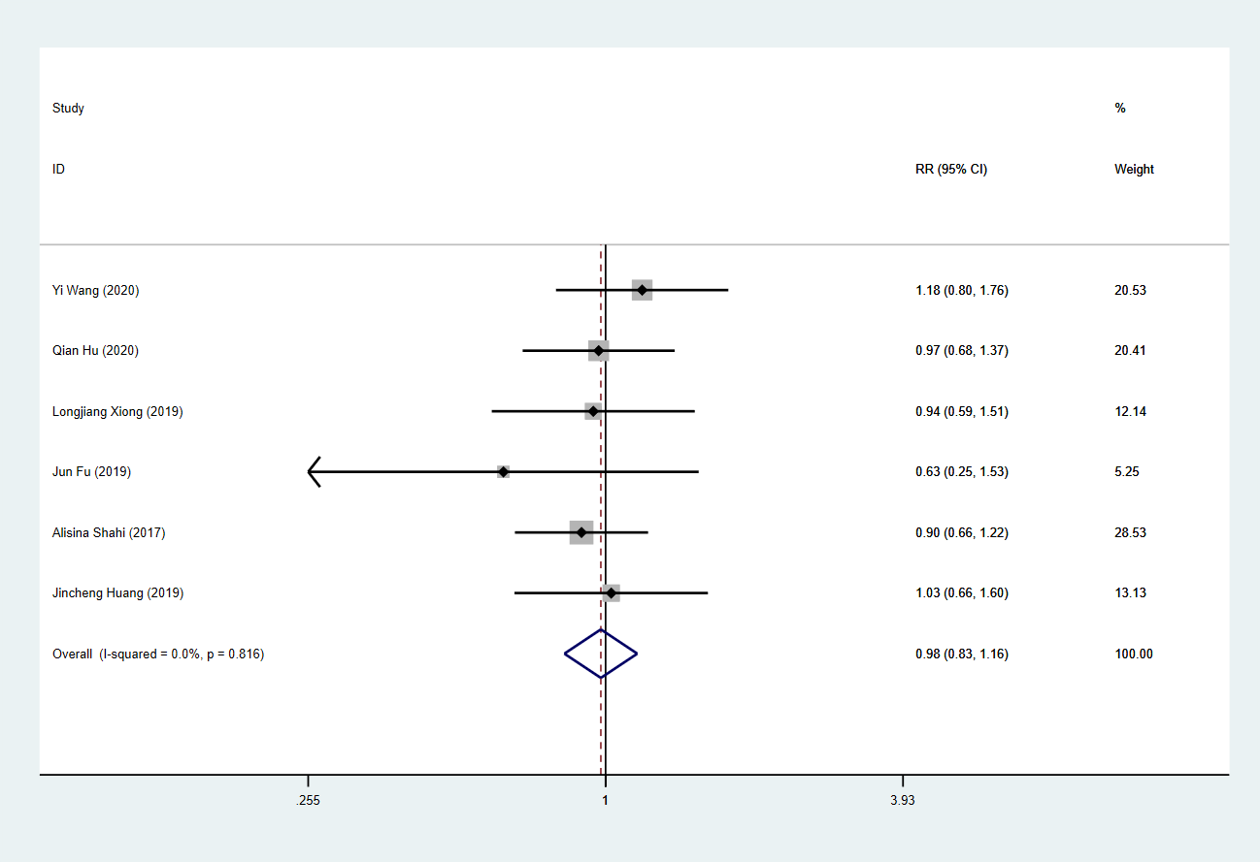
A meta-analysis comparing the sensitivity of ESR and D-dimer in the diagnosis of PJI

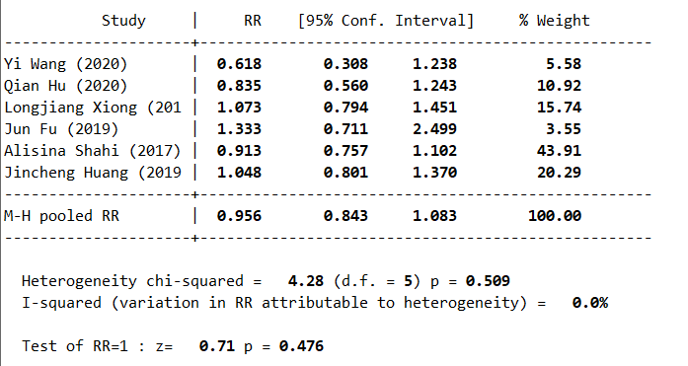
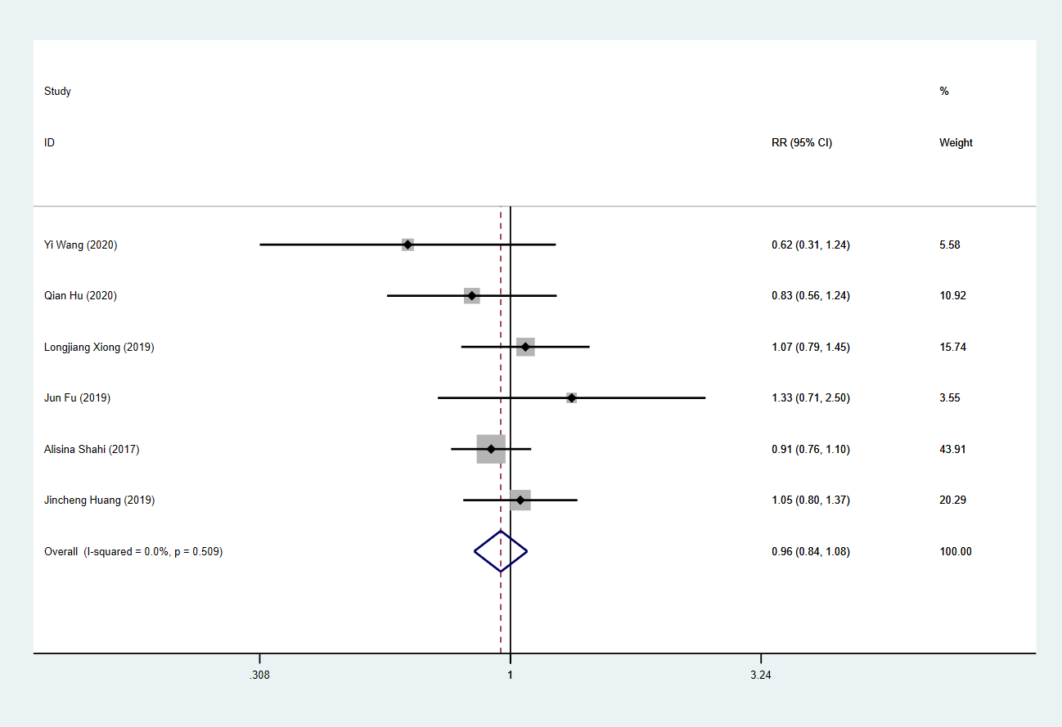
A meta-analysis comparing the specificity of ESR and D-dimer in the diagnosis of PJI

