Appendix 3: Risk of bias assessment: A) risk of bias in indivisual studies. B) summary risk of bias asseessment.
A.
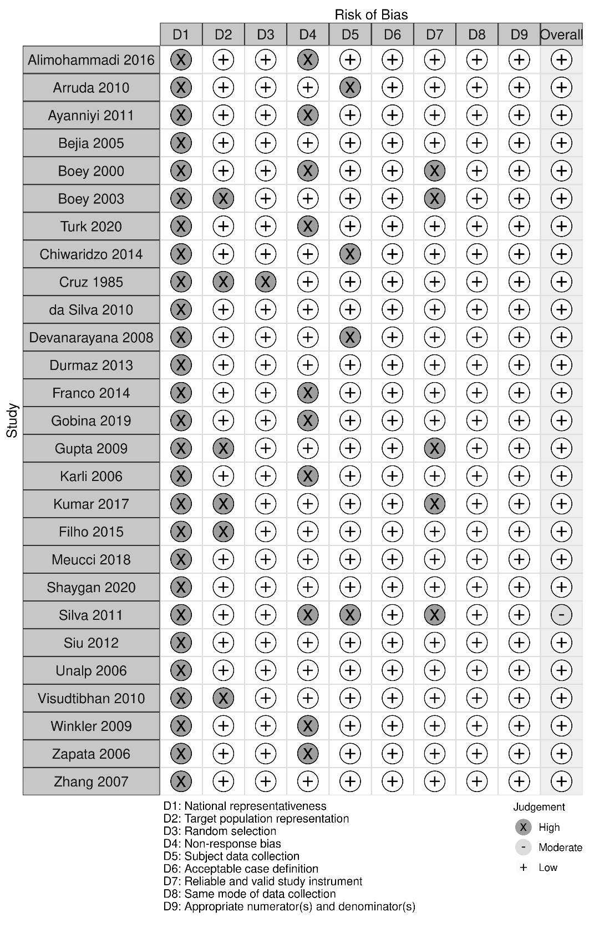

B.


