Supplementary File, Tables and Figures

Table of Contents
Search Strategy 1
Medline 2
Table S1. GRRAS tool for quality assessment of measurement comparison studies (Guidelines for Reporting Reliability and Agreement Studies). Adapted from Harford et al 2019. 8
Table S2. Influential analysis on Pearson’s correlation coefficient 9
Table S3. Meta-regression analysis for various moderators or confounders on Pearson’s correlation coefficient 9
Figure S1. One study removed meta-analysis 10
Figure S2. Cumulative meta-analysis 11
Figure S3. Publication bias Funnel plot 12
Figure S4. Meta-regression analysis plot for various moderators or confounders on Pearson’s correlation coefficient. A) Mean age in years B) Male gender in percentage C) Year of publication D) Sample size 12

Search Strategy

Date completed: September 28, 2020

The databases searched were: MEDLINE (Ovid), PubMed-Not-MEDLINE (NLM), Embase, Cochrane Central Register of Controlled Trials, and Cochrane Database of Systematic Reviews.

Medline

Ovid MEDLINE(R) 1946 to September 28, 2020

# | Searches | Results
1 | Cell Phones/ | 8613
2 | "Cell Phone Use"/ | 202
3 | Computers, Handheld/ | 3638
4 | Fitness Trackers/ | 594
5 | Mobile Applications/ | 6299
6 | Remote Sensing Technology/ | 2967
7 | Smartphone/ | 4679
8 | Telemedicine/ | 24025
9 | Telemetry/ | 9763
10 | Wireless Technology/ | 3616
11 | "e-health*".mp. | 2360
12 | "m-health*".mp. | 435
13 | "no touch*".mp. | 828
14 | "p-health*".mp. | 34
15 | "u-health*".mp. | 43
16 | "wifi".mp. | 266
17 | "wi-fi".mp. | 320
18 | ((electronic adj2 health*) not (electronic health* record? or electronic health* care record?)).mp. | 1264
19 | (activit* adj2 tracker?).mp. | 294
20 | (activity adj2 (logger? or logging)).mp. | 48
21 | (activity adj2 counter?).mp. | 147
22 | (activity adj2 monitor*3).mp. | 9603
23 | (ambient adj1 intelligen*).mp. | 106
24 | (android adj2 (app or apps or application?)).mp. | 314
25 | (apple adj2 (app or apps or application?)).mp. | 148
26 | (digital adj1 patient?).mp. | 284
27 | (digital adj2 health* adj1 tech*).mp. | 110
28 | (digital adj2 health* adj1 tool?).mp. | 44
29 | (fitness adj1 monitor?).mp. | 14
30 | (fitness adj1 tracker?).mp. | 644
31 | (google adj2 (app or apps or application?)).mp. | 94
32 | (health care app or health care apps).mp. | 16
33 | (health* app or health* apps).mp. | 417
34 | (intelligent adj1 sensor?).mp. | 69
35 | (ipad or ipads).mp. | 1107
36 | (ipad?? adj2 app?).mp. | 53
37 | (ipad?? adj2 application?).mp. | 104
38 | (mobile adj2 health* adj1 tech*).mp. | 272
39 | (mobile adj2 health* adj1 tool?).mp. | 41
40 | (mobile adj2 health*).mp. | 6685
41 | (motion adj2 tracker?).mp. | 73
42 | (patient? adj2 tracker?).mp. | 49
43 | (person* adj2 health* adj1 tech*).mp. | 33
44 | (person* adj2 health* adj1 tool?).mp. | 6
45 | (person* adj2 tracker?).mp. | 15
46 | (personal adj1 digital* adj1 device?).mp. | 11
47 | (portable adj2 (app or apps or application?)).mp. | 169
48 | (smart adj2 (phone? or device? or app or apps or application? or sensor?)).mp. | 1788
49 | (tablet* adj1 (app or apps)).mp. | 36
50 | (tablet* adj1 application?).mp. | 91
51 | (ubiquitous adj2 health*).mp. | 240
52 | (ubiquitous adj2 monitor*).mp. | 72
53 | (wireless* adj2 (device? or communicat* or handheld or sensor? or technolog*)).mp. | 5498
54 | activity monitor*.mp. | 3231
55 | android tablet?.mp. | 47
56 | apple ios.mp. | 18
57 | bluetooth*.mp. | 750
58 | camera?.mp. | 34063
59 | cellphone??.mp. | 262
60 | cell-phone??.mp. | 9671
61 | consumer-based monitor?.mp. | 2
62 | contactless*.mp. | 1093
63 | contact-less*.mp. | 103
64 | digital tablet?.mp. | 46
65 | ehealth*.mp. | 2679
66 | electronic tablet?.mp. | 91
67 | google android.mp. | 15
68 | google pixel?.mp. | 2
69 | google play.mp. | 188
70 | health* application?.mp. | 1535
71 | health* tech* enable?.mp. | 10
72 | interactive health* tech*.mp. | 6
73 | "internet of things".mp. | 575
74 | internet* tablet?.mp. | 10
75 | ipad?? app?.mp. | 41
76 | iphone?.mp. | 641
77 | mhealth*.mp. | 2657
78 | microsoft surface??.mp. | 2
79 | mobile app?.mp. | 1263
80 | mobile application?.mp. | 6912
81 | mobile health*.mp. | 6313
82 | motion sensor?.mp. | 752
83 | movement sensor?.mp. | 183
84 | noncontact*.mp. | 3526
85 | non-contact*.mp. | 3927
86 | nontouch*.mp. | 47
87 | non-touch*.mp. | 145
88 | pedometer?.mp. | 2278
89 | personali#ed health*.mp. | 740
90 | phealth*.mp. | 52
91 | phone app?.mp. | 255
92 | phone application?.mp. | 394
93 | physical activity monitor?.mp. | 172
94 | samsung galaxy.mp. | 52
95 | samsung tablet?.mp. | 2
96 | smartphone*.mp. | 8377
97 | tablet? computer?.mp. | 604
98 | telecare.mp. | 647
99 | tele-care.mp. | 29
100 | telehealth*.mp. | 4010
101 | tele-health*.mp. | 136
102 | telemonitor*.mp. | 1276
103 | tele-monitor*.mp. | 120
104 | touchless*.mp. | 65
105 | touch-less*.mp. | 19
106 | uhealth*.mp. | 4
107 | webcam*.mp. | 302
108 | web-cam*.mp. | 135
109 | or/1-108 [ Contactless or Mobile Apps or Camera or WebCam ] | 127620
110 | exp vital signs/ | 411459
111 | (vital adj2 sign?).mp. | 12664
112 | (vital adj2 biosign?).mp. | 0
113 | (vital adj2 bio-sign?).mp. | 1
114 | blood pressure/ | 275443
115 | body temperature/ | 47470
116 | heart rate/ | 164861
117 | respiratory rate/ | 2876
118 | Oximetry/ or Oxygen/ | 172784
119 | (blood adj2 pressure?).mp. | 423449
120 | (body adj2 temperature?).mp. | 79674
121 | (heart?? adj2 rate?).mp. | 230246
122 | heartbeat?.mp. | 3912
123 | heart beat?.mp. | 2549
124 | (pulse adj2 rate?).mp. | 8229
125 | respiration.mp. | 194956
126 | (respiratory adj2 rate?).mp. | 17044
127 | (breathing adj2 rate?).mp. | 1558
128 | (oxygen* adj2 saturat*).mp. | 24767
129 | apn?ea*.mp. | 53915
130 | oximetr*3.mp. | 16981
131 | or/110-130 [ Vital Signs & related terms ] | 987315
132 | 109 and 131 [ Contactless/Mobile/Camera + Vital Signs ] | 9414
133 | Clinical Trial, Phase III.pt. | 17272
134 | Clinical Trial, Phase III/ | 17272
135 | Clinical Trial.pt. | 524516
136 | Clinical Trials, Phase III as Topic/ | 9615
137 | Comparative Study.pt. | 1871321
138 | Comparative Study/ | 1871321
139 | Controlled Clinical Trial.pt. | 93842
140 | Controlled Clinical Trial/ | 93842
141 | Controlled Clinical Trials as Topic/ | 5536
142 | Cross-Sectional Studies/ | 338460
143 | Double-Blind Method/ | 160040
144 | Equivalence Trial.pt. | 635
145 | Equivalence Trial/ | 635
146 | Equivalence Trials as Topic/ | 390
147 | Evaluation Study.pt. | 253901
148 | exp Case-Control Studies/ | 1106725
149 | exp Cohort Studies/ | 2036160
150 | exp Randomized Controlled Trial/ | 514737
151 | exp Randomized Controlled Trials as Topic/ | 139797
152 | Longitudinal Studies/ | 137827
153 | Meta-Analysis as Topic/ | 18385
154 | Meta-Analysis/ | 120143
155 | Multicenter Studies as Topic/ | 18679
156 | Multicenter Study.pt. | 279890
157 | Multicenter Study/ | 279890
158 | Observational Study/ | 85210
159 | Observational Studies as Topic/ | 5427
160 | Placebos/ | 35106
161 | Pragmatic Clinical Trial.pt. | 1511
162 | Pragmatic Clinical Trial/ | 1511
163 | Pragmatic Clinical Trials as Topic/ | 485
164 | Prospective Studies/ | 549856
165 | Randomized Controlled Trial.pt. | 513800
166 | Retrospective Studies/ | 841389
167 | Systematic Review/ [ New MeSH 2019 ] | 134540
168 | Systematic Review.pt. [ New PT 2019 ] | 134540
169 | Systematic Reviews as Topic/ [ New MeSH 2019 ] | 3981
170 | Validation Studies/ | 102159
171 | Validation Study.pt. | 102159
172 | ("phase 3" or "phase3" or "phase III").mp. | 52483
173 | ((multicenter* or multicentre*) adj2 (trial? or study or studies)).mp. | 313891
174 | ((noninferiority or non-inferiority) adj4 (trial? or study or studies)).mp. | 4065
175 | ((single or double or triple or treble) adj3 (blind* or mask*)).mp. | 223384
176 | (case control* adj2 (study or studies)).mp. | 312118
177 | (comparative adj2 (trial? or study or studies)).mp. | 1920973
178 | (conceal* adj2 allocat*).mp. | 2595
179 | (controlled adj1 clinical adj2 (trial? or study or studies)).mp. | 125056
180 | (cross-sectional* adj2 (study or studies)).mp. | 360343
181 | (equivalen* adj4 (trial? or study or studies)).mp. | 4794
182 | (evaluation adj1 (study or studies)).mp. | 380075
183 | (longitudinal* adj2 (study or studies)).mp. | 171043
184 | (meta-anal* or metanal* or metaanal*).mp. | 175756
185 | (observational adj2 (trial? or study or studies)).mp. | 158004
186 | (overview? adj4 (review or reviews)).mp. | 14787
187 | (pragmatic adj2 (trial? or study or studies)).mp. | 3649
188 | (prospective* adj2 (study or studies)).mp. | 633178
189 | (retrospective* adj2 (study or studies)).mp. | 872724
190 | (superiority adj4 (trial? or study or studies)).mp. | 2910
191 | (systematic adj4 (review or reviews or overview or overviews)).mp. | 163875
192 | (validation adj1 (study or studies)).mp. | 112826
193 | cohort*.mp. | 607044
194 | placebo*.mp. | 210811
195 | quasirandom*.mp. | 107
196 | random*.mp. | 1211109
197 | semiquantitative.mp. | 18251
198 | or/133-197 [ Studies - alphabetical ] | 5795864
199 | Diagnosis/ | 17364
200 | Diagnostic Errors/ | 37808
201 | di.fs. [ Diagnosis floating subheading ] | 2580744
202 | Follow Up Studies/ | 647899
203 | Incidence/ | 265000
204 | Likelihood Functions/ | 22081
205 | Mass Screening/ | 104198
206 | Mortality/ | 44662
207 | Odds Ratio/ | 91296
208 | Prognosis/ | 513350
209 | Propensity Score/ | 9585
210 | exp Risk/ | 1220162
211 | ROC Curve/ | 58903
212 | "Sensitivity And Specificity"/ | 348392
213 | course?.mp. | 548234
214 | diagnos*.mp. | 4692616
215 | likelihood?.mp. | 133867
216 | predict*.mp. | 1403039
217 | prognos*.mp. | 788295
218 | screen*3.mp. | 718756
219 | (odds adj ratio*).mp. | 280021
220 | (propensity adj (score or scores or scored or scoring)).mp. | 20535
221 | (receiver operat* adj2 characteristic*).mp. | 63767
222 | (risk or risks or risked or risking).mp. | 2358708
223 | (sensitivity and specificity).mp. | 464710
224 | or/199-223 [ Diagnostic Accuracy & related terms ] | 8495713
225 | 198 or 224 [ Studies or Diagnostic Accuracy ] | 11092202
226 | 132 and 225 [ Contactless/Mobile/Camera + Vital Signs + (Studies/Diagnostic Accuracy) ] | 5480
227 | limit 226 to english language | 5161
228 | exp animals/ not (exp animals/ and exp human/) | 4738846
229 | 227 not 228 | 4273
230 | limit 227 to humans | 4150
231 | 229 or 230 | 4273
232 | limit 231 to ("all infant (birth to 23 months)" or "all child (0 to 18 years)" or "newborn infant (birth to 1 month)" or "infant (1 to 23 months)" or "preschool child (2 to 5 years)" or "child (6 to 12 years)" or "adolescent (13 to 18 years)") | 616
233 | 231 not 232 | 3657
234 | limit 231 to ("all adult (19 plus years)" or "young adult (19 to 24 years)" or "adult (19 to 44 years)" or "young adult and adult (19-24 and 19-44)" or "middle age (45 to 64 years)" or "middle aged (45 plus years)" or "all aged (65 and over)" or "aged (80 and over)") | 2528
235 | 233 or 234 | 3985
236 | remove duplicates from 235 | 3984
237 | limit 236 to yr="1946 -2004" | 676

Table S1. GRRAS tool for quality assessment of measurement comparison studies (Guidelines for Reporting Reliability and Agreement Studies). Adapted from Harford et al 2019.

Last name, year | Population/  set-up  reporting | Statistical score | Study reporting  score | Study reporting  quality
Yang, 2020 | 2 | 3 | 5 | Good
Wang, 2020 | 2 | 1 | 3 | Fair
Benedetto, 2019 | 3 | 3 | 6 | Good
Luo, 2019 | 1 | 0 | 1 | Weak
Gonzalez Viejo C, 2018 | 2 | 1 | 3 | Fair
Rodríguez, 2018 | 3 | 3 | 6 | Good
Sanyal, 2018 | 3 | 1 | 4 | Fair
Tang, 2018 | 3 | 0 | 3 | Fair
Coppetti, 2017 | 2 | 1 | 3 | Fair
Wei, 2017 | 1 | 3 | 4 | Fair
Yan, 2017 | 2 | 1 | 3 | Fair
Huang, 2016 | 2 | 1 | 3 | Fair
Koprowski, 2016 | 1 | 2 | 3 | Fair
Cheatham, 2015 | 1 | 2 | 3 | Fair
Couderc, 2015 | 3 | 0 | 3 | Fair
Lin, Australia, 2015 | 2 | 0 | 2 | Weak
Li, Finland, 2014 | 2 | 0 | 2 | Weak
Xu, 2014 | 1 | 3 | 4 | Fair
Holton, 2013 | 3 | 3 | 6 | Good
Bousefsaf, 2013 | 3 | 3 | 6 | Good
Lewadowska, 2012 | 3 | 0 | 3 | Fair
Sun, 2012 | 1 | 1 | 2 | Weak
Tsouri, 2012 | 2 | 2 | 4 | Fair
Zhu, 2012 | 2 | 0 | 2 | Weak
Poh, 2011 | 3 | 0 | 3 | Fair
Poh, 2010 | 3 | 1 | 4 | Fair

Table S2. Influential analysis on Pearson’s correlation coefficient

Criteria for study removal | Study removed | Point estimate  (95% Confidence interval) | P value
Study with lowest effect estimate | Coppetti et al. 2017 | 0.968 (0.920 – 0.987) | 0.000
Study with highest effect estimate | Poh et al. 2011 and Yan et al. 2017 | 0.935 (0.890 – 0.962) | 0.000
Study with wide confidence interval | Wang et al. 2020 | 0.963 (0.906 – 0.986) | 0.000

Table S3. Meta-regression analysis for various moderators or confounders on Pearson’s correlation coefficient

Moderator or confounder | Co-efficient | Standard error | 95% confidence interval | P value
Mean age in years | -0.0506 | 0.0265 | -0.1025 to -0.0012 | 0.0556
Male gender in percentage | -0.0054 | 0.0195 | -0.0436 to 0.0327 | 0.7797
Year of publication | -0.0669 | 0.1398 | -0.3410 to 0.2072 | 0.6323
Sample size | 0.0150 | 0.0399 | -0.0632 to 0.0931 | 0.7072

Fig. S1 One study removed meta-analysis

Fig. S2 Cumulative meta-analysis

Fig. S3 Publication bias Funnel plot

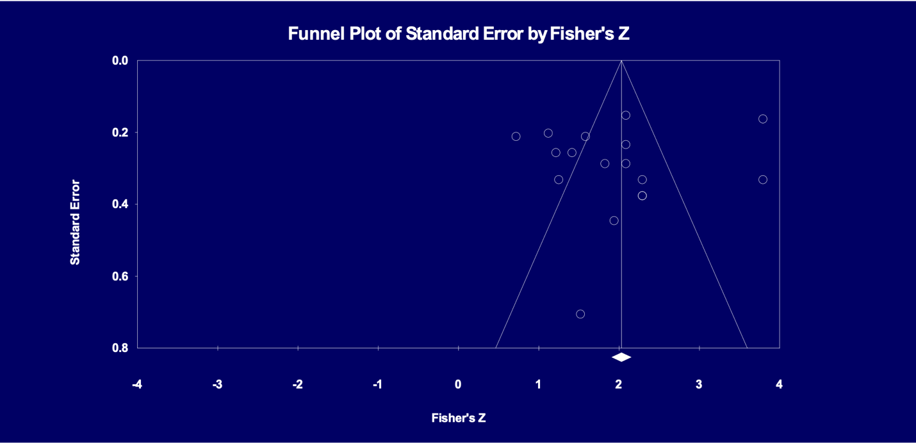

Fig. S4 Meta-regression analysis plot for various moderators or confounders on Pearson’s correlation coefficient. A) Mean age in years B) Male gender in percentage C) Year of publication D) Sample size

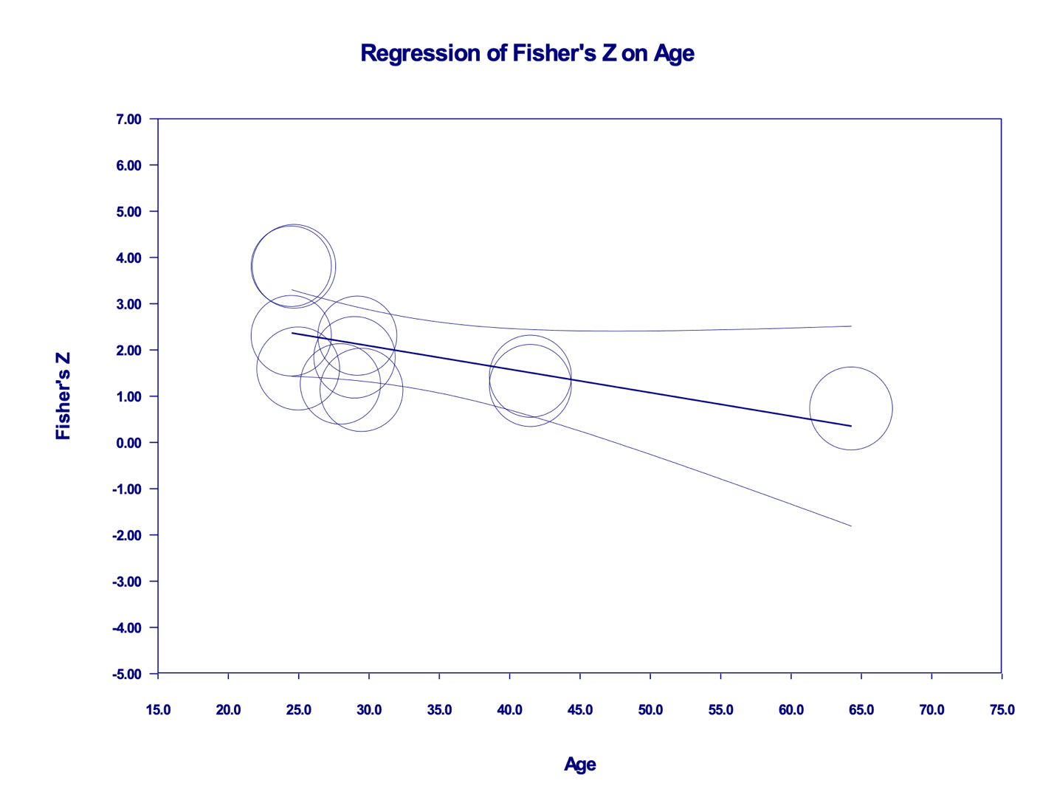
a) Metaregression of the effect of mean age on the Fisher’s Z pooled estimate. Each circle represents a study, telescoped by its weight in the analysis. The relationship was nonsignificant.

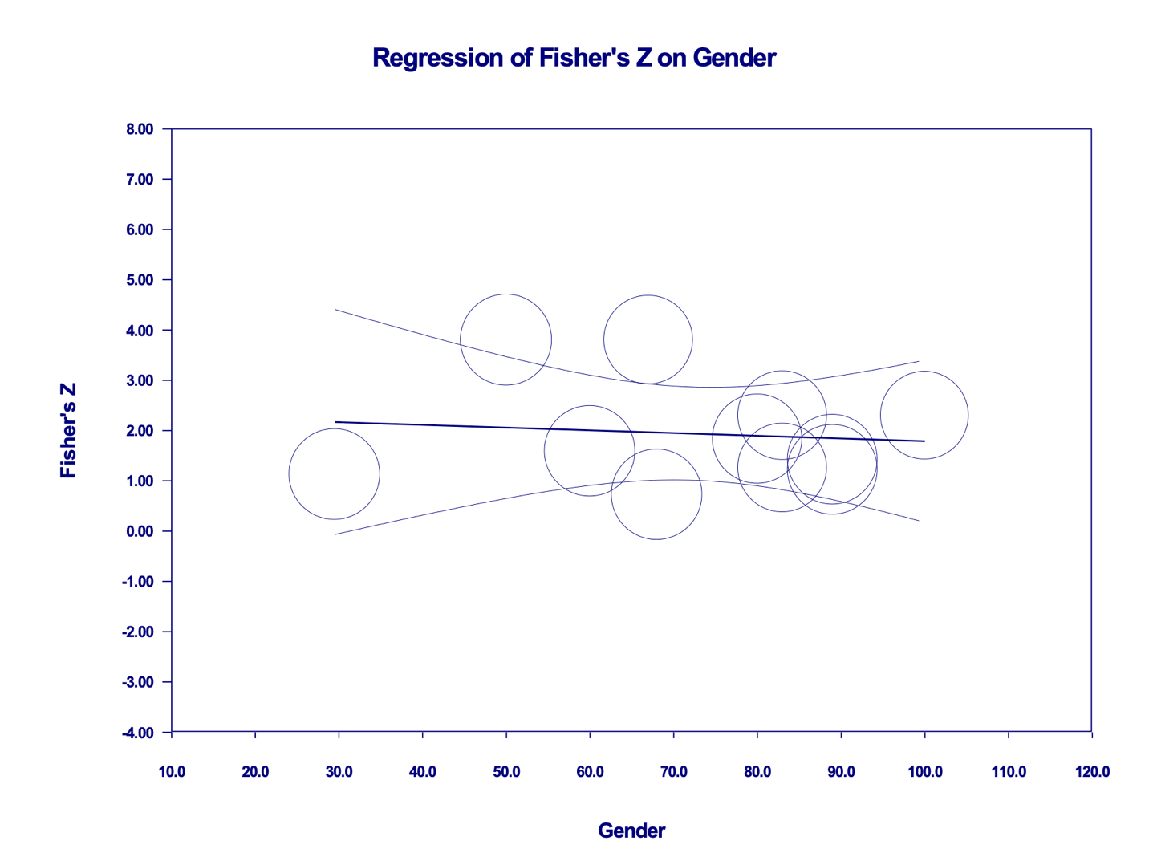

b) Metaregression of the effect of male gender on the Fisher’s Z pooled estimate. Each circle represents a study, telescoped by its weight in the analysis. The relationship was nonsignificant.

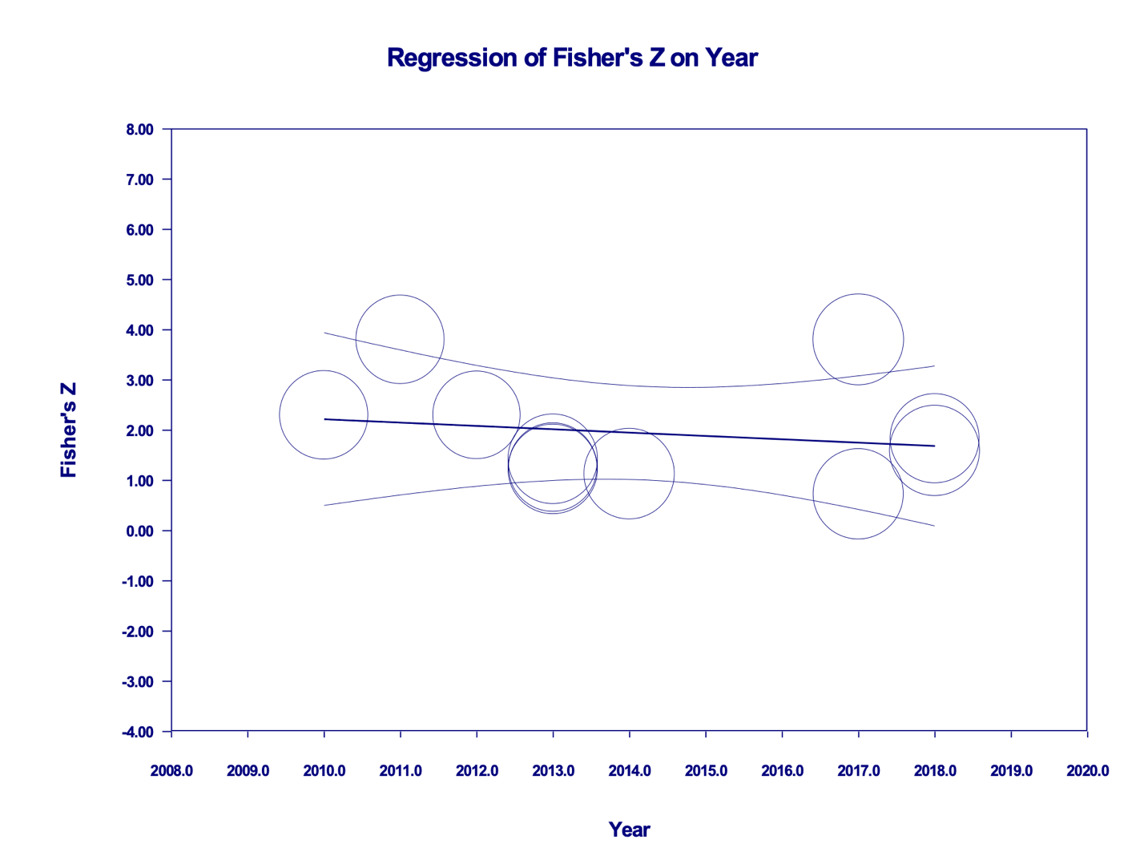

c) Metaregression of the effect of year of publication on the Fisher’s Z pooled estimate. Each circle represents a study, telescoped by its weight in the analysis. The relationship was nonsignificant.

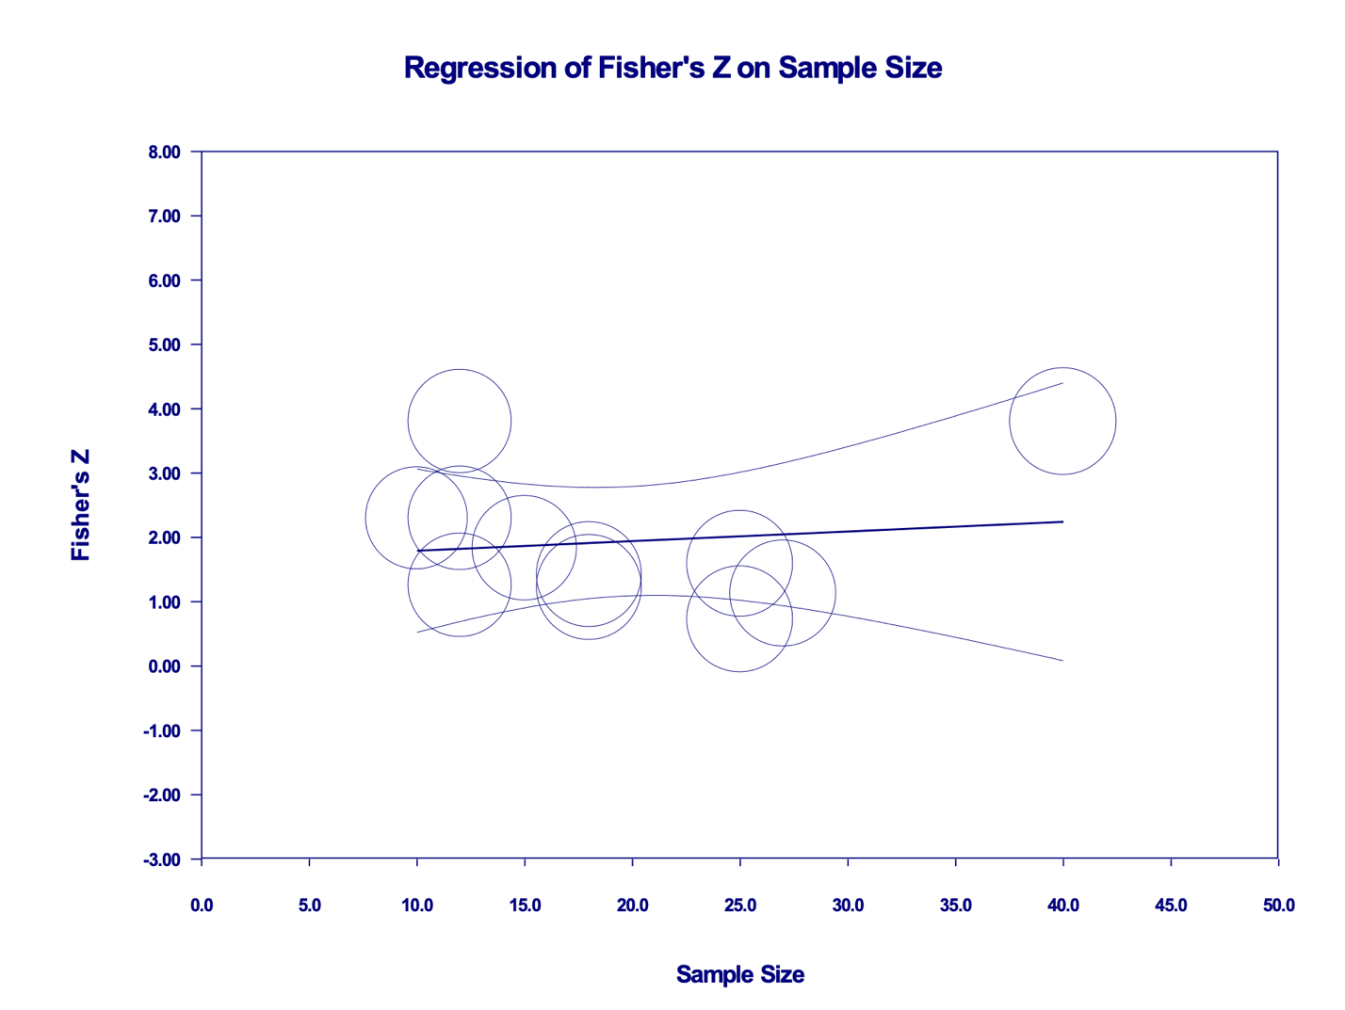

d) Metaregression of the effect of sample size on the Fisher’s Z pooled estimate. Each circle represents a study, telescoped by its weight in the analysis. The relationship was nonsignificant.

