Supplementary materials

Table 1. Quality and risk of bias assessment using the Newcastle-Ottawa Scale (NOS) for observational studies.
Study ID | Selection |  |  |  | Comparability | Outcome |  | Total  (7*)
Study ID | Representativeness of the exposed cohort (*) | Selection of non-exposed cohort (*) | Ascertainment of exposure (*) | Demonstration that outcome of interest was not present at start of study (*) | Comparability of cohorts (*) | Assessment of outcome (*) | Adequacy of follow up (*) | Total  (7*)
Coppo 2020 |  |  | * | * |  | * | * | 4*
Ding 2020 |  |  | * | * |  | * |  | 3*
Dubosh 2020 |  |  | * | * |  | * | * | 4*
Elharrar 2020 |  |  | * | * |  | * | * | 4*
Fazzini 2021 |  |  | * | * |  | * | * | 4*
Ferrando 2020 |  | * | * | * | * | * | * | 6*
Jouffroy 2021 |  |  | * | * | * | * | * | 5*
Nauka 2020 |  |  | * | * |  | * | * | 4*
Padrao 2020 |  | * | * | * | * | * | * | 6*
Thompson 2020 |  | * | * | * | * | * | * | 6*
Tonelli 2020 |  | * | * | * | * | * | * | 6*
Zhang 2020 |  | * | * | * | * | * | * | 6*

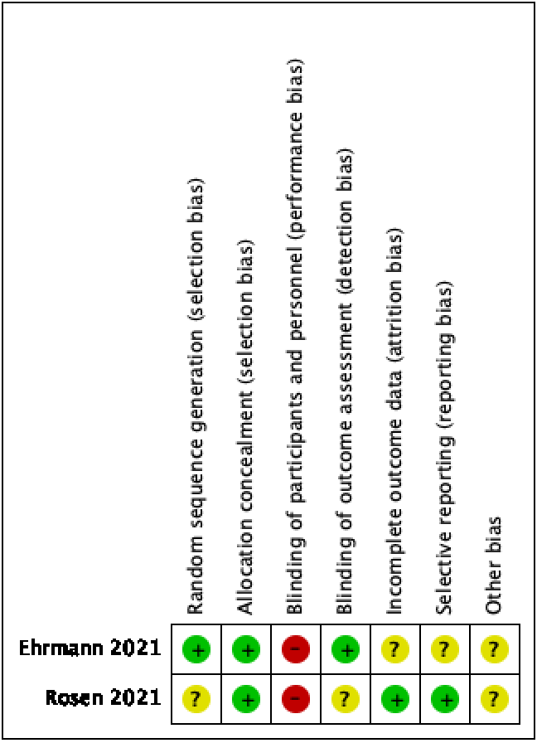
Figure 1. Risk for bias assessment using the Cochrane collaboration tool for randomized trial.

Study | Changes in RR pre and post APP | ROX index
Coppo 2020 | No difference; p= 0.40 | -
Dubosh, 2020 | No difference, p = 0.36 | -
Ehrmann, 2021 | Mentioned lower RR post APP, but no p reported | -
Fazzini, 2021 | Lower RR post APP; p < 0.001 | -
Padrao, 2020 | Lower RR post APP; p < 0.001 | Lower ROX index; p< 0.001
Zang, 2020 | No difference, p= 0.203 | Increased ROX, p< 0.01
Table 2. Summary of studies reporting changes in respiratory rate (RR) pre and post awake prone position (APP)

Study | Time of enrolment | Oxygen delivery interface | VAP
Coppo 2020 | Not reported | CPAP (helmet), reservoir mask, venturi mask | Not reported
Ding, 2020 | If SpO₂<90% on HFNO or NIV | HFNO and NIV | Not reported
Dubosh, 2020 | If SpO₂<93% on nasal cannulae or reservoir mask | Nasal cannulae and face mask | Not reported
Elharrar, 2020 | If patients required oxygen supplementation | Nasal cannulae, face mask and HFNO | Not reported
Ehrmann, 2021 | If S/F ratio ≤315mmHg (equal to P/F ratio ≤300mmHg) | HFNO | Not reported
Fazzini, 2021 | If RR>30 and SpO2<90% on FiO₂ 40% | Face mask, reservoir mask, HFNO, CPAP and NIV | Not reported
Ferrando, 2020 | If SpO2<93% on reservoir mask | HFNO | Not reported
Jouffroy, 2021 | If P/F ratio <90mmHg | Nasal cannula, face mask, reservoir mask, HFNO, CPAP and NIV | Not reported
Nauka, 2020 | Not reported | Nasal cannula, reservoir mask, HFNO | Not reported
Rosen, 2021 | Inclusion criteria based on SpO₂ at various FiO₂ values approximating a PaO₂/FiO₂ ratio of 20 kPa (150 mmHg) | HFNO, NIV | Not reported
Padrao, 2020 | respiratory rate ≥ 24 using supplemental oxygen with a flow rate ≥ 3 L/min. | Nasal cannula, face mask, HFNO, NIV | Not reported
Thompson, 2020 | If RR>30 and SpO₂<93% while on O₂ ≥ 6 L/min | Nasal cannula, reservoir mask | Not reported
Tonelli, 2021 | If RR>30, SpO₂<93% and P/F ratio <300mmHg | HFNO, CPAP, NIV | Not reported
Zang, 2020 | In case of severe hypoxia | Nasal cannula, HFNO, NIV | Not reported
Table 3. Summary of studies reporting time of enrolment for APP, respiratory oxygen interface and VAP incidence.

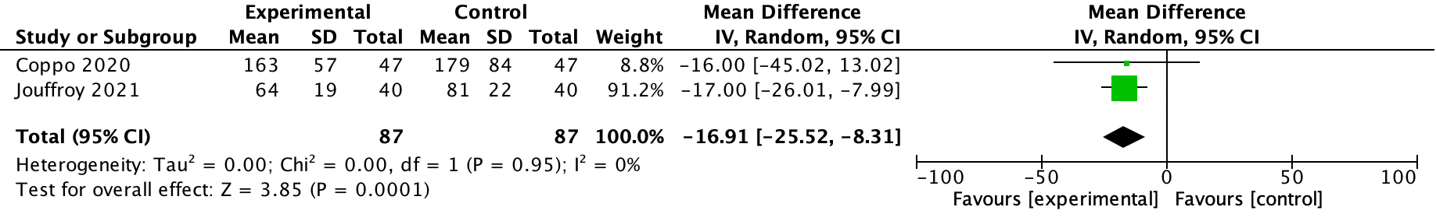
Figure 2. Subgroup analysis regarding changes in oxygenation for those proned <4 hours.

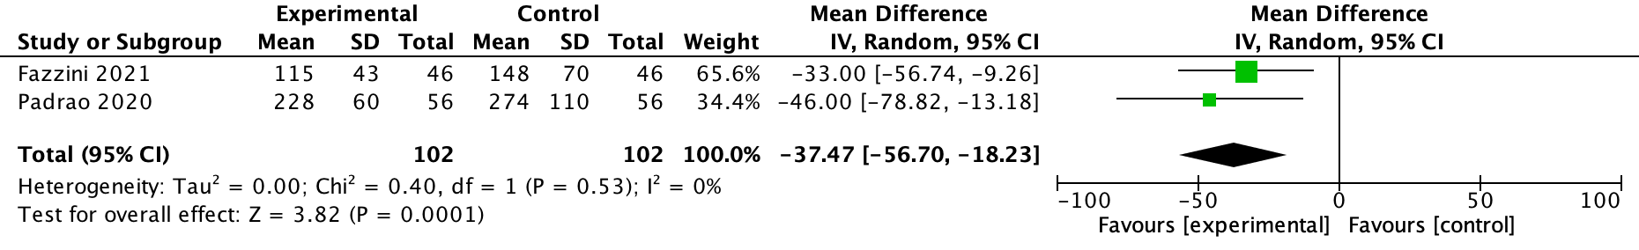
Figure 3. Subgroup analysis regarding changes in oxygenation for those proned >4 hours.

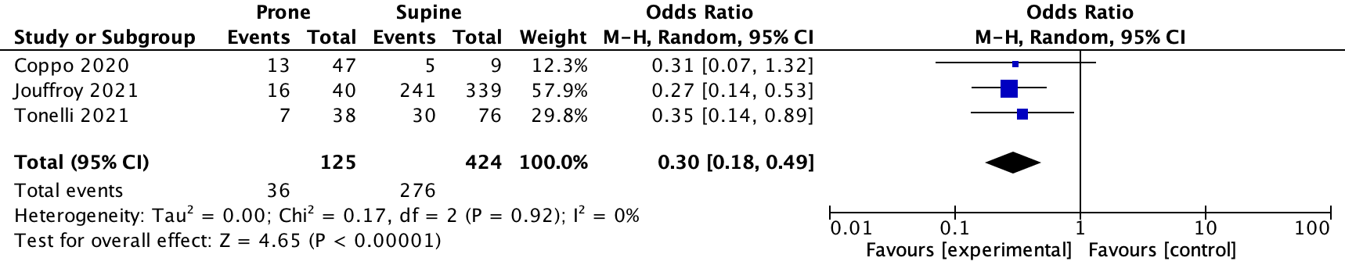
Figure 4. Subgroup analysis regarding intubation ratio for those proned <4 hours.

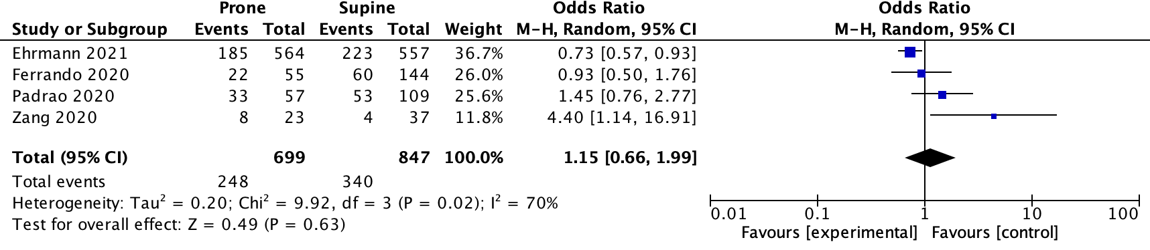
Figure 5. Subgroup analysis regarding intubation ratio for those proned >4 hours.

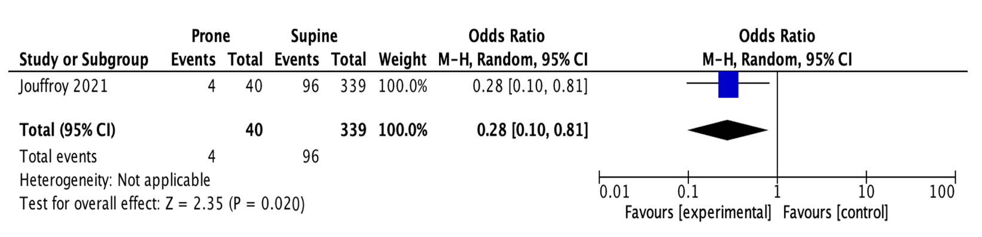
Figure 6. Subgroup analysis regarding mortality ratio for those proned <4 hours.

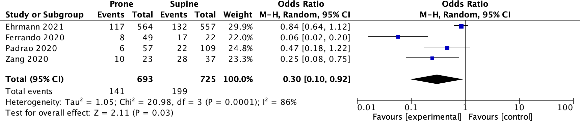
Figure 7. Subgroup analysis regarding mortality ratio for those proned >4 hour

